PLANNING CONSULTATION RESPONSE
Application No | 2026 /0657
Proposal
  Erection of 1no. building for industrial (class E(g)(iii)/B2) or storage and distribution (class B8) use with associated yard, parking, landform and landscaping (Reserved matters of the outline part of hybrid planning permission 2019/1573) for Unit 6 seeking approval of access, appearance, landscaping, layout and scale.
Address | Land to North and south of Dearne valley parkway, Hoyland,Barnsley
Date of Consultation Reply | 26/08/2026
Consultee | Air Quality

Consultation Assessment and Justification
The documentation associated with this proposal has been assessed re Air Quality and my comments are as below.

It would appear the requirements laid out by Chris Shields in 2019 have been met . As per condition 31 in the document these mitigation must be adhered to.

No Objection
*Delete as applicable
Consultation Conditions: As listed in the document

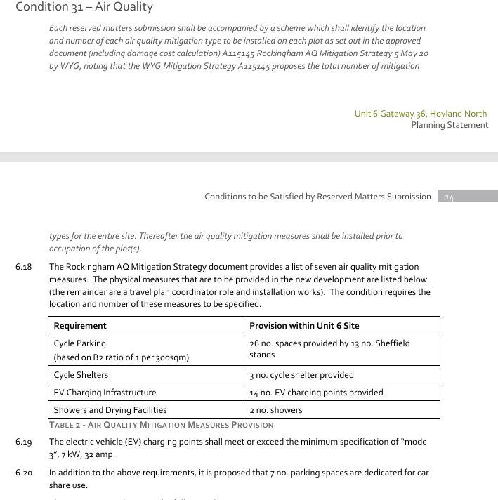

Reason :
Policy Poll1 - Pollution Control and Protection “Development will be expected to demonstrate that it is not likely to result, directly or indirectly, in an increase in air, surface water and groundwater, noise, smell, dust, vibration, light or other pollution which would unacceptably affect or cause a nuisance to the natural and built environment or to people.

Consultation Informative(s):

As we have a duty under the Environment act to monitor Air Quality and also under the Environmental protection act 1990 and the Clean Air Act to respond to complaints about Noise, Light, Dust, Smoke. If a statutory nuisance is found to exist BMBC will have a duty to act upon this and issue an abatement notice. Any failure to comply with such notice may result in a prosecution being taken and upon conviction a fine of up to £20,000 could be issued by a magistrates court. In view of this it is strongly recommended that all necessary steps are taken to mitigate any pollution be that Noise, Light or Dust.

Planning Obligations required:

N/A

