BROAD CLOSE FARM, CONE LANE, SILKSTONE, S75 4LY
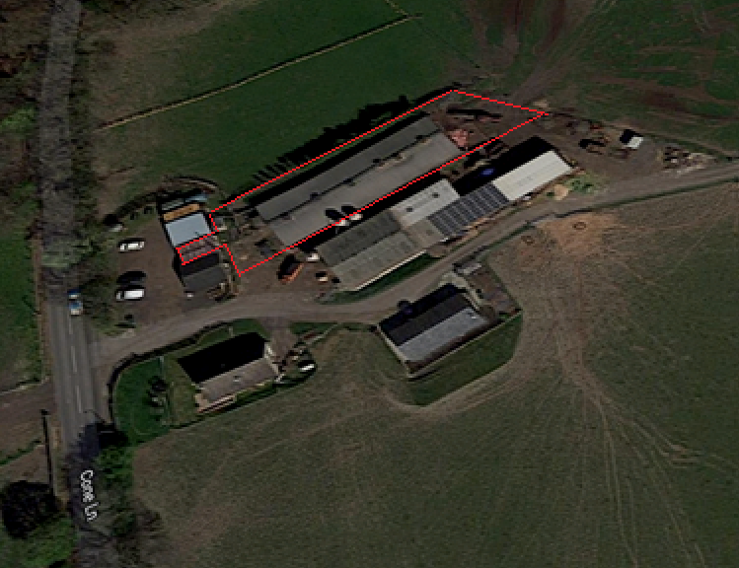

PLANNING APPLICATION FOR A CERTIFICATE OF LAWFULNESS FOR THE PROPOSED CHANGE OF USE OF AN AGRICULTURAL BUILDING TO CLASS D2 (ASSEMBLY AND LEISURE)

David Nicholas Taylor
BA (Hons.) Town Planning D.M.S
August 2022

CONTENTS PAGE

1.0 INTRODUCTION 3
2.0 BROAD CLOSE FARM 4
3.0 PROPOSED DEVELOPMENT 8
4.0 POLICY ASSESSMENT 10
5.0 CONCLUSIONS 15

INTRODUCTION
  - David N. Taylor holds a BA (Hons) Degree in Town Planning and a Diploma in Management Studies. He has undertaken MSc Urban Renewal at Liverpool Polytechnic. He was a Member of the Royal Town Planning Institute for twenty five years dating from 20th January 1993 and a Chartered Member of the Institute of Management for fifteen years dating from 27th August 1998. He has previously held Membership of The Institute of Directors and Associate Membership of the Royal Institute of British Architects. He became a Member of the Royal Town Planning Institute whilst employed by The Long-Collins Partnership of Chester: John Long FRTPI (Fellow Royal Town Planning Institute) and John Collins OBE PPRTPI (Past President Royal Town Planning Institute).
  - David Taylor has been engaged by the owners of Broad Close Farm to seek a Certificate of Lawfulness for the change of use of an agricultural building to Class D2 Assembly and Leisure.
1.3 Photographs have been photo-reduced and their dimensions adjusted for illustrative purposes. Some visual distortion may have occurred.

2.0 BROAD CLOSE FARM

2.1 Broad Close Farm Agricultural Holding Number is 477-3000-42. The farm comprises seventy acres and operates under Part 6 Class A of the GPDO (2015).
2.2 The primary activity has been pig farming. A pig breeding unit was erected in the 1980’s. The pigs roamed free and foraged in wooded areas in the wider agricultural holding. They were butchered to produce free range organic pork. This venture was years ahead of the now established market for all things organic; at the time it was insufficiently supported and was sadly not able to be sustained.
2.3 Instead, Broad Close Farm decided to adapt the unit to supply a pig rearing and finishing service for pig farmers across the region. The business grew and the farm would nurture batches of six hundred piglets per quarter. This equated to 2400 per annum. Over an eight year period almost 20,000 pigs were reared and finished for pig farmers. The waste matter was spread across the agricultural holding.
2.4 DEFRA introduced Nitrogen Vulnerable Zones in 2018 (NVZ). The production of nitrogen is restricted to 250kg nitrogen per hectare per annum at all farms located within an NVZ. Broad Close Farm is located in the Dearne Valley NVZ. The annual waste produced by twelve hundred pigs exceeded the 250kg nitrogen per hectare per annum and the business of rearing and finishing pigs was ended. Today, the pig unit is empty and unused.

2.5 Operating under the NVZ nitrogen restriction, Broad Close Farm currently farms around one hundred breeding sheep and thirty beef cows including Herefords.
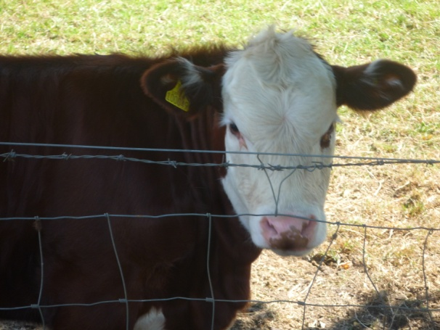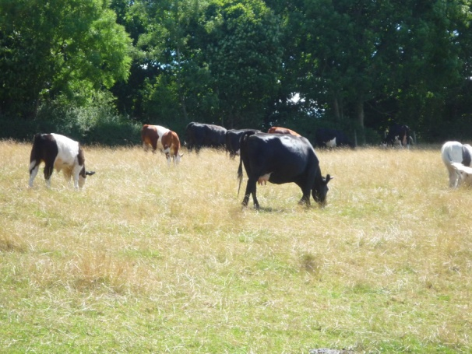
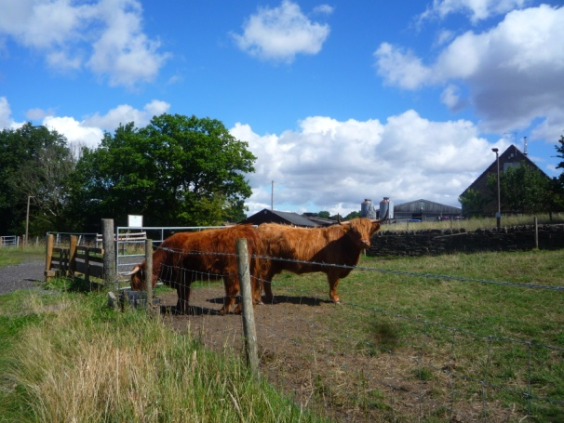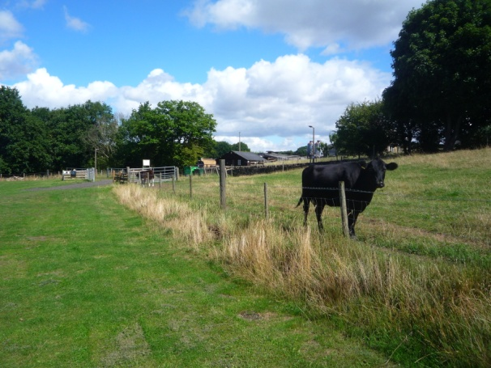

2.6 To overcome the pressure to their livelihoods caused by the loss of the pig rearing and finishing unit the owners of Broad Close Farm have been compelled to diversify.

2.7 They rent a unit to a charity called Greenworks, which provides gardening and woodworking experience to adults with learning difficulties to enable them to gain skills required for employment. (Appendix 1)
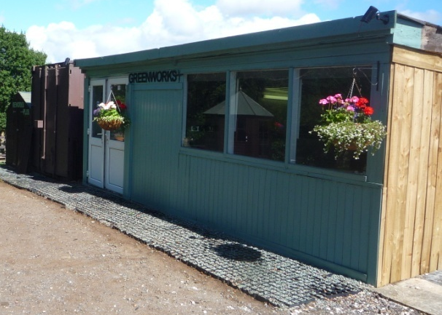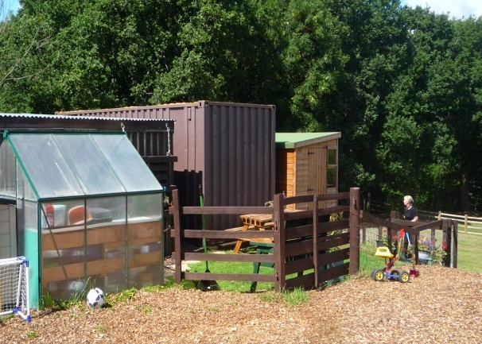
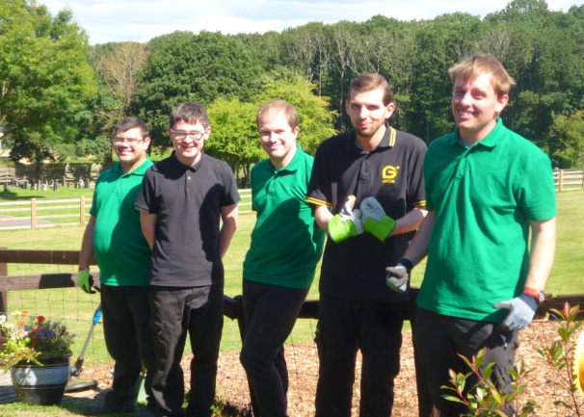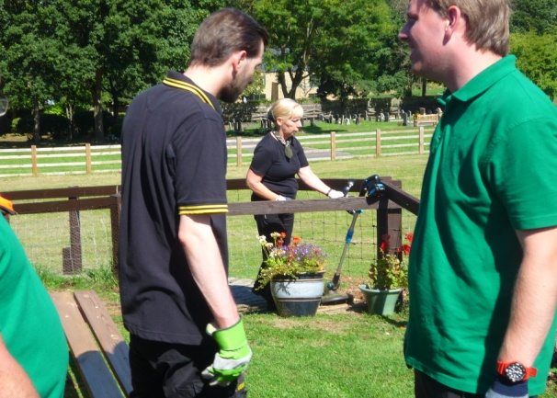
2.8 The following location advantages have inspired the owners of Broad Close Farm to diversify to form a small camping site on part of their land.
- It is within 400m of The Station Inn, The Bells Bar & Kitchen, The Red Lion and the Co-Op PFS and convenience store.
- It is 400m from Silkstone Common railway station with its link via Barnsley to Holmfirth and “Last of The Summer Wine country”.
- It is within two miles of Cannon Hall Farm which is the subject of the Channel 5 TV series “The Farm”.
- It is within two miles of the annual “Underneath The Stars” three day outdoor music festival. High profile acts have included Billy Bragg, Paul Carrack, The Proclaimers, Eddie Reader and Suzanne Vega.
2.9 Broad Close Farm camp site is limited to only fifteen pitches and is usually fully booked; with much custom being from repeat visitors (Appendix 2).
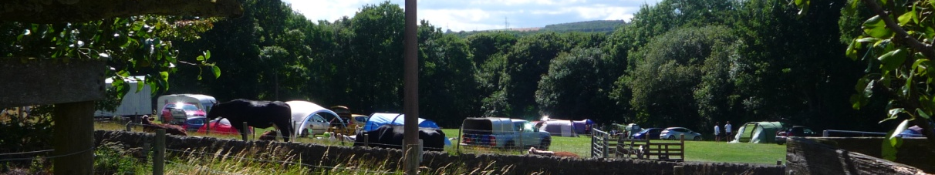
2.10 Toilets, showers and grey water and foul water disposal are provided on the farm. The farm offers streamed recycling of the waste generated by campers.
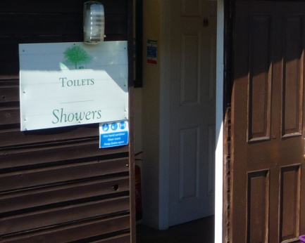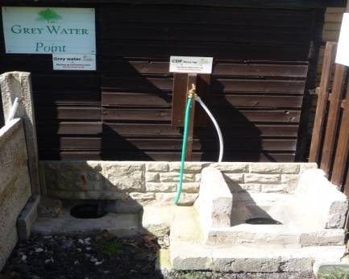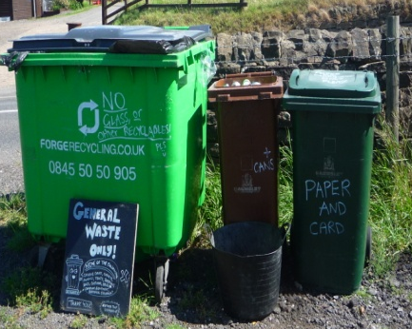
3.0 PROPOSED DEVELOPMENT
3.1 It is proposed to change the use of the former pig rearing and finishing unit to Class D2 (Assembly and Leisure) to cater for recreational activities related to the tourist visitor economy.
3.2 The unit is a single-floored breeze block and wood-panelled structure with regularly spaced and uniformly-sized screened ventilation apertures. The area of the unit is 414m².
3.3 There will be no external modifications and the outside appearance of the unit will be unchanged. No technical drawings are provided because the proposed change of use has no material visual effect on the existing unit. We show various external images below.
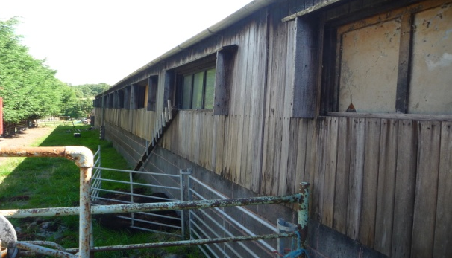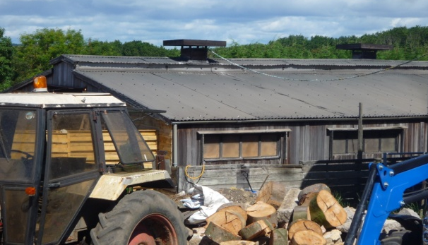
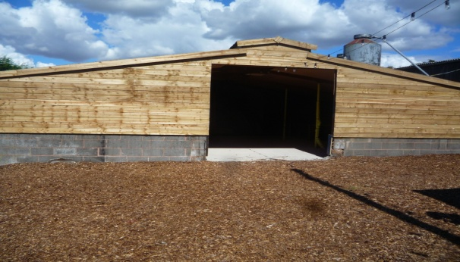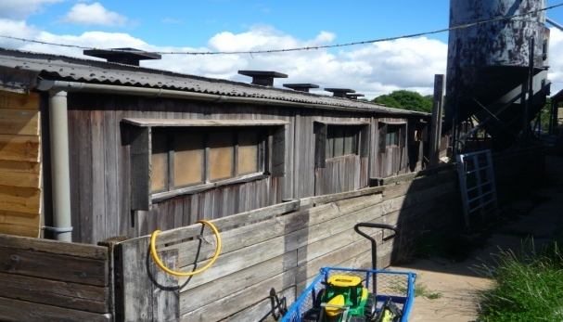

3.4 Internally the unit has been improved by the removal of the pig rearing stalls and their replacement with a concrete screed floor. The ceiling has been skinned with ply-wood and the breeze blocks have been whitewashed. We show these internal features below.
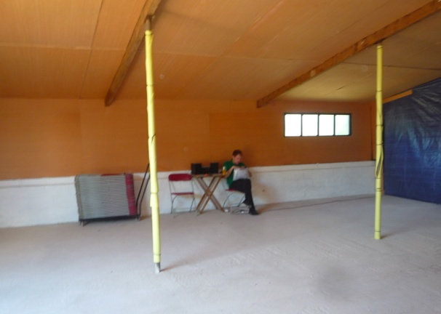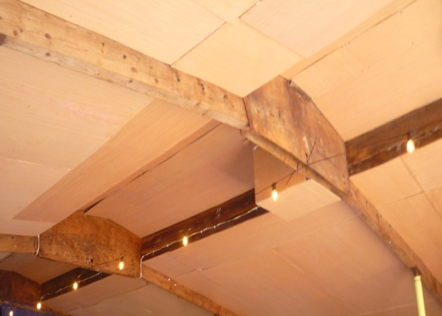

4.0 POLICY ASSESSMENT
4.1 The proposed change of use is permitted development.
4.2 The former pig rearing and finishing unit dates from the 1980’s and was operational as part of an established agricultural unit 2021. Its area is 414 m^{2.}
4.3 Under Class R (Agricultural Buildings to a Flexible Commercial Use), the General Permitted Development Order (2015) permits the change of use of an agricultural building smaller than 500m² , and any land within its curtilage, to a flexible use falling, inter alia, within Class D2 (assembly and leisure) of the Schedule to the Use Classes Order. Class R sub-paragraph (3) provides for associated operational developments which are reasonably necessary to use the building for the use proposed under Class R
4.4 Under Class R.3, for agricultural buildings greater than 150m² the local planning authority will require the following information to determine whether the prior approval of the authority will be required:-
- transport and highways impacts of the development
- noise impacts of the development
- contamination risks on the site
- flooding risks on the site

Transport and Highways Impacts of the Development
4.5 It is envisaged that users of the campsite will make use of the assembly room. Their vehicles would already be parked on the campsite. The farm has sufficient land to allow up to ten cars to park; with sufficient space to enable them to egress the farm onto Cone Lane in a forward gear. Cone Lane links Silkstone with Silkstone Common. It is not heavily trafficked and does not offer a short-cut route to other destinations. One area of car parking is shown below
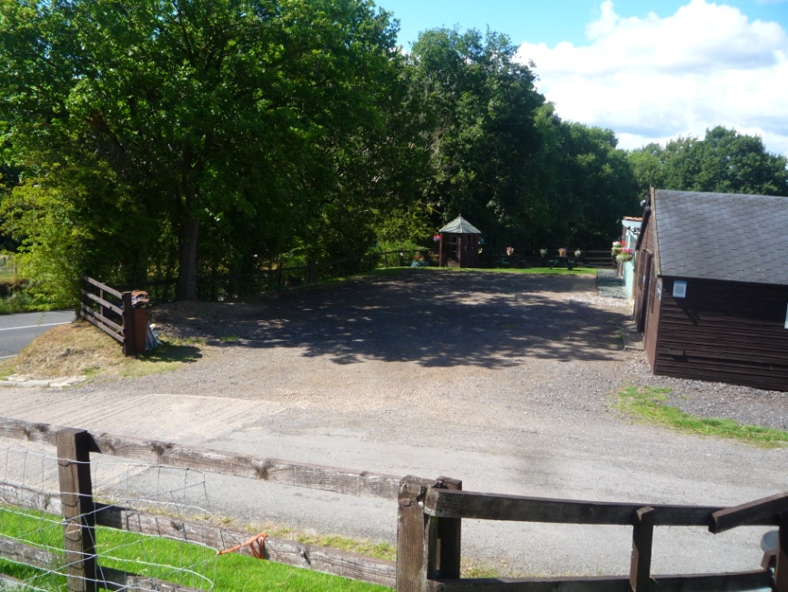

Noise Impacts of the Development
4.6 It is envisaged that the users of the camp site using the assembly room would make no noise greater than that which permeates the camp site. The assembly room currently contains a pool table and table tennis table for communal activities. Such activities are not aurally intrusive and noise impacts would not permeate beyond the assembly room into the Silkstone community.
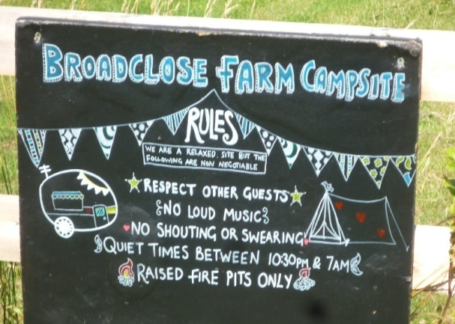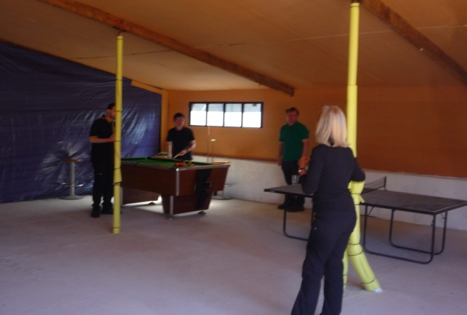

Contamination Risks on the Site
4.7 The former pig rearing unit is contaminant-free. Furthermore, it is segregated from the farm yard activities by a high wooden fence.
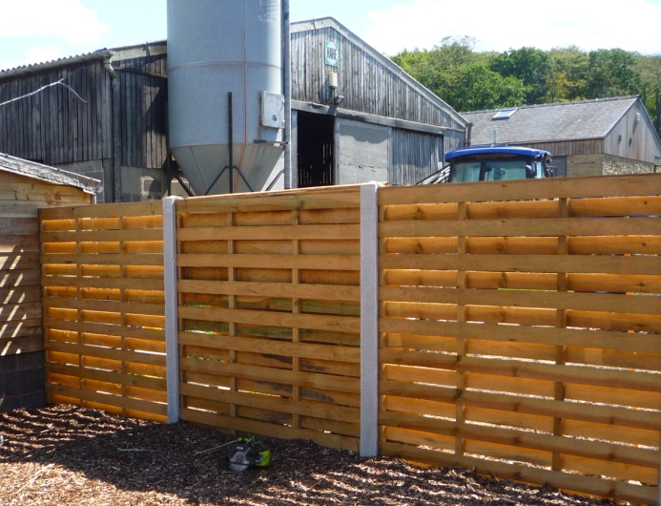
Flooding Risks on the Site
4.8 Broad Close Farm is located around 400m up Cone Lane from the A628. It is isolated topographically from Silkstone and the Silkstone Beck water course which runs behind Silkstone High Street towards Cawthorne. There are no flood risks in Broad Close Farm yard and surface water run-off would be absorbed into the grassed areas. The existing short driveway to the farm yard is constructed from water absorbent, limestone-based concrete.
4.9 Other planning policy considerations are the National Planning Policy Framework and relevant policies set out in the Barnsley Local Plan (January 2019)

4.10 National Planning Policy Framework paragraph 84 supports the development and diversification of agricultural and other land-based rural businesses, and sustainable rural tourism and leisure developments which respect the character of the countryside.
Barnsley Local Plan (January 2019)
Policy E5 Promoting Tourism and Encouraging Cultural Provision
4.11 Tourist related development in rural areas will be protected and encouraged to support and diversify the local economy, subject to the requirements of Policy E6 Rural Economy

Policy E6 Rural Economy
4.12 A viable rural economy will be encouraged by allowing development in rural areas, inter alia, where it
- re-uses existing rural buildings in the first instance
- achieves sustainable diversification and development of the rural economy
- Is related to tourism or recreation

5.0 CONCLUSIONS
5.1 It has been demonstrated that Broad Close Farm’s longstanding primary activity as a pig farm has been ended by the onset of the Dearne Valley Nitrogen Vulnerable Zone in 2018.
5.2 It has been demonstrated that the cessation of pig farming has resulted in the pig rearing unit being empty and unused.
5.3 It has been demonstrated that Broad Close Farm is diversifying its activity by renting floor space to a local charity and by developing a small fifteen pitch campsite.
5.4 It has been demonstrated that the change of use of the pig rearing unit to Class 2 Leisure and Assembly is permitted development under Class R of the General Permitted Development Order (2015).
5.5 It has been demonstrated that Local Policy E5 promotes tourist related development that diversifies the local economy in rural areas and Policy E6 specifically encourages development in rural areas that re-use existing rural buildings.
5.6 It has been demonstrated that the external fabric of the existing unit will remain unchanged and that the impact of associated noise and traffic impacts are not significant.

APPENDIX 1
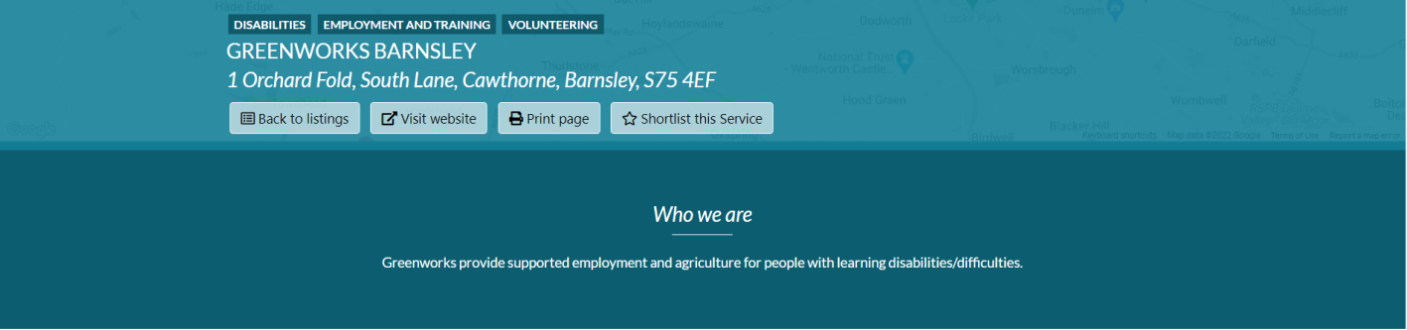
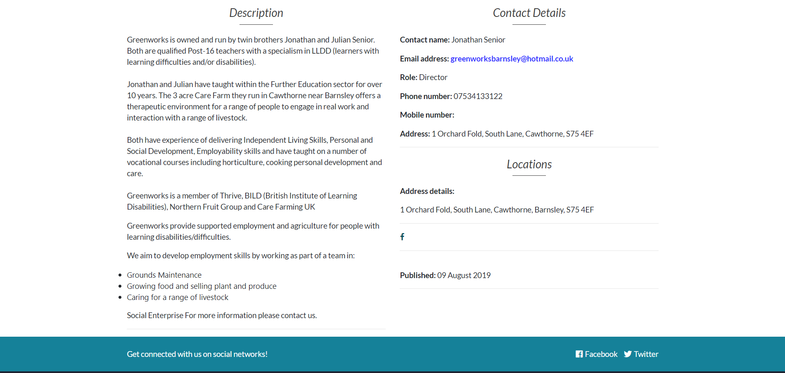

APPENDIX 2

