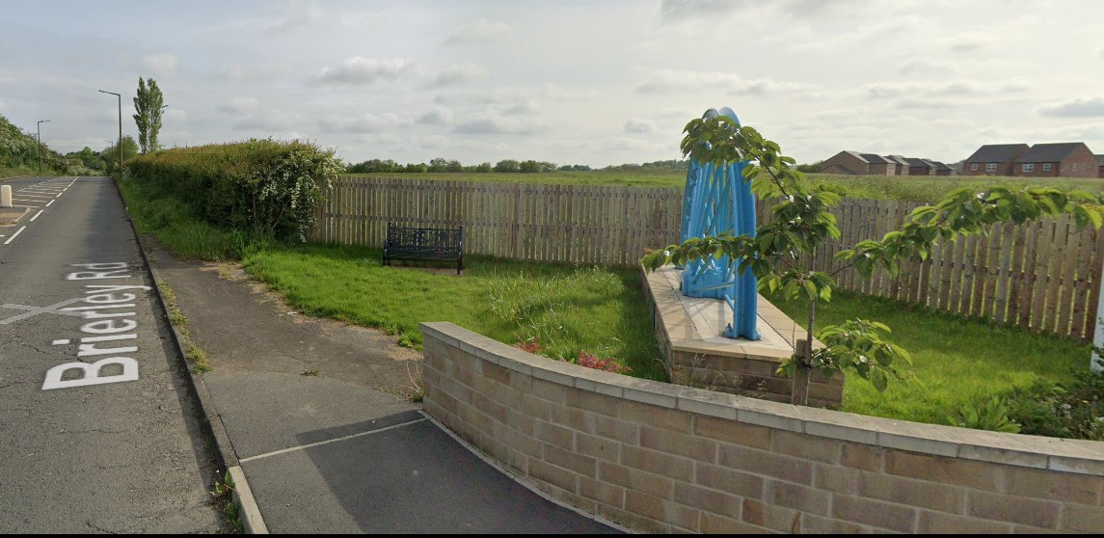

Hedgerow Image 1

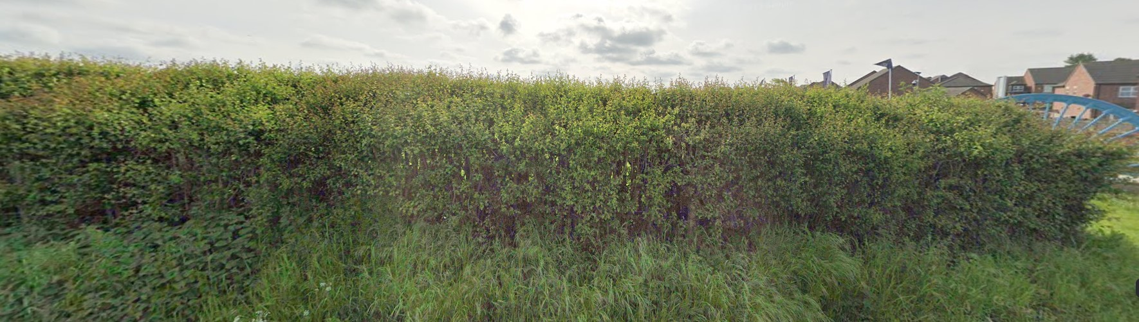

Hedgerow Image 2

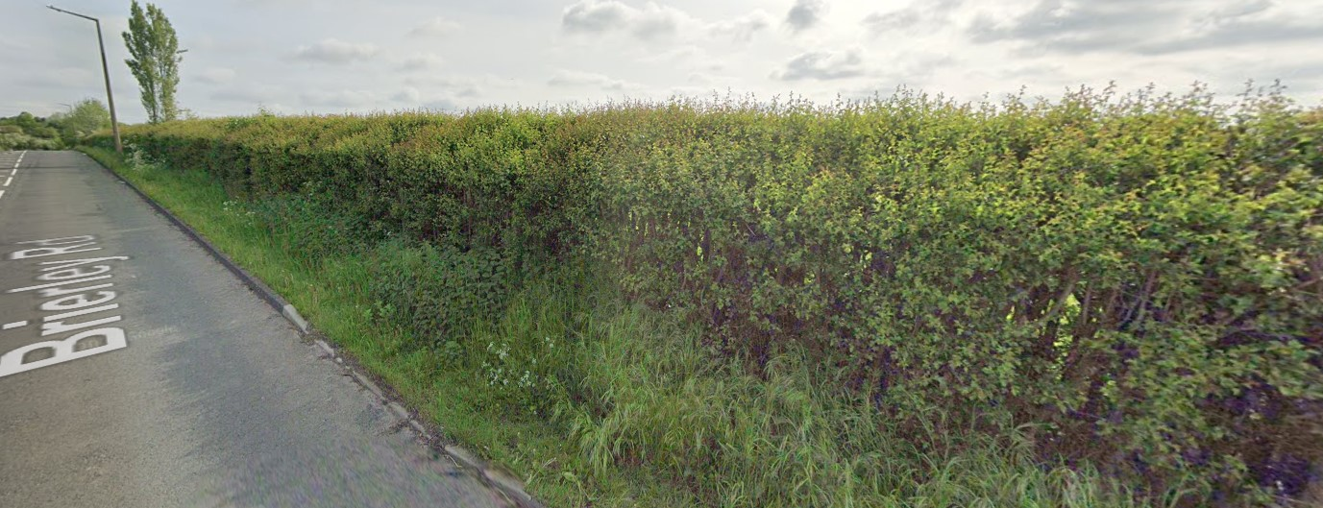

Hedgerow Image 3

