1.0 The site was used solely for an agricultural use as part of an established agricultural unit on 20th March 2013. Holding number; 47/610/0009.
2.0 The cumulative floor space of the existing building does not exceed 450 square metres.
3.0 The cumulative number of separate dwelling houses developed under Class Q within the established agricultural unit does not exceed 3.
4.0 The site is not occupied under an agricultural tenancy.
5.0 Development under Class A(a) or Class B(a) of Part 6 of this Schedule (agricultural buildings and operations) has not been carried out on the established agricultural unit.
6.0 The development will not result in the external dimensions of the building extending beyond the external dimensions of the existing building at any given point;
7.0 The development under Class Q (together with any previous development under Class Q) will not result in a building or buildings having more than 450 square metres of floor space having a use falling within Class C3 (dwelling houses) of the Schedule to the Use Classes Order.
8.0 The development under Class Q(b) will not consist of building operations other than—
the installation or replacement of—
windows, doors, roofs, or exterior walls, or
water, drainage, electricity, gas or other services,
to the extent reasonably necessary for the building to function as a dwelling house; and techpartial demolition to the extent reasonably necessary to carry out building operations allowed
9.0 The site is not on article 2(3) land.
10.0 The site is not a site of special scientific interest.
11.0 The site is not in a safety hazard area.
12.0 The site is not in a military explosives storage area.
13.0 The site is not and does not contains a scheduled monument.
14.0 The building is not a listed building.
15.0 HERITAGE IMPACT STATEMENT

The listing description is attached below for reference

SE 20 NE CAWTHORNE SOUTH LANE
(south side,)
3/73 L-shape range of
barns and stabling
at Upper Elmhirst Farm
II
Range of barns and stabling. Late C18 or early C19. Thinly-coursed rubble.
Stone slate roof. L-shape plan. 2 storeys. 2, large, segmental-headed cart
entries, to left, with quoined jabs. 3 small quoined entrances to right,
2 of which have slightly-cambered heads. Two square pitching-holes at high
level. At far left the range returns at 90° and has a quoined entrance and a
single-light window. Roof hipped at right end. Rear main range: two,
quoined, square-headed opposed cart entries. Some later lights. Symmetrical
arrangement of round-arched ventilation loops.
Interior: slender queen-post roof trusses.
Listing NGR: SE2635906023

The barn is situated 30 m to the south west of the listed farm buildings. The host building has been in existence for a number of years and does not impact on views of the listed building nor does it harm the architectural character or historical significance of the heritage asset.
The proposed change of use will not represent a material change of scale, appearance or result in an intensification of vehicle movements. All domestic paraphernalia will be contained within the proposed courtyard where impact will be minimal
16.0 STRUCTURAL ASSESSMENT
The host building has been surveyed and a structural assessment has been carried out by Carl Devenish BSc Hon of SGM Structural Design Limited. This is an archetypal steel framed storage building dating from the final quarter of the 20thC. A variety of cladding materials are apparent including profiled asbestos cement panels and timber boarding. The building is inherently sound and shows no signs of deterioration or distress.
It is acknowledged that the building will have been designed to the predecessor of BS 5502 “Buildings and Structures for Agriculture” which will have resulted in allowable loads be less that those applied to residential accommodation
A structural strategy has been adopted which employs solid masonry shear walls. These will stabilize the structure and minimize axial loadings on existing columns.
A structural concept sketch accompanies this application This clearly demonstrates that the existing structure can be adapted to be suitable for residential occupation without the need to remove existing structural members.

17.0 PLANNING PRECEDENTS
Application references 2017/0343 and 2018/0464 in connection with redundant farm buildings within a 5 mile radius of the application site have been approved on the basis of compliance with the criteria as set out for permitted development under class Q
18.0 SITE PHOTOGRAPHS
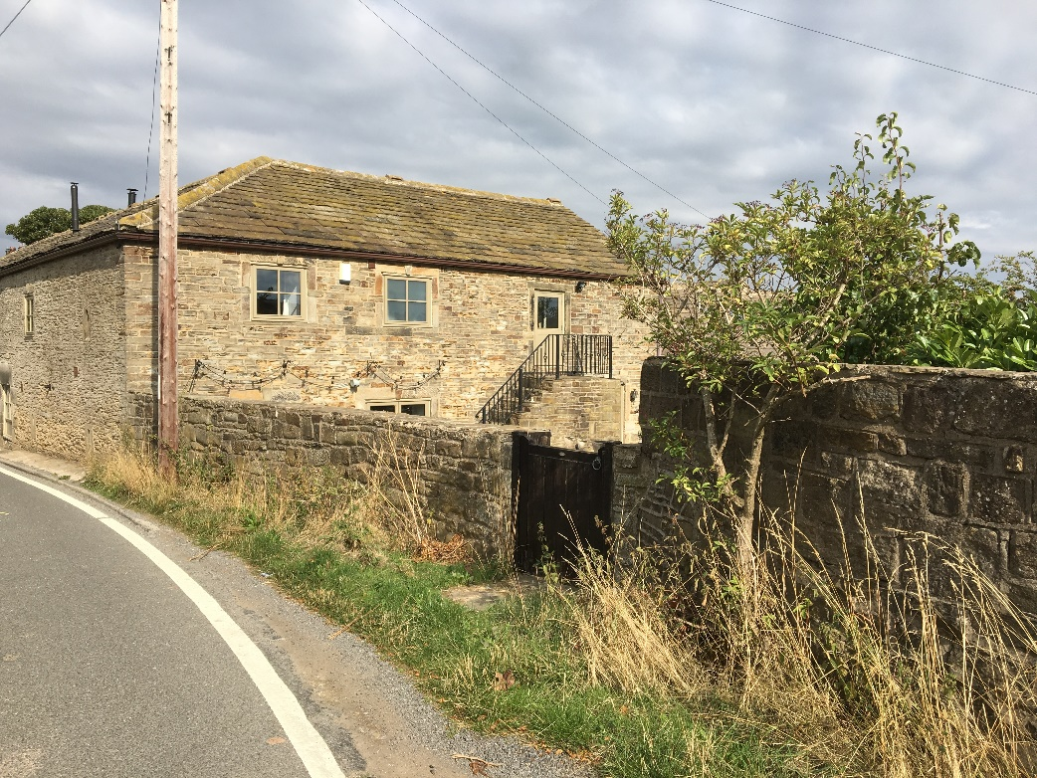
View of adjacent listed converted farm buildings

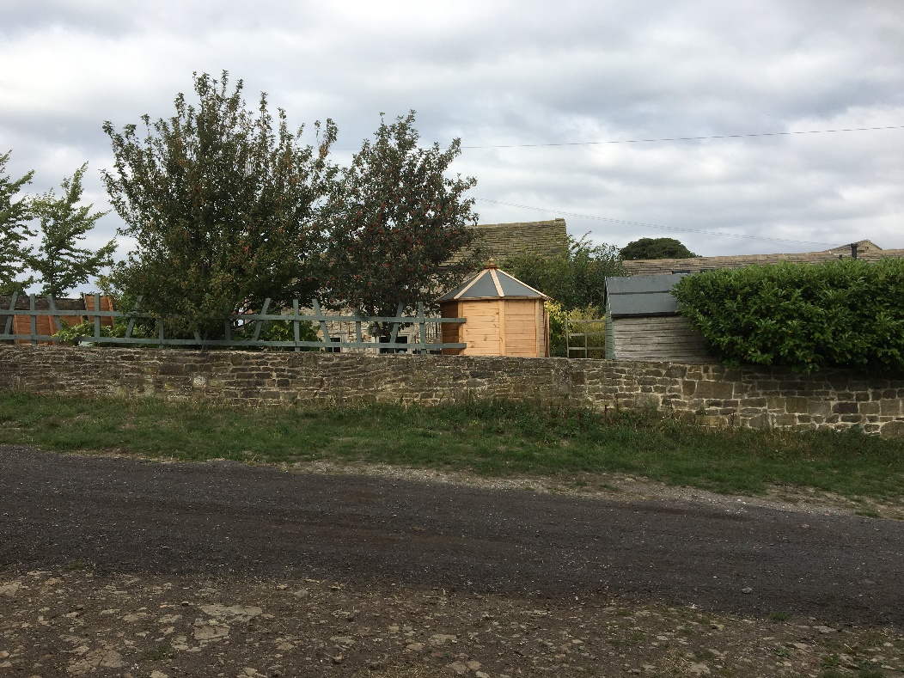
View of the site boundary

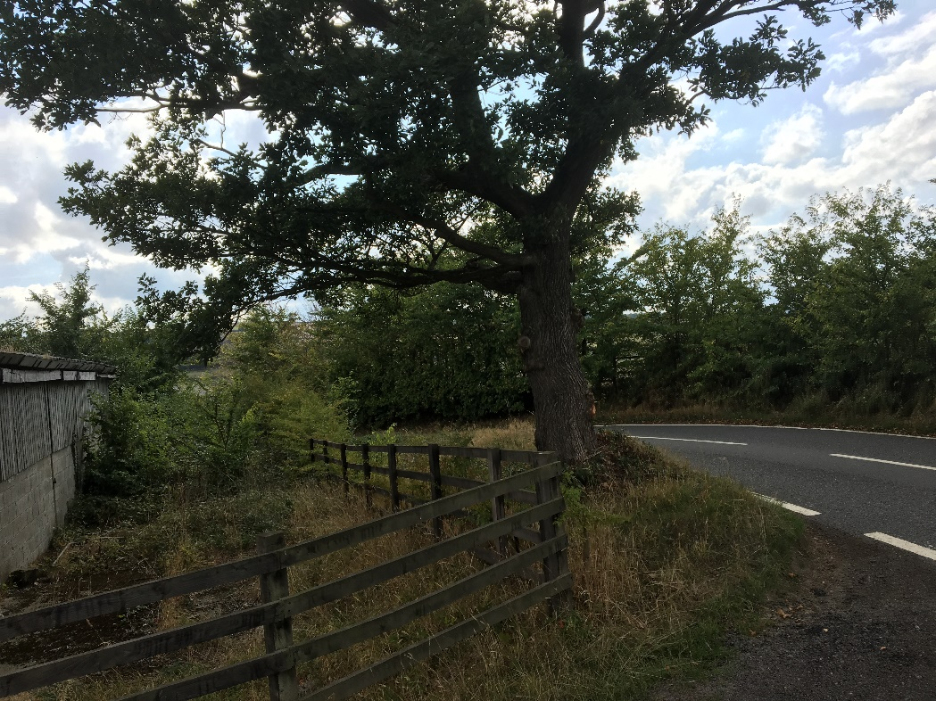
View of existing mature tree and site boundary

