Construction Method Statement for Parkside Sports & Community Centre
1. Introduction
This Construction Method Statement outlines the procedures and processes for the construction of Parkside Sports & Community Centre. It ensures that all activities are carried out safely, efficiently, and in compliance with relevant regulations and standards.
2. Project Overview
- Project Name: Parkside Sports & Community Centre
- Location: Land To The East Of Sheffield Road, Hoyland Common, Barnsley, S74 0ah
- Client: Barnsley Metropolitan Borough Council
- Main Contractor: Hughie Construction Limited
- Project Duration: 48 Weeks
3. Scope of Work
The scope of work includes:
- Site preparation and clearance
- Installation of utilities and services
- Reducing Levels, Earthwork Support, Surface Treatments and Backfilling
- All piling works to be carried out
- Pile Caps, Groundbeam and Foundation works
- Erecting Structural Steel framework & secondary steelwork.
- Proprietary Roofing System to be erected
- Eaves, Fascias, Soffits Gutter and Ridge detailing
- External Construction of the sports building
- External Installation of Windows and Doors
- Internal Installation of Screeding Floors
- Installation of Internal Partitions and Doors
- Installation of Internal Fxings and Fitting
- Painting and Decoration
- Installation of Floor Finishes
- Installation of Sundry Items
- External works of Carpark / Surfacing Overspill Carpark
- External works of Disabled and EV Parking
- Erecting Fencing around site
- Installation of Site Furniture and Glazed Balustrades
- Crossover works
- Construction of the sports pitch
- Landscaping and finishing works
- Hours of work: Between 8:00 to 18:00 Monday to Friday excluding Saturdays, Sundays and Bank Holidays.
4. Site Preparation
- Site Survey: Conduct a detailed site survey to identify existing conditions and utilities.
- Clearance: Remove any vegetation, debris, and obstructions from the site.
- Fencing: Erect temporary fencing around the site to ensure safety and security.
5. Excavation and Foundation Works
- Excavation: Reduce levels for building and external surfacing.
- Piling: Piling the site to required depth as per the structural engineer’s design.
- Foundation Construction: Construct foundations as per the structural engineer’s design, including pile caps, groundbeam, footings, slabs, and retaining walls.
- Backfilling: Backfill around foundations with suitable material and compact to required specifications.
6. Construction of Sports Building
- Structural Framework: Erect the structural framework using steel as specified.
- Walls and Roof: Construct walls and roof using appropriate materials, ensuring insulation and weatherproofing.
- Internal Works: Complete internal works including partitions, flooring, ceilings, and finishes.
- Mechanical and Electrical Services: Install all necessary mechanical and electrical services, including HVAC, plumbing, and lighting.
7. Construction of Sports Pitch (To be completed by others – Tiger Turf)
- Tigerturf are Construction the pitch on a totally separate phase to Hughie Construction Limited)

8. Utilities and Services
- Water Supply: Connect the building to the main water supply and install necessary plumbing fixtures.
- Electricity: Connect to the main electrical supply and install all required electrical systems.
- Sewage and Drainage: Ensure proper sewage and drainage systems are in place and connected to the main network.
9. Health and Safety
- Risk Assessment: Conduct a thorough risk assessment for all activities.
- Site Plan: Develop and implement a site plan, including emergency procedures and first aid.
- PPE: Ensure all workers are provided with and use appropriate personal protective equipment (PPE).
- Training: Provide necessary training for all workers on site safety and specific tasks.
10. Environmental Considerations
- Waste Management: Implement a waste management plan to minimize and properly dispose of construction waste.
- Noise Control: Take measures to control noise levels and minimize disturbance to the surrounding area.
- Dust Control: Implement dust control measures such as water spraying and covering materials.
11. Quality Control
- Inspections: Conduct regular inspections to ensure work is carried out to the required standards.
- Testing: Perform necessary testing on materials and installations to verify compliance with specifications.
- Documentation: Maintain detailed records of all construction activities, inspections, and tests.
12.Communication and Coordination
- Site Meetings: Regular site meetings will be held to discuss progress, address issues, and ensure coordination among all parties.
- Reporting: Regular reports will be submitted to the Local Planning Authority to provide updates on compliance with the Construction Method Statement.

13. Completion and Handover
- Final Inspections: Conduct final inspections to ensure all work is completed to the required standards.
- Handover: Prepare and hand over all necessary documentation, including as-built drawings, operation manuals, and warranties.
- Training: Provide training to the client on the operation and maintenance of the building and pitch.
14. Parking of Vehicles of Site Operatives and Visitors
- Designated Parking Area: A designated parking area will be established within the site boundaries to accommodate vehicles of site operatives and visitors.
- Signage: Clear signage will be installed to direct vehicles to the designated parking area.
- Monitoring: A site supervisor will monitor the parking area to ensure compliance and manage any issues that arise.
15. Means of Access for Construction Traffic
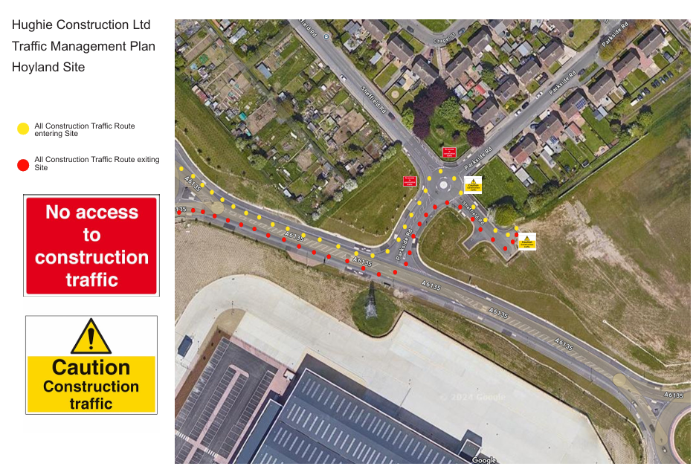
- Access Routes: Please find attached Traffic Management Plan for Safe Routes of Traffic to and from Site, along with Site Safety Signage to aid Vehicles with access routes for All Construction Traffic as identified, this will be communicated to all site operatives and all relevant parties.

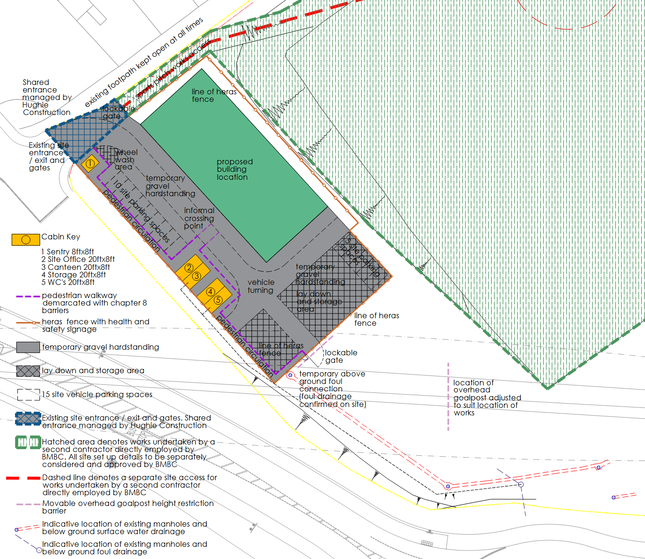
Below is a Site Access Map for Safe Routes on and off site for Vehicles, Plant and Pedestrians.

- Signage and Barriers: Appropriate signage and barriers will be installed to guide construction traffic, prevent unauthorized access, warn the Public of the Dangers on Site and keep them safe while on site. .
Signage as below is for Construction Traffic:

Signage below is prevent unauthorized access, warn the Public of the Dangers on Site and keep them safe while on site.
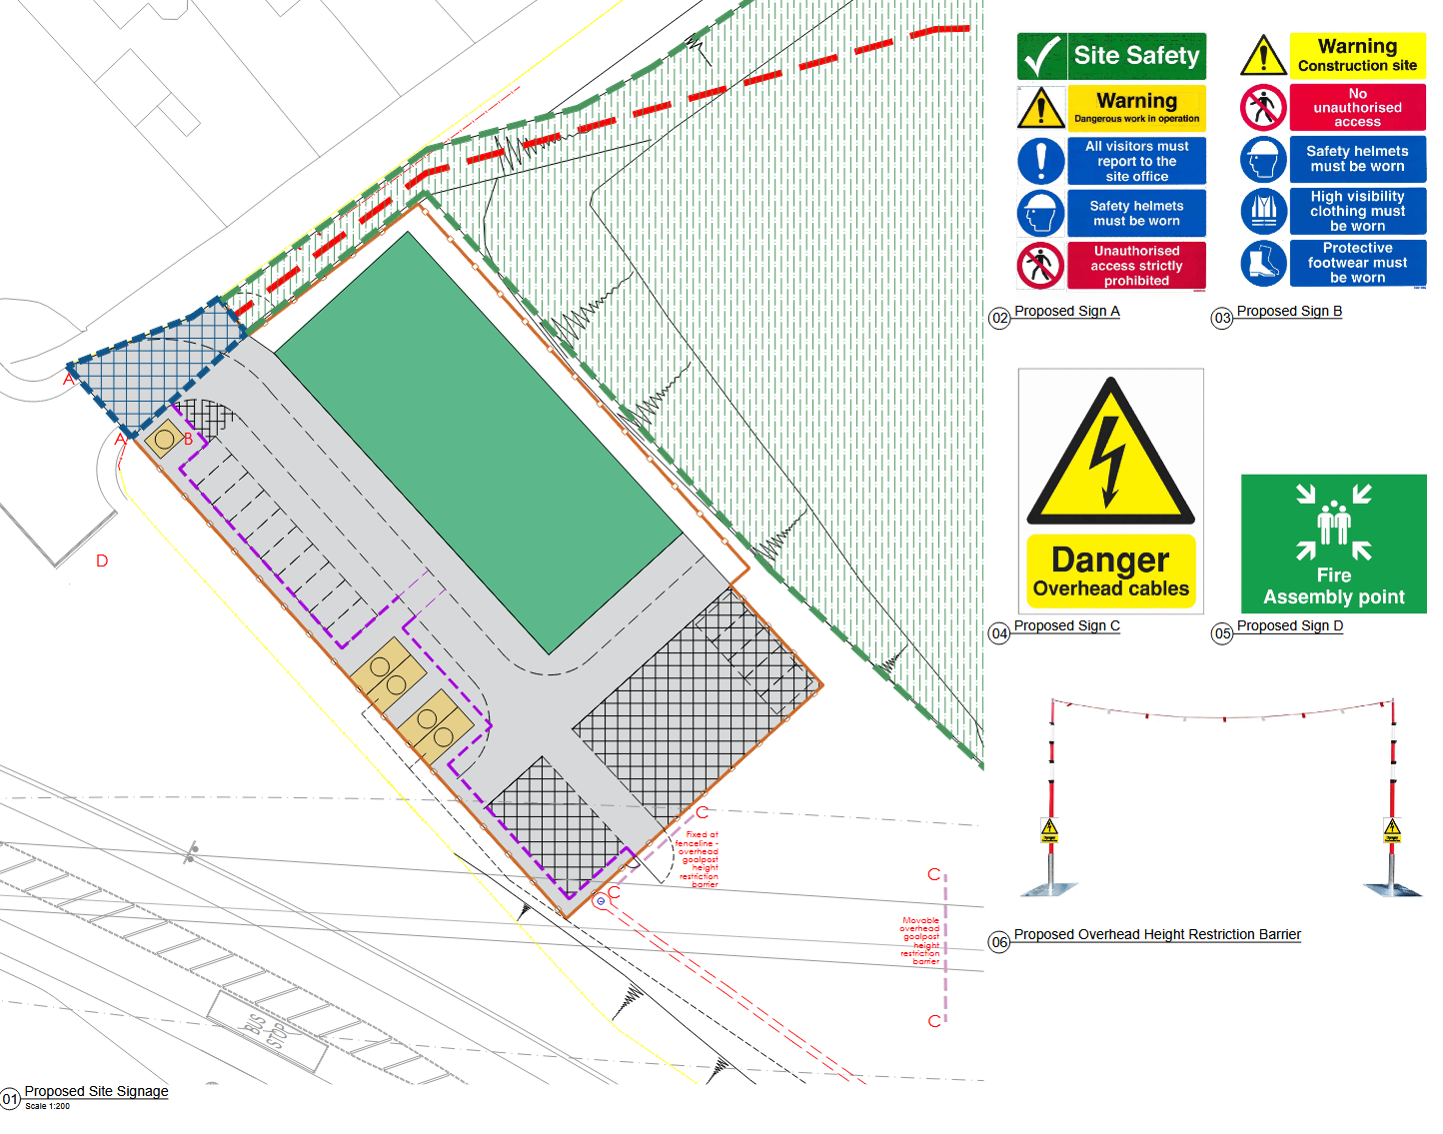
16. Loading and Unloading of Plant and Materials
- Loading/Unloading Zones: Designated zones for loading and unloading have been established within the site, these are the Crosshatched Areas on the drawing.
All Materials with be offloaded and stored as close to containers as possible ie bricks/blocks etc, All Small expensive items that can be stolen easily will stored and locked in the site container.
All Big Plant will be stored on site, all Small Plant will be taken away from Site.
- Supervision: A site supervisor will oversee all loading and unloading activities to ensure safety and efficiency.

- Timing: Loading and unloading will be scheduled during off-peak hours to minimize disruption. Permitted hours for Site Activity is ONLY Between 8:00 to 18:00 Monday to Friday excluding Saturdays, Sundays and Bank Holidays.
17. Storage of Plant and Materials
- Storage Areas: Secure storage areas will be designated for materials.
- Inventory Management: An inventory management system will be implemented to track the storage and usage of materials.
- Protection Measures: Materials will be stored in a manner that protects them from damage and weather conditions.
18. Measures to Prevent Mud/Debris Being Deposited on the Public Highway
- Wheel Washing Facilities: Wheel washing facilities will be installed at the site exit to clean vehicle wheels before they leave the site.
- Road Sweeping: Regular road sweeping will be conducted to remove any mud or debris deposited on the public highway.
- Monitoring and Maintenance: Continuous monitoring and maintenance will be carried out to ensure the effectiveness of these measures.
19. Conclusion
This Construction Method Statement provides a guide to the construction of a sports building and pitch. Adherence to this statement along with the Project forecast will ensure the project is completed safely, efficiently, and to the highest standards.

