Supporting Documentation _ PP-07976690_Sketch Plans
Applicant: Chris Bould, 15 Chedworth Close, Darton, Barnsley, S75 5PR (07818 223695)
Work to be undertaken: 10% Crown lift on Pine Tree (Reference Number 11, Tree Reference Number T5)
Work to be undertaken by: Profell Tree Services, (Phone: 01226 207327 / Email: profell@yahoo.co.uk)

Diagram 1: Location of Pine Tree (T5) (circled)
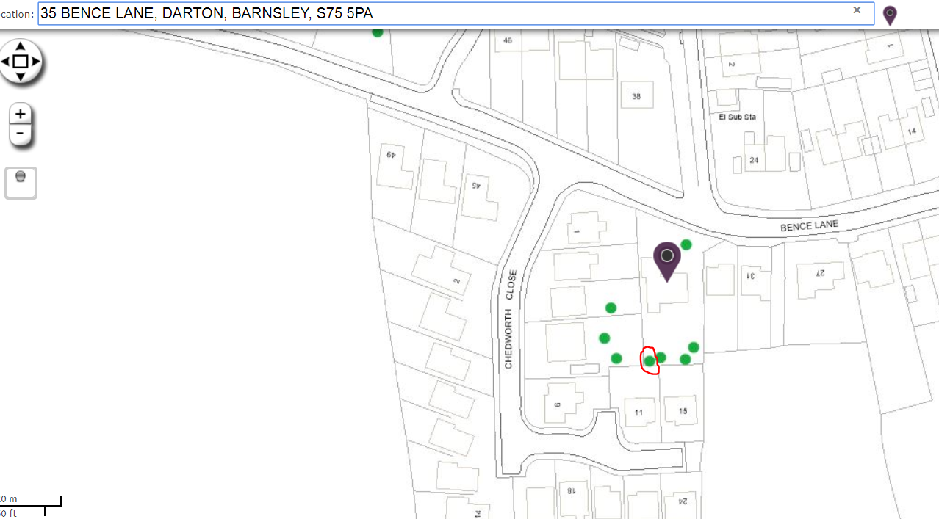

Diagram 2: Location of Pine Tree (T5)
