**Dorothy Hyman Sports Centre**

**Snydale Road**

**Cudworth**

**S72 8LH**

**Noise Management Plan 3G Artificial Grass Pitch (AGP)**

1. Introduction 2
2. Potential Noise Sources 2
3. Site Description and Nearest Noise Sensitive Locations 3
4. Details of Noise Policy 3
5. Noise Complaints Procedure 5
6. Complaint Reporting 6

# Introduction

* 1. The purpose of this plan is to outline robust policies and procedures to minimise the potential noise impact on local residents, and to satisfy the requirements of the Local Authority.
  2. This plan identifies potential noise sources, local Nearest Noise Sensitive Locations (NNSL), noise management policies, and communication and complaints procedures.
  3. It is the responsibility of the nominated noise monitoring supervisor to ensure the detailed policies and procedures are adhered to.
  4. The noise management plan is considered to be a live document which may be revised during the operation of the 3G Artificial Grass Pitch in order to create an acceptable balance between the requirements for a successful recreation facility and the protection of local residents’ amenity.

# Potential Noise Sources

* 1. Potential noise sources identified relating to the sports pitch and its vicinity include:
     + Footballs being kicked, hitting the ground and perimeter fencing
     + Shouting / cheering during matches
     + People arriving / leaving the facility
     + Car park movements, including cars arriving / leaving and car doors slamming

As part of planning requirements, neoprene isolators will be fitted to the perimeter ball stop fencing to avoid fence rattling noise associated with balls impacting on the perimeter ball stop fencing. The fence panels will be checked during routine weekly maintenance and tightened if necessary.

1. **Site Description and Nearest Noise Sensitive Locations (NNSL)**
   1. The 3G Artificial Grass Pitch and NNSL identified are shown as follows:

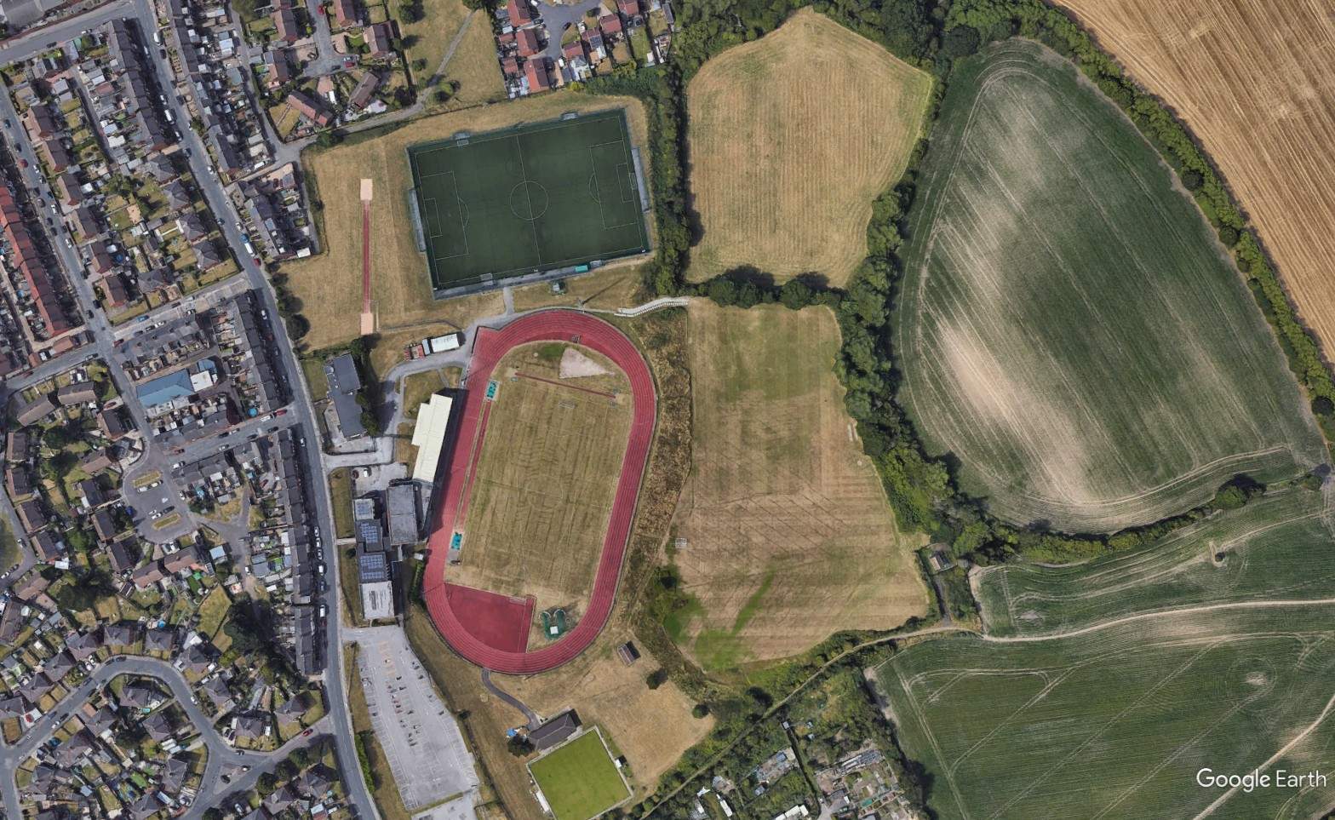

Proposed pitch

* 1. The nearest noise sensitive receiver to the proposed AGP are the residential properties approximately 138m to the north on Belle Green Gardens

# Details of Noise Policy

* 1. The nominated noise monitoring supervisor to regularly monitor activities on the AGP.
  2. All members of the complex senior leadership team will be fully aware and conversant with the noise management plan.
  3. Limit use of the 3G Artificial Grass Pitch between the following hours:
* 08:00 and 22:00hrs Monday to Friday
* 08:00 and 18:00hrs Saturday/Sunday/Bank Holidays
  1. Ensure the maximum user capacity of the 3G Artificial Grass Pitch is not exceeded.
  2. Only pre-booked lettings under a signed lettings agreement will be permitted to use the 3G Artificial Grass Pitch. All clients as part of the letting agreement will sign up to the Code of Conduct which includes arriving and leaving the site plus expectations whilst on site.
  3. Liaise with users to ensure noise management policies and the Code of Conduct are adhered to.
  4. Provide a clear and reliable mechanism whereby noise complaints can be made and logged.
  5. Follow the complaints procedure set out in sections 6 and 7.
  6. Respond to noise complaints within a reasonable time period.
  7. When requested, provide the Local Authority with details of logged complaints and any actions taken.
  8. Liaise with the Local Authority to ensure the noise management plan remains effective and revise the noise management plan accordingly.

# Noise Complaints Procedure



COMPLAINT RECEIVED

COMPLAINT LOGGED AND RECORDED

VERIFY COMPLAINT RELATES TO 3G

ARTIFICIAL GRASS PITCH

NOISE LEVELS

NOISE MONITORING SUPERVISOR INFORMED

ACTION TAKEN TO REMEDY SITUATION AND REDUCE RISK OF REOCCURENCE

ACTION RECORDED AND LOGGED

RESPONSE BACK TO COMPLAINANT IF REQUESTED

# Complaint Reporting

|  |
| --- |
| Complaint made by: |
| Date of complaint: |
| Complaint received by: |
| Date complaint received: |
| Time of occurrence(s): |
| Amount of occurrences: |
| Details of complaint: |
| Action(s) taken: |
| Review of action(s): |
| Details of adjustment(s) made to noise management plan if required: |
| Signed  (Noise Monitoring Supervisor) Date |