Barnsley Metropolitan Borough Council (Co. S)  developmentmanagement@barnsley.gov.uk  Highways Department  Central Offices  Kendray Street  BARNSLEY  South Yorkshire  S70 2TN |  | Your Ref:  Our Ref: NP/B/0325/0307  Date: Tuesday, 08 April 2025
Application Number: | NP/B/0325/0307
Location: | Pennine Cottage, Whams Road, Hazlehead,
Proposal: | Retrospective consent for the permanent siting of hot food trailer
Dear Sir / Madam

I am writing to give you an opportunity to comment on the above planning application. You can view a copy of the application and associated documents on the National Park Authority website by following the link: https://planning.peakdistrict.gov.uk/AssureLive/ES/Presentation/Planning/OnlinePlanning/OnlinePlanningSearch and entering either the application number or address into the search box. Please be aware that it may take a couple of days from an application being registered before documents are available to view online.

To enable us to make a decision on this planning application, please respond by returning comments within 21 days of the date of this letter, or by e-mail if possible to customer.service@peakdistrict.gov.uk.

Please ensure that your response makes clear not just your organisation’s formal view but also the planning reasons for it, whether in support of the application, objecting to it, or only advising us of comments you wish to be considered. Please be aware, that we can only take into account ‘material’ planning matters when making decisions. Information on ‘material’ and ‘non-material’ considerations can be found on our website at https://www.peakdistrict.gov.uk/planning/have-your-say/comment-on-an-application
The application is being dealt with by Liz Coleman who can be contacted on 01629 816204 or by email to liz.coleman@peakdistrict.gov.uk

Our public participation scheme enables individuals or organisations to speak about any planning application that goes to a committee or full authority. All you need to do is make a request, which we need to receive at the latest by noon two working days before the meeting date. You will then be able to speak for three minutes and make your points directly to the members who make decisions. You may be asked questions by those members. Details of how to do this can be seen on our website at https://www.peakdistrict.gov.uk/planning/have-your-say/comment-on-an-application or can be obtained by emailing customer.service@peakdistrict.gov.uk or ringing 01629 816200
I look forward to receiving your response.

Yours faithfully
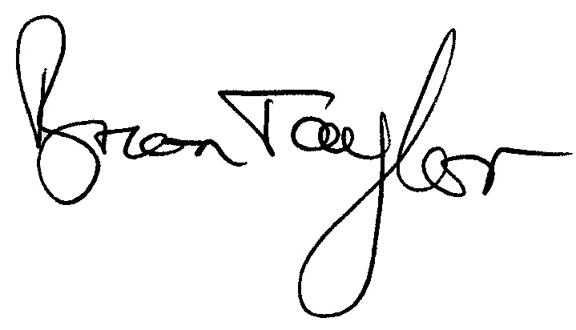
Brian Taylor
Head of Planning
Please include our reference and application number in any correspondence

