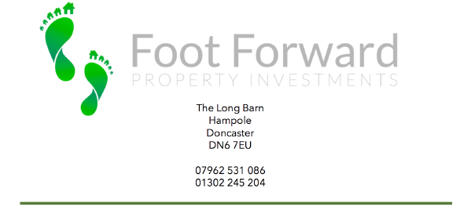

To whom it may concern,

In regards to the application for a Lawful Development Certificate (LDC) 48 Hope Avenue, Goldthorpe, S63 9DT, please find attached as requested:
- Site plan
- Site plan
- Sales Particulars as proof of C3 and this;
- A supporting statement

Foot Forward Property Investments purchased this property as a C3 dwelling. Building Control has been applied for a five bed, five ensuite C4 HMO.
The property was purchased by Foot Forward Properties on 13/09/2018 as C3.

We do hope that this will be satisfactory evidence for your consideration.

Yours,

Steph Arrand
Office Manager
Foot Forward Investments Ltd & Bespoke Lettings Doncaster Ltd
01302 245 204

