HERITAGE STATEMENT

Site Address

The Barn
Mitchell St
Swaithe
S70 3QF

Grid Reference
E:437220
N:404088

- SCHEDULE OF WORKS

The proposal is described as a single storey extension to the dwelling on the rear aspect.
This will include introducing a new window and patio door as per the existing elevation (with square top rather than the current arch). The existing stone arch will be repurposed around the new door and a match set of stone surround will be installed around the new window so as to maintain the historic appearance of the Barn. The existing rear stone work is to be taken down and re-used in creating the extension and more of this material will be sourced to complete the work. Pointing will be as existing, slight recessed and done in lime based mortar.
The hipped roof is to be covered in composite slate effect tiles capped with a glass skylight to the ridge which will sit flush within the roofline. All new windows and doors will be in Oxford Stone (Fallow & Ball – RGB 204,190,170) Upvc and the existing upstairs windows will be changed or sprayed to match. Windows are to be flush casement type.

Some internal alterations are also being proposed. The new extension will have an opening made to the existing external rear elevation. Also, the existing kitchen will be converted into a utility room and downstairs WC.

- PRE-APPLICATION ADVISE

No Pre-application advise has been sought.

- HERITAGE ASSETS

The asset(s) identified are the property itself and the adjacent c17th Swaithe House, a Grade 2* listed building. The House and The Barn where renovated and made into dwellings in the 1990’s, with the Barn conversion remaining sympathetic to the historical appearance of the surrounding buildings.

- AFFECTED ASSETS

The proposed changes will affect the rear elevation of the property. The rear wall will be carefully taken down so as to re-use the stone and surrounds on the new extension. More reclaimed stone will be acquired to complete the remaining stonework to the exterior. The existing roof is clad in concrete tiles but the proposed extension will be clad in Welsh Slate effect composite tiles. This is to allow for a low pitched 4 hipped roof structure that will have less of an impact when viewed from neighbouring properties and not obscure the views from the upstairs windows. The extension will be set away from the boundary wall and run aligned with the Northern elevation. In this way, the new will appear subservient to the original. Internal construction will be using modern materials such as light weight internal skin with insulation batts, an insulated concrete floor with DPC and pre-fabricated roof trusses.

- ASSET RESEARCH

Information about the property has been gathered from the owner and Historic England.org.

- SIGNIFICANCE & IMPACT

The significance of the asset is somewhat less than that of Swaithe House, as it is/was an ancillary barn structure. The building is now a private dwelling and has been since 1990. It’s place in the surrounding scene will remain in keeping and sympathetic to the original part of the property. The house to other end has had an addition in recent years, using similar materials to those in this proposal. This proposal is to use reclaimed stone to better match the existing (where possible and subject to availability). Doing so will greatly reduce the impact on the street scene and will help to conserve the context of the asset within its setting.

- The Historic Environment Record (HER) returned no results

- JUSTIFICATION

The justification for this planning application comes from the need of the Client to have more downstairs space. The property benefits from Permitted Development rights and as such, could extend the rear up to 3 meters in any style she wished. The reason this is not being explored at present is because, while only a meter extra, this will allow for a much better kitchen layout and has the added benefit of allowing the Conservation Officer to see that every effort is being made to build the extension to be sympathetic to the original and surrounding setting.

- Photographs of Proposal

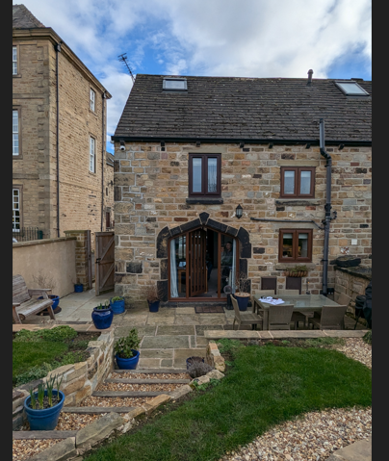
Rear Elevation

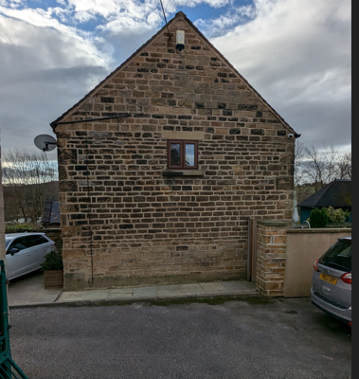
Side Elevation

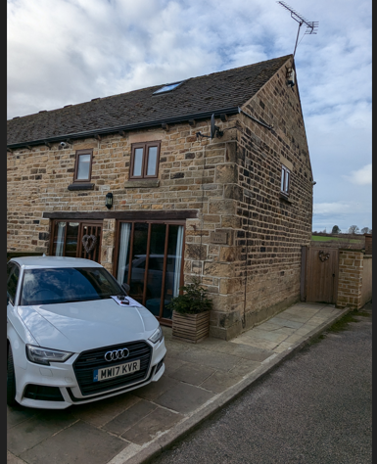
Front/Side Elevation

