HERITAGE IMPACT STATEMENT

Installing replacement heritage Steel windows into Lewden Farm Cottage.

Lewden Farm Cottage, Lewden Farm Lane, Worsbrough Dale, Barnsley, S70 4SZ.

Mr Howard Fearnley
List Entry Number = 1315082 (attached in separate document Lower Lewden Farmhouse Historic Listing.docx )
History and Character
Lewden Farm Cottage is a 17th Century Cottage located in a small hamlet of other dwellings consisting primarily of the converted associated farm buildings. None of the buildings still function as a farm. The hamlet is surrounded by farm/paddock land but is easily accessible by local roads.
The buildings are general constructed of local sandstone with either stone tiles or slate roofs. Most are two storeys. Roads are tarmacadam with block paved drives.
The Cottage itself is semi-detached to the adjoining farmhouse. Historically these would have formed a single dwelling but have been divided at some point in the past. Other buildings in the area are either detached or semi-detached.
The current dwelling has a mixture of metal casement single glazed windows (Crittall) and double glazed wooden windows. Some of these windows are fixed and some have openers.
The existing cottage was extended in circa. 2008 to include a two storey high quality stone built extension on the rear of the property, the windows in this section of the property are wooden framed double glazed as per planning consent at the time.

Archaeology Significance
As no disturbances to the ground is required, no disturbance of any archaeology will occur.

Justification and Impact to Character and Setting
We are extremely conscious around the history and character of the building and are dedicated to doing our best to maintain and improve this. In particular we feel by adding double glazing to the property will reduce condensation and subsequent mould, this will help protect the original stone mullion windows which are a prominent feature of this property and are showing signs of deterioration (see picture below). Additionally in the original building two of the windows at the rear of the property have been changed to wooden double glazed windows, we feel these should be replaced with double glazed steel heritage windows which are more in keeping with this type of property.
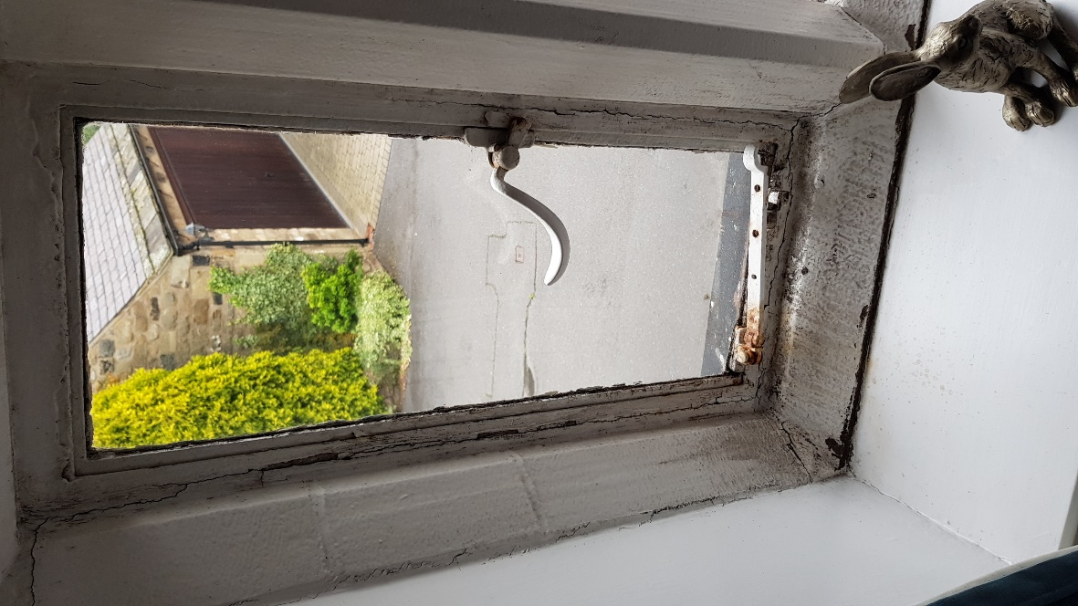
The Picture above is showing the effects of mould on the existing stone mullions.

It is important that we retain the appearance of the original building and the manufacturer of metal window we use will only be selected if they can provide windows that match the character of the building and also are able to match the existing profile of the current windows. Below are pictures, with measurements showing the existing windows and the chosen window supplier.
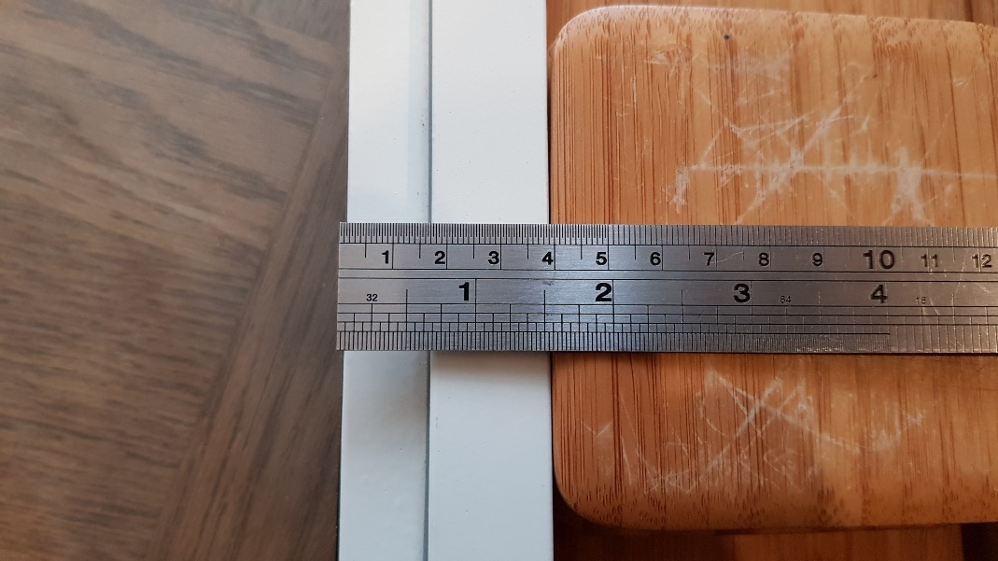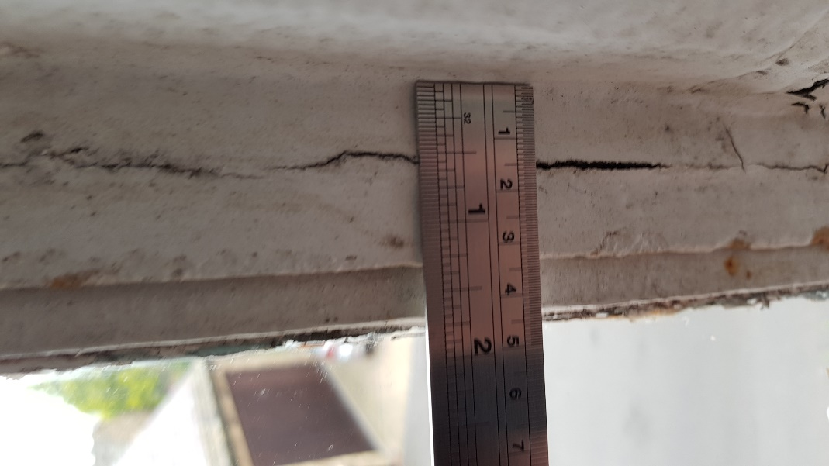

The existing metal windows fitted to the property are Crittall steel windows and in keeping with the existing property we have decided to replace these with Crittall steel windows. We are replacing like for like. Below is an example of the type of window we will be installing (ours will not be leaded)

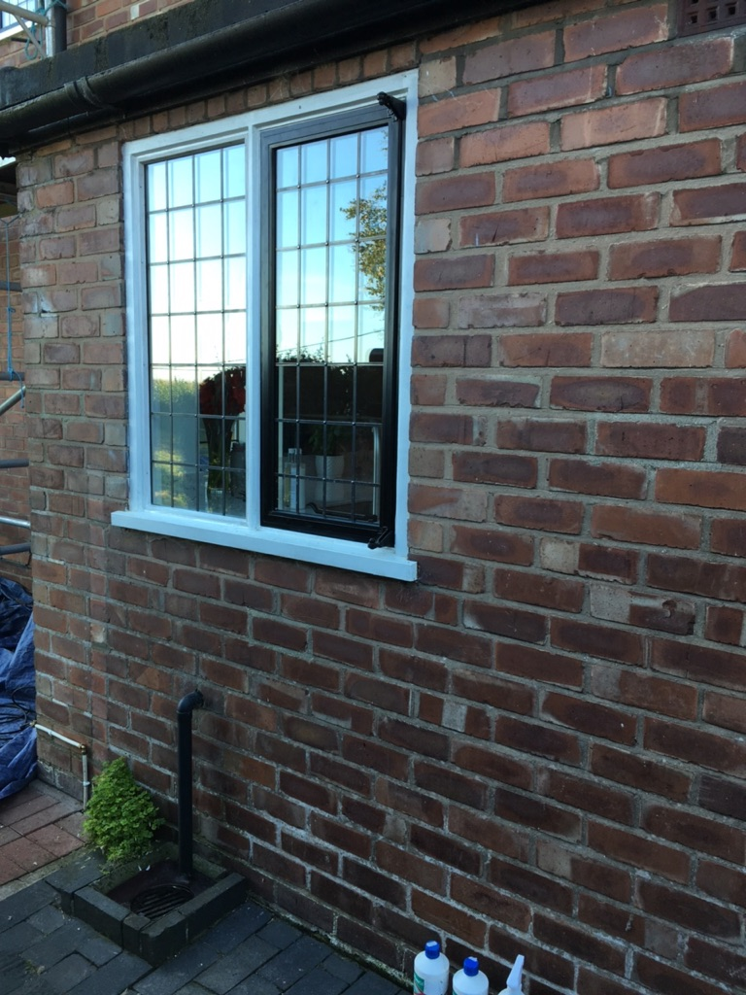

We have already had an onsite meeting with Tony Wiles, Barnsley Conservation officer, we have agreed that the windows will be dark grey and the double glazed seal will be black in colour. Traditional heritage window furniture also dark grey in colour will be used to match the character of a building of this type. The double glazed units will consist of 4mm glass + 8mm krypton gas + 4mm glass. (Pilkington).

Window Replacement Front Elevation

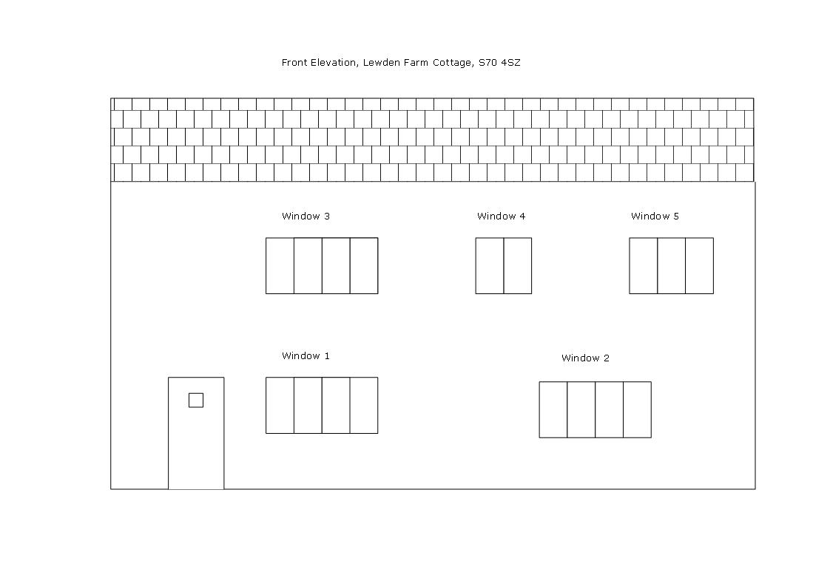
Window1 Lounge – The existing windows are Crittall, single glazed metal casement windows, 2 x fixed and 2 x openers. These windows will be replaced with Crittall double glazed units. Colour Heritage Dark grey.
Window 2 Kitchen - The existing windows are Crittall, single glazed metal casement windows, 2 x fixed and 2 x openers. These windows will be replaced with Crittall double glazed units. Colour Heritage Dark Grey.
Window 3 Large Bedroom - The existing windows are Crittal, single glazed metal casement windows, 2 x fixed and 2 x openers. These windows will be replaced with Crittal double glazed units. Colour Heritage Dark Grey.
Window 4 Small Bedroom - The existing windows are Crittal, single glazed metal casement windows, 1 x fixed and 1 x openers. These windows will be replaced with Crittal double glazed units. Colour Heritage Dark Grey.
Window 5 Bathroom - The existing windows are Crittal, single glazed metal casement windows, 2 x fixed and 1 x openers. These windows will be replaced with Crittal double glazed units. Colour Heritage Dark Grey.

Window Replacement Rear Elevation
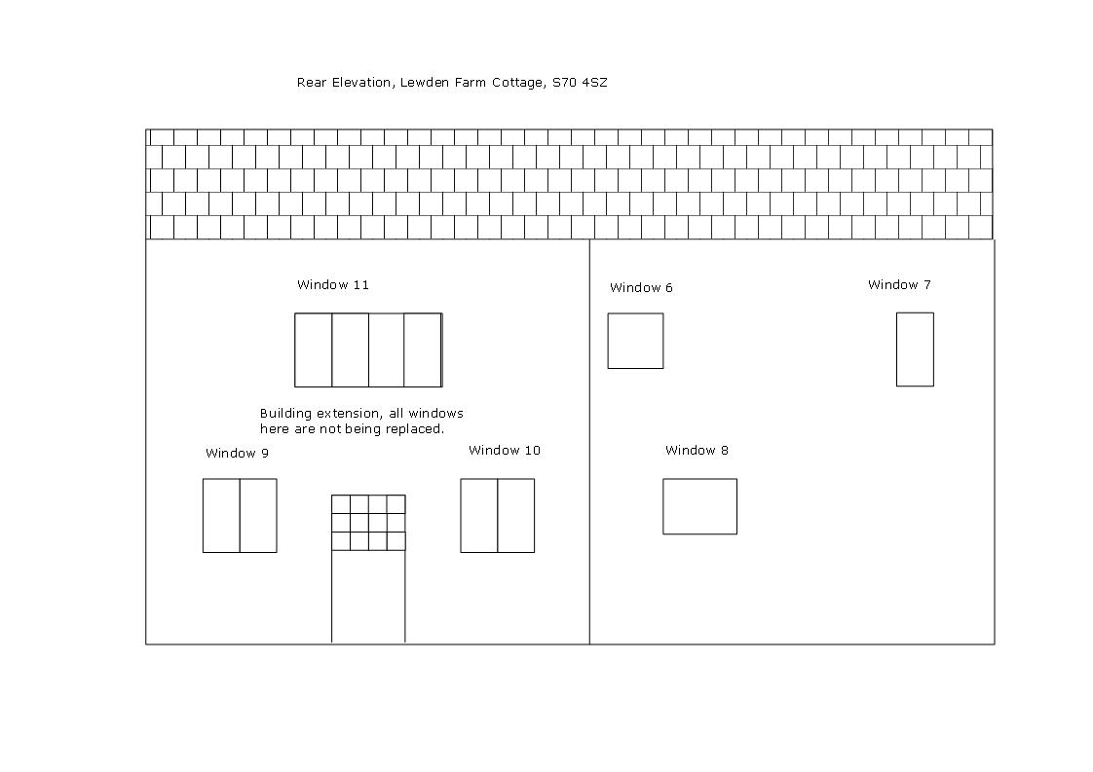
Window 6 first floor landing – The existing window is wooden framed double glazed, 1 x opener. This windows will be replaced with Crittall double glazed units. Colour Heritage Dark Grey.

Window 7 first floor landing – The existing window is metal framed single glazed, 1 x fixed. This windows will be replaced with Crittall double glazed units. Colour Heritage Dark Grey
Window 8 rear lounge – The existing window is wooden framed double glazed, 1 x opener. This windows will be replaced with Crittall double glazed units. Colour Heritage Dark Grey.

Windows 9, 10, 11 new rear extension – The existing windows are wooden framed double glazed. These windows will not be replaced as they were fitted in line with a planning consent in circa 2008.

Front view of Lewden Farm Cottage

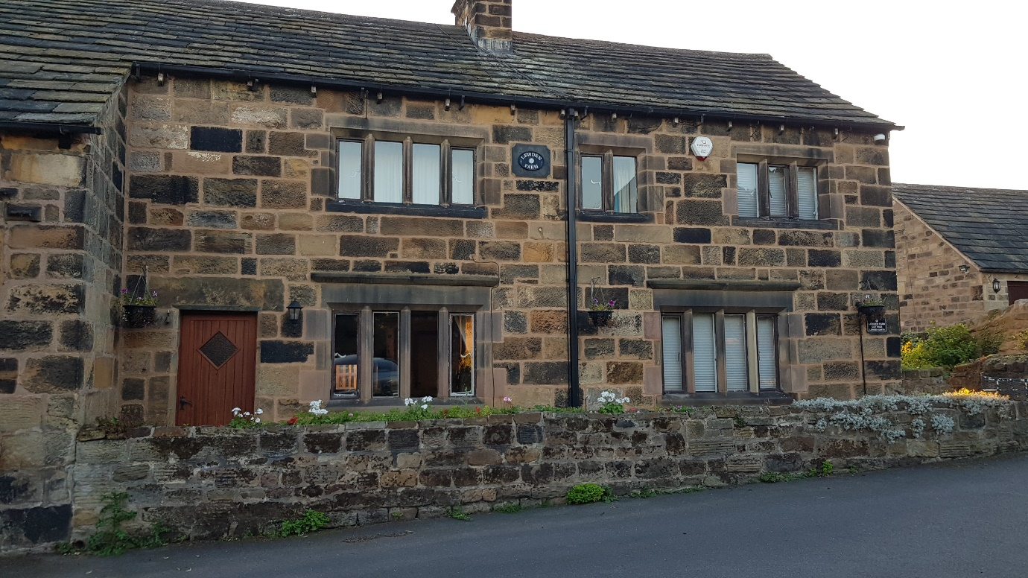

Rear View of Lewden Farm Cottage
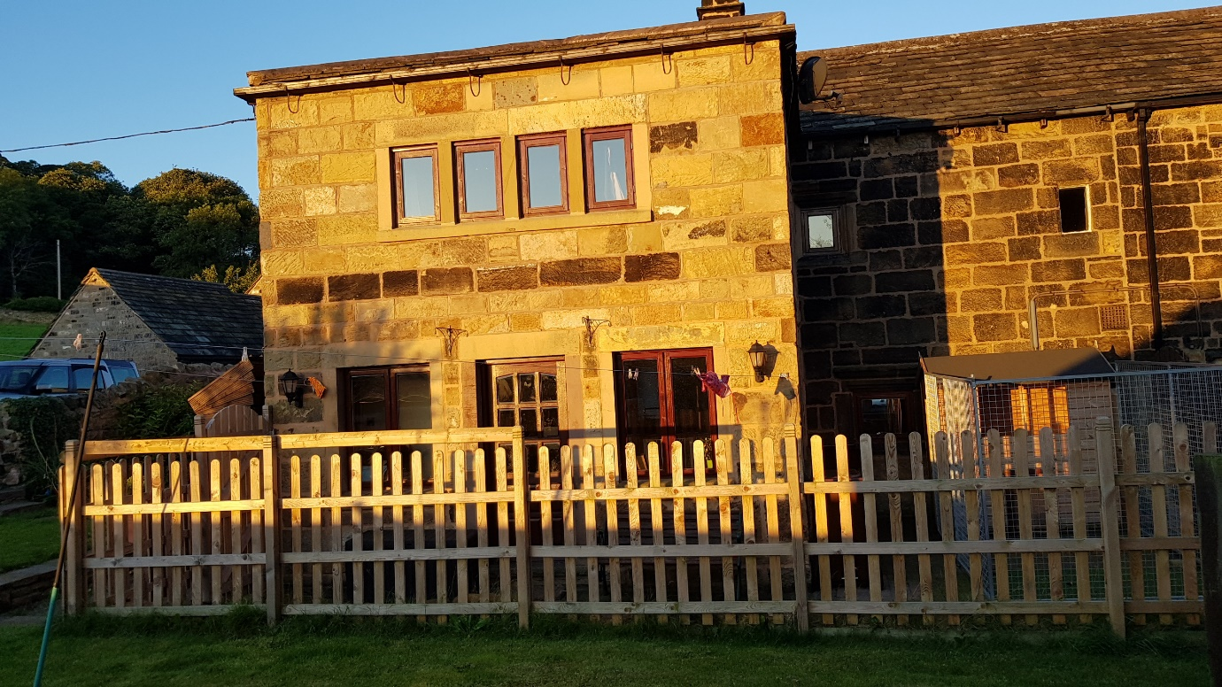
Location and Site plans
No 8 Lewden Farm Lane (Lewden Farm Cottage), Station Road, Worsbrough Dale, Barnsley, S70 4SZ.
