

84 Barnsley Road, South Kirkby
Pontefract, West Yorkshire, WF9 3QE
01977 219152 | 07468 535511
info@rbatownplanning.co.uk | www.rbatownplanning.co.uk

Former Health Centre
Church Street
Darfield
Barnsley

Proposed Change of use from Health Centre to Office with Ancillary Storage

Contents
Introduction……………. Page 3

The Conservation Area..Page 4, 5, 6

Policy……………………Page 7

Heritage Assessment…. Page 8,9

Introduction
RBA Town Planning provides the following Heritage Statement to accompany the planning application submitted to Barnsley Council for the change of use of the former Health Centre to Office with Ancillary Storage including the provision of a new access and fencing. The Heritage Statement is required given the application sites location within a Designated Conservation Area and sits opposite a Grade II Listed Building.

In determining applications, local planning authorities should require an applicant to describe the significance of any heritage assets affected, including any contribution made by their setting. The level of detail should be proportionate to the assets’ importance and no more than is sufficient to understand the potential impact of the proposal on their significance.

This statement is provided in line with guidance contained within the National Planning Policy Framework and has been undertaken to a level of complexity proportionate to the development proposal and the site.

This statement shall be read in association with all other documentation and plans submitted as part of the application.

The Conservation Area
The site is located within Darfield Village, and an area of the village designated as a Conservation Area. The immediate Conservation Area is made up of predominantly commercial properties some likely to have been once residential dwellings with the odd remaining residential property. Adjacent the site there is a public open space in which sits a war memorial. The area of land is unkept and suffers from antisocial behaviour. Directly opposite the site is a Grade II Listed Building that has been subject to significant extension with a wide access point and black powder coated railing fence to front and side.

The Application site is a modern estate constructed on a former meadow and falls just within the Conservation Area, a large open space to the front of the property provides defensible space from the adjacent highway.

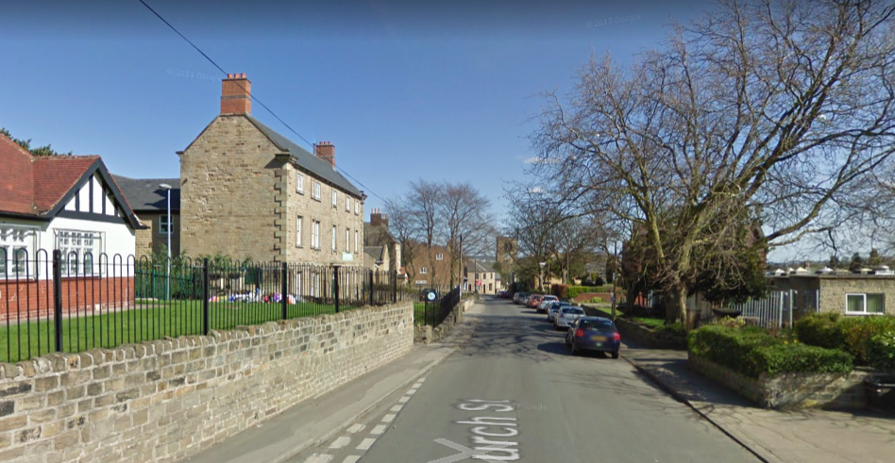
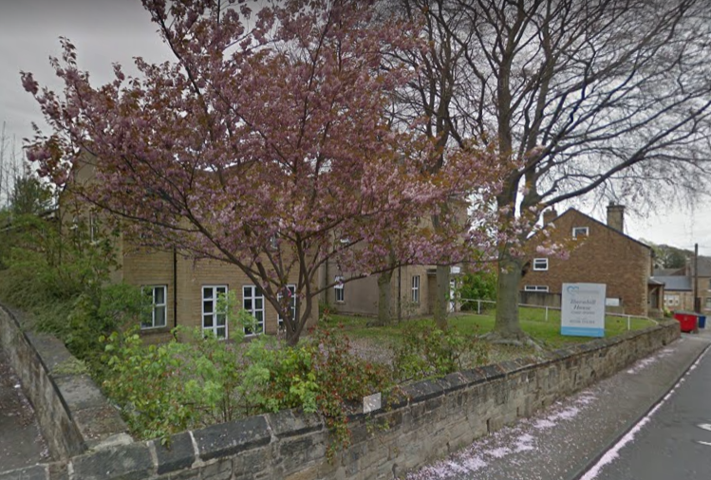
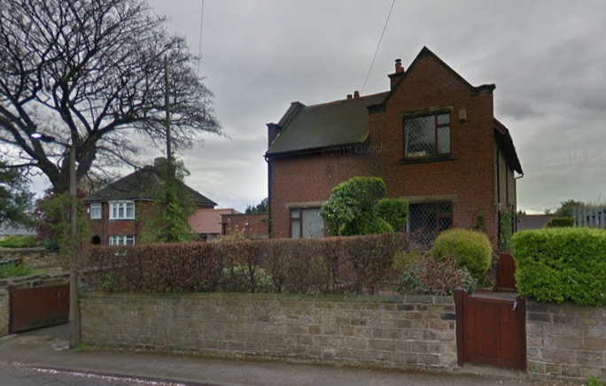

Street Scene – Church Street
Property styles – Main Street
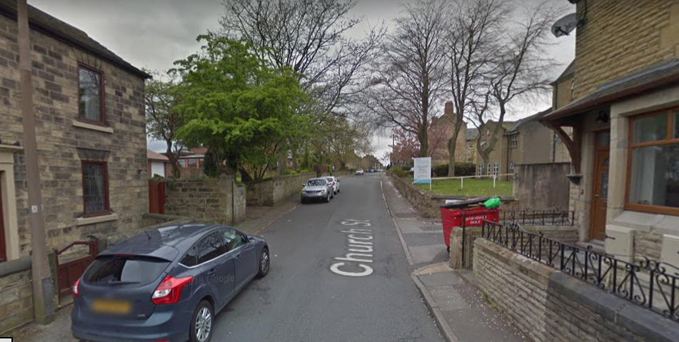
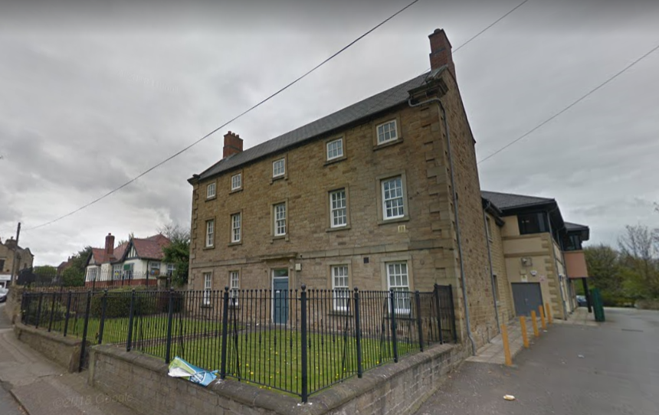

Listed Building
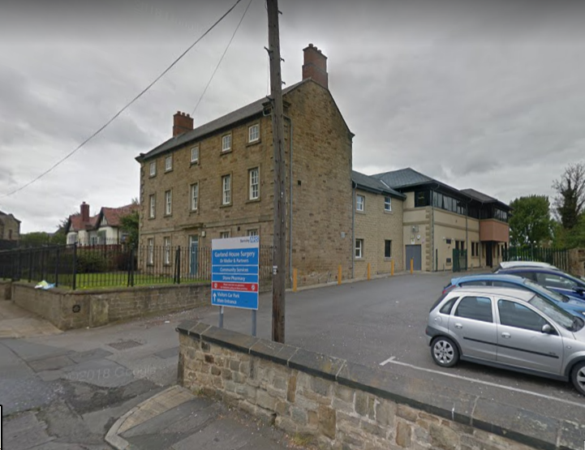
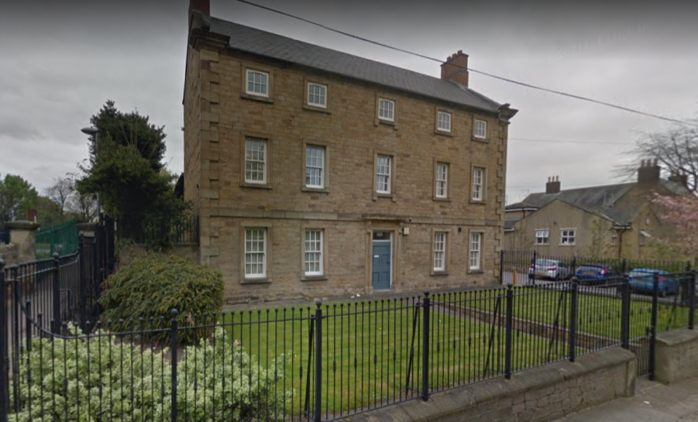
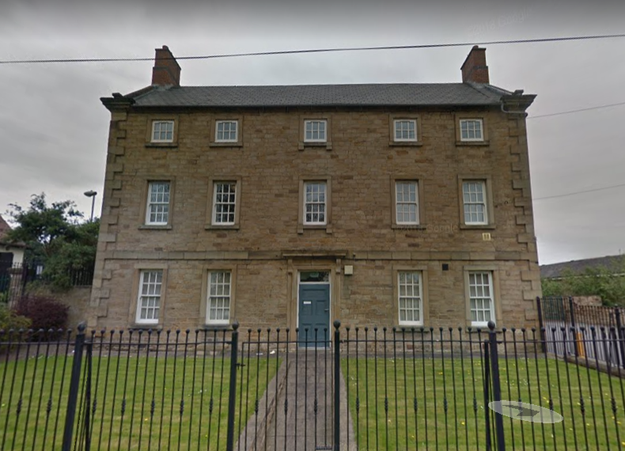

Policy
The following National Policy Guidance is considered appropriate to the consideration of the proposal;

NPPF Chapter 7. Requiring good design Para.56 - The Government attaches great importance to the design of the built environment. Good design is a key aspect of sustainable development, is indivisible from good planning, and should contribute positively to making places better for people.

NPPF Chapter 12. Conserving and enhancing the historic environment Para.126 - Local planning authorities should set out in their Local Plan a positive strategy for the conservation and enjoyment of the historic environment,29 including heritage assets most at risk through neglect, decay or other threats. In doing so, they should recognise that heritage assets are an irreplaceable resource and conserve them in a manner appropriate to their significance. In developing this strategy, local planning authorities should take into account:
● the desirability of sustaining and enhancing the significance of heritage assets and putting them to viable uses consistent with their conservation.

Para.131. In determining planning applications, local planning authorities should take account of:
● the desirability of sustaining and enhancing the significance of heritage assets and putting them to viable uses consistent with their conservation;
● the positive contribution that conservation of heritage assets can make to sustainable communities including their economic vitality; and
● the desirability of new development making a positive contribution to local character and distinctiveness.

Heritage Assessment
The Application Site consists of an un assuming flat roof brick building with little architectural merit. A small stone dwarf wall retains a raised land level with a sloped access to the main entrance. Metal palisade fencing encloses the site to the front and partial side which erodes the Conservation Character and appearance. The Listed Building opposite is a tall imposing building used as a health care centre, it has a large open access point leading a car parking area and a large modern extension to the rear. The building is bound to the front by powder coated railings.

The proposed change of use will have no impacts upon the listed building or the Conservation Character, however alterations to the boundary wall to allow access will have some impacts although these are considered to be limited. The stone taken to open up the access will be used within the site and the existing palisade fencing is to be removed and replaced with powder coated railings to match the Listed Building Opposite. It is considered that the proposal will seek to preserve and enhance the Conservation Area and not have any detrimental impacts upon the setting of the Listed Building.
