SITE NOTICE

APPLICATION FOR PRIOR NOTIFICATION OR PROPOSED DEMOLITION OF EXISTING BUILDINGS SUBMITTED UNDER TOWN & COUNTRY PLANNING (GENERAL PERMITTED DEVELOPMENT) (ENGLAND) ORDER 2015 SCHEDULE 2 PART 11, CLASS B

APPLICATION FOR THE PRIOR NOTIFICATION OF THE PROPOSED DEMOLITION OF 134 MILTON ROAD, HOYLAND BARNSLEY, S74 9BJ

TOMSAM Limited has submitted an application for prior Notification of Demolition to Barnsley Metropolitan Borough Council for determination. Local Planning Authority Address: Barnsley Metropolitan Borough, PO Box 634, Barnsley – S70 9GG
DevelopmentManagement@barnsley.gov.uk Any representations about the proposal should be made to Barnsley Metropolitan Borough Council within 21 days hereof

Signed: For and on behalf of TOMSAM Limited
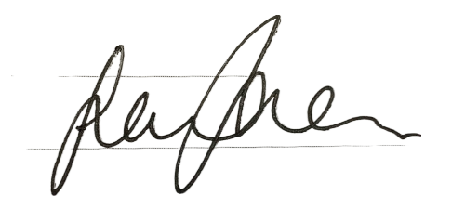
Dated: 04/07/2025

