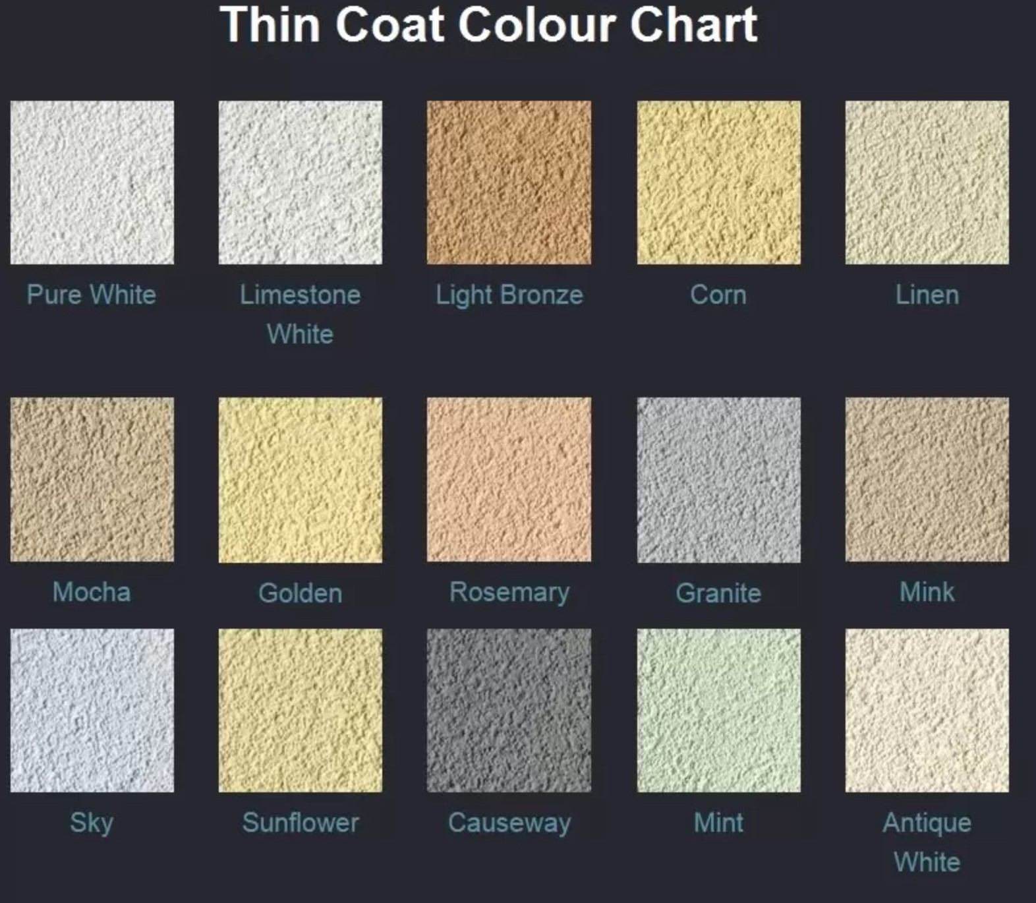

Samples of colour rendering for 52 Wingfield Road, Athersley South, Barnsley, S71 3PR

The preferred colours are SKY followed by Granite. We want to go lighter rather than darker.

