
Committed to sustainable modes of travel
for customers & employees

Staff Travel to Work 2018 - can you share a lift with someone who lives near to you?

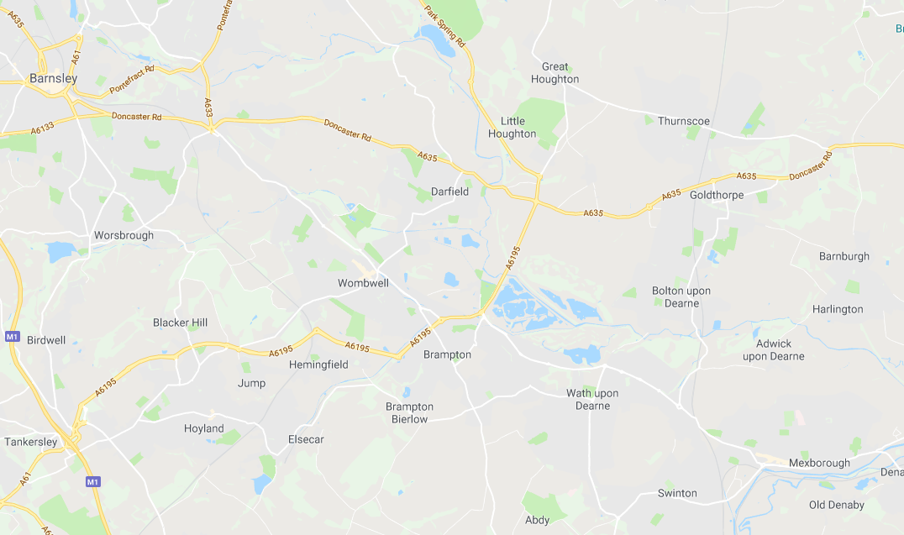
1600 Wombwell

I drive to work. Can I offer anyone a lift?

I already use sustainable transport to get to work - but I might be interested in having a lift off a colleague - and contributing to their travel costs.

