Planning Statement
The English Heritage website states that, “Listing is not a preservation order, preventing change, it does not freeze a building in time, it simply means that listed building consent must be applied for in order to make any changes to that building which might affect its special interest”. We fully respect and appreciate the value of preserving a listed building’s inherent character as far as possible and whilst we are mindful of this, we are also mindful that the installation of UPVC windows and doors at Windhill Gate Farm and other outbuildings has already been honored.
We understand that Grade II buildings are of national important and of special interest. We have learned that 92% of all listed buildings are in this class and it is the most likely grade of listing for a home owner. We understand the value of protecting the Gate House.
As doors and windows are important features that contribute greatly to the character of the building and in particular, by those who can view the properties from the kerb side, our aim is to improve the current appearance of the property.
We propose to replace all ‘existing’ external Rosewood glazed ‘UPVC doors’ (see figure 5) with partially glazed cottage style stable Composite Door in Chartwell Green (see figure 6) and a second partially glazed cottage style standard Composite Door in Chartwell Green (see figure 7)
As new technology is advancing in the field of composite doors, and UPVC windows, products are becoming more authentic. The 44mm composite door is constructed from fibre glass skins for a timber-like appearance and aesthetically look far more traditional than existing doors of the gate house. (See appendix 7 Composite Collection brochure and Spec Northern Trade Windows) The proposed illustrations as shown in figures 6 & 7 are far more authentic than the existing UPVC in Rosewood.
Figure 7. Partially glazed Composite standard door in Chartwell Green
Figure 6. Partially glazed Composite Stable door in Chartwell Green
Figure 5. Existing UPVC doors in Rosewood at The Gate House
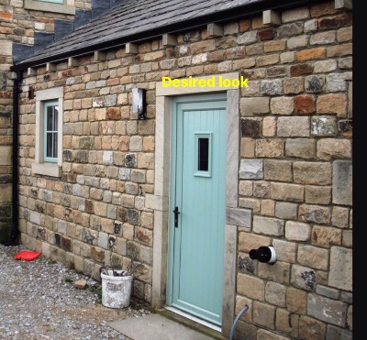
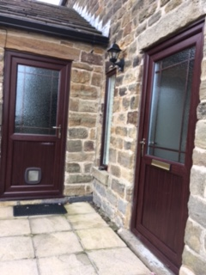
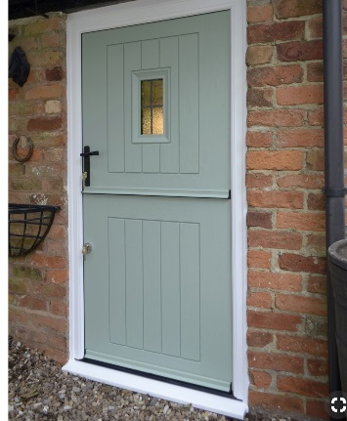
F7
F5
F6

There will be considerable layout of costs and we have done our best to approach, and if approved, instruct a reliable supplier (Northern Trade Windows), so that work will be carried out with superior quality UPVC and Composite materials to a very high standard.
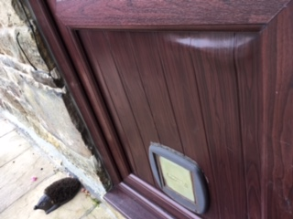
The existing UPVC doors are of poor quality which has led to weakness and warping. This lowers the tone and appearance of the listed property (See figure 8) there is also difficulty with locks and we are fearful for the security of the property and needs replacing as soon as possble.

Figure 8 The Existing Door showing the warped panel and faded Entrance door

F8

- We will replace the 2 UPVC Rosewood Gothic Arch Patio Doors Right and Left (See figure 9) with durable UPVC doors in Chartwell Green
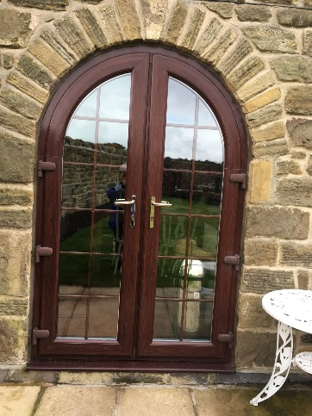
F9
Figure 9. Existing UPVC Gothic Arch glazed patio doors Right and Left in Rosewood Greeen

By replacing the windows and doors we hope to achieve a more authentic and complimentary style as well as quality to the aging property. This will, without any doubt, improve the kerb side appeal. The proposed illustrations as shown in figures 6 & 7 on page 3, are far more authentic than the existing UPVC in Rosewood.
This we feel will enhance and complement the historic features of the property. As pre development photographs seems to illustrate that there were no existing window features in the outbuildings and paintwork on a garage door appears to be green, this proposal would change the existing Rosewood back to green.

- We propose to replace all 11 Rosewood ‘UPVC windows’ with UPVC Frames in Chartwell Green and with A Grade glass sealed units (see figure 10a, 10b & 10c)
Figures 10a, 10b & 10c Replace 11 UPVc windows in Chartwell Green
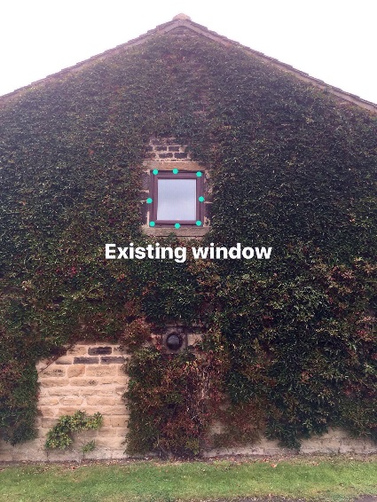
F10b
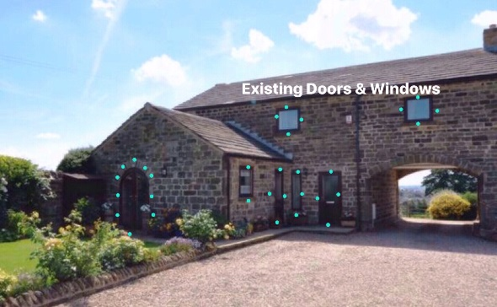
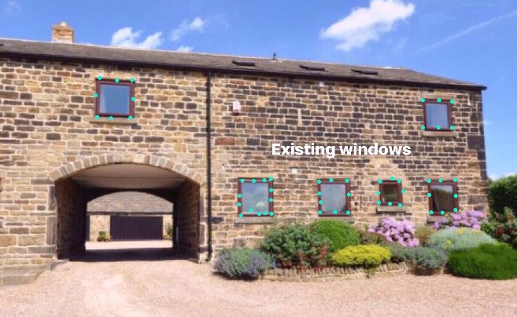
F10a
F10c

- The 70mm lead free PVCu outer frame is fully reinforced for added strength and security. The design and materials offer quality, security and durability. They will not fade or rot with the constant weathering, do not require sanding and painting or varnishing to keep them looking smart and will thus maintain a minimum of maintenance to sustain the beauty of the listed building. The windows are warmer, improving levels of thermal efficiency, quieter and more secure.
- The sealed units will protect us from the external elements and noise and preserve the lost energy. They will not fade or rot with the constant weathering, will not require sanding and painting or varnishing to keep them looking smart and will thus maintain a minimum of maintenance to sustain the beauty of the listed building. (See Appendix 8 - Window Frames Spec VEKA Group M70-launch (Northern Trade Windows)
- The skylights in the ensuite and bathroom are jarred and will not open. These rooms do not have windows and are the only source of ventilation to allow air and steam out when taking a shower or bath and this has created condensation and mold on the internal walls.

- We would aim to protect the appearance and exchange these in the same color. By replacing 3 of the existing roof skylights with UPVC Velux windows in like for like colour (see figure 11a & 11b over the page) this will help avoid internal damp to the property.

Figure 11a & 11 b Replace 3 roof windows circled in green F11a replaced in Velux UPVC black F11b

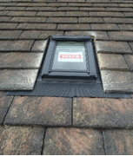
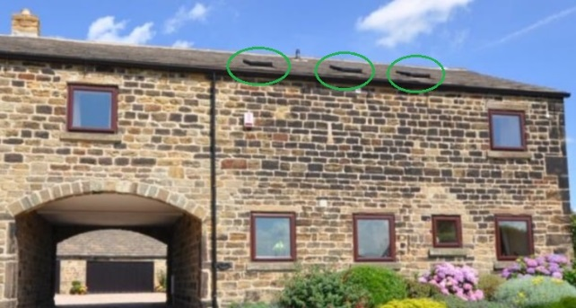
F11a
F11b

The Velux Roof Windows
The proposed roof windows are solar powered centre-pivot roof window in a high quality polyurethane finish. The moisture-resistant white polyurethane finish is ideal for humid rooms such as bathrooms. The fully programmable control pad with touch screen for easy operation to operate the roof window opening and closing. https://roofwindows.veluxshop.co.uk/velux-ggl-2060r21u

