2017/1387

Mr Malc Beechill
Demolition of existing dwelling and outbuildings and erection of up to 6 dwellings (Outline).
28 Paddock Road, Staincross, Barnsley

Description

The site is a 0.27ha area of land situated to the rear of number 28 Paddock Road, but also includes the dwelling and its garden area. The land has a number of outbuildings which were previously used in connection with agriculture. The outbuildings are a mix of concrete block/panel, stone built and metal sheet agricultural buildings. The buildings appear to have been unused for some time.

The adjacent property to the west, known as number 26, has a similar length area of land to the rear which has a number of long outbuildings and an access road which runs along the boundary. To the east is numbers 30 and 32 which is set back from Paddock Road. There are trees along the southern and eastern boundaries of the site, some of which are located on the adjacent land.

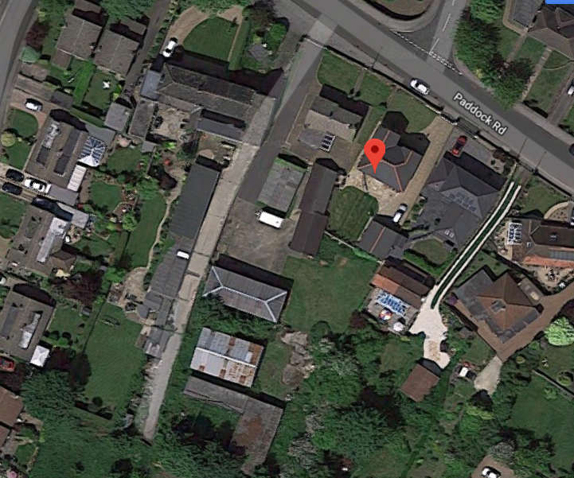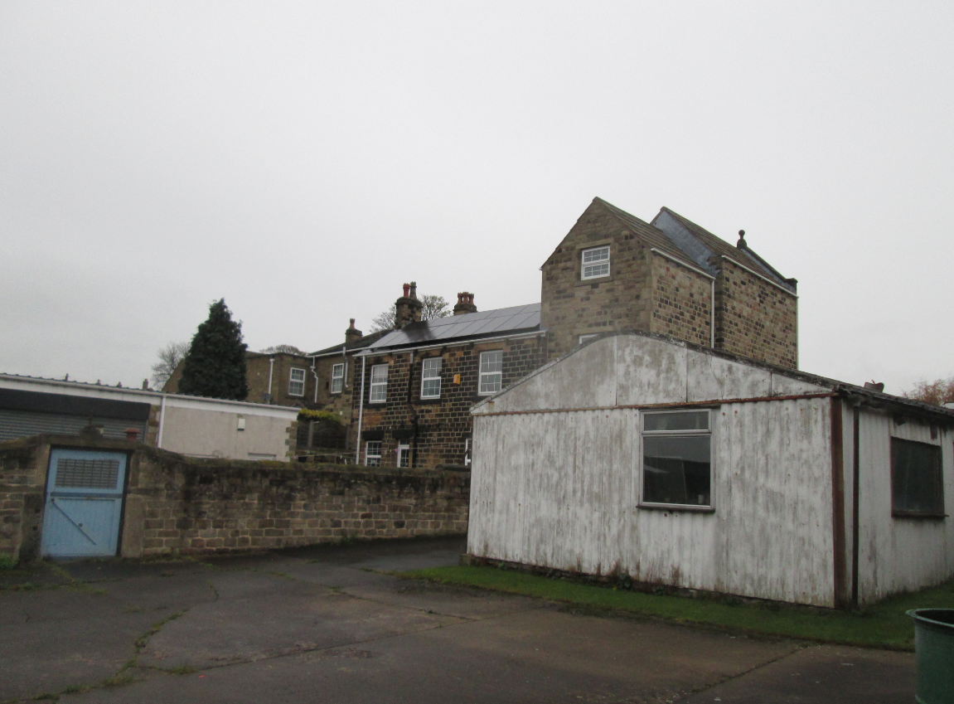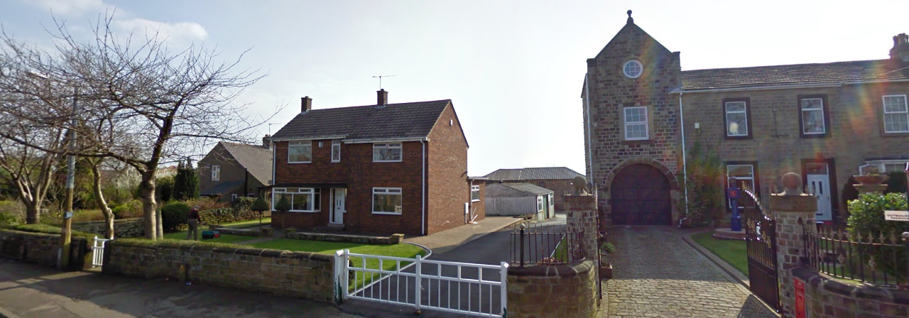
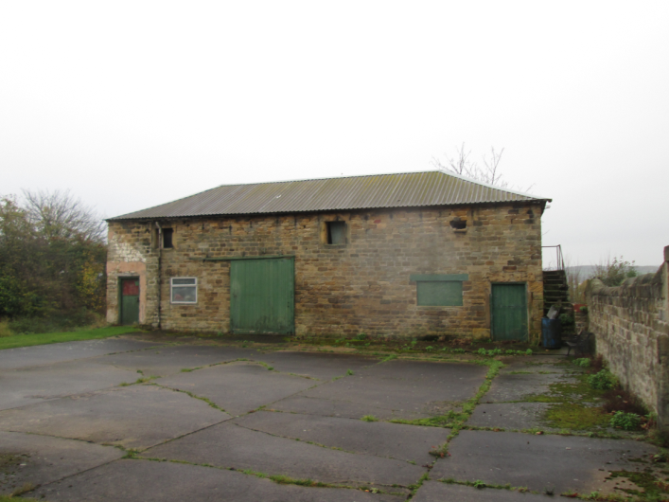
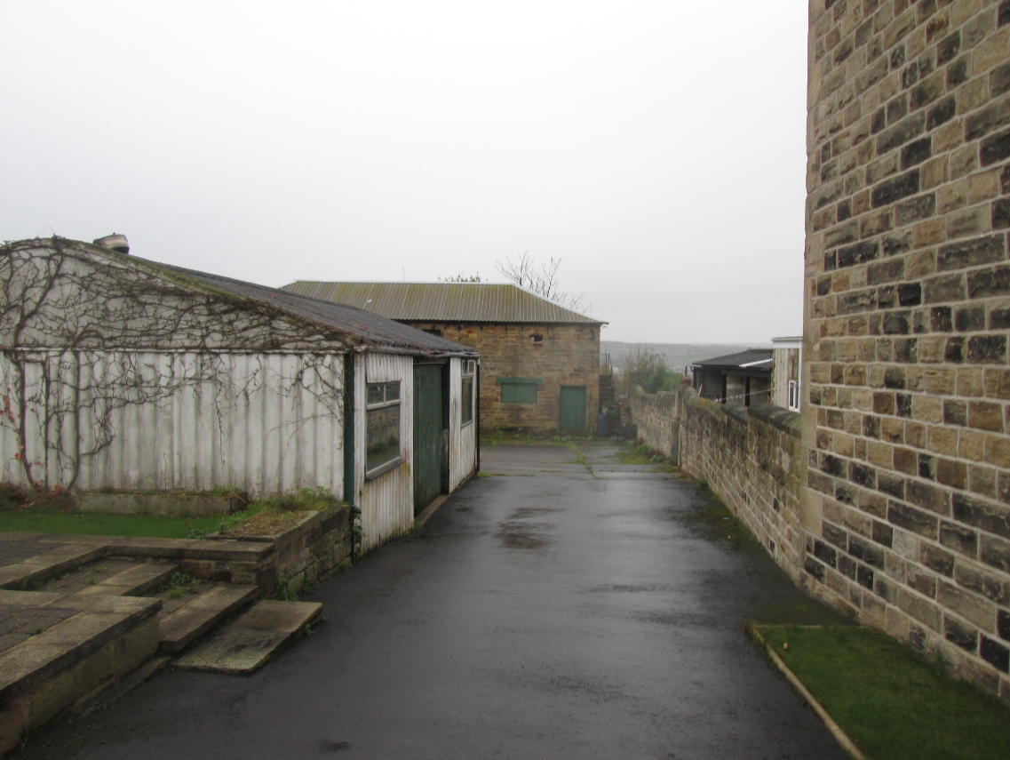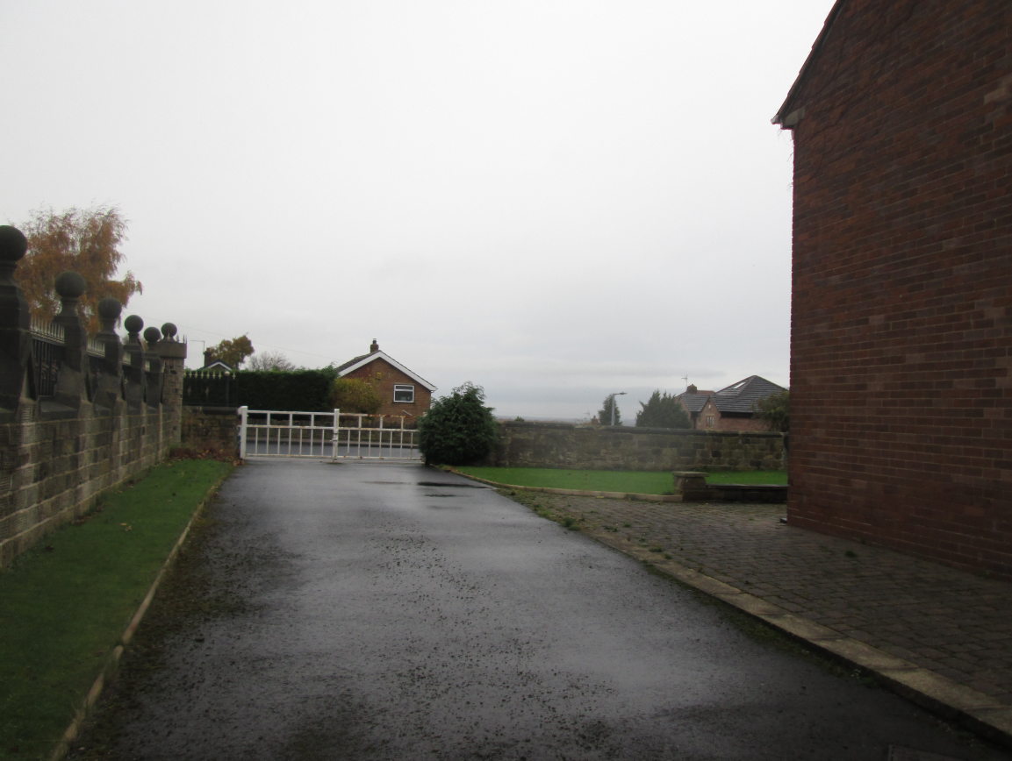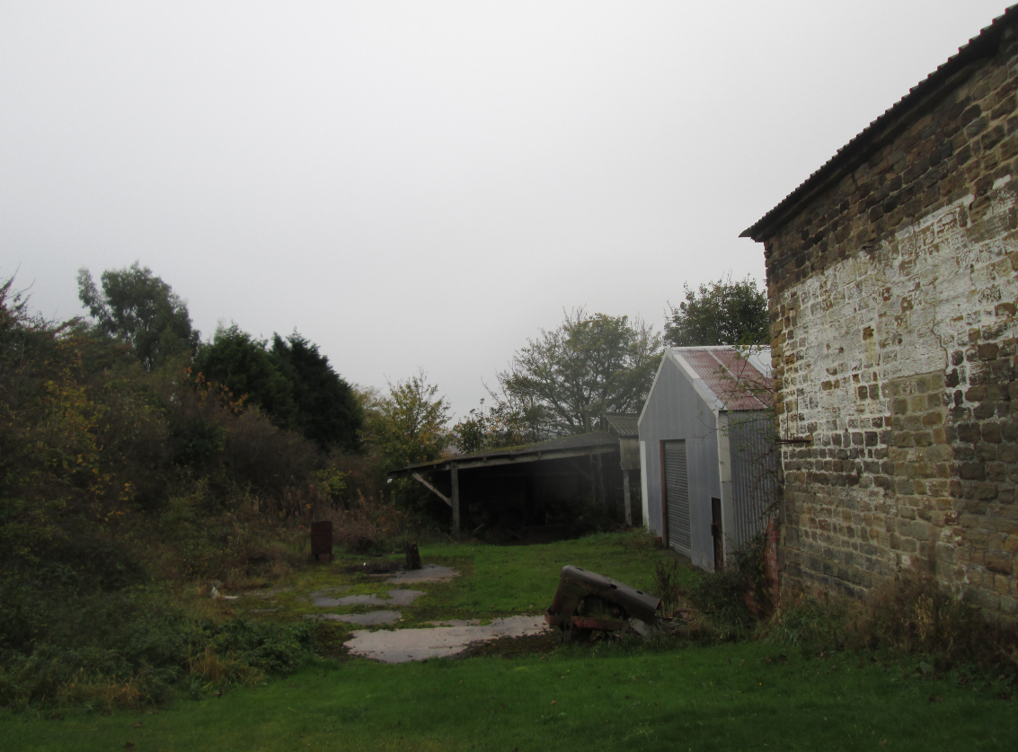

Proposed Development

The proposal an outline application with all matters reserved, for a residential development of the land. Due to the limited information submitted with the application, further detail was sought from the applicant:-

The agent has stated that:- ‘The clients parents have passed away and he is selling the land as part of the estate. The applicant doesn’t have an indicative plan at this stage, but it is presumed No 28 will be demolished along with all the redundant buildings. We estimate there will be 5 new dwellings served off a private drive. The site would be accessed from Paddock Road. I can confirm the applicant owns all of the site within the red line.’

The agent has agreed to amend the description of the application to ‘Demolition of existing dwelling and outbuildings and erection of up to 6 dwellings (Outline).’ This would allow for 5 new dwellings and a replacement dwelling for number 28.

Policy Context
Unitary Development Plan allocation – Housing Policy Area

Local Development Framework – Local Plan Proposals Map – Urban Fabric

The Council has submitted our emerging Local Plan to the Secretary of State but we are at an early stage in the examination process. It establishes policies and proposals for the development and use of land up to the year 2033. The document is a material consideration and represents a further stage forward in the progression towards adoption of the Local Plan. As such increasing weight can be given to the policies contained within the document although, in accordance with paragraph 216 of the NPPF, the extent of this will depend on:
- The extent to which there are unresolved objections to relevant policies (the less significant the unresolved objections, the greater the weight that may be given) and;
- The degree of consistency of the relevant policies in the emerging plan to the policies in the NPPF (the closer the policies in the emerging plan to the policies in the NPPF, the greater the weight that may be given).

Core Strategy

CSP2 – Sustainable Construction
CSP 26 New Development and Highway Improvement
CSP29 – Design

Saved UDP Policies

H8D – Infill residential development

SPDs

SPD – Designing new housing development

NPPF

The National Planning Policy Framework sets out the Government’s planning policies for England and how these are expected to be applied. At the heart is a presumption in favour of sustainable development. Development proposals that accord with the development plan should be approved unless material considerations indicate otherwise. Where the development plan is absent, silent or relevant policies are out-of-date, permission should be granted unless any adverse impacts of doing so would significantly and demonstrably outweigh the benefits, when assessed against the policies in the Framework as a whole; or where specific policies in the Framework indicate development should be restricted or unless material considerations indicate otherwise.

Consultations

Yorkshire Water – No objections subject to conditions

Pollution Control - No objections subject to conditions

Highways DC – No objections in principle
Drainage – No objections subject to conditions

Contaminated Land Officer - No objections subject to conditions

Tree Officer - No objections subject to conditions

Ward Councillors –Councillor Miller requested further information regarding number of units, highways, backland development and land allocation. No objections have been raised as a result.

Waste Management – No objections
Representations

3 objections have been received and have been summarised:-

Objection received from number 26

- ‘The application form states that the property is not vacant, this is not correct. We have lived here for 18 months and the property is empty. The front garden is maintained by who we understand are the sons of the now deceased owners. The back garden/land is not maintained and infringes in places, detrimentally into our boundary.

- The application also refers to 5 existing residential units. Please can you explain further as there is one main dwelling and the other buildings are a barn, 2 workshops and a couple of run down sheds.

- Our property sits right up to the boundary of the land referred to and we believe that any residential buildings built behind the current house will directly overlook us causing a loss to privacy as they will overlook us on 2 sides. Although not clear on the submitted plan, we also own the land at the bottom of the site in question. This we feel will have a direct impact on our enjoyment of our home and garden. We bought the house as it stands on a large plot which is not currently overlooked. We also feel strongly that any roads required to provide access to the development will cause added noise disruption to us and the surrounding existing properties.

- We also feel that multiple dwellings will not be in keeping with the surrounding houses which currently sit in relatively large plots, nor do we feel that this is required to meet current housing shortages due to the planned development of 200 plus houses to the rear of the property, off Wakefield Road (2017/0520)

- We are also aware of several other large developments in the wider community. We also feel that this development will increase the level of traffic on Paddock Road which is already a 'rat run' to motorists avoiding the junction from Shaw Lane on to Wakefield Road, seeing motorists regularly exceeding the current 30mph speed limit. We are already concerned about highway safely and feel strongly that any further development will have an added impact on the community and its children.’

Objection received from number 32

- ‘If houses are built close to the eastern boundary they will cause loss of light and overshadow my home, I will be overlooked and suffer loss of privacy. To mitigate this, I ask that the access road is built down the eastern edge of the site, and the houses are built with their fronts facing my house. Also bungalows would not overshadow as much, but 3 story houses would be a disaster.’

Objection received from number 30a

‘I have assumed that the application is for conversion of existing farm buildings as this is not clear. I have no objections to the conversions but would object strongly to any further increase of residential units’

Assessment

Principle of development

The site is located within a Housing Policy Area within the Unitary Development Plan where infill residential development is considered acceptable in principle, subject to impact on visual amenity, residential amenity and highway safety. The site could be considered as backland development given that the majority of land is behind the existing dwelling. However, there are already buildings behind this property, which appear to have been previously in agricultural use, so therefore there has been a previous use which has generated activity and disturbance on the land behind No. 28. The Council’s SPD on Designing New Development acknowledged that backland development may be more acceptable in circumstances where there is an existing use at the rear of dwellings. Although the use has appeared to cease the buildings still remain. In addition, properties 32 and 36 Paddock Road, adjacent to the site, are already positioned behind existing houses so there is an existing pattern of this type of development.

Visual Amenity

The siting and design of the proposed dwellings remains a reserved matter, however the dwellings could be designed in a style and materials to reflect the scale and design of adjacent dwellings, in keeping with the surrounding area.

An objection has been raised by an adjacent resident which states ‘we also feel that multiple dwellings will not be in keeping with the surrounding houses which currently sit in relatively large plots’ however there are a number of styles of properties in this area, ranging from large detached dwellings and traditional semi-detached dwellings in much smaller plots on Elliston Avenue and Paddock Road. The development of the site for up to 6 dwellings (including the replacement of the existing house) would be in keeping with the pattern of development of the area and would replace a group of unattractive existing buildings and an overall improvement of the site. The proposal is considered to be acceptable in terms of visual amenity, subject to the submission of detailed plans at reserved matters stage in accordance with policy CSP 29.

Residential Amenity

The proposed development of the site for 6 dwellings would not significantly impact upon the residential amenity of adjacent dwellings. The siting of the properties proposed would be considered in any future reserved matters application; however on measuring the plan it is apparent that 6 adequately sized dwellings could be sited on the plot with adequate garden areas and still maintain recommended separation distances between habitable room windows within the SPD. It is therefore considered that adequate space exists on the site in order to site the dwellings so that they do not overlook or reduce privacy to adjacent dwellings.

In terms of potential back land development, the site has a number of existing outbuildings set to the rear of the site which have been in agricultural use previously. The development of the land and removal of the agricultural buildings would allow for the site to be used for residential purposes which is considered more compatible with the surrounding residential uses than the existing agricultural buildings. In terms of disturbance, the site was previously used as a farm, which would have involved the use of large farm vehicles and associated activity therefore a residential use of the site is more appropriate considering the surrounding residential properties.

Concerns have been raised with regard to the height of any properties proposed, however at this stage the scale and design of the dwellings is not been considered, but would be carefully looked at during the reserved matters stage. It is not considered that there would be any significant impact upon neighbouring residents by way of overshadowing, overlooking or increased disturbance, subject to a detailed reserved matters application in accordance with policy H8D of the UDP and the SPD.

Impact on Trees

The Tree Officer has been consulted and has no objection to the proposal subject to conditions. There are some trees on and adjoining the site and as such a tree survey will be required along with the necessary tree protection documents at the reserved matters stage. It should also be noted that the tree survey will need to be used to inform any proposed layout so as to minimise and preferably completely avoid any arboricultural impacts.

Given the existing buildings and access there is no objection to the development of the site providing the trees are properly considered so as to avoid impacts on better specimens. Given that the impacts are unknown and replacement tree planting may be needed then a landscaping condition is also required.

Highway Safety

The highways section has no objection to the redevelopment of the site, subject to detailed layout and access plans being submitted at reserved matters stage. Adequate parking and turning can be provided within the site for the proposed dwellings and the visibility at the access point adjacent to Paddock Road is considered to be acceptable. The proposal is considered to be acceptable in terms of highway safety in accordance with policy CSP26 subject to the access, parking, visibility and turning/manoeuvring facilities should be designed in accordance with the South Yorkshire Residential Design Guide, Lifetime Homes and SPD2-Parking standards.

Recommendation

Grant subject to conditions

