Planning Design and Heritage Statement

The proposed works are the installation of a bespoke metal weather louvre grille into the lower left pane of a side window in Mill Cottage.

The grille will be black in colour and made from aluminium and powder coated black to minimise its visual impact.

The dimensions of the grille are as follows:
Height: 410mm
Width: 390mm

The proposed works are extremely minimal and are completely reversible.

The Mill Complex has a number of historically significant buildings and structures listed by Historic England:
The Mill Cottage, Park Road, Worsbrough Grade II Listed no’ 1192294 (4th December 1986) now known as the Miller Tea rooms and visitor centre.
Worsbrough Corn Mill Park Road Grade II* listed no’ 1151044 (11th December 1966) used today as a museum and corn mill.
Bridge some 60 metres from the Mill Grade II listed no’1151045 (11th December 1966)
In terms of planning, design and heritage we have consulted the Council’s Senior Conservation Officer over the most appropriate location for installation and have chosen the side window on a return wall of Mill Cottage to have minimal impact on the setting of the site, We feel that this location balances the needs of the Historic setting but also facilitates the purpose of the louvre grille to allow effective extraction from the small onsite bakery, which is situated within Mill Cottage.

Heritage Assets and Heritage Significance

The proposed building intended for the installation of the grille is Grade II. As such we recognise that it has heritage significance and is sensitive to change, hence the consideration taken to minimise the visual impact and to make the installation fully reversible.

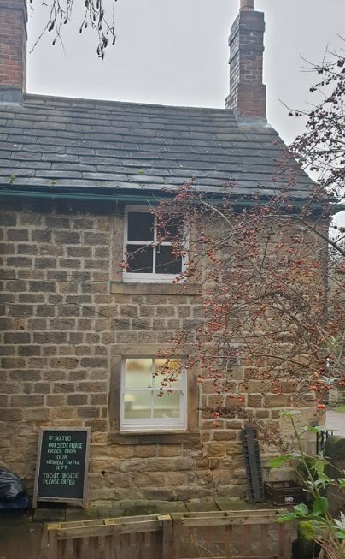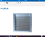
Proposed location of the louvre grille, for illustration purposes only

Impacts and Justification

The installation of a louvre grille on a listed building will have a small impact on the appearance of the building. However, we have explored other solutions to the extraction problem in the bakery and this is the only viable one. We feel strongly that any impacts are mitigated by the fact that the installation method will be 100% reversible (the grille will be attached in place of a window pane). The bakery allows visitors to the site to see completely the “field to fork” story of the grain milled at Worsbrough Mill. As such, we feel that the proposal is justified and accords with BMBC Local Plan policies.

