• Why does outdoor sound recording require a building?

The entire uniqueness of the sound design creation centre is to allow a seamless/time efficient/ cost effective process to record sounds both inside and outside and be able to put them straight into the game’s computer engine.

To record a sound outside, in close proximity to the building, will allow Pitstop to offer a unique service that:

- Improves the sound quality and detail that makes up the sound design in the video games we are working on.

- Make it easier to make changes in the recording process

- Create a fast, efficient process of creating and making detailed sound changes.

The system being created allows the company to record the sound outside with it going directly into the internal studios Pitstop plan to have in the building. This process the company calls “direct input wiring”.

What is recorded outside will instantly be heard in studio and be allowed to go straight into the game engine.

Once that sound is heard in game, the Pitstop team may feel that it is not right or needs slightly changing. For example, the Pitstop team may want to re-record something completely different, or slightly change that sound by adjusting the microphone positions or adjusting the way in which that sound has been made.

Case Study
Imagine a scene in a game where our main character is digging a hole in his garden to hide some treasure. He’s in a rush. He’s nervous, and in the distance he hears an angry crowd approaching.

To record the sound of the digging, we would do the following process.

Inside the building in one of the studios, Pitstop will have a sound engineer. Outside is a sound recordist, armed with shovel and a section of gravel mixed with soil that has been prepared, ready to insert their shovel into.

Meanwhile the animation (film /video) of the scene is being played in the studio and the sound engineer is asking the sound recordist to do his first recording of digging into the ground with the shovel. They have asked the sound engineer to do this aggressively. The recording is instantaneously fed back to the internal studio.

The sound engineer immediately takes that recording, cuts and edits it and places into the scene.
If it doesn’t fit, the recording can be immediately repeated until the team have what they need. This means that the correct sound can be recorded and placed into game in a fraction of the time, compared to multiple trips back and forth required of standard ‘field recording’.

Evaluation
By having this outdoor and indoor connectivity, Pitstop can efficiently make sound-scapes that are high in quality, and this level of detail and flexibility means the game’s sound quality is significantly improved. Over the years the Pitstop team have recorded in various ‘onsite’ locations, before taking recording back to the studio to test them, so you can imagine how time consuming that process is compared to the one we are wanting to create here.

Summary
This unique flexible process would only work with a facility that allows a space where indoor and outdoor sounds can be recorded.
- It sets the company apart from its competitors,
- It’s a unique service
- It attracts companies from all over the world to want to work in this way.
- It means students/ sound design professionals can experiment and learn techniques that can be reviewed instantly.
- It raises the bar on what Pitstop does to another level

• Can’t some outdoor equipment be located here and the building elsewhere?

The information provided above covers this question. It’s essential to understand the production flow we are trying to create here, as we are wanting to create a facility that means we no longer need to do ‘field recording’ for outdoor recording.
The sound design creation centre will allow the indoor and outdoor recording of sound for video games to be able to go straight into game and therefore create a uniquely efficient process of high-level creativity and quality in video game audio production.
The Sound Design Creation Centre allows for instantanous evaluation of recorded sounds, and the ability to immediately rerecord, vs the trial and error method of ‘field recording’, which results in multiple trips backs and forth between the site and the studio achieve what’s required.

From Pitstop’s perspective, this is a considerable financial investment to build this facility, which is fundamental to the continued growth and success of the business.

The company is highly skilled and knowledgeable in this area and is risking its future growth and reputation in this venture.

• There is significant background noise in the locality so why are other sites so problematic in respect of outdoor noise?

We were asked by planning to consider other sites within the Borough. These sites are listed in the original document Pitstop submitted to planning. The problem with all of the sites was the location, size, or proximity to our existing offices in Barnsley, or a combination of the 3.

Barnsley Council provided us with a list of sites to assess, and there has been no objection to our “not suitable” response. To summarise, the sites offered up:

- Did not have enough outdoor space to record
- Were in a location where industrial noise pollution would make the processes impossible
- Were either too big, or had outline planning permission for residential buildings, making them too expensive to consider
- Were not near enough to our existing offices

The site does not have to be silent. If this was the case Pitstop would be locating the whole operation to remote space in the middle of the countryside.

The site needs to have sufficient space where sound can be recorded, with no Major continuous/regular noise interference such as heavy plant machinery, HGV wagons, proximity to a railway, loading and unloading of goods etc.

As a result of this, industrial parks in the area are not suitable for the reasons stated above.

The site at Staincross does have some road noise but this would not be an issue for the recordings we want to make. All our recordings required a silent environment would be recorded indoors in the soundproof studios. When you combine the design of the building acting as a shield for most of the outdoor recording bays, we are confident that the traffic noise would not be an issue.

The diagram below shows this.

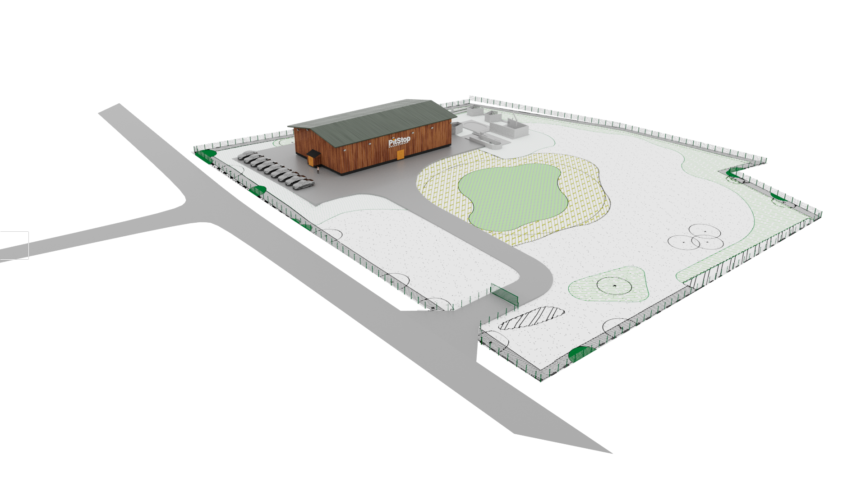

• Precisely what sort of Sounds will be created outdoors?

Most of the sounds recorded outside will be very low in volume. As stated in the opening section it’s the flexibility of recording that Pitstop is allowing itself with this facility. This is a Sound Creation facility not a Noise Making place.

To be clear, the company will NOT be using the outside space to blow anything up. Explosion sounds can be created much more safely (any quietly) by creatively layering and adding multiple sounds together. For example, if you correctly set up a microphone around a Bunsen Burner and light it, you have created an explosion sound. Add to that the sound of a crackling twigs recorded up close, and you can create the sound of an inferno.

The company will not be recording firearms on the site. The legal and safety reasons for this are obvious.

There will be the occasional need for smashing, hammering etc of objects, but these are generally done in short bursts, and not for prolonged periods of time. There may also be the odd occasion where a car is brought in to record its engine. As stated, sound from these recordings would be shielded as shown in the diagram above. Pitstop are of the opinion that the sound of the bin lorry, or residents mowing their lawn would be far more invasive that ‘noise’ generated from these types of audio recordings. When combining the location and shielding of the building, the occasional requirement to record sounds of this nature, then we have a situation whereby the sound heard by residents would be hardly noticeable.

In order to put residents’ minds at rest ,Pitstop are willing to agree to a noise limit.

To summarise, here is a list of the sounds we DO NOT plan to record:

Sound Effects That won’t be recorded | Reasons
Gunshots | Illegal /too dangerous
Explosions | Wrong process/too dangerous

Here our some of the examples of sound that could be recorded outside.
Examples of Sound Effects That will be Recorded
Footsteps on different surfaces
Environmental – wind, rain, foliage etc
Hammering/Pounding of Metal
Hammering of Wood
Hammering of Ceramics
Glass being broken
Engines
Water sounds
Digging
Rolling of objects
Voices

Summary

The activity outdoors will be at worse the noise someone cutting a hedge, or mowing a lawn might make. The indoor recordings will take place in completely soundproofed studios, so will be completely silent to anyone outside of the building.

The location of the outdoor areas where the sounds would be recorded are set back as far away from the road and residents as possible.

The placing of the building in front of the outside recording spaces will act as a buffer.

As an assurance, the company are willing to agree to an outdoor noise level limit, set by the council. It has already agreed to a curfew on early mornings, evenings and weekends. We would defer to the council’s noise pollution control officers to set an appropriate level.

• Why no noise assessment given outdoor recording taking place?

There has been no requirement for a noise assessment, as we believe the sound made by the centre would be negligible. This is a creative space, not an in industrial one.

As said in the original document any major noise will be made inside the building which will be sound proofed and acoustically treated.

The committee are maybe being slightly confused by their perception of what video games sound like and how sound is created.

To briefly explain this, small sounds make up big noises. The skill of the audio team is their ability to combine and merge small sounds to make the desired sound they want for the game.

In the event of the team needing to record a large crash/smash, we plan to build the facility indoors whereby we can drop things from a great height – this wouldn’t take place outside. This will allow us to be extra noisy without anyone hearing us, and allows us the freedom to create in a controlled and safe way.

Summary
This site is not an industrial site. Pitstop agree to certain measures being imposed on the site such as not going above a certain noise threshold and only working outside between set hours, as stipulated in the conditions document.

The Sound Design Creation Centre will not create a huge amount of noise. It’s the space both indoor and outdoor that are central to its success and uniqueness.

If co-location of the building and outdoor sound recording is unavoidable, why can’t the building be single storey, or the site graded to reduce its ridge height?

It would be indeed more cost effective for Pitstop to build this facility as a single storey building however the space needed for the various studios and recording-facilities would not make single storey be viable for the company.

The reason we need the building to be two storeys is to provide enough space to accommodate the meeting rooms and recording studios we need set out in the plan. It should also be noted that the possible footprint of the building is restricted due to the presence of an historic mining shaft and the need for the building to be located a sufficient stand off from this feature. The reduced footprint also ensures the consolidation of built form which is beneficial to the openness of the Green Belt and allows greater biodiversity benefits across the rest of the site. So to have sufficient space, we need to build to two storeys.

In additional to the building operating on a commercial basis, Pitstop plan to work closely with Barnsley College, creating spaces where students can, with the support of Pitstop, learn their craft. Most of Pitstop’s commercial work is done under a Non-Disclosure Agreements, (N.D.A.) and many clients demand that we have our own separate space for their games where only the designated team working on that project can function.

This type of set-up will be common-place for Pitstop as the nature of games we plan to be working on will need this type of exclusive space.

At the same time the company wants to be sure that its investment into Barnsley is a genuine full-hearted attempt to create a space that can best serve the future of all. The company feels that the floor size and layout it is suggesting will allow for this.

The main recording hall Pitstop is planning is needed to be double storey. This will allow the company the space and safe place to record larger objects indoors. This space will be sound proofed, so if we were to drop a piano from a great height, the surrounding area would not hear a note.

The diagram below shows the floor layout for the ground floor.

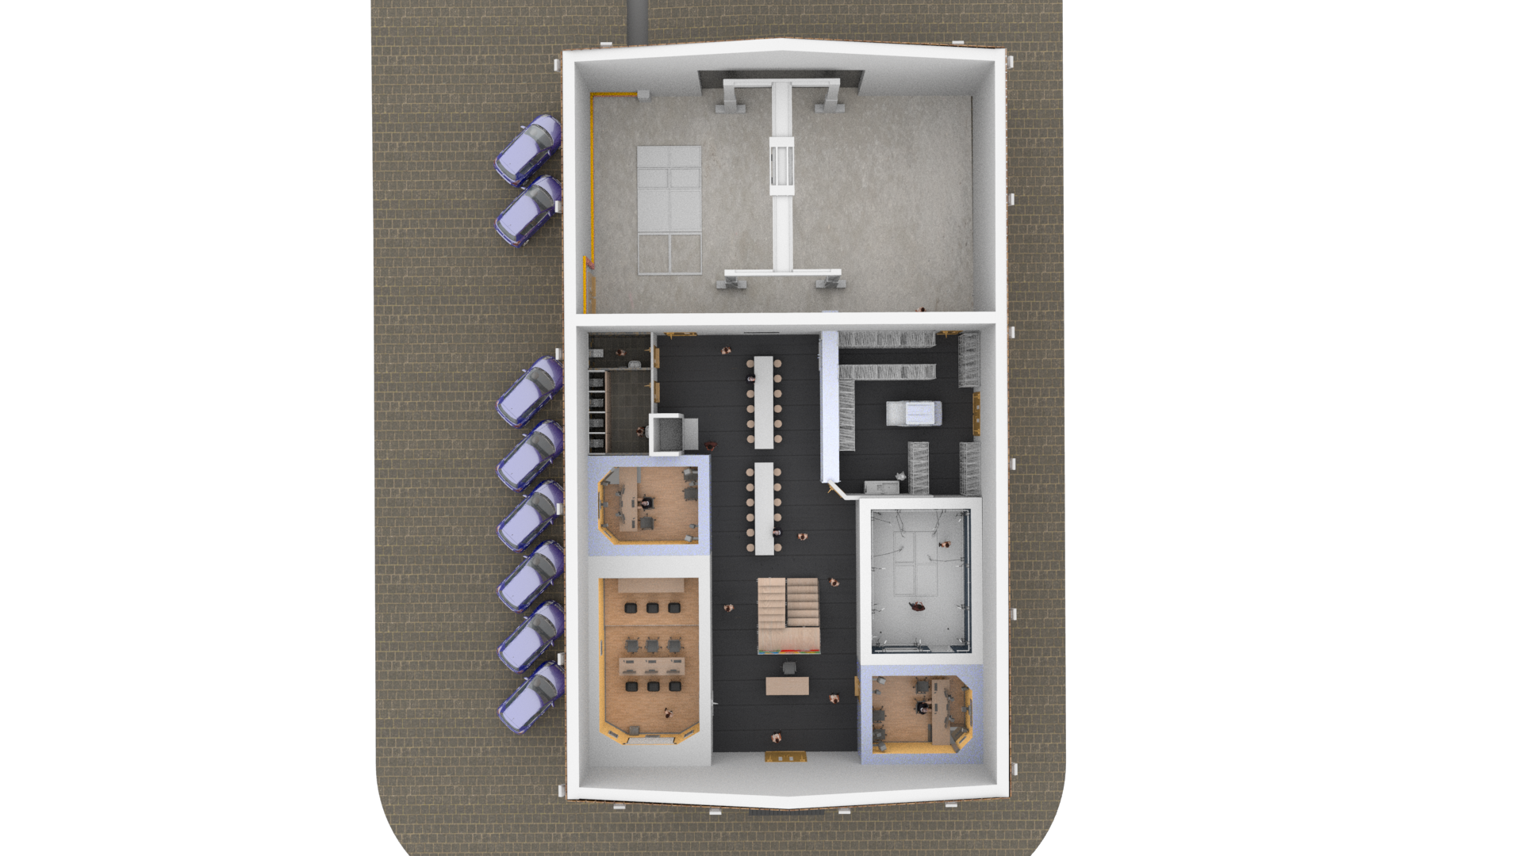

The design is intended to keep each room separate and sound proofed with a meeting area in the middle.

The design of the area means that each space is private, and sound-proofed allowing a multi-project system of working to take place.

The large space at the back is where our “creation of sounds” would be made. This is why we have put it as far away from the road and residents as possible. This is why we are so confident any noise pollution will not be an issue.

Upper Floor.

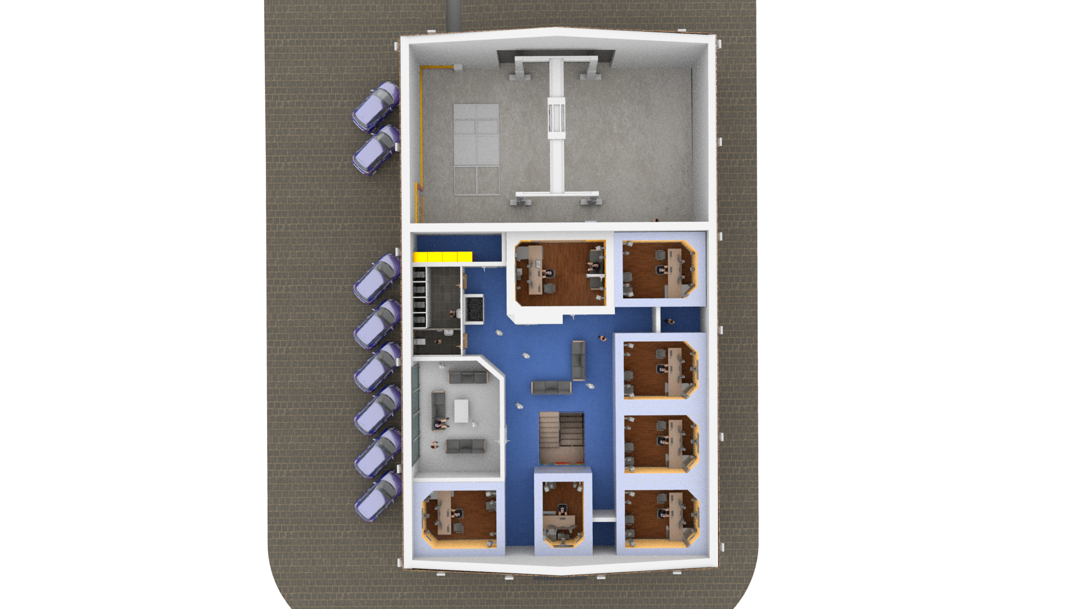

The upper floor is self-contained studio space. Please note all these recording rooms will be set up so whatever is recorded outside can be wired into any of the studio rooms in building. As stated, sound-proofing is key to the quality of what Pitstop does. The room next door will not be able to hear any sound, nevermind anyone outside.

As demonstrated from the diagram it would prove rather difficult to have the building single storey. We believe it would take up too large a footprint and not look as aesthetically pleasing as is intended.

As well as this, the company is planting the landscape as shown in the original document presented to planning.

With regard to grading the land, there is already some grading in place the below diagram shows how the building will look

The building as planned will very similar to this artists impression.

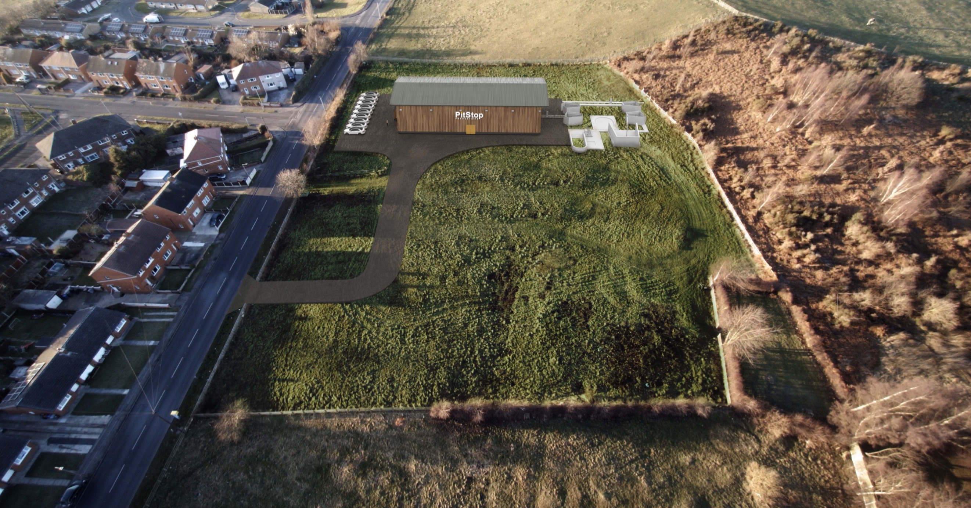

Summary
Pitstop are willing to try and grade the land for the two-storey building. This has already been considered and it is anticipated that some land lowering will be required. A condition is suggested by officers which would ensure BMBC have full control over the final levels at the site and we are happy to work with officers to ensure the visual impact of the development is as minimal as possible.

A single storey building won’t allow the space the company will need to fulfil its needs both in the games industry, local economy, and education areas.

Furthermore, the coal mining history at the site, along with the ambition of limiting the spread of built form/ providing substantial biodiversity enhancements, limit the footprint of the building we could have.

