Design & Access Statement to Support Planning Application -
Document date 23/05/2024

Rev -

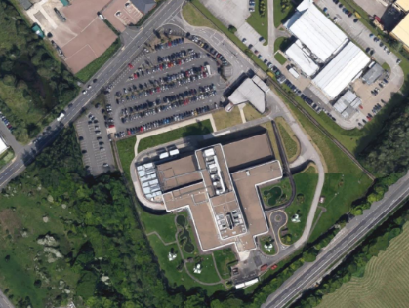
Site Address:
SYGDC (South Yorkshire Group Data Centre)
Tankersley,
Barnsley,
S75 3DJ

Figure 1 |
SYGDC Tankersley, South Yorkshire (image from Google maps)

- PROPERTY DESCRIPTION

  - The data centre site was designed by Whinney, Son and Austen Hall and was completed in 1981. The data centre was constructed using pioneering building materials of the time, as the building was clad in glass-reinforced cement (GRC). The cream pre-cast panels offer curvature and sleekness whilst the deep chamfered reveals and bronze-tinted glass sweep across each façade.
  - The main purpose of this building is to house computer servers. In addition to this, the building includes facilities for staff, storage, plant rooms and a loading bay.

- ACCESS STATEMENT

2.01 Vehicular and pedestrian access to the site will be unchanged by this application.
- DESIGN STATEMENT

3.01 Context;
The application site is located in Tankersley, surrounded by a range of other commercial , industrial developments. None of which hold any significant architectural merit.

The HSBC South Yorkshire Global Data Centre (SYGDC) comprises of two floors, with an extensive partial basement at the lower ground level, house computer rooms and ancillary plant and services with various mezzanine levels for additional plant. The ground floor has a significantly smaller footprint sitting above the semi-basement core and houses support offices, meeting rooms and some smaller computer rooms. The first floor reduces footprint again. All roofs to the building are flat and the basement roof is covered by extensive landscaping.
The site is located at HSBC SYGDC, Maple Road, Tankersley, Barnsley, S75 3DL
53°29'21.5"N 1°29'29.5"W | 53.489310, -1.491520
3.02 Proposals;
As part of the planned refurbishment the cooling systems includes the removal of an array of air-cooled chillers, located on the first-floor roof, approaching end of life together with a large plantroom. The proposal includes the replacement with two smaller air-cooled units to assist with secondary cooling. The building is well set back from the road but the roof plant is visible. The proposed replacements have a significantly reduced footprint and the proposal is to located these away from the roof edge nearest to Maple Road. The supporting steelwork will be modified to accommodate the new plant and a replacement covered access area is proposed.
Figure 2 |
Google Street View existing image with Roof plant structure to be removed
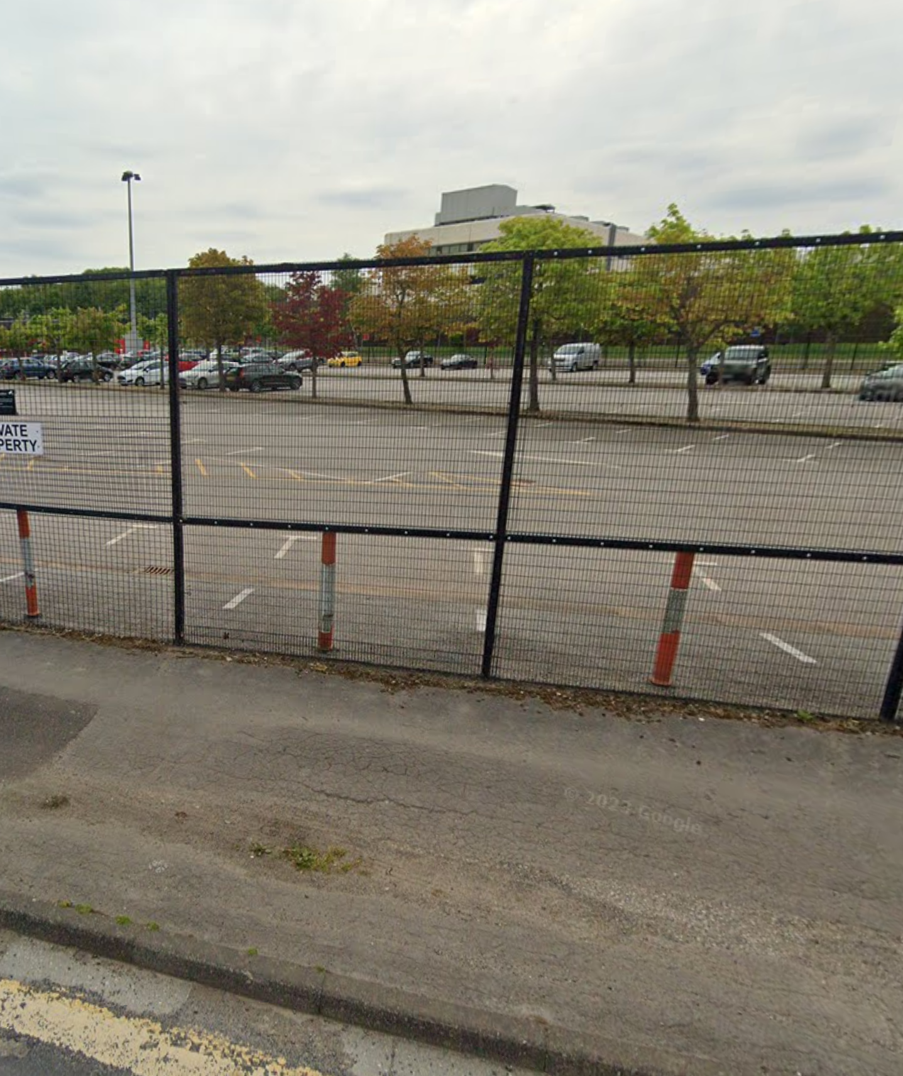
The applicants agents, AXIS Architecture, are seeking advice on the necessary planning consents to Barnsley Metropolitain Borough Council for the updating of the elements of the cooling systems described in this summary.

Figure 3 | Arial view of existing plant to be removed (Red outline) .
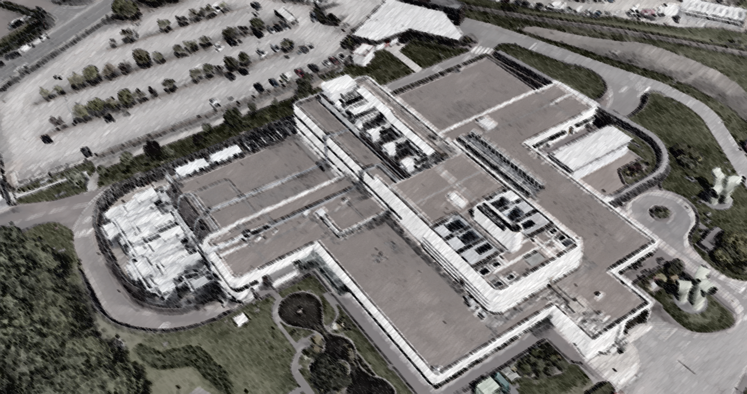
c

The proposed works are staged to maintain the operational function of the centre.
In the first instance, new chilled water pipework will be installed across the roof from an existing rooftop louvre cowl on top of an existing riser through to the existing rooftop plant room with temporary roof edge protection to safely allow the pipework to be installed and the subsequent phased alterations as the plant is decommissioned and removed.
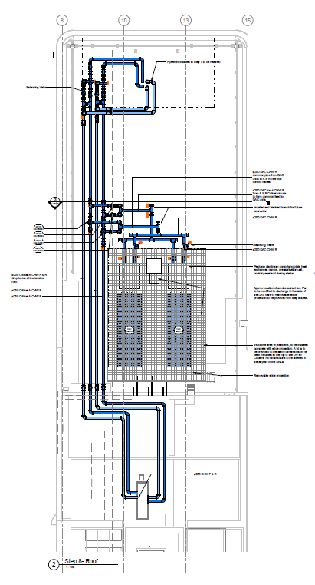
Figure 4 | Plan of final arrangement of replacement Direct air-cooled and water chiller pipework

Figure 5 | Site Boundary Plan

3.03 Scale;
The scale of the building will be unchanged by this application.

3.04 Layout;
The layout of the site will be unchanged by this application.

3.05 Landscape;
The landscape of the site will be unchanged by this application.

3.06 Appearance;
The appearance will not be negatively affected by this application as stated previously, the replacement rooftop equipment is similar to the existing form without the Plantroom and with a reduced footprint.

