Method Statement Bar Ln & Carlton 001 Rev01

Contract Name: | Barnsley MBC - A61 & A635 Footways - Cycleways |  |  | Contract Number: |  |  | 3609
Method Statement for:
Bar Lane & Carlton - Site Establishment

Document compiled by Name: |  | Tim Brain |  | Revision Date (1) |  | 30/11/22
Date: |  | 14/11/22 |  | Revision Date (2)
Check list prior to works commencing, tick relevant box if section applies to this task

Safety Documentation |  |  | Form Number |  | Tick (√)
Daily Risk Assessment |  |  | OH&SF 053
Hand arm vibration record |  |  | OH&SF 038
Permit to excavate |  |  | OH & SF 026
Site safety and environmental report |  |  | ECEF005
Weekly Plant Inspection |  |  | OH & SF 003
Scaffold / Tower scaffold inspection form |  |  | OH&SF 055 and OH&SF 056
Personnel training certificates
Service drawings

Ground Investigation Reports

Other safety documents referred to within method statement e.g. traffic management plans

Footpath closures

Site Address | 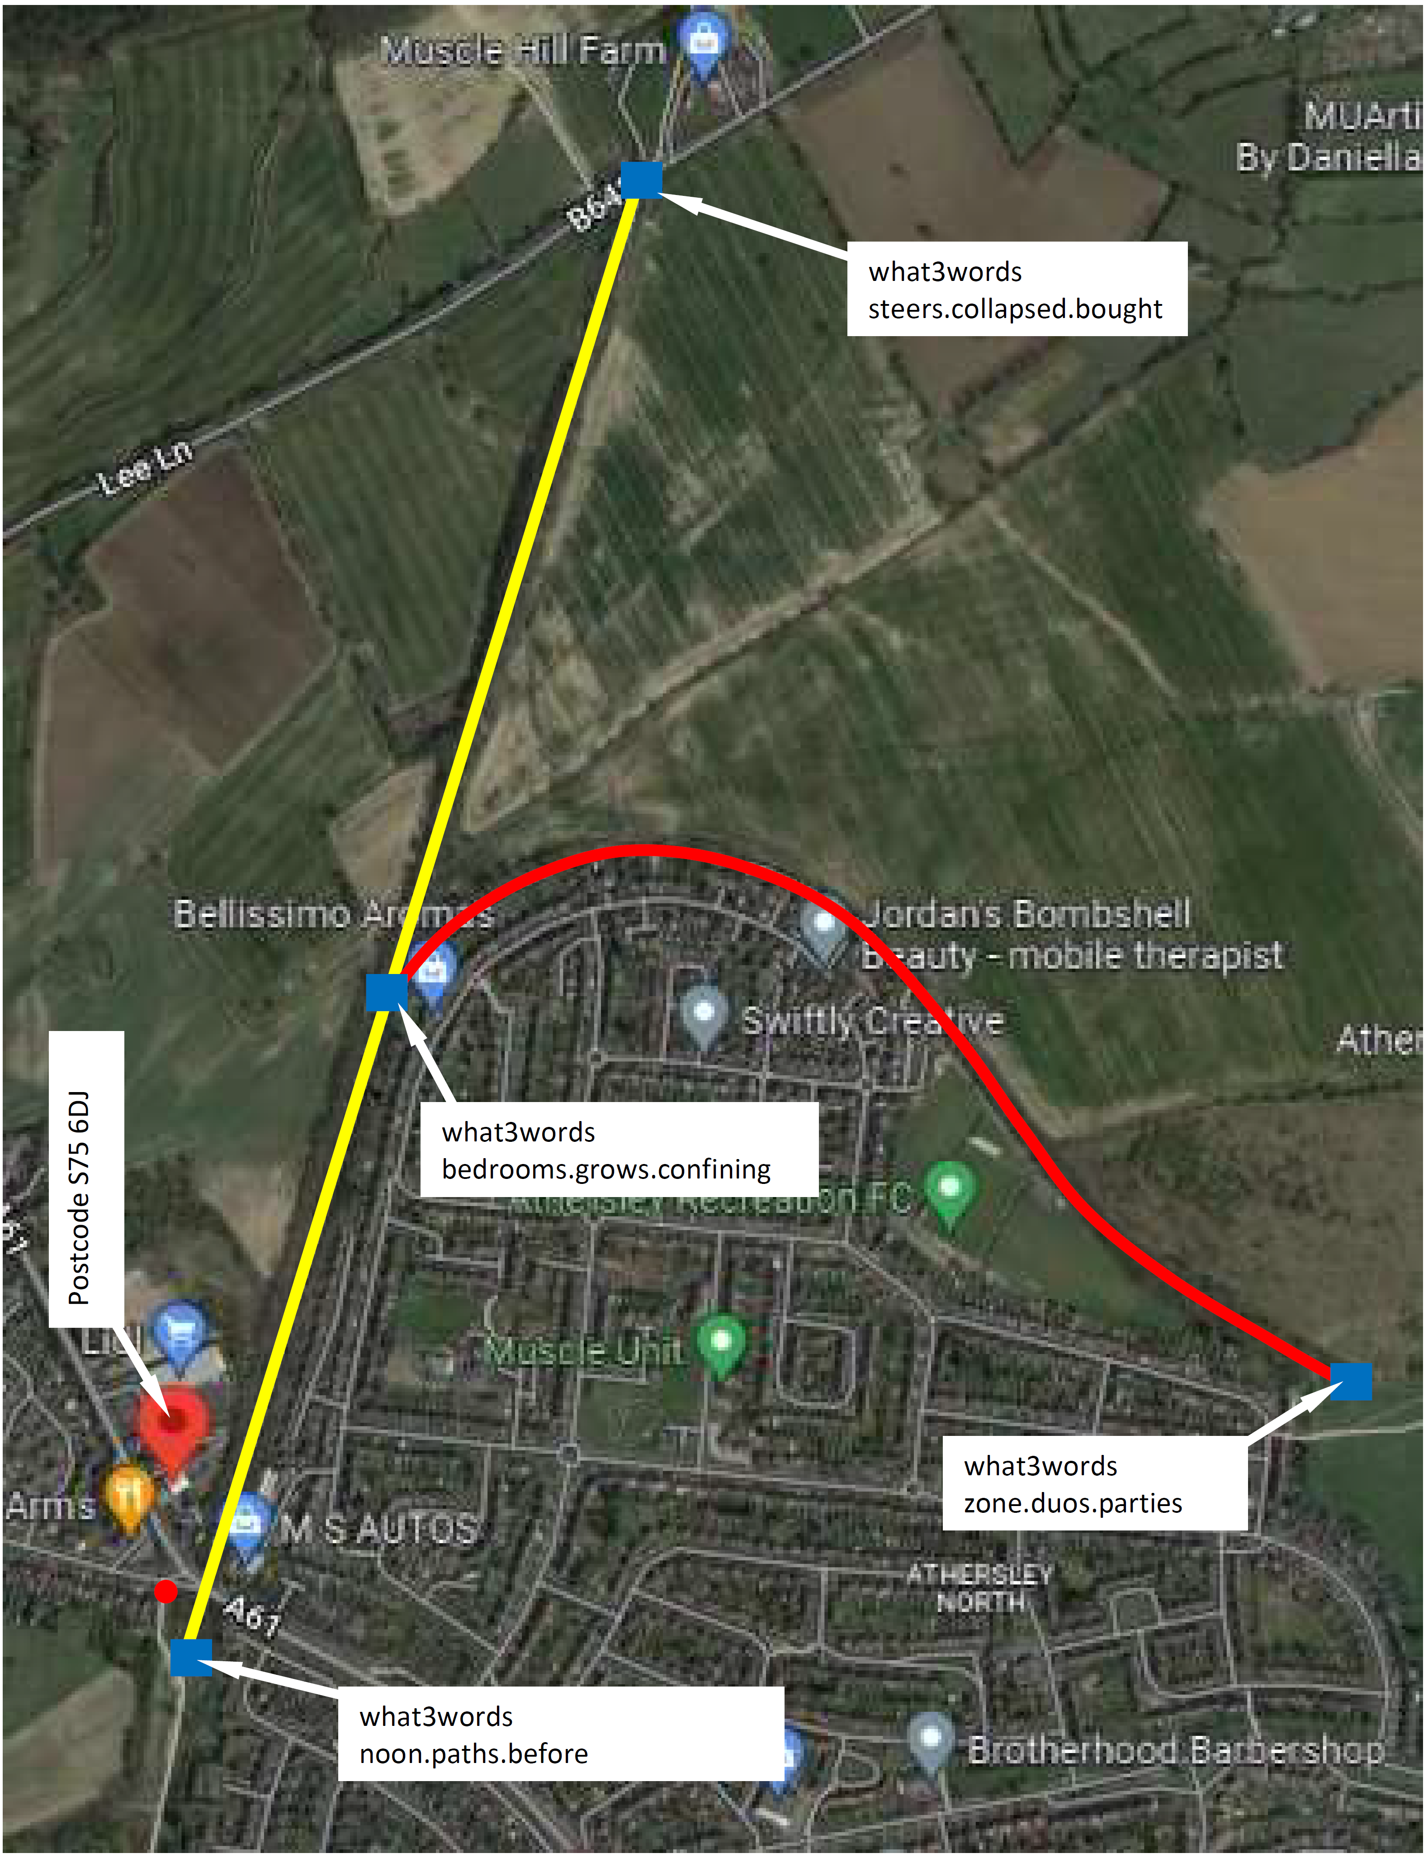  Bar Lane  S71 6DJ  The trail is along a section of the Barnsley Coal Railway which became disused in 1961. The disused trackbed fell under the ownership of Barnsley MBC and has become an unmaintained walk and track. There are signs of fly tipping which have to be cleared as part of the works. In the cuttings the trackbed is waterlogged and overgrown with trees.  At the southern end, CH0 there is an open grassed area where the site compound is proposed to be. This area is accessed off Bar Lane and along an existing cycle track. CH 80-90 existing brick arched A61 bridge. CH90 – CH700 East side is a residential estate and commercial estate to the west. At CH700 the Carlton works curves off the east. CH700 - CH1600 farm land on both sides.
What3words address | Noon.paths.before
Description of Works | In depth description of works to be carried out under this method statement:  Establish the offices, compound and traffic management for the construction of a 3km 3m wide unbound cycleway/footpath and associated drainage.
Expected duration of works: | Commencement date and expected completion – total number of days / weeks  Footpath/cycleway construction to start 09/01/23 to be completed 23/05/23.
Supervision | Name the supervisor who is responsible for day to day control of the operation and if necessary, who will supervise different parts of the job. Include sub-contractor supervisors where necessary.
Supervision | Name: Tim Brain | Site Agent | Name:
Supervision | Name: Julien Musimwa | Site Engineer | Name:
Supervision | Name: |  | Name:
Workforce details | Identify the specific labour required to carry out the job in a safe and healthy manner, any special training or skills required, details of competence cards held  Operatives CSCS and operators CPCS trained  Site Establishment – ESH self delivery  Vegetation clearance – Subcontractor, specifically trained in the use of chainsaws and chippers  Earthworks – Subcontractor  Drainage – Subcontractor  Footpath construction – Subcontractor  Traffic Management - Subcontractor
Plant / Equipment required to carry out the activity | Description of Plant (include insulated hand tools if required) |  |  | Certificates required on site before use: i.e. certificate of thorough examination / PAT test.
Plant / Equipment required to carry out the activity |  |  |  | Yes | No
Plant / Equipment required to carry out the activity | Wagon mounted cranes for the cabin delivery |  |  | Yes
Plant / Equipment required to carry out the activity | 360 excavators |  |  | Yes
Plant / Equipment required to carry out the activity | 6t swivel dumpers |  |  | Yes
Plant / Equipment required to carry out the activity | Chainsaw and chipper |  |  |  | PUWER
Risk Assessments | Detail specific risk assessments relating to the work: e.g. RA07 Underground Services
Reducing Risk | State what control measures highlighted by the risk assessments will be introduced to reduce likelihood of hazards occurring e.g. suitable fall prevention measures etc. How will members of the public including occupiers of any building be protected and isolated from the works.  RA05 Overhead services. GS6, Goal Post c/w any height restriction if required.  RA07 Service. Trial holes, Stats drgs, Permits to dig.  RA17 Lifting Qualified operatives, lifting plan, LOLER checks  RA22 Use of excavators CPCS qual. Operator, PUWER checks  RA28 Use of dumpers CPCS qual operator , PUWER checks  RA32 Chainsaws Undergone training, appropriate PPE  RA34 Use of Stihl saws Undergone training, appropriate PPE  RA35 Use of hand tools Undergone training, appropriate PPE  RA62 Heras fences Undergone training, appropriate PPE  RA104 Manual handling Undergone training, appropriate PPE  RA145 Bucket changing Undergone training, appropriate PPE  OHSF 025 Fuel Storage Risk Assessment.  TBT 011 Environmental awareness  TBT Ecology Calendar.  TBT 043 Waste disposal  TBT 069 Ecological awareness  TBT Getting your site right – pollution prevention  TBT 055 Site waste management plan  TBT 083 Tree Protection  TBT 088 Asbestos awareness  TBT Waste handling  TBT 090 Bats  TBT 126 Working around trees.  TBT 127 Badgers.  TBT 127 Be a good neighbour  TBT 128 Dust and air quality  TBT 129 Noise and vibration.  TBT 141 Waste Hierarchy.  TBT 143 Segregation of waste.  Subcontractors to submit their owner RAMS for ESH comment.
Outline steps required to identify Service location, | With ref to Stats drawings, CAT scanning and trial holes all services located will be referenced and drawn up on a project lay out drawing to be displayed in the office and referenced to when producing permits to dig.
Disconnection /  Reconnection of services | Identify which services must be isolated /reconnected, who will carry out the work, methods of locating buried services, who will certify that the services have been isolated / reconnected.  N/A
Isolation of the working area | N/A
Communication of hazards to others who may be affected i.e. other trades. | Supervisors to produce a 3 weekly target programme on a weekly basis to identify hazard awareness, clashes of trades and material ordering.
Security of site:  Detail method of fencing working area, out of hours security incl plant and machinery, fuel | The office compound, material compound, excavations, any unofficial accesses and trees/ecological findings that the Environmental Clerk of Works needs protecting.  Monitored CCTV will be installed in the Site Offices and material compound.

Work Method | Site Compound Layout  Bar Lane  The works is accessed off Bar Lane at the junction with the A61 through a barrier gate and along an existing tarmacked cycleway which continues towards the city centre. The A61 is a busy road and there is often traffic congestion at the junction.  Bar Ln Compound TM  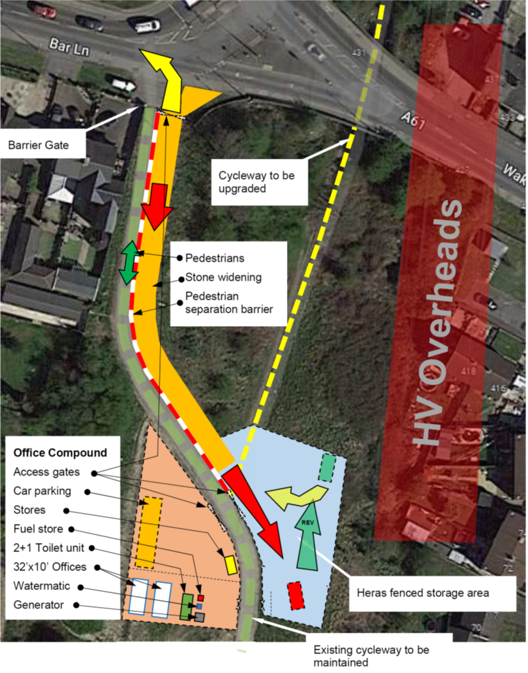  Lee Ln hardstanding TM  Entry onto site off Lee Lane will be done under traffic signal control

Environmental issues | Detail how specific issues will be controlled on this site  Ref to other environmental issues
Asbestos | If asbestos is found it will be tested and disposed of by an asbestos specialist.
Dust | We don’t envisage there being an issue with dust, if dust arises it will be suppressed with water.
Mud on Roads | Tipping areas will be on to stoned area which will be kept clean. A traffic marshall will be in attendance to manage the traffic in pedestrian areas and will maintain the cleanliness of the pedestrian way and roads. A call out order for a road brush will be put in place and called upon when needed.
Fuel /oil spillage | A fuel storage risk assessment has been carried out. The fuel store will be sited on an impermeable base, at the end of the contract will be disposed of as hazardous waste. The fuel storage tank will be 110% bunded and protected from damage from plant movements as much as possible.
Waste Disposal | All waste will be kept to a minimum. Waste will be disposed of by a licensed waste carrier and to a licensed tip as described in the Site Waste Management Plan.
Other environmental issues | Archeological remains, trees, invasive weeds etc.  BMBC are to provide a complete list of or mark trees to be felled or protected. Works cannot commence until BMBC have approved environmental construction method statements.  Environmental sub-contractors to submit to ESH for approval prior to starting on site. They are to include the following preclearance protection measures as laid down by the Brooks Construction Environmental Management Plan and AWA Arboricultural Method Statement as follows:  Site Clearance  - All the trees as identified by the Ecological Clerk of Works (ECoW) are to have a protection zone demarcated with temporary mesh fence supported with steel fence pins. The mesh will be further supported with draw cord.  - The works is programmed to start Jan 2023, which will fall outside the bird nesting period.  - If at any time during the works it is noticed that there is a protected species, nesting bird, roosting bat or badger, that hasn’t been identified the works and adjacent works stops and the ECoW advised. Works will not restart until the ECoW has dealt with it.  - Hedgehogs are also to be treated as protected during this works. Ground surveys to identify any hedgehogs will be carried out in advance of clearance using brush cutters which are to be worked from the track outward towards the boundary.  - Trees are to be felled in as smaller limbs as practicable (soft felling) to prevent disturbance or damage to the surrounding areas.  - Vegetation will be chipped down and broadcast as required by the ECoW.  - Some logs will be retained to form log piles in accordance with contract.  Earthworks  - All works to be undertaken with awareness of the natural habitat and to stop if anything is identified and wait to be advised by the Site Agent before continuing.  - The track will be scraped off of leave mould and mud and disposed of in accordance with the SWMP.  - Imported material will be brought on to site long the existing cycleway directed by a site vehicle marshall and tipped at CH0 then taken up the site using a dumper.  - Material to be disposed of will be brought to a separate stockpile at CHO by dumper then loaded and taken off site along the cycleway directed by a site vehicle marshall.  - Surface water will be pumped into a silt separation tank before discharging into the existing drains.

Hazardous substances | COSHH assessments will be produced using manufacturers data sheets to ensure safe storage, handling and disposal of materials brought onto site.  Drug waste is likely to be present as there is evidence of fly tipping and camps. Appropriate PPE and mechanical equipment to used when clearing the flying tip debris.
Vibration / Noise monitoring | Identify which activities will require health surveillance for the operatives carrying them out e.g. vibration exposure  It isn’t envisaged that there will be any vibration works that could affect the adjacent properties being carried out.  The working hours are 08:00 – 18:00 Monday to Friday & 09:00 – 14:00 Saturday. No Sunday or Bank Holiday working.  The compound generator timer will be set to 07:00 to 17:00 Mon – Thurs, 07:00 to 16:00 Friday & 12:00 – 13:00 Saturday(to charge CCTV)
PPE | Identify which items of PPE /RPE will be used for which training will be required e.g. harness, face fit testing  The minimum standard PPE will worn at all times:  - Safety helmets.  - Safety boots.  - Hi-viz vests.  Further PPE will be described in the specific RAMS.
Emergency | Detail how working area can be accessed by rescue team if required. Consider use of harnesses etc  Contact details for out of hours emergencies  Access points for emergency services are to be kept clear at all times.

Site Critical Issues | State key issues that relate to site so Operatives signing in next section are aware of main issues e.g. lifting operations, public protection etc
Site Critical Issues | Hazard | Control Measures
Site Critical Issues | Lifting | Lifting plan  Trained operatives
Site Critical Issues | Existing services | Refer to existing Stats information  CAT scan, trial holes.  GS6 permit.
Site Critical Issues | Cuts, needle/stick injuries | Gloves and retractable knives. Mechanical or equipment means of picking up
Site Critical Issues | Manual handling | 2 per lift
Site Critical Issues | Disruption/loss of natural habitat | Carry out protection and clearance as instructed by the ECoW’s
Toolbox Talk | All operatives to fully understand proposed method of works. Toolbox talk to be held prior to works commencing Include excavator driver. Include all personnel who will be on task – ensure relevant training has been carried out.  See key issues in section above.
Toolbox Talk
  Name | Signature | Date | Time
  State any review date on first page and add amendments / comments to relevant sections or detail below
  Sketch

