3500 OCH

WENTWORTH CASTLE, STAINBOROUGH, BARNSLEY:
PROPOSED REPAIR OF OLD COACH HOUSE:
CHANGES TO EXTERNAL APPEARANCE

DESIGN AND HERITAGE STATEMENT Revised 20: 08: 2015

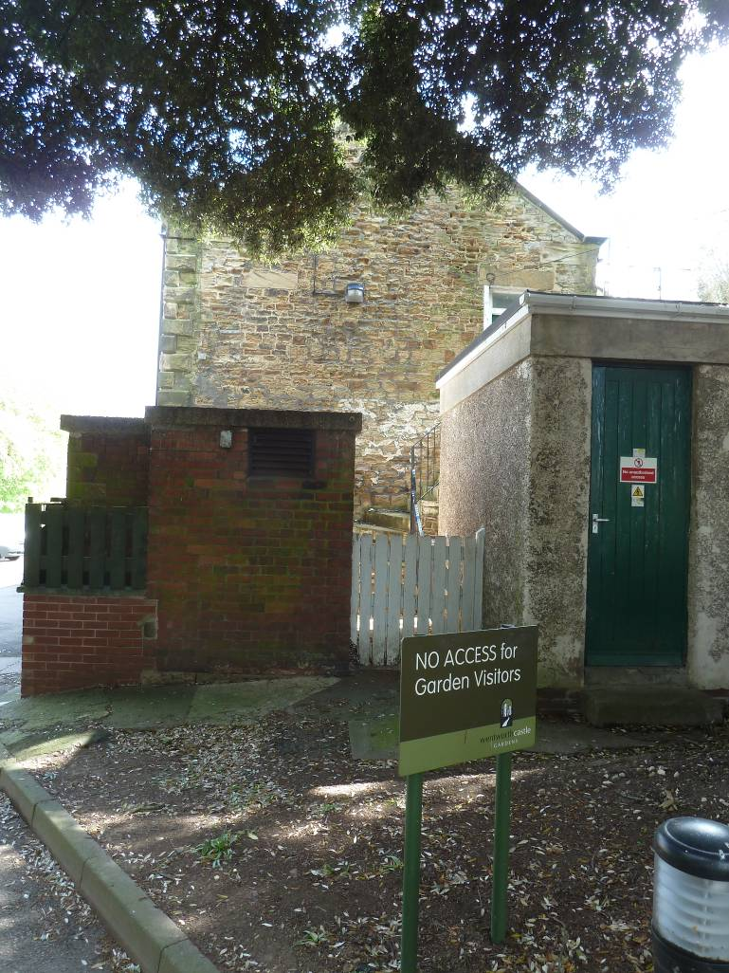

ARCHITECTS
www.birkettcolelowe.com
BCL

- Context

  - The Old Coach house is an ancillary building situated to the north of the main house at Wentworth castle. It would appear to have been built in the nineteenth century. It is a two storey building. The ground floor consists of a range of coach houses with arcaded doors with first floor accommodation, probably originally servants’ quarters. The south end of the building takes the form of a cottage and is attached to an earlier cottage that forms part of the Gun Room building. At the west side another later two storey building has been attached with a duo-pitch roof. There is a central valley gutter. This other building is, presently, occupied by the Wentworth Castle Trust and does not form part of this application. The building has coursed sandstone rubble walls and a simple duo-pitch roof covered in slate with parapet gables. Quoins, lintols, cills, and the arches are of ashlar stone. The building has been altered, presumably with the advent of motor cars in the early twentieth century. Four of the six coach house bays have been extended to the east. This single storey extension has a flat roof covered in asphalt. There are various other functional single storey extensions at the north end of brick, stone and render with flat concrete roofs. The fenestration has been much altered and the present windows are 1960s softwood casements of ordinary quality.

  - The building is not of exceptional architectural quality but is of traditional form and has a certain charm and value as part of the group of ancillary and agricultural buildings associated with the Main House, which is listed Grade 1.

- Disrepair

  - In common with other ancillary buildings on the site, and, indeed, less conspicuous parts of the main house, the stone is of less than first class quality. It contains substantial iron nodules has marked bedding planes and is prone to splitting and shaling. The iron has a tendency to corrode leading to further deterioration of the stonework. Over the years repairs have been made to the eroded stone with crude mortar repairs and unsympathetic hard cementitious pointing which have also hastened the decay of the masonry

  - The rainwater goods and external joinery are in poor repair.

- Proposed Repairs and Changes to the External Appearance

  - Northern College presently use parts of the ground floor as general storage and as a caretakers’ workshop. Parts of the first floor are used as a caretaker’s flat. Other parts are disused.

  - As part of the strategy to vacate the Wollstonecraft Block: a well designed but inappropriate 1960’s block in very close proximity to the listed building which is in a poor state of repair and which mars the setting of the grad e 1listed building, refurbishment and internal alteration of the garages is proposed to form stores and a laundry area.

  - External repairs will be carried out at the same time some of which will alter the external appearance of the building.

  - Repairs proposed include

- Repair and redecoration of the windows and doors
- Replacement of perished ashlar voussoirs to the northernmost arch, and a failed lintol.
- Overhaul and repair of the rainwater goods
- Repair and / or replacement of the existing steel fire escape stair.
- Removal of hard cement pointing to the south and east elevations, selective plastic repairs to badly weathered stones and complete repointing in sympathetic hydraulic lime mortar.

These repairs will not have a significant effect on the external appearance. Items which will alter the appearance are:

- Replacement of the sliding door to the northernmost garage with side-hung doors to match the remainder and removal of the unsightly externally mounted sliding door track

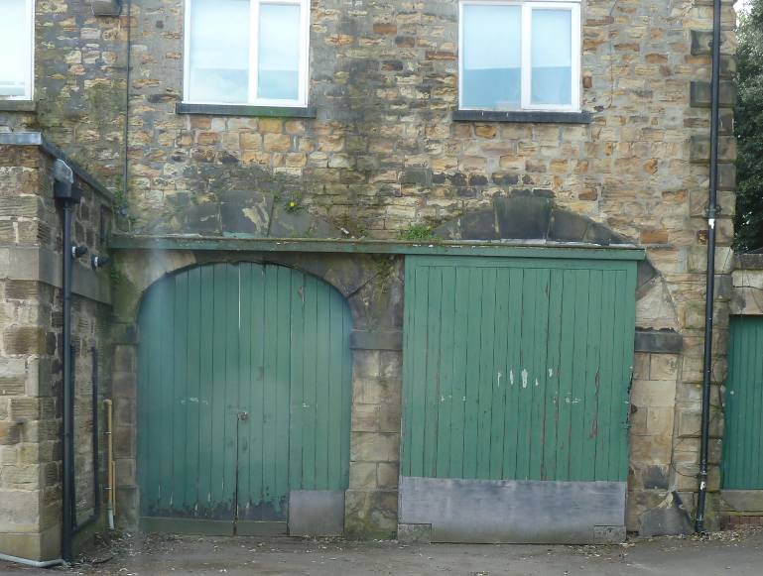

- Over-cladding the north gable with ‘Warmshell’ lime render on wood fibre thermal insulation. This is necessary because the masonry in this part of the building is so severely eroded as to be beyond economic repair. The perished stone is a cause of both damp penetration and, more significantly, cold surface internal surfaces leading to severe condensation in cold weather. This is leading to poor living conditions within the caretaker’s flat that are becoming unacceptable to the College as a responsible employer.
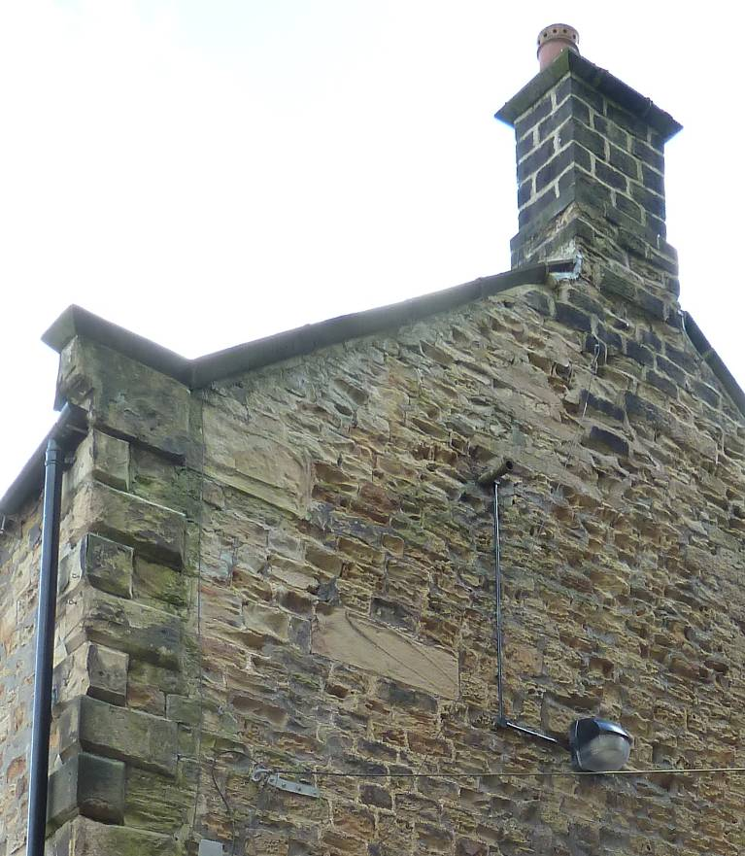

  - Over- cladding

The over-cladding of the north gable is the most significant change. To avoid the necessity to make extensive alterations to the gable parapet coping and the quoins and to leave these features which contribute to the character of the building exposed, the projecting cladding will be ‘held back’ from the perimeter and there will be a margin of plain render around it. The ‘Warmshell’ render is a revised proposal following consultation with Historic England, and is agreed both to be more sympathetic to the existing structure and less conspicuous than the previous proposal for timber over-cladding.

The system consists of a modified hydraulic lime render applied in two coats over wood fibre thermal insulation boards. The render is tinted with natural ochre pigments and is self-coloured. It is reinforced with nylon mesh. The thermal insulation will be 60mm thick This will give a worthwhile improvement to the thermal performance of the wall U= approx 0.56W/m2K. Although this is considerably in excess of the building regulations maximum of 0.3W/m2K, this thickness has been selected since it will minimise the overall thickness of the proposed construction keeping it similar to the projection of the existing ashlar quoins at the northeast corner of the building.

The proposed over-cladding will alter the appearance of the building which will, inevitably, have an effect on the setting of the grade 1 listed main house, but it is considered that, due to the fundamentally traditional appearance of the cladding now proposed, the distance from the listed building, and the fact that the gable of the coach house is screened from distant view by a large mature evergreen oak,this will be minor, and less than significant.

The minor harm to the listed building can be weighed against the public benefit of the proposal, securing its optimum viable use as caretaker’s living accommodation.

Overall, the project is part of a scheme of work to vacate the Wollstonecraft building to enable its demolition in the medium term. The demolition of the Wollstonecraft block will both enhance the setting and better reveal the significance of the main house.

Birkett Cole Lowe
ARCHITECTS

20 : 08 : 2015

