Preliminary Ecological Appraisal (PEA) Report.

207 – 209 Manchester Road, Thurlstone, S36 9QS.
21st December 2022.

Dan Wildsmith BSc MSc MCIEEM

8, Hartcliff Ave, Penistone, Sheffield, S36 6BQ
Tel: 07500 751019 - E-Mail: wildsmithjd@yahoo.com

Report Summary

- Stuart and Anita Kimberley commissioned Dan Wildsmith to undertake a Preliminary Ecological Appraisal at 207 – 209 Manchester Road, Thurlstone, S36 9QS. The purpose of this report is to present the findings of the appraisal and identify potential ecological constraints to the proposed construction of a 2 story house at the top of their land with access to High Bank Lane.

- An assessment of the site was carried out by Dan Wildsmith on the 9th December 2022. This included a ground-based inspection of the building plot defined as within the red line boundary of the architectural plans and an appraisal of the surrounding habitats.

- The plot is approximately 0.0875ha in size and is surrounded by extents of dry stone walling, bare rock face, trees and non-native hedge. In the immediate vicinity gardens, modified grassland, woodland and neutral grasslands were present.

- The residential building situated on Manchester Road, and associated garage, sheds and green houses are deemed to be at a sufficient distance not to be subject to disturbance for potential bat roosts. Access to the plot will be from High Bank adjacent to the plot and not via Manchester Road.

- The residential property on Manchester Road is not subject to any works.

This document has been prepared on behalf of, and for the exclusive use of Dan Wildsmith’s’ client, and is subject to, and issued in accordance with, the provisions of the contract between Dan Wildsmith and the client. Dan Wildsmith accepts no liability or responsibility whatsoever for, or in respect of, any use of, or reliance upon, this document by any third party.

CONTENTS PAGE
1 INTRODUCTION 4
1.1 Purpose of the Report 4
1.2 Background 4
1.3 Policy and Legislation 6
2 Methodology 7
2.1 Desk Study 7
2.2 Field Survey 7
2.3 Other protected and/or notable species 8
2.4 Limitations 8
3 RESULTS/OBSERVATIONS 9
3.1 Desk Study 9
3.2 Site Habitats and Site Context 10
3.3 Inspection for Bats and Other Species Recorded 11
4 ECOLOGICAL CONSTRAINTS AND OPPORTUNITIES 12
4.1 Bats 12
4.2 Other protected and/or notable species 13
4.3 Enhancement Opportunities 13
APPENDIX 1 –Wildlife Legislation and National Planning Policy 14
Appendix 2. 16
Appendix 3 17

INTRODUCTION

Purpose of the Report
Dan Wildsmith has been commissioned to undertake a Preliminary Ecological Appraisal (PEA) at a plot of land in the garden of 207 – 209 Manchester Road, Thurlstone, S36 9QS by Stuart and Anita Kimberly. This report presents the findings of a walkover survey, undertaken by Dan Wildsmith BSc (Hons) MSc MCIEEM and holder of Natural England Level 2 (Class Licence) for bats (2019-42895-CLS-CLS) on 9th December October 2022. It provides details on the potential for any protected species and/or habitats to be present at the site and provides an assessment of the potential ecological constraints to the proposed redevelopment of the site. Recommendations for further surveys that are likely to be required to inform a planning application are provided, if necessary. Where appropriate, measures to avoid, mitigate and/or compensate for impacts are outlined.

Background
The proposed works is located to the rear of 207 – 209 Manchester Road, Thurlstone, Sheffield, S36 9QS. The grid reference for the site is SE 22776 03448, What3Words slime.showcases.fanfare.

The survey area is based on the site plan provided by Mr Stuart and Mrs Anita Kimberly, which shows the boundary to the development site and is reproduced in Figure 1.

The proposed works comprises of the construction of a two storey residential property with access afforded from High Bank Lane.

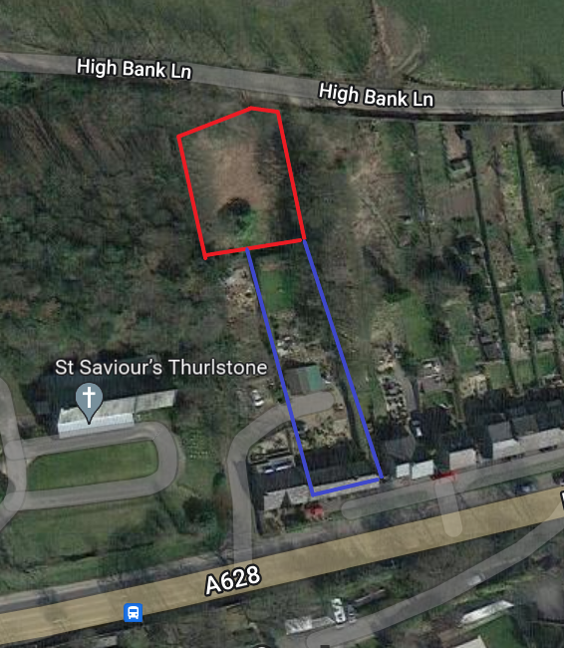
Figure 1. The construction boundary is shown with an approximate red line. The blue denotes the garden and residential building at 207 – 209 Manchester Road not subject to development. Images produced courtesy of Google maps (Map data ©2019 Google).

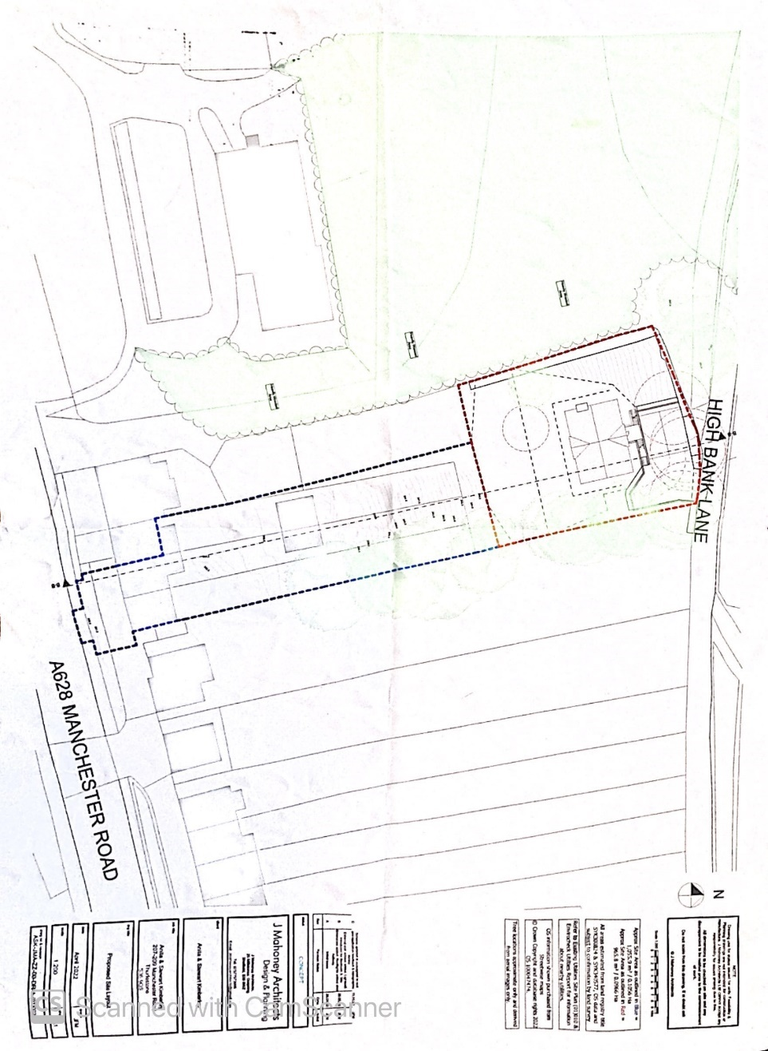

Figure 2. Architects drawing showing location of proposed residential building.

Policy and Legislation
Legal protection applying to all bat species in the UK is outlined in Appendix 1 of this report.

The results of this survey will be used to determine the need for further surveys, impact avoidance measures and/or an appropriate mitigation strategy to ensure compliance with UK and EU wildlife legislation.

Methodology
The methodology used for the PEA are in accordance with the survey guidelines produced by Chartered Institute of Ecology and Environmental Management.

Desk Study
A search of on-line mapping resources was undertaken to characterise the local context of the site with respect to semi-natural habitats and linear features of value to foraging and commuting bats.

A search of priority habitats and ancient woodland classified as habitats of principal importance was undertaken using the MAGIC website resource (www.magic.gov.uk) up to 1km of the proposed building. These are detailed within the report where these are present, adjacent or in close proximity to the site.

Habitats of principal importance and ancient woodland are also afforded protection through the National Planning Policy Framework (NPPF) 2018, Paragraph 174b, which states that council policies should “promote the conservation, restoration and enhancement of priority habitats, ecological networks and the protection and recovery of priority species; and identify and pursue opportunities for securing measurable net gains for biodiversity.” The Office of the Deputy Prime Minister (ODPM) Circular 06/05 also states that the potential effects of a development on nearby habitats or species listed as priorities in the UK Biodiversity Action Plan (BAP) (now Habitats and Species of Principal Importance) can be a material consideration in planning decisions.

The MAGIC website resource was used to identify the location of designated sites for nature conservation and European Protected Species licences granted within a 1km radius of the survey site.

Field Survey
The area within the red line boundary of the proposed building was inspected in detail noting any vascular plants present and any signs of animal species there in. This included the inspection of trees on site for bats.

Bats can use a wide range of features including loft spaces, cavity walls, loose tiles, mortice joints and cracks/gaps in a variety of built structures. They can also be found in trees with knot holes, splits, cracks, cavities and loose bark.

The detailed inspection involved looking for potential access points and potential roosting features (PRFs) that bats could use and any evidence indicating the presence of bats using trees, such as rub marks, staining or droppings. A high-powered torch, binoculars and endoscope was used to investigate external features from the ground.

The potential for roosting bats for each feature, or group of features was assessed as either negligible, low, moderate, or high, in accordance with best practice guidelines. Any evidence confirming the presence of bats would be recorded including photos and dropping samples taken where appropriate.

The habitats surrounding the site and wider landscape were broadly assessed for their potential to support foraging and commuting bats.

Other protected and/or notable species
Any evidence of nesting birds discovered during the site visit were recorded. Special attention was paid to notable species such as red-listed Birds of Conservation Concern (Eaton et al. 2015) and those species afforded special protection on Schedule 1 of the Wildlife and Countryside Act (1981).

Whilst this survey focussed on habitats no specific searches were made with respect to other protected species, any evidence of other protected species that was encountered during the site visit was also recorded. This included badgers, great crested newts and reptiles.

Limitations
The timing of the survey is considered to be sub-optimal. Plants have died back and can prove more difficult to identify. However, identification was possible and considered not to impact on the data provided in this report.

RESULTS/OBSERVATIONS

Desk Study
Table 1 summarises the results of the desk study for designated sites in proximity to the proposed site using the Magic website.

Table 1. Summary of designated sites from the desk study.
Site and Designation | Distance | Direction
Spring meadows, Alderman’s head & Cow Croft meadows SSSI | 2.06km | South
Pye Flatts SSSI | 4km | Northeast
South Pennines Moors SAC | 4km | Southwest
Peak District Moor SPA | 4km | Southwest

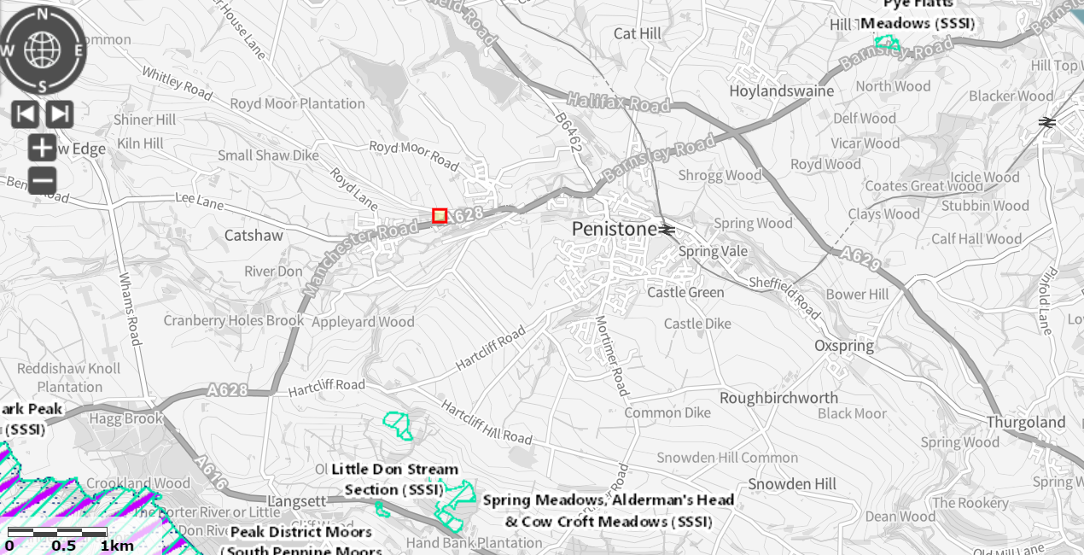
Figure 4. Map indicating the location of designated sites in proximity to the proposed works. Images produced courtesy of Magic maps (http://www.magic.gov.uk/, contains public sector information licensed under the Open Government Licence v3.0).

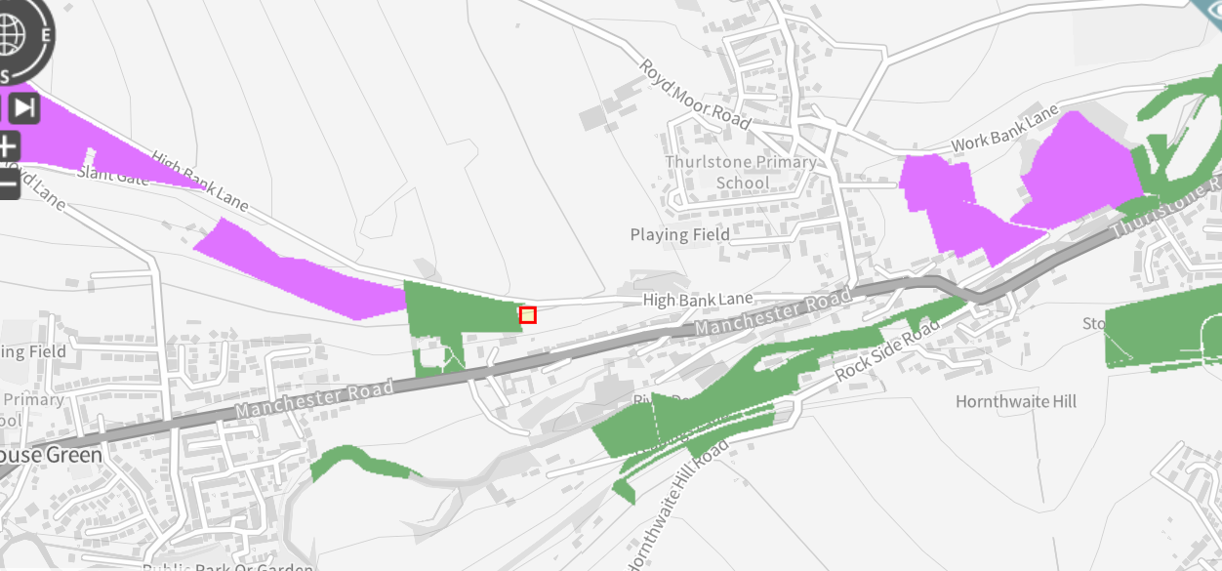
Figure 5. Map indicating the location of habitats adjacent to the Proposed Works. Purple – Good Quality Semi Improved Grassland. Green – Priority Habitat Deciduous Woodland. Images produced courtesy of Magic maps (http://www.magic.gov.uk/, contains public sector information licensed under the Open Government Licence v3.0).

The following table (Table 2) summarises the proximity of habitats to the proposed works to the Proposed Works.

Table 2. Proximity of notable habitats to the proposed site.
Habitat | Distance | Direction
Good Quality Semi Improved Grassland | 20m | West
Priority Habitat Deciduous Woodland | 225m | West

Given the low risk posed on adjacent habitats and the distance to priority habitats and designated areas the works are deemed to have negligible impacts.
There is one European protected Species Licence (EPS) license granted concerning bats within 1km of the site shown on the Magic Maps website. There are no other EPS license for other protected species within 1km of the site.

Site Habitats and Site Context
The site of the proposed works is set in a semi - rural location to the west of the town of Penistone and is situated approximately at an altitude of 254m above sea level. The site is located at the top of strip of land belonging to 207 – 209 Manchester Road which includes areas of garden, hard standing and a residential property.

The surrounding residential properties, grasslands, woodlands and occasional hedge is deemed to be a high value foraging, commuting and roosting habitat for bats, for breeding birds and other mammal species. The mosaic of habitats provides insect prey, of various sizes, for a variety of species of bats encountered in South Yorkshire. Ten species of bat have been recorded in South Yorkshire, including Brandt’s bat (Myotis brandtii), Daubenton’s bat (Myotis daubentonii)¸ whiskered bat (Myotis mystacinus), Natterer’s bat (Myotis nattererii), Leisler’s bat (Nyctalus leisleri), noctule (Nyctalus noctula), Nathusius’ pipistrelle (Pipistrellus nathusii), common pipistrelle (Pipistrellus pipistrellus), soprano pipistrelle (Pipistrellus pygmaeus) and brown long-eared bat (Plecotus auratus) (Harris and Yalden, 2008).

The site supports a two-story stone built residential property greater than 100 years old, a recently constructed garage with wooden open carport, small wooden sheds and greenhouses.

The garden is divided into two compartments. The compartment adjacent to the residential property, which is not directly impacted by the works and a compartment south of High Bank Lane which is the site of the proposed works. The compartment adjacent to the residential property is comprised of hard standing patio areas, gravel pathways with steps and associated ornamental planting. A small rectangular area of mown modified grassland is observed at the top of this compartment bordering the site of the proposed works. Non -native hedges of laurel (Prunus spp.) are recorded on the boundaries of the mown modified grassland.
The compartment of the proposed site had been recently cleared and constituted abundant bracken (Pteridium aquilinum), frequent bramble (Rubus fruticosus), frequent nettle (Urtica dioica), occasional common hogweed (Heracleum sphondylium), frequent creeping buttercup (Ranunculus repens), occasional false oat grass (Arrhenatherum elatius), frequent creeping bent (Agrostis stolonifera), frequent cleaver (Galium aperine), occasional narrow leaf buckler fern (Dryopteris carthusiana) occasional foxglove (Digitalis purpurea), occasional daffodil (Narcissus var.) and occasional ivy (Hedera helix). The habitat has been categorised as other scrub h3h using UK Habitat Classification.
Woody species were mainly confined to the periphery of the site of the proposed works and included frequent sycamore (Acer pseudoplatanus), occasional holly (Ilex aquifolium), occasional hawthorn (Crataegus monogyna), rare apple (Malus spp.), rare silver birch (Betula pendula) and rare elder (Sambucus nigra). One specimen of laurel was noted within the proposed site.
Dry stone walling and small areas of bare rock outcrop are also observed surrounding the site of the proposed works which harboured mosses, false oat grass and narrow leaf buckler fern.
See Appendix 3 for habitat map.

Inspection for Bats and Other Species Recorded
The residential property and garage are at distance not to be impacted by the proposed works. The access for the development is off High Bank Lane immediately adjacent to the site. Therefore, no inspection was carried on these structures as they deemed at a minimal risk of disturbance.
The wooden sheds offered a low potential for bats and are also not directly impacted by the development. One snagged branch with an associated tear out on a sycamore on the eastern periphery of the proposed site had a low potential bats. See Figure 6. The other trees are of negligible potential for roosting bats. The dry stone walls and bare rock also afforded low roosting potential for bats (see images in Appendix 2).
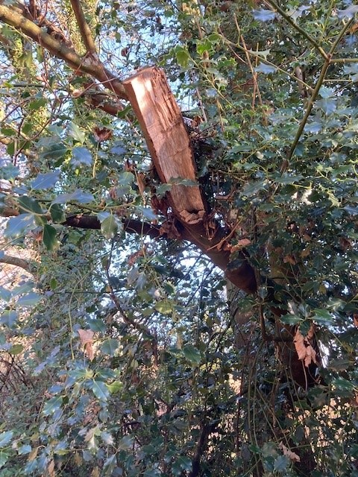
Figure 6. Snagged branch and small void with low potential for bats

No evidence of other mammals including were evident on the site of the proposed works. Birds observed during the site survey included robin (Erithacus rubecula), blue tit (Parus caeruleus), great tit (Parus major), wren (Troglodytes troglodytes), house sparrow (Passer domesticus), chaffinch (Fringilla coelebs), gold finch (Carduelis carduelis) and long tailed tit (Aegithalos caudatus).

ECOLOGICAL CONSTRAINTS AND OPPORTUNITIES

Bats
Using best practice guidelines outlined by the Bat Conservation Trust the potential for the external areas of the dry stone wall and the feature in the sycamore tree to support bats is rated as Low. A low potential for bats requires 1 visit for survey in the period April to September. Given the features are accessible this can be conducted with a torch, endoscope and binoculars.

Young sycamores are due to be removed for the access off High bank Lane. These are not deemed significant in hindering commuting bats.

Other protected and/or notable species
Since the site comprises predominantly of bracken and bramble scrub the risk of impacts on reptiles and amphibians is considered negligible and no surveys for other protected species are considered necessary.

The site does offer suitable habitat for birds and there is a risk that the construction works may disturb nesting birds. Therefore, the removal of trees should be undertaken out of the breeding bird season and construction work should be timed outside of the nesting bird season (1st March – 31st August). As opportunities for nesting birds are mainly on the peripheries of the site, any nest found during construction should be given a 5m buffer until the fledging has occurred.

Enhancement Opportunities
The proposed development represents an opportunity for habitat enhancement to benefit insects, birds, and bats. Therefore, in line with the guidelines of the NPPF (see Appendix 1) the following enhancement measures may be considered favourably when determining the planning application.

To help create nesting opportunities for house sparrows, which are Red List Species, a 1SP Schwegler Sparrow Terrace (see Figure 7) can be affixed to a wall of the newly constructed property. Ideally this should be placed 2m minimum above the ground and away from prevailing winds.

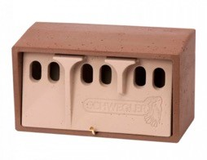
Figure 7. 1SP Schwegler Sparrow Terrace.

Specific mitigation measures and enhancements for roosting bats should include bat boxes attached to the new property and kept trees.

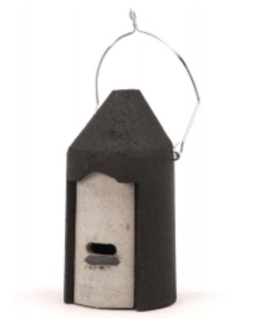
Figure 8. Schwegler 2f Bat Box

*If any protected species are found during the proposed work, work should be stopped immediately, and an ecologist must be contacted immediately for advice.

Should you need any further advice on the information provided above, please do not hesitate to contact Dan Wildsmith.

APPENDIX 1 –Wildlife Legislation and National Planning Policy
The following text is intended for general guidance only and does not constitute comprehensive professional legal advice. It provides a summary of the current legal protection afforded to bats.

All bat species in the UK are included in Schedule II of the Habitats Regulations 2017, which transpose Annex II of the Council Directive 92/43/EEC 1992 on the Conservation of Natural Habitats and of Wild Fauna and Flora (“The EC Habitats Directive”). As such all bat species in the UK are defined as ‘European Protected Species (EPS).

Four species of bat (Bechstein’s bat Myotis bechsteinii, Barbastelle bat Barbastella barbastellus, greater and lesser horseshoe bats, Rhinolophus ferrumequinum and R. hipposideros) are also listed on Annex IV of the EC Habitats Directive. This requires the designation of a series of sites which contain important populations of these species as Special Areas of Conservation (SACs).

All species of British bat are also fully protected under the Wildlife and Countryside Act (1981), as amended, through inclusion in Schedule V.

All species of bat are listed on Section 41 of the Natural Environment and Rural Communities (NERC) Act (2006). Section 41 of the NERC Act lists the habitats and species of principle importance. This places a statutory duty on all public bodies, including planning authorities, under Section 40, to take, or promote the taking by others, steps to further the conservation of habitats and species of principal importance for the conservation of biodiversity in England (commonly referred to as the ‘Biodiversity Duty’). This duty extends to all public bodies the biodiversity duty of Section 74 of the Countryside and Rights of Way (CROW) Act 2000, which placed a duty only on Government and Ministers.

Under the above legislation it is an offence to:

- Kill, injure or take any individual bat of any species;
- possess any part of an individual bat, either alive or dead;
- intentionally or recklessly damage, destroy or obstruct access to any place or structure used by bats for shelter, rest, protection, or breeding;
- intentionally or recklessly disturb these species whilst using any place of shelter or protection; or
- deliberately disturb bats in such a way as to be likely to impair their ability to:
- survive, to breed or reproduce, to rear or nurture their young; to hibernate or migrate; or to affect significantly the local distribution or abundance of the species to which they belong; • keep (possess), transport, sell or exchange, or offer for sale or exchange, any live or dead bat, or any part of, or anything derived from a bat.

It is also an offence to set and use articles capable of catching, injuring, or killing bats (for example a trap or poison), or knowingly cause or permit such an action. There is also protection under Schedule 6 of The Wildlife and Countryside Act 1981 (as amended) relating specifically to trapping and direct pursuit of bats.

A European Protected Species License (EPSL) in relation to bats is required from Natural England for any work that would result in an otherwise unlawful activity (e.g. damage to a bat roost). A license can only be issued to permit otherwise prohibited acts if Natural England are satisfied that all the following three tests are met:

- The proposal is for ‘preserving public health or public safety, or other imperative reasons of overriding public interest including those of a social or economic nature and beneficial consequences of primary importance for the environment’;
- There is no satisfactory alternative; and
- The action authorised by the license will not be detrimental to the maintenance of bat populations at a favourable conservation status in their natural range.

A bat roost is defined by the Bat Conservation Trust’s Bat Surveys—Good Practice Guidelines 3rd Edition as “the resting place of a bat”. In general, the word roost is interpreted as “any structure or place, which any wild bat uses for shelter or protection.”

Bats tend to re-use the same roosts; therefore, legal opinion is guided by recent case law precedents, that a roost is protected, whether or not the bats are present at the time. This includes summer roosts used for breeding; or winter roosts, used for hibernating.

Appendix 2.
Images from the site survey.

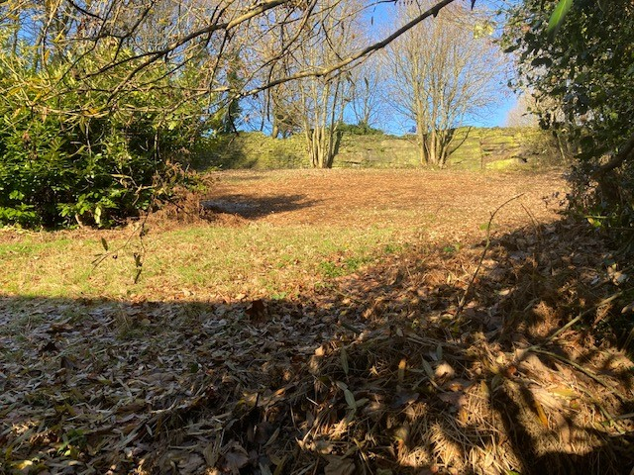 | 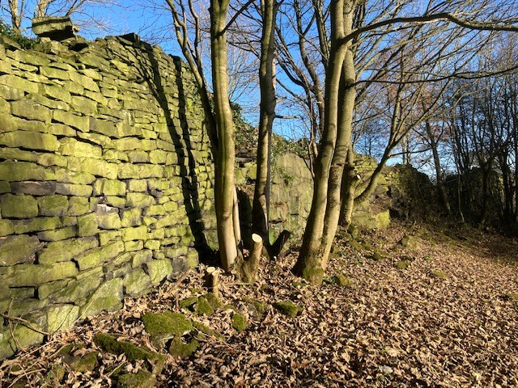
Photo 1: View from fence line looking at the site of the proposed works | Photo 2: Dry stone wall and bare rock with coppiced sycamore.
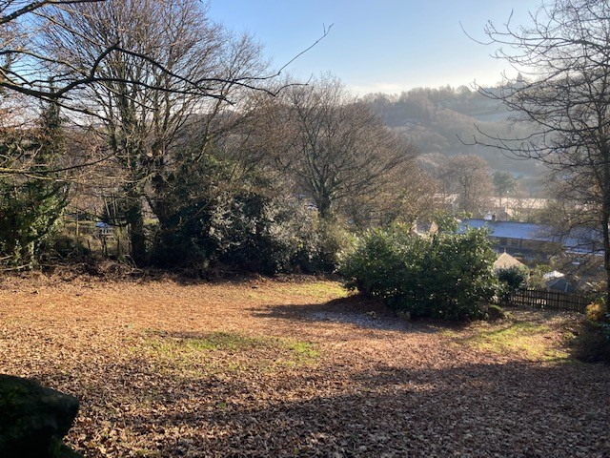 | 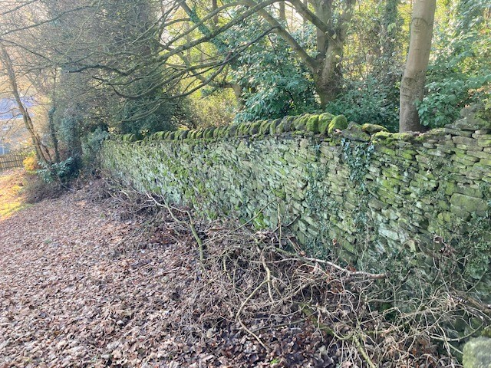
Photo 3: View from north of the site of the proposed works. Laurel tree in the middle right. Bracken scrub (cut back) is predominant habitat. | Photo 4: Dry stone wall on west periphery of the site.

Appendix 3
Site Habitat Map

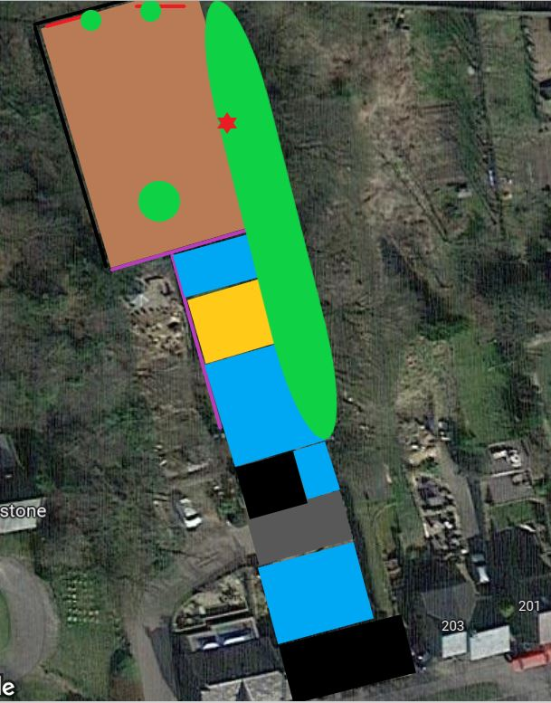
Habitat Map Legend: Black line – dry stone wall. Red line – bare rock. Purple line – non native hedgerow. Brown – bracken scrub. Blue – garden. Yellow – modified grassland. Green shapes denote trees in woodland strip or individual trees.

https://cieem.net/wp-content/uploads/2018/01/Guidelines-for-Preliminary-Ecological-Appraisal-Jan2018-typo-edit.pdf.
HM Government (2018). National Planning Policy Framework. Department for Communities and Local Government. Available online at: https://assets.publishing.service.gov.uk/government/uploads/system/uploads/attachment_data/file/728643/Revise d_NPPF_2018.pdf.
HM Government (2005) ODPM Circular 06/05 Government Circular: Biodiversity and Geological Conservation – Statutory Obligations and their Impact within the Planning System. Available online at: https://assets.publishing.service.gov.uk/government/uploads/system/uploads/attachment_data/file/7692/147570.pdf.
Eaton et al (2015). Birds of Conservation Concern 4: the population status of birds in the UK, Channel Islands and Isle of Man. British Birds 108: 708-746
Wildlife and Countryside Act 1981. [online] Available at: http://www.legislation.gov.uk/ukpga/1981/69/contents
Harris, S., Yalden, D. (eds.) (2008). Mammals of the British Isles: Handbook 4th Edition. The Mammal Society, London
https://ukhab.org/ukhab-documentation/ (2020)

