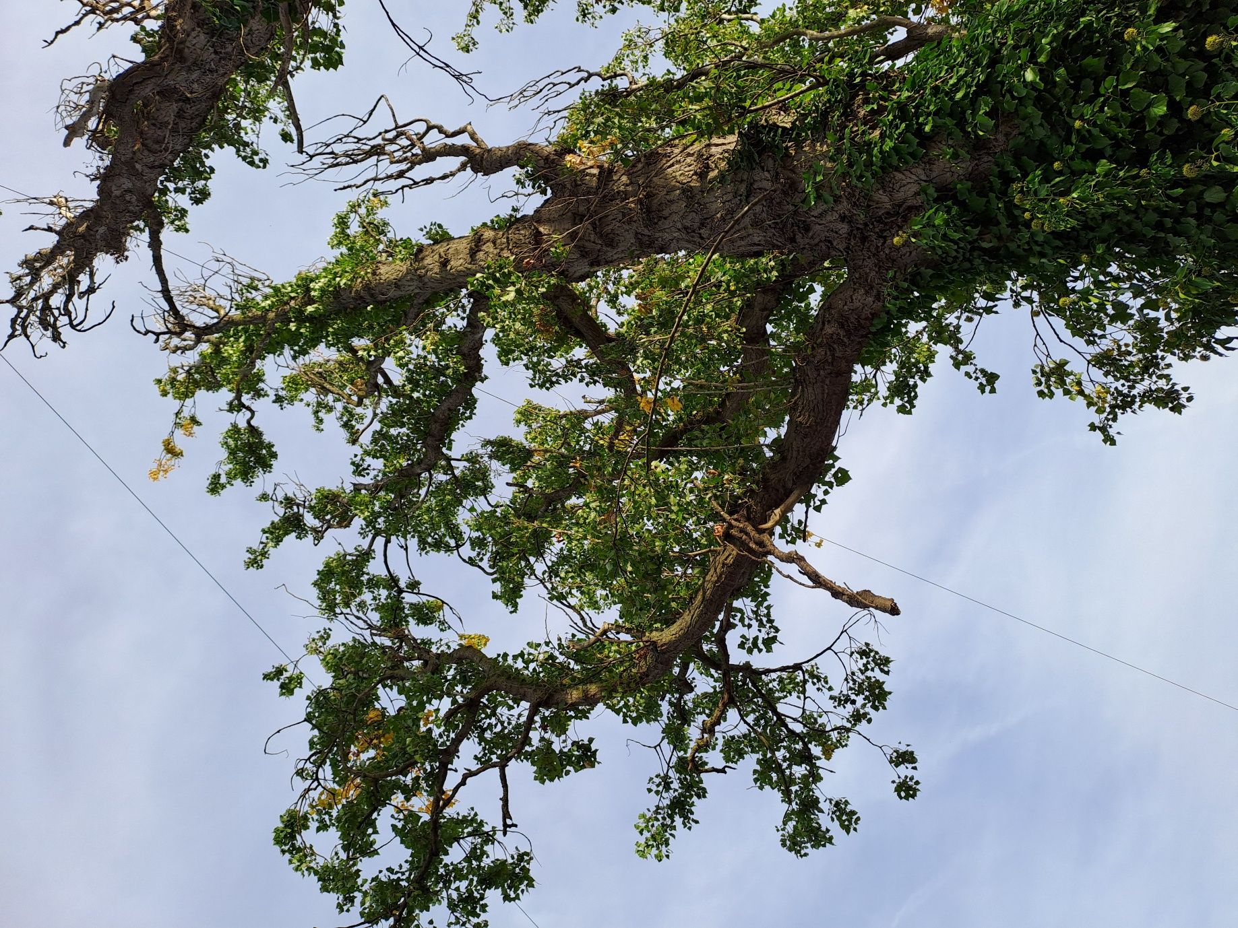
T

T3 additional photograph
Note: All other photographs are included with the tree surveys

