Supporting Statement – 1 Wood Walk

The application property is located on the Southern side of Wood Walk, Wombwell and consists of a 1930’s extended 4 bedroom semi detached dwelling located within a predominantly residential area. There is an ‘L’ shaped garden to the rear which contains a number of large, mature trees (6no. Beech Trees and 1no. Sweet Chestnut). There was a further Beech Tree on the Northern boundary but the roots failed due to Kretzshmaria Deusta and fell during the high winds on 13th November 2023. The tree fell towards number 2 Hemingfield Road, damaging the roof, guttering and electrical equipment at the property, as well as the boundary treatment between the properties.
3no. Beech Trees (and the fallen Beech tree) on the Northern boundary are within an area TPO (Ref 14:1977) which predominantly covers the garden of 2 Hemingfield Road but does cross the rear boundary of that property into the garden of 1 Wood Walk.
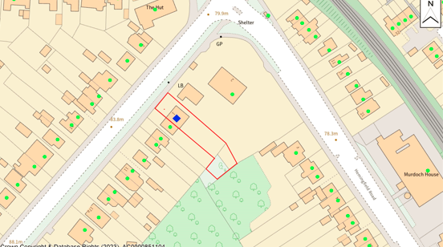

The location of the trees are shown on the plan below, with the fallen tree highlighted in red. There are further trees within the bottom of the garden (3no. Beech Trees and a Sweet Chestnut) but these are not within the TPO and do not form part of this application.

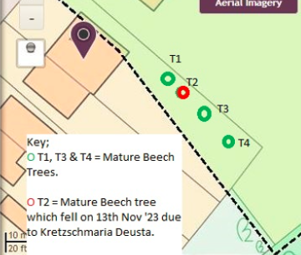

T1
T1 is a mature Beech Tree over 15m in height. It is located adjacent to the Northern boundary and it is the closest tree to the property within the curtilage. The tree is immediately adjacent to the fallen T2 and, as such, there was concerns that the roots of this tree could be compromised and be a safety risk. Oakwell Tree and landscaping have assessed the tree and found that the moisture levels within the roots are lower than would be expected. This raises concerns regarding health and safety.
Given T1 is immediately adjacent to the fallen tree it was competing for light, as such, the majority of its branches are on one side resulting in an uneven weight distribution (shown on the photo below). All the weight is on the North Western side of the tree which faces the rear elevation of 1 Wood Walk. The concern is, if the roots were to fail then the tree would fall towards the property causing significant damage and posing a safety risk.
As such, the tree surgeons have recommended veteranisation including heavy reduction works. This would reduce some of the weight of the tree and also redistribute the weight, encouraging growth into the area left by the canopy of T2. The reduction in the canopy would also reduce the pressure of the roots due to a lower wind resistance, especially when in leaf.
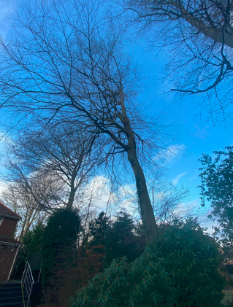
T2
This was a large Beech Tree over 15m in height. The tree was seemingly healthy and was in leaf during 2023. There was no visible signs of the tree being unhealthy or having a disease. However, on 13th November 2023 during high winds the roots failed and the tree fell onto the neighbouring property and within its curtilage. It damaged the boundary treatment and the neighbouring dwellings roof tiles, guttering, air handling unit and security lighting. The reason for the failure is thought to be Kretzshmaria Deusta.
The majority of the trunk and branches of this tree have been removed from the neighbours garden but the stump remains within our curtilage.
Given the failure of this tree it lead to the other trees on the site being inspected by a tree specialist to ensure they did not suffer the same fate. This in tern lead to this planning application following their inspection and advice.
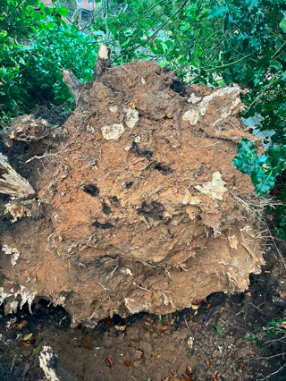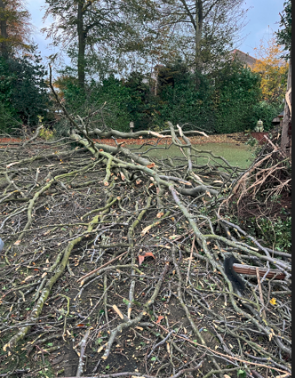
T3
The roots of this tree were inspected and found to be low in moisture, raising fears of a possible failure. This tree competed for light given its position between T2 and T4, as such, the tree is very tall and thin with a very high canopy (as shown in the photo below). This results in there being a lot of whip in the trunk, especially when the tree is in leaf and on windy days. The concern is that the roots are failing and the movement in the tree could result in failure. As such, unfortunately the recommendation from Oakwell Trees is that the tree be ground levelled.
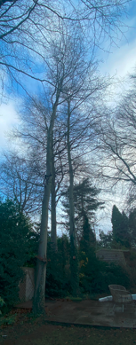
T4
Following inspections this tree is considered to be healthy and no works are required

.Mitigation
The loss of T3 is considered to be regrettable but unavoidable due to the safety risk it poses. The works to T1 are relatively heavy but are also considered to be necessary for the long term health of the tree.
In order to mitigate the loss of T3, as well as T2, it is proposed to plant 2no. new trees. The species, size and position of which will be discussed with the Councils Tree Officer and agreed. It is anticipated that if this application is supported it will be subject to a condition regarding the replanting.

