Ref: 2016/0065

Applicant: Mr David Dickinson
Description: Crown lift to 5.2m leaving no pruning wounds greater than 30cm of Sycamore (T1) within TPO 12/1994
Site Address: 271 Pontefract Road, Cudworth, Barnsley

Site Description

The tree is a large mature Sycamore situated in the rear garden of the property and has significant amenity value. There are no leaves on these pictures but on file the picture shows it in summer.

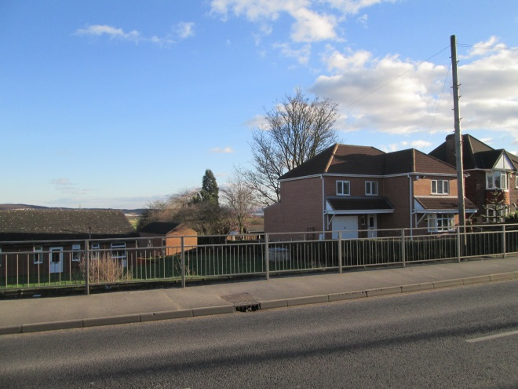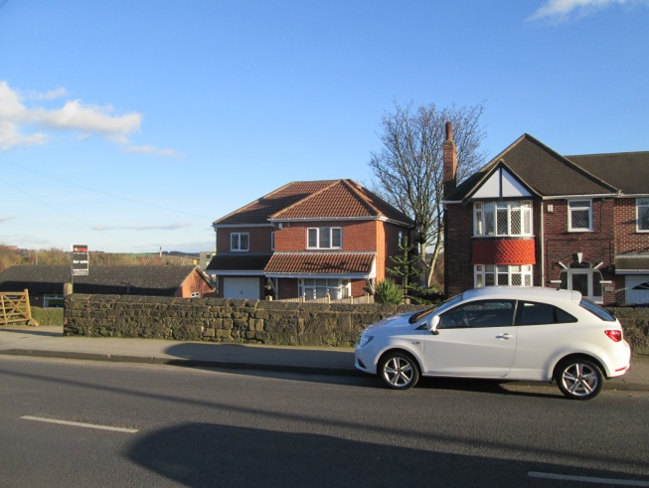

Proposed Development

Crown lift Sycamore to 5.2m. Previous approval given for similar works.

Policy Context

The statue law on TPO’s is in the Town and Country Planning Act 1990 and in the Town and Country Planning (Trees) Regulations 1999.

Primarily the aim of making a TPO is to protect the amenity value of the tree or trees. LPAs may make a TPO if it appears to them to be: 'expedient in the interests of amenity to make provision for the preservation of trees or woodlands in their area'.

The Act does not define 'amenity', nor does it prescribe the circumstances in which it is in the interests of amenity to make a TPO. Normally trees should be visible from a public place e.g. road or footpath for a TPO to be made but the courts have decided that trees should be protected for “pleasure, protection and shade they provide”. Taking this into account trees should be considered for other aspects of amenity that they provide other than visual amenity.

Government advice and guidance available on the administration of TPOs, is:- ‘Tree Preservation Orders: A Guide to the law and Good Practice’ 2000.

The guidance states that ‘LPAs must include in their plans land use and development policies designed to secure the conservation of natural beauty and amenity of the land. Plans should not, however, include policies which are unrelated to the development or use of land. They should not therefore include the LPA's policies for deciding applications for consent under a TPO; but they should include policies on measures that the LPA will take, when dealing with applications to develop land, to protect trees and other natural features and provide for new tree planting and landscaping.’

In deciding an application the LPA’s are not required to have regard to the development plan. Section 54A of the Act, 88 therefore, does not apply to the LPA's decision, which means that there is no general duty on the LPA to indicate otherwise.

Consultations

Trees- No objections subject to conditions.

Representations

Assessment

Principle of development

In line with good practice, primarily the aim of making a TPO is to protect the amenity value of the tree or trees. In considering TPO applications the LPA is advised:

(1) to assess the amenity value of the tree or woodland and the likely impact of the proposal on the amenity of the area, and

(2) in the light of their assessment at (1) above, to consider whether or not the proposal is justified, having regard to the reasons put forward in support of it.

The application is as described above. The works applied for are in accordance with good practice and British Standards and are considered to be acceptable and justified.

Visual Amenity

An application was approved previously to crown lift the tree to 5m and crown thin removing no more than 30% of the total leafing area back in 2011. This current application if for crown lifting the tree again to 5.2m which is basically maintenance of the previous crown lift. As such there is no objection to the proposed works as when a tree has been crown lifted then maintenance is required to keep the level of clearance.

The works proposed are appropriate and in line with good arboricultural practice and as such there is no objection to the crown lifting works proposed.

Recommendation

Grant subject to conditions

