


Design and Access Statement

Penistone Banking Hub

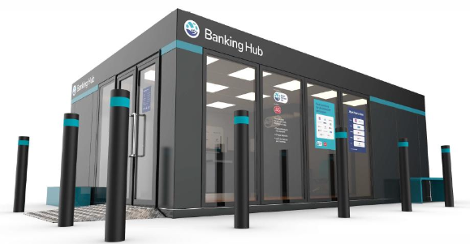

Contents

- Project Details Page 2
- Introduction Page 2
- Site Context Page 2
- Site Location Page 3
- Assess, Involvement and Evaluation Page 3
- Evaluation Page 5
- Design Page 5
- Access Page 6
- Flood Risk Page 6
- Conclusion Page 7

Project Details

Client: Cash Access UK [CAUK]

Project number: NCRA6110

Hub ID: Hub_220

Project address: Tesco Supermarket, Market Lane, Penistone, South Yorkshire, S36 6TS

Description: Standalone modular banking cabin

Introduction

NCR Atleos have been commissioned by Cash Access UK [CAUK] to submit for full planning and advertisement consent for a new modular banking hub to serve the local community of Penistone and local area, which is to be positioned within the existing Tesco supermarket demise.

Site Context

The site is situated to the west of Penistone town centre, with access taken from Market Lane via the Bridge Street and St Mary’s Street roundabout. It lies adjacent to a large Tesco supermarket to the east and near the Penistone Show Ground to the west of Barnsley.

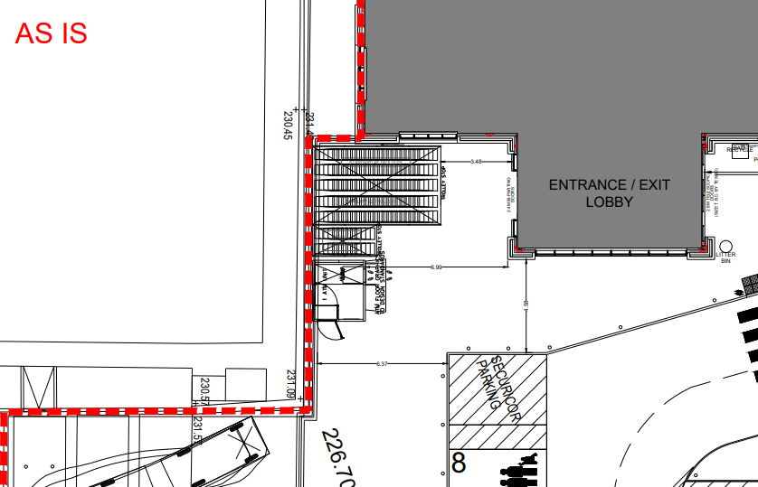

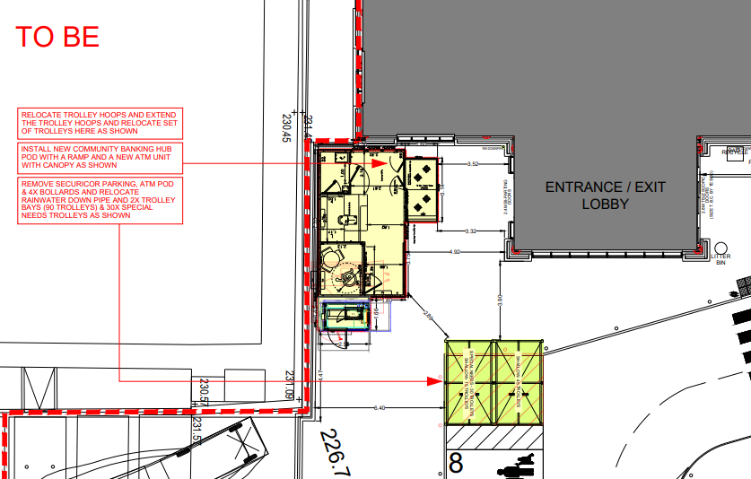

Site Location

Location of property below. Information available from planning.data.gov.uk
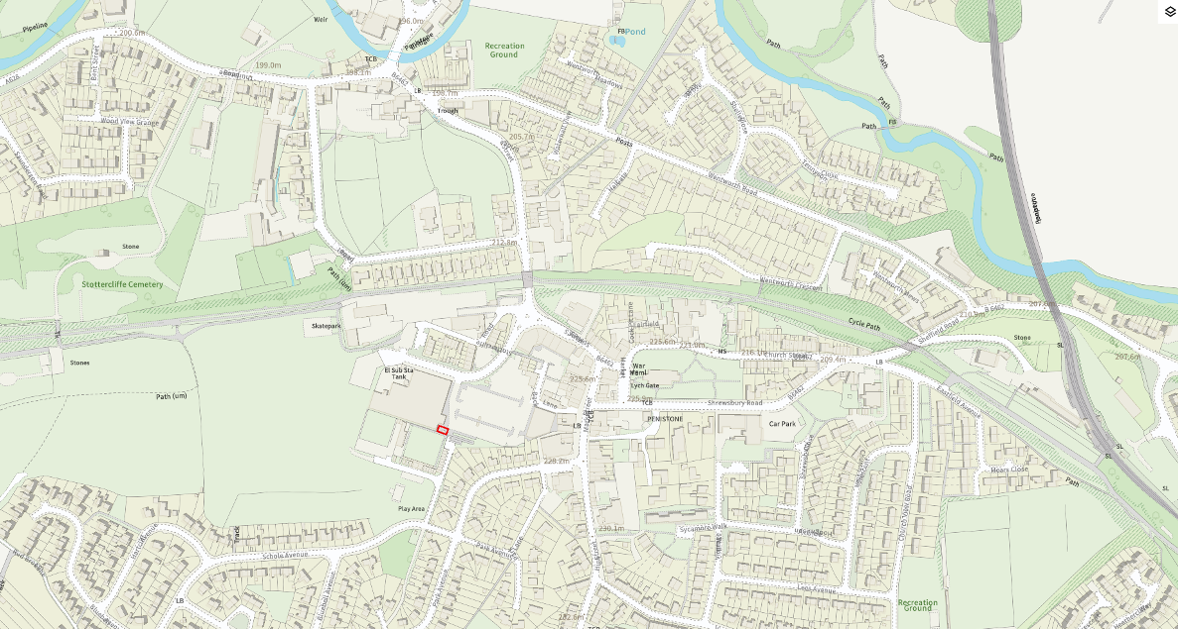
The modular banking hub is to position within the Tesco supermarket pedestrian area, as shown by the red boundary opposite the main store entrance.

Assess, Involvement and Evaluation

An assessment has been carried out by the client and driven by the need for the community to have access to banking facilities in the town and local area.

Physical - From a physical perspective, the design of the banking hub will not adversely affect its surrounding environment with the relocation of 2 trolley bays and ATM housing.

Social – Enabling the Tesco supermarket to not only have a retail offer but financial services to benefit all.

Economic - Either whilst visiting their local Supermarket or just requiring the use of local banking facilities, the Penistone community will have access to standard financial professional services and the ability to undertake banking transactions.

Policy – We see no adverse effect on current planning policy for the introduction of these services or siting the hub into this location.

Cash Access UK have involved the following parties and gathered their respective inputs:

Local community groups – through CAUK’s Community Engagement team, we have gathered community insight and understanding of community need through local forums and community group meetings. Engagement is ongoing with these groups. Although we have not yet confirmed the location with the group as it is subject to planning, recent feedback included suggestions that we should look at the Tesco as a potential option as it is convenient and accessible, has plenty of parking and lighting, and that area of town has become increasingly busy due to other shops or facilities in the area. This has provided reassurance of communities’ recognition of the benefits of the Banking Hub services in the chosen location.

Local MP – CAUK has approached the local MP and their office to outline the hub and deployment plans and gather early feedback and is currently awaiting a response to confirm the MP’s support.

Tesco Store Manager and Head Office staff – CAUK are in partnership with Tesco and as part of the initial scoping of the location, have engaged the Store Manager to gather insight on the local area, the stores customer base, any considerations to be made or challenges to be aware of.

Our contacts at Tesco Head Office have provided the relevant car park and store plans and highlighted any areas to avoid or those that we may face challenges to support the identification of the chosen placement within the car park.

Post Office Limited – CAUK are working collaboratively with the Post Office on the development and deployment of the hub, security/risk reviews, and operational design, engaging their local staff who will run the banking hub once live.

Member Banks – CAUK have involved each of their member banks to review plans and designs from a customer, staff, security and risk perspective. CAUK have engaged the members banks to utilise customer insights to agree the rotation of community bankers for this location to maximise availability to customers in that locality.

R&D Sheetmetal – CAUK are working with experienced suppliers, providing technical designs, hub build and deployment works. Suppliers are leaders in providing secure structures for financial services and have advised on plans and designs to ensure a consistently high standard of security which is integrated into a user-friendly, welcoming hub.

Eversheds Sutherland – CAUK have involved independent, third-party legal counsel to provide an assessment of the banking hubs design and operational workings against relevant legal and regulatory considerations. Eversheds confirmed that the hub, its designs, deployment plans and operations all meet or exceed expectations from a legal/regulatory perspective.

Evaluation

Evaluation has taken place at an early stage to decide on hub location. Assessing the feedback from local groups as well as the location options within the town provided rationale and evidence to support a Banking Hub at the Tesco store. This was particularly related to accessibility, convenience and ability to provide a purpose-built structure suitable for the requirements of a Banking Hub, where other options in the locality did not.

Visits to and surveys of the Tesco site and engagement with the Store Manager and Head Office staff were used to evaluate the options of hub placement within the carpark. This enabled CAUK to choose a prime location for the hub - for customers and hub staff to safely journey from hub to store and vice versa; for convenient parking close to the hub with easy and safe access via the footpaths; to minimise disruption to store parking and flow of traffic; and to ensure minimal impact to any businesses or residences around the Tesco perimeter.

Insight gathered on the local area and the Tesco vicinity has informed the Banking Hub designs; for example, the installation of lighting on the external of the hub to provide visibility at night and deter groups from loitering around the hub outside of operational hours. Evaluation of the local public transport has also provided further support for the hub location, with a bus stop directly outside the store’s main entrance.

Design

The Banking Hub follows a modular design and is to be fabricated and built offsite at the supplier’s factory. The build will then be transported to the Tesco site, minimising the works on site and therefore disruption the customers of the store.

Use – The Banking Hub will be used as a cash and basic banking facility, providing cash transactions via the counter service, and basic banking support through a rotation of Community Bankers from CAUK’s member banks.

This will be incredibly beneficial for all members of the community including local business, who have all been affected by recent branch closures and lack of access to cash and banking services in the town and surrounding area.

The Banking Hub fulfils a regulatory requirement under the FCA and so the community are assured of consistent opening hours, availability and service.

CAUK’s agreement with Tesco includes provision of welfare facilities within the Tesco store, including toilets for staff and customers, and the break room/canteen use for staff.

Amount – The modular hub itself will only take up approximately 30m² in floor excluding a small perimeter access area surrounded by anti-ramraid bollards linked to an existing pedestrian footpath.

Layout – The internal layout of the hub itself is very simple with a main cashier desk and private meeting room space if required.

Scale – The scale and massing of the proposed hub is very typical of a small modular hub, and not out of context with the car park and adjacent Supermarket.

Landscaping – No landscaping will be required only minor hardscaping changes with the introduction of a raft slab and bollards.

Appearance – The outer envelope of the modular unit will be made from steel and wrapped in vinyl with branding and logos to suit CAUK branding. Light strips and a small condenser will also be fitted to the cabin.

Access

There are good vehicular, transport and pedestrian links all around and to the site as you would expect being and existing Supermarket store.

Inclusive access to the new hub has been allowed for to the approach and with the Banking Hub itself.

Compliance with approved document Part-M has been adhered to incorporating ramped access, handrails and a fully automated door at the entrance to the hub, with manoeuvrability zones within for wheelchair use.

Flood Risk

Location of the modular banking cabin is shown below. Information available from planning.data.gov.uk and flood-map-for-planning.service.gov.uk

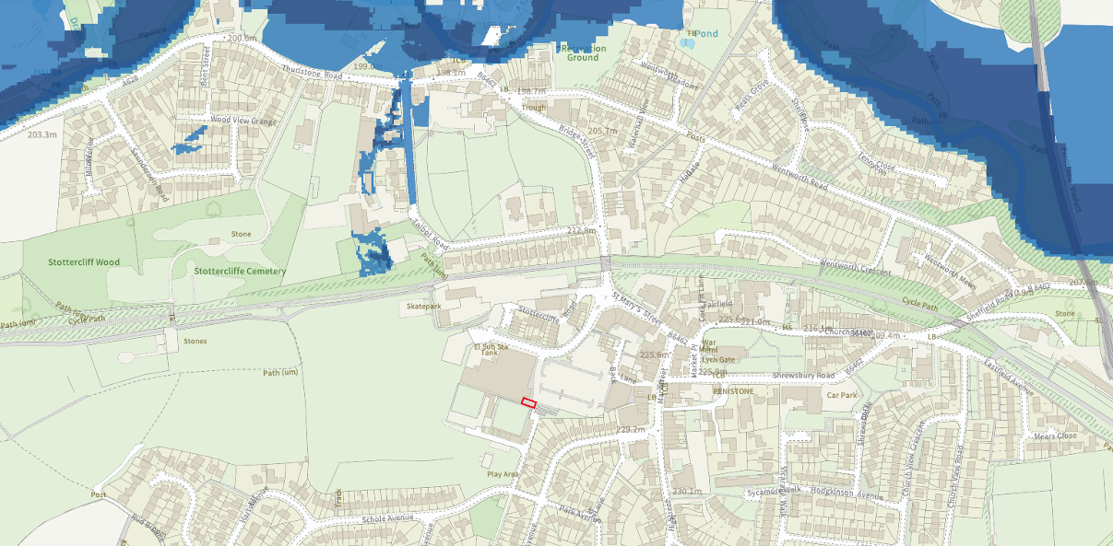

After reviewing the flood mapping for planning data, the surrounding land falls outside Flood Zone 1 has a low probability of flooding from rivers.

Conclusion

The scheme seeks to offer more choice to customers and generating new employment opportunities through the provision of the banking hub. Cash Access UK, in conjunction with Tesco, hope that the advantages of this proposal as well as the overall benefits to the local community will be supported.

