Goldthorpe A635 Sculpture Project
Design and Access Statement

Contents
Goldthorpe A635 Sculpture Project 1
1. Overview 2
2. Inspiration for the Design 3
3. Description of the Design 5
4. Appearance / Materials 7
5. Colour choices 8
6. Location 9
8. Installation method Summary 10
10. Access 10
11. Risk Mitigation 11
12. Maintenance 11

Overview
Name of Artwork: due process was followed when delivering the official consultation
Artist, Dan Jones was commissioned to create a permanent sculpture to be sited in the same vicinity of the recently completed ES10 A635 roundabout (funded by the Goldthorpe Towns Fund Programme as part of UK government) which will provide the major access into the ES10 Employment Site and will create a substantial number of new and additional job opportunities for the local area.
The artist has undertaken extensive engagement with the local community and key stakeholders to develop the design for the artwork and a name.
This place-specific sculpture will also act as a key landmark gateway which will welcome residents and visitors to the area. The project is funded by the Goldthorpe Towns Fund Programme as part of UK government.

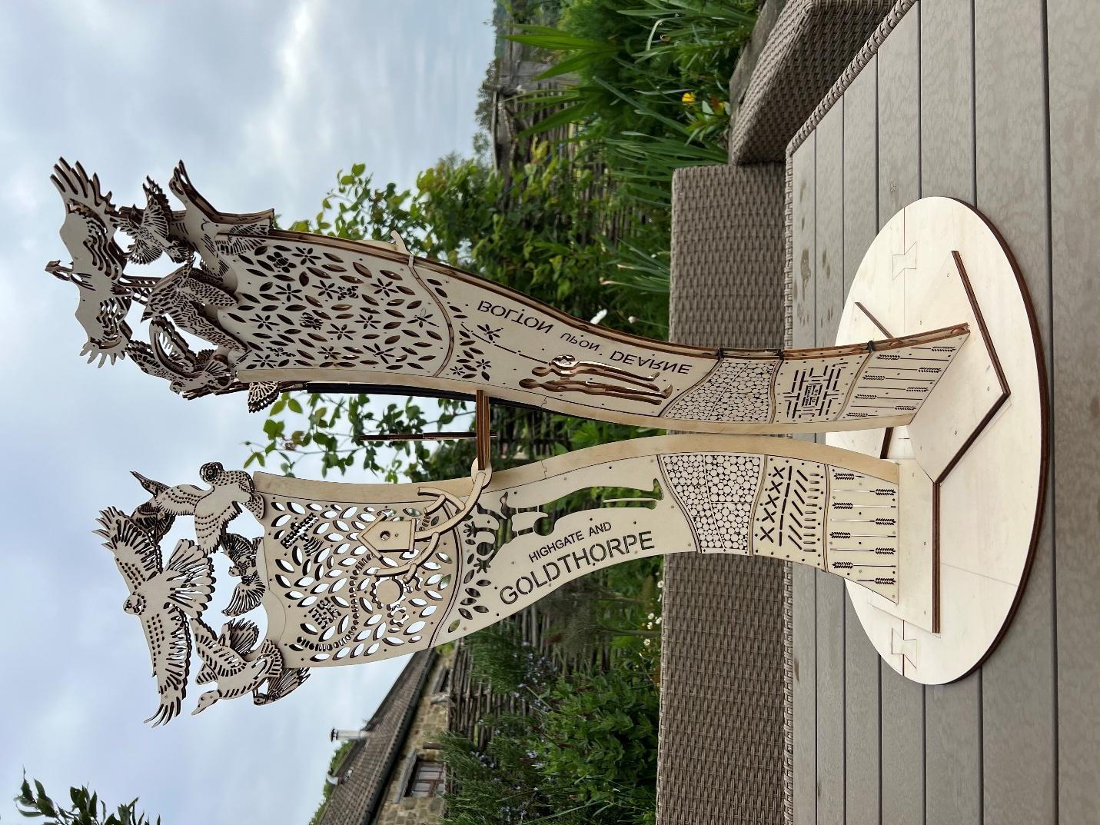

Image: Maquette artwork by Dan Jones

Inspiration for the Design
The artist undertook a period of research into the heritage of the area as well as a series of site visits to the Dearne Villages (Thurnscoe, Bolton Upon Dearne and Goldthorpe) and conversations with representatives from the Dearne Valley Old Moor Nature Reserve.
The artist conducted 15 creative workshops, engaging 240 people in the project. Groups were selected to represent a mix of age ranges from Goldthorpe, Thurnscoe and Bolton upon Dearne including: IKIC (I Know I Can) Juniors, IKIC Pandas, IKIC Seniors (Bolton Upon Dearne), Let's b friend group Thurnscoe and Let's b friends group Bolton Upon Dearne; Dearne Astrea Academy (Goldthorpe) and the Goldthorpe Development group (Goldthorpe) as well as an open drop in event held in Goldthorpe.
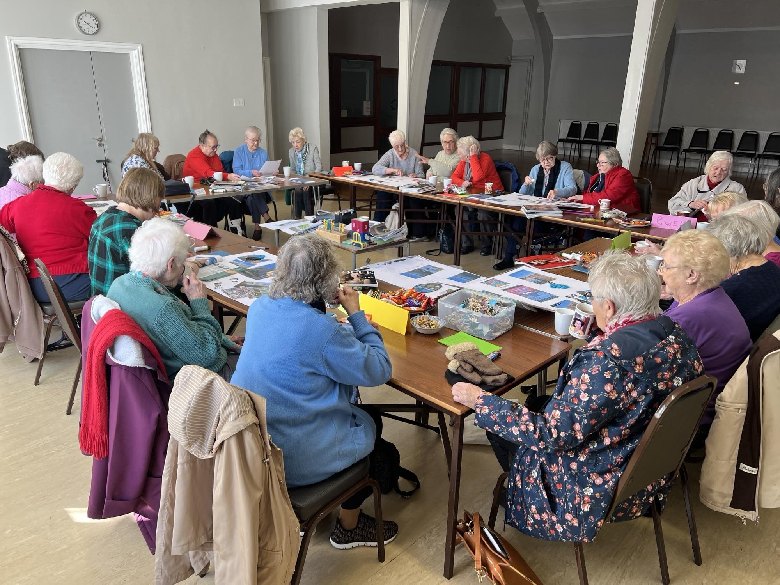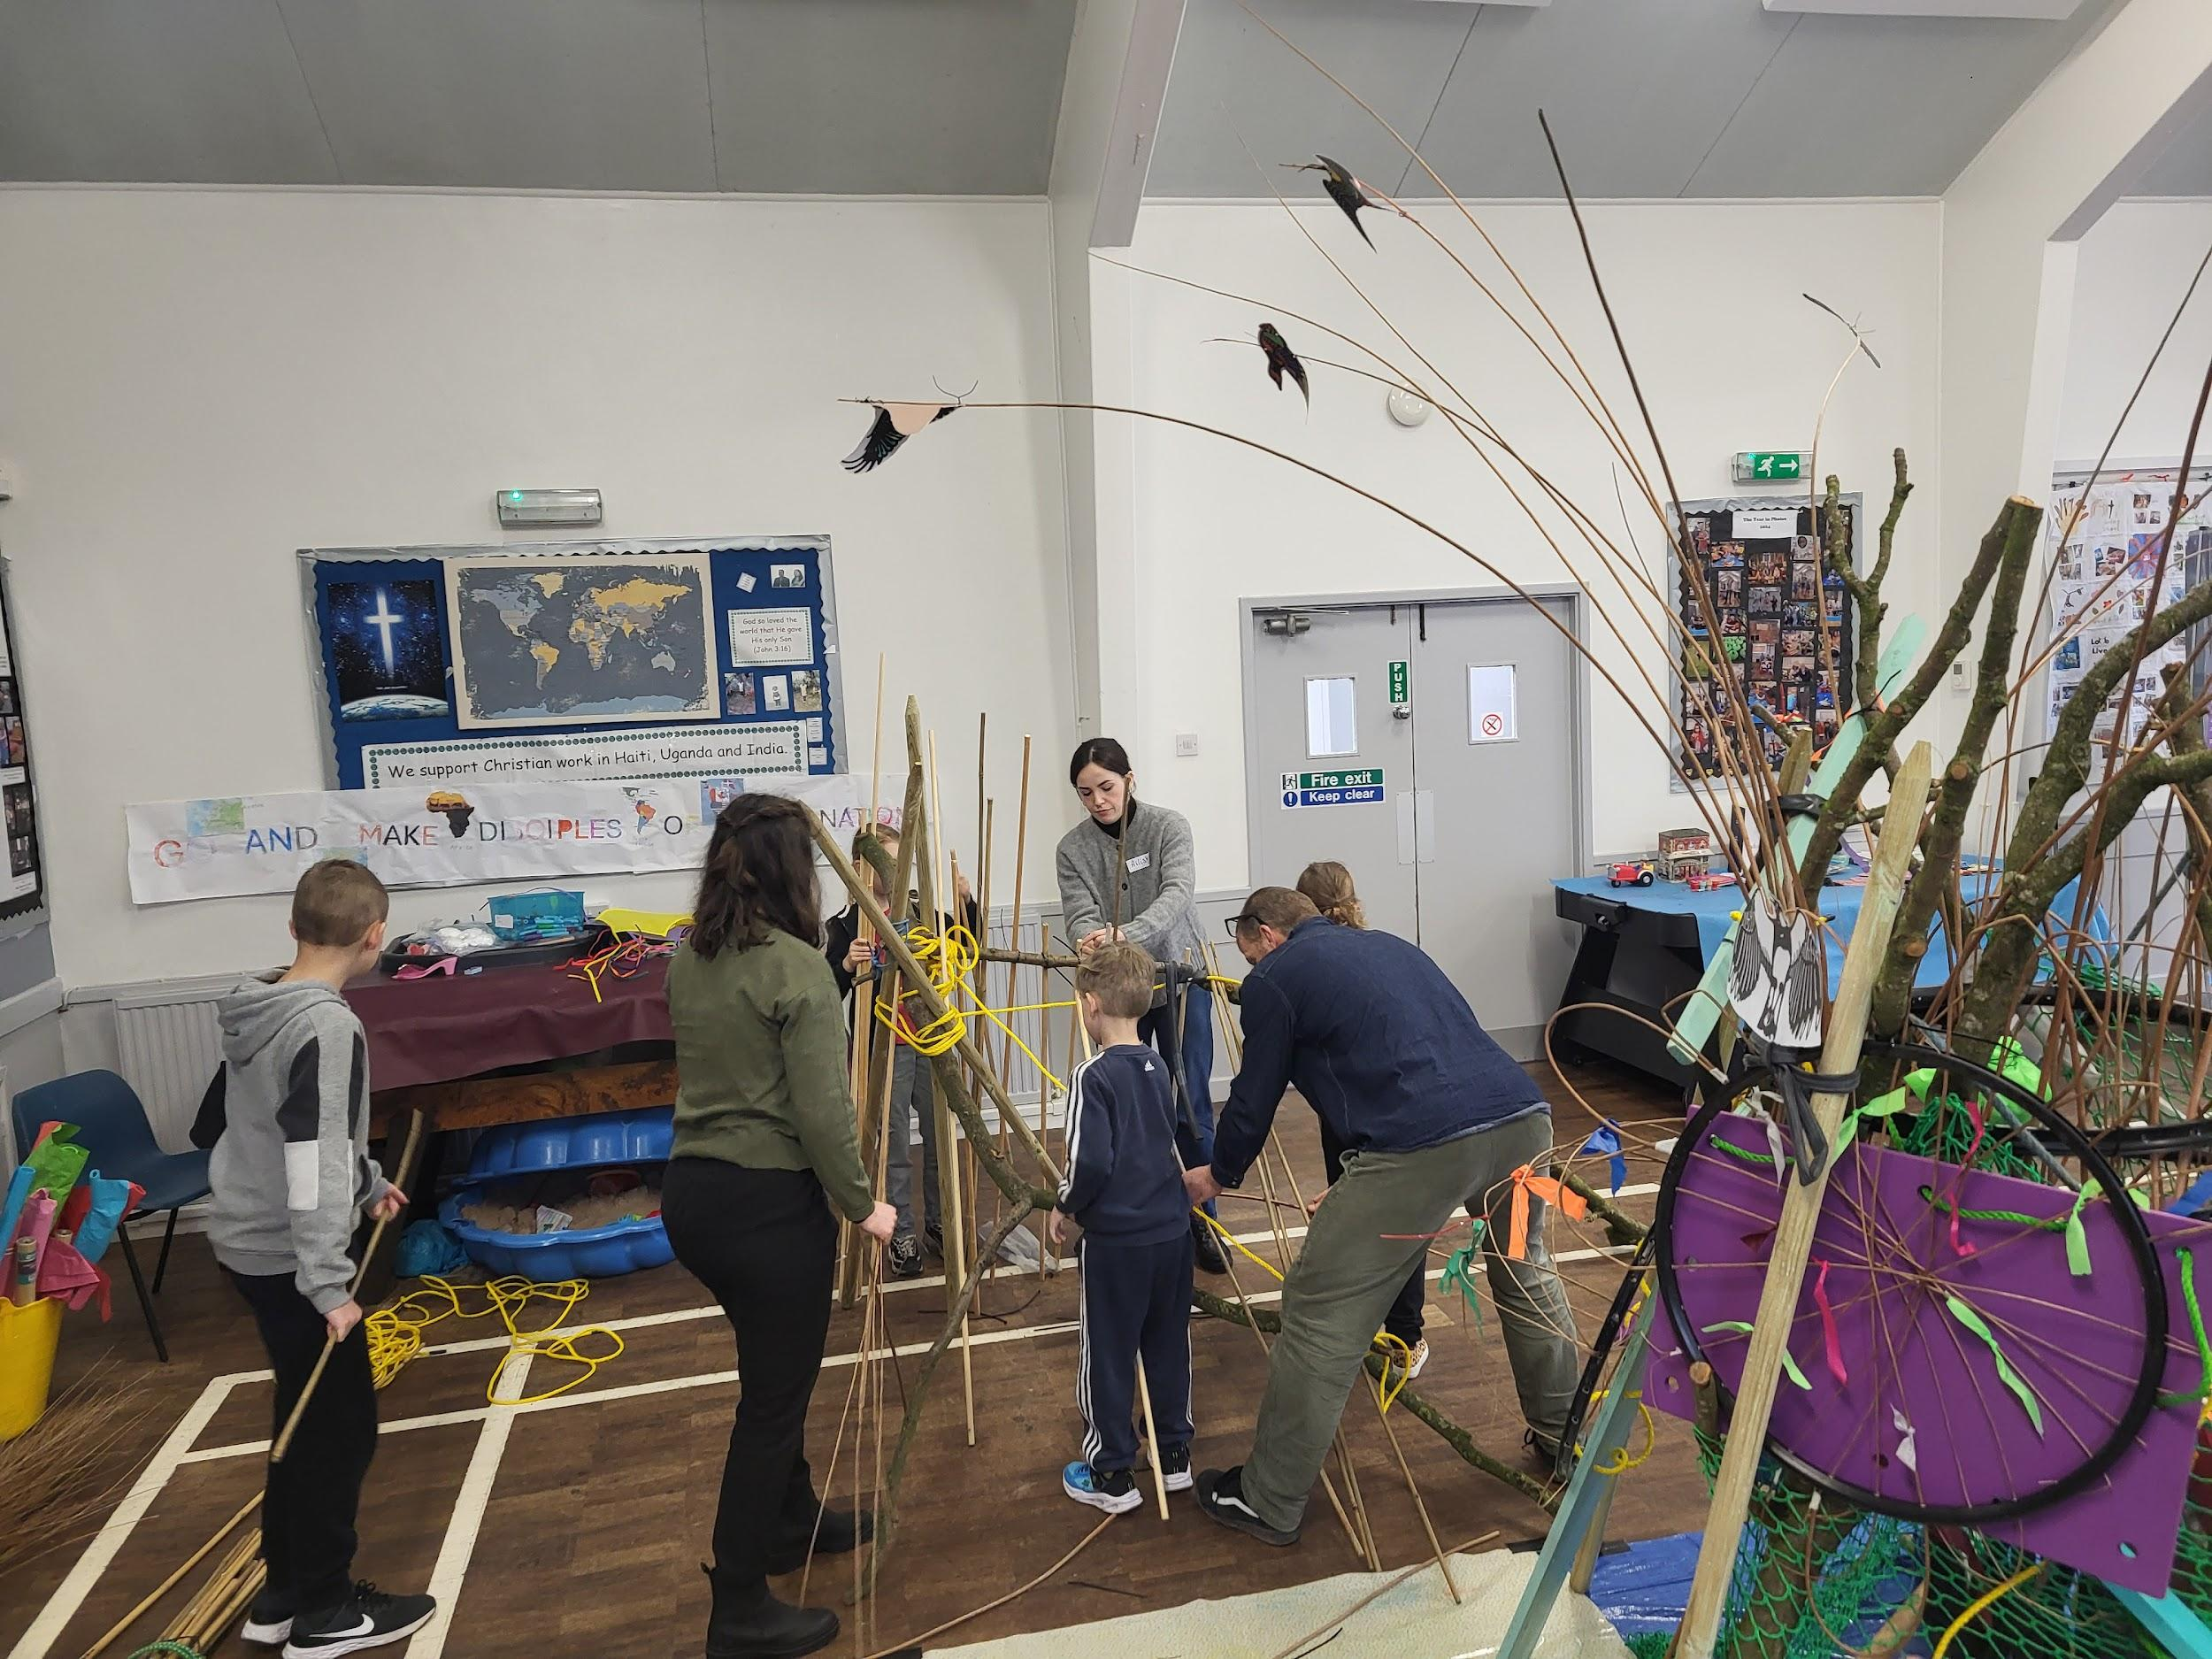
These workshops were structured to enable participants to share what is important to them about the area, thinking about the past, present and future, expressing their thoughts through collage and making activities as well as suggesting a new name for the roundabout.
In addition, an online survey was available for contributions from those who were unable to participate in the formal workshops.
Dan also engaged with a Project Steering Group including representatives from: BMBC (Senior Engineers, Structures, Project Manager (Economic Development Barnsley Council), Dearne Area Council Manager, Dearne Community Development Officer, Senior Urban Design Officer), Ward Councillors for Dearne North, PWP landscape design and the developer. Wider key stakeholders have been kept informed about the project including Ward Councillors for Dearne South and Darfield and Goldthorpe Towns Fund Board.
Analysis of the outcomes of community and stakeholder input demonstrated a number of recurring themes around - pride in the areas agricultural and industrial heritage, a desire to celebrate and conserve the areas natural environment and wildlife, a need to represent the coming together of the local communities, looking to the future from all age ranges and wanting to demonstrate unity and equal opportunities.
These themes inspired the final design as described below.
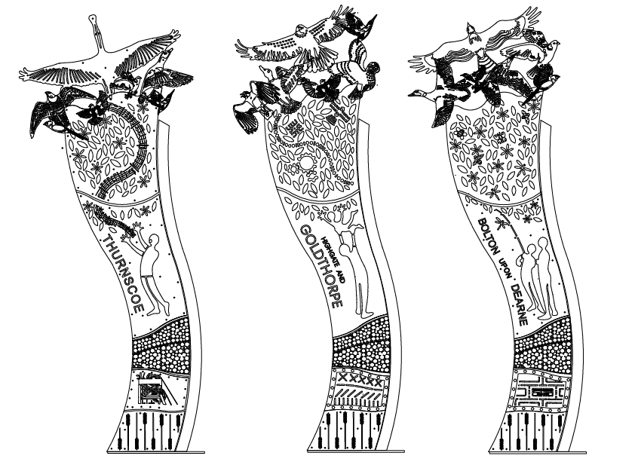
Image: Drawings of each panel.

Description of the Design
The concept for Dan’s design represents the three communities coming together illustrated by 3 vertical panels layered with design features to include:
- At the base of each panel are design features to represent the agricultural heritage of Highgate, Goldthorpe, Bolton Upon Dearne, Thurnscoe and Billingley.
- Representation of industrial heritage
- A section designed to be used as a habitat stack for bugs and insects
- A figure to represent the community
- A functional birdhouse
- Imagery to represent flora / fauna and local bird species as advised by Old Moor Wetland Centre
These panels are symbolic of the growth of the area and how the area's future is built on the foundations of its heritage. The ring in the centre provides structural stability but also represents the communities coming together.
Each panel also includes detailed content/imagery that is specific to each area that Dan has collated from community input:

Highgate and Goldthorpe:
- Representation of women's contributions through inclusion of sewing reference
- Figures represent the older generation lifting up the next generation
- Environmental elements include representation of training, education and new technology
Bolton Upon Dearne:
- Representation of The Brickworks ex industry
- Representation of fishing at Brick ponds
- Representation of reclaimed spoil heap and increase in pollinators
- Bird box - woven structure taken from community drawings
Thurnscoe:
- Representation of ex industrial area / coal mining through the pit head
- Representation of singing / performance - specific musical notes as advised by Thurnscoe Harmonic Male Voice Choir from the song TAKE ME HOME by Edwards and Hand
- Bird box - pineapple designed by young people as a symbol of wealth and prosperity (In the 17th and 18th centuries, the pineapple became a symbol of wealth and luxury in Europe due to its exotic nature and rarity.)
The local bird species featured will include:
- Marsh Harrier, Pigeon, Barn Owl, Bearded Tit, Bittern, Duck, Falcon, Godwold, Kingfisher, Buzzard, Lapwing, Spoonbill, Starling, Mallard.

Appearance / Materials
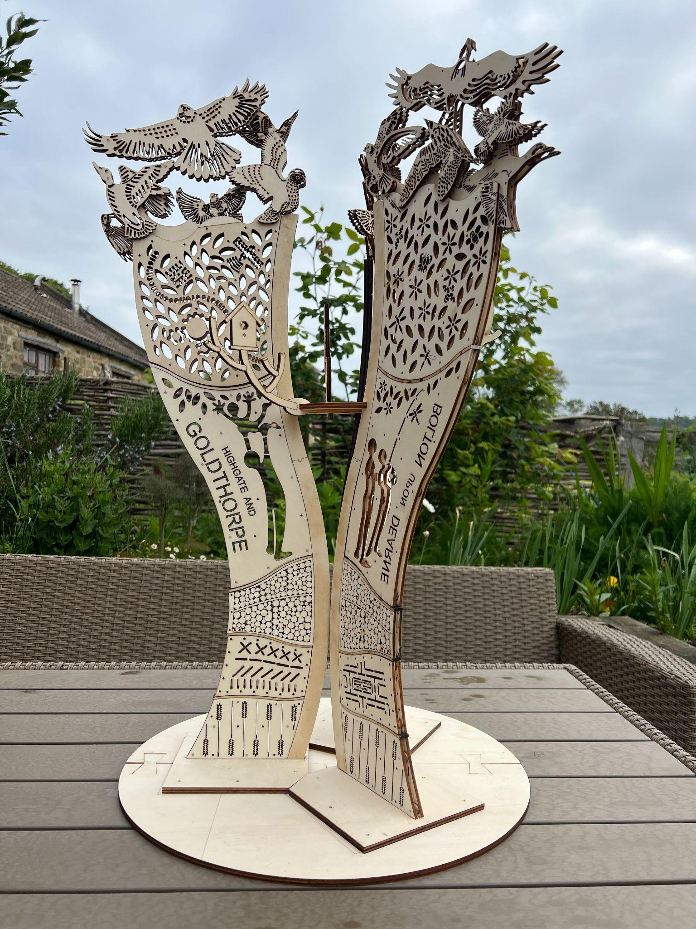
Image: Maquette artwork by Dan Jones
Each panel will be made up of 2 layers of mild steel separated with a 8mm mild steel washer with tinted resin coating to provide texture and colour. This finish also has anti graffiti properties.
The designs in each panel will be laser cut.
Each section incorporates a three dimensional, functional birdhouse that will be insulated and then painted. The designs of the bird houses were directly influenced by young people’s designs through the workshops as described in Section 3.
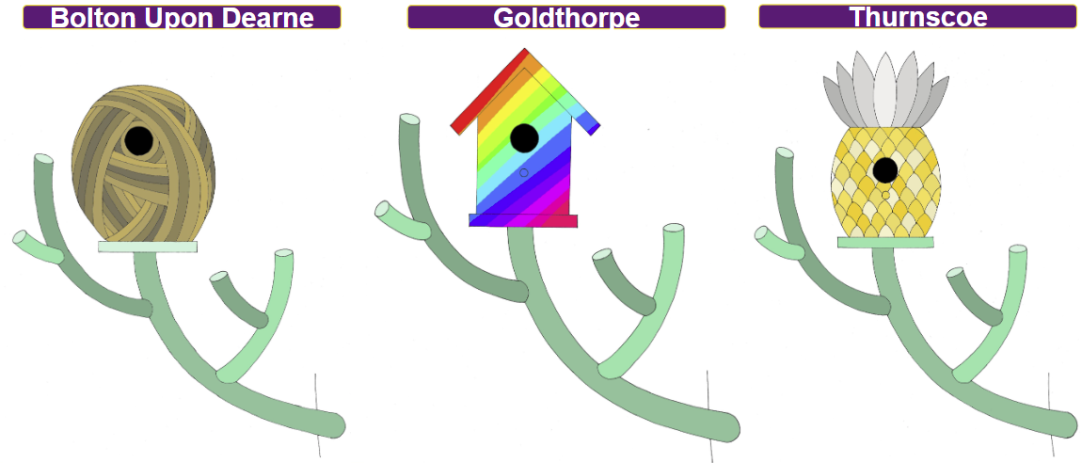

Colour choices
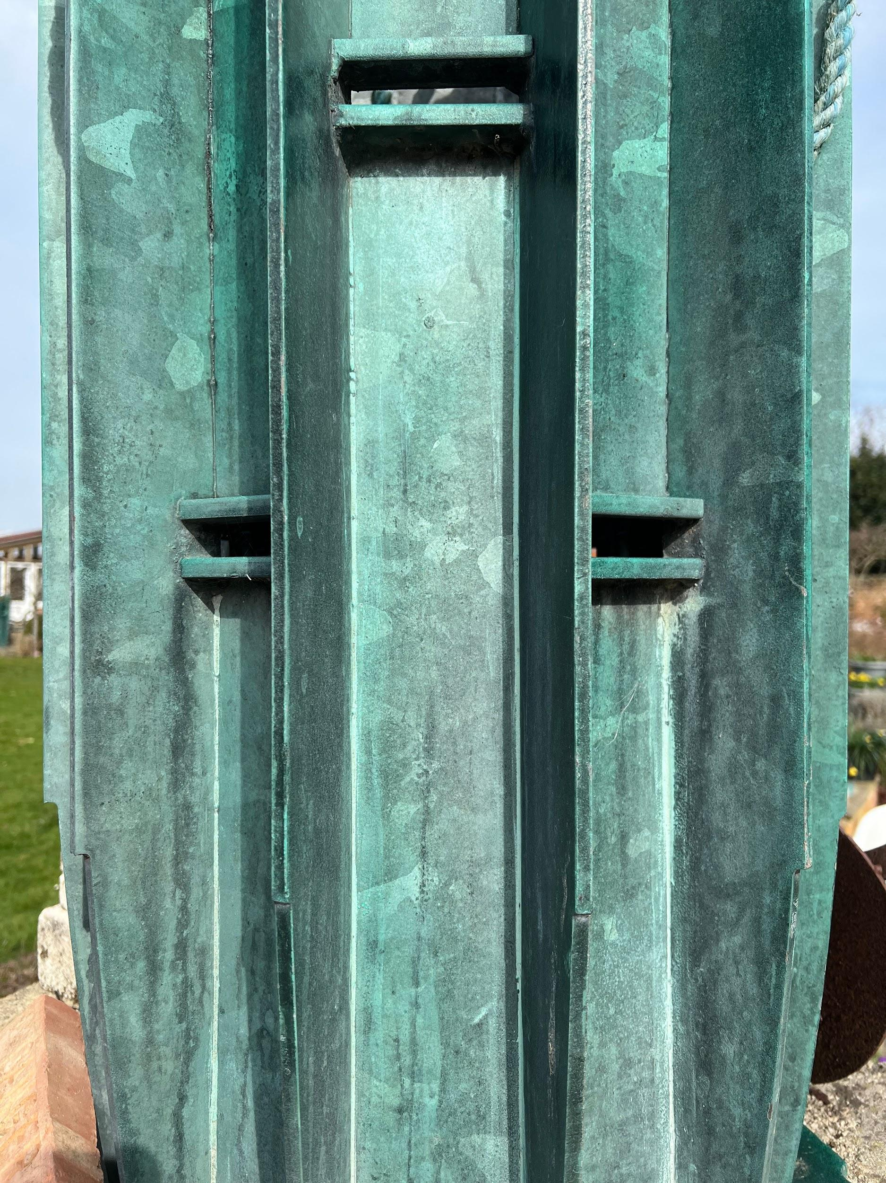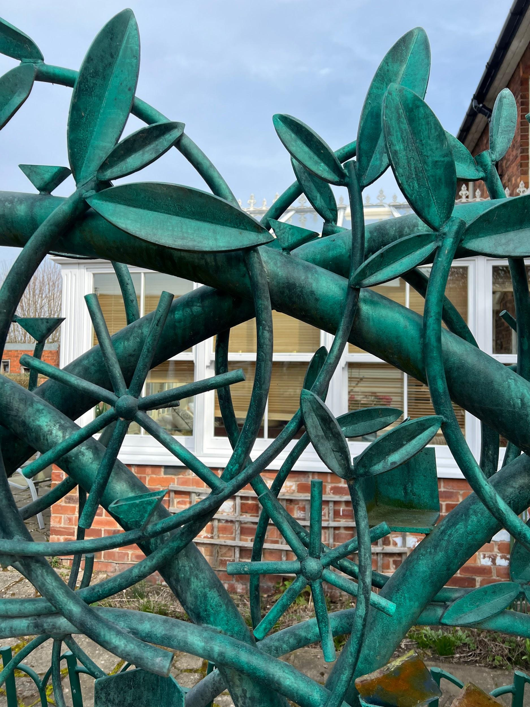

The mild steel with tinted resin coating results in a green coloured hue. It will be applied at different intensities to create textures as shown in the examples above.

Location
The sculpture will be located on a site adjacent to the southern side of the eastern (westbound) approach to a new roundabout on the A635 Doncaster Road just to the west of Goldthorpe
The sculpture’s specific location is as as per the drawing below.
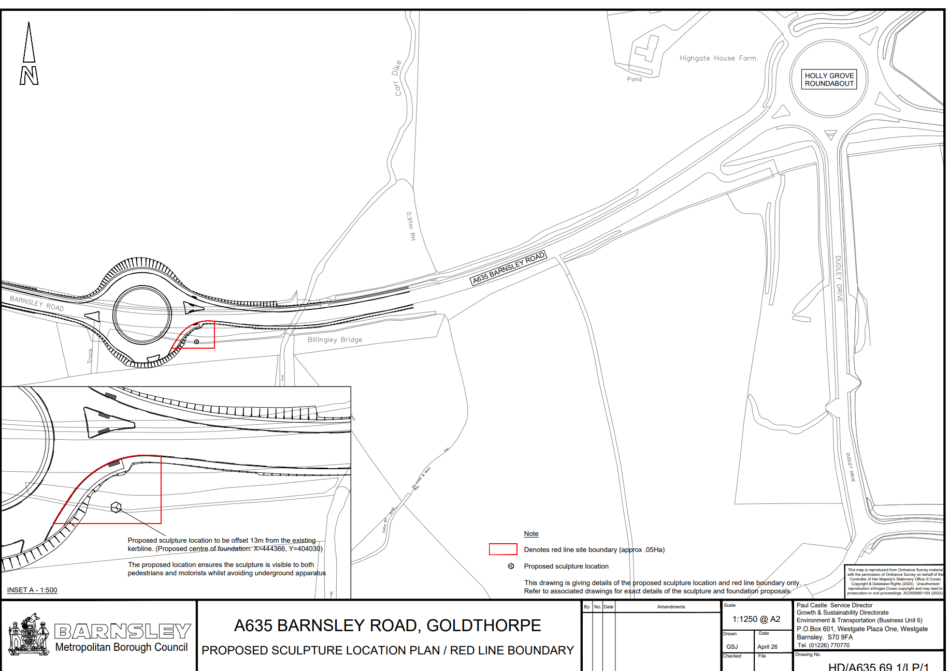

The artwork will be 5m in height onto a precast concrete foundation. The sculpture is fabricated in 3 parts. The diameter of the sculpture is 3000 mm. The total estimated weight of the sculpture is sculpture is 1875 kgs.
The sculpture is to be positioned approximately 13 metres back from the carriageway kerbline and is to be mounted on a one metre raised concrete foundation.
- Construction of foundations and installation of sculpture
CDE will manufacture a steel Jig for the foundations to be poured onto.
The design of the foundations has been undertaken by Barnsley Council and the foundation preparation works and concrete pouring will be undertaken by the Council’s highways dept.
The foundations are to be cast and let set for a minimum of 14 days prior to the installation of the 3 sculpture panels.

The installation of the sculpture will be by CDE

Installation method Summary
Ground preparations and concrete pouring of the foundations will be delivered and managed by the councils highways depot who will act as the Principal Contractor and Site Supervisor to manage the operations on site.
CDE have been requested to provide a Risk Assessment Method Statement.
The council are also undertaking the role as Principle Designer for the Foundation design element.
Traffic Management.
The councils highways dept will be co-ordinating the traffic management for the concrete pouring and installation of the sculpture.
- Flood Risk
Due to nature of the works, that are being a proposed sculpture and landscaping works, it is considered that the proposals will have no negative impact on flooding in the area.
The nearest residential property lies approximately 250m from the proposed site and is currently outside any flood zones 2 or 3
Extract provided below from government web site for flood risk maps for the location S63 9FA.
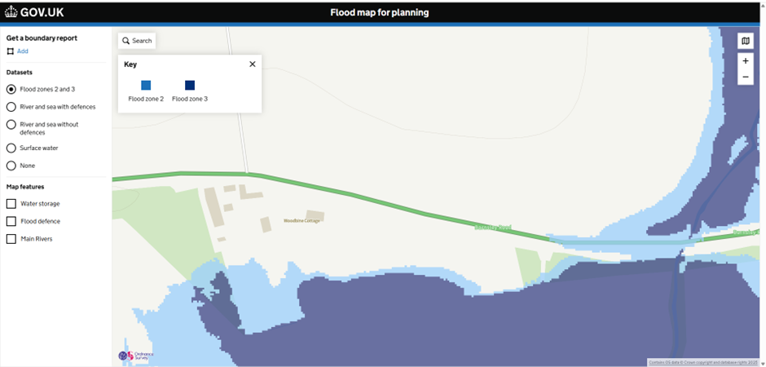

Access
The public will be able to view the artwork, from a public footpath
An interpretation board will be installed within close proximity of the sculpture and public footpath. This will provide a brief outline as to the inspiration behind the work and the artists’ concept for the design and a QR code, linking to a web page. Details will be hosted on an appropriate council web page/site, and this will be sign posted in Goldthorpe Library, Thurnscoe Library and other council owned buildings as appropriate

Risk Mitigation
Safety considerations have been of utmost importance from the beginning of the design process, including an RSA1/RSA2 assessment. A risk mitigation in response to the assessment was undertaken by BMBC engineers and traffic and this was authorised/signed off by the Highways Authority.

Maintenance
The artwork has been designed, with a depth of 1000 mm with minimal maintenance in mind. The longevity of galvanised steel in typical conditions is estimated at 75 years.
The mild steel has anti-graffiti properties.
Upon completion Daniel Jones will provide a maintenance plan which will recommend the frequency of the visual inspections.

