

Three types of charging point are currently used in the UK:
- 'Slow' points use a standard 13 Amp supply (6-8 hours for full charge);
- 'Fast' points use single or three-phase 32 Amps supply (3-4 hours); and
- 'Rapid' points provide direct current supply (typically 80% charge in 30 mins).

Additional costs are also incurred by electric vehicle users who install recharging equipment. While standard 13 A 3-pin sockets can be used for most electric cars, installation costs for a circuit protected 'slow' charging point cost around £250-£1000, depending on the difficulty of installation. Fully installed 'fast' and 'rapid' charging points cost between £5,000-£50,000 per point (depending on whether an on-board or off-board fast-charging system is used).
For most electric cars, It is expected that most charging will be performed at home, during (off-peak) night time hours when electricity is cheapest and it carbon intensity is lowest. Although a standard single-phase 13 amp three-pin domestic socket is adequate to charge a car in 6-8 hours, our advice is that a qualified electrician conducts a house survey to ensure that the wiring will safety support the relatively long periods of charging.
'Fast' charging at 32 amps using single- and three-phase supply is also possible for some electric vehicles, which reduces charging times to 3-4 hours for a standard EV. Faster still are 'rapid' chargers which use direct current (DC) – although these can only be used on some models.

Slow chargers
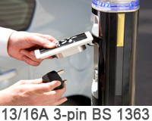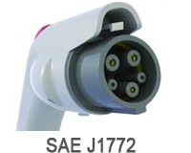The most common method of charging electric vehicles, uses a standard single-phase 13 Amp three-pin plug (BS 1363) and draws 3 kW of power – with a full charge typically taking 6 to 8 hours. The vast majority of publically accessible on-street chargers currently use this charger type, but more advanced alternatives are being developed (see below).
Nearly all electric models can be slow charged with each vehicles being supplied with a charging cable with the appropriate connectors – in this case with a standard three-pin plug or Blue Commando connector (IEC 60309) at the charging point end, and either a Commando unit or the more modern gun shaped SAE J1772 socket for connection to the vehicle.

Fast chargers
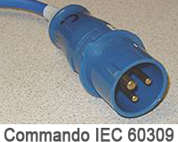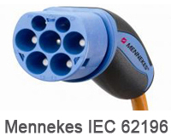Fast charging reduces charge times to around half that of a slow charge by at least doubling the current to around 32 amps (7 kW) – so that the time for a full charge is typically taking 3 to 4 hours. Most commercial and a small number of public on-street chargers use this technology – however, it is very likely that this charge rate will become increasingly used across the UK.
While not all electric vehicles are able to accept a fast charge at 32 amps, most can be connected to them (with the right connector) and will draw either 13 or 32 amps depending on their capability. Blue Commando plugs (IEC 60309) are the most common connector type used at the charger end, but these are being replaced by the versatile Mennekes plug (IEC 62196).
A limited network of High Power Chargers fast chargers, known as HPC chargers, has been installed by Tesla. These use the SAE J1772 plug connection at both ends of the charger cable and supply a 70 Amp single-phase current with power at 16.8 kW.

Rapid chargers
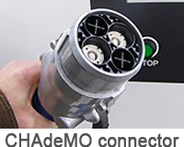Rapid chargers supply an electric vehicle directly with a direct current (DC) from a dedicated charging unit using a specialised plug socket (usually using the Japanese CHAdeMO standard). Often rated at around 50 kW (400 V DC/125 Amps), charging an electric vehicle to 80% typically takes less than half an hour. Due to their high cost only a few dozen rapid chargers are currently installed in the UK.
As with fast charging, not all electric vehicles can use a rapid charger. Unlike slow and fast chargers, the rapid units use dedicated CHAdeMO standard connectors that are required to carry the very high current. While the short charge times make this option very convenient, regular use of rapid charging can reduce battery life.
In all around 30 rapid charge points are installed in the UK (as of 2011) and are either located at selected Nissan dealerships (to support the LEAF) or within the One North East region.

Electric Car Site

Electric Car Charging Posts
The electric car charging post market is rapidly developing with new companies and products coming to the market almost every few months. The basic technology has become established - a secure post with one socket, accessed by an electronic tag. However, variations on this are springing up. Charging posts for 2 cars, quick charging, different outputs, electronic displays, consumption monitoring software etc.
As with the electric car charging points we will try to keep this up to date but if you think we've missed something please email us here .
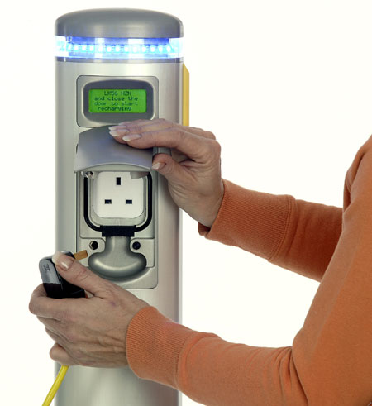
Electromotive - By far the most common public charging points are 'Elektrobays'. They are basically shoulder high posts with a plug socket mounted near the top. The bays have a yellow coiled power lead which will supply 240 volts AC at 13 amps. This is compatible with most electric vehicles.

They are suitable for installation indoors or out in the street and are supplied by a company called Elektromotive. The socket has a cover which is unlocked and opened by an RFID (radio-frequency identification) tag. This will be kept somewhere near the charging bay usually by a car park attendent or by shopping centre facilities management etc. In return for the tag you may be required to show some form of ID and / or leave a deposit.


POD Point - Hot on their heels however is the new 'POD point'. These are compatible with existing electric car charging tags.

You swipe the tag, open the socket, plug in and charge. You use your own cable for these charging points.

All POD points are wirelessly connected to a central communications network so usage and availability is monitored in real time and you have a linked online account.

Although focussed in London, POD points are available throughout the UK notably in Ireland and Scotland.

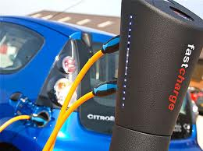
Chargemaster - Also on the UK scene is Chargemaster with their range of charging posts: fastcharge (twice the electric car charging speed of a standard post); homecharge (easy home driveway installation and automatically uses low-cost night-time electricity tariffs ); combicharge (capacity to charge at both 3kw (13A) and 7kw (32A); and dualcharge (can charge two electric cars simultaneously). The company is also getting involved in electric car charging schemes.

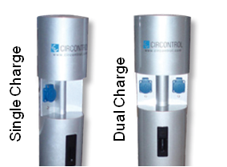
APT - APT Technologies have also entered the electric car charging market with their evolt on-street chargers. Like all charging posts they are designed against potential vandalism and are fully compliant with all electrical security regulations.
Easy to use and equipped with a simple secure access system. There is the single charge, dual charge (for 2 electric cars to charge simultaneously) and the evolt Xpress for faster charging.

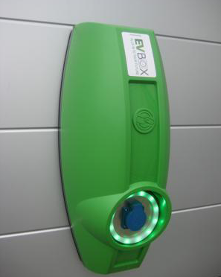
Charging Centre - Charging Solutions Ltd. Another new entry to the electric car charging market. They claim this charging system is future proof as it can incorporate all types of EV sockets and modular design allows easy assembly / disassembly. An LED ring lights up to display the status of the chargingcentre and imilar to all the other offerings it can be fitted with various control, access, or payment systems. The charging system does come with flexible mounting - a pole, wall bracket or surface mounting which should be good for different users . Available in standard Green but also Blue, Silver, Grey, Yellow or Orange.

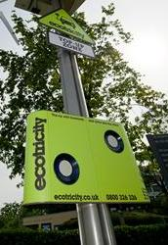
Ecotricity - ChargePoint Services Ltd and Ecotricity. This partnership is currently rolling out new electric car charging posts with a distinctive green triangle and solar panel. The hype is this is a free charging point powered by renewable energy. See our ecotricity blog article for more details. Photo and specification to come...

Nearest public charging point to Holmfirth appears to be at the Meadowhall Centre in Sheffield.

Charge Your Car Electric Car Charging Scheme

Charge your Car was launched in North East England in 2010. By 2013, the plan is that the North East region will be home to over 1,300 charging points, at key locations on streets, in car parks, at residential and commercial locations such as retail and leisure facilities.
The vision is not just for a regional scheme but a UK wide offering. It is hoped that other regions in the UK will join the scheme in 2011 and beyond creating a national network of charging points all available to existing and new Charge Your Car members.
Electric vehicle users can register to use any of the CYC charge points by becoming a Charge Your Car member. This allows you to charge your vehicle free of charge at all CYC networked charging points. Membership includes free parking whilst charging. Registration to CYC is online and users are sent a welcome pack and card to access the charging points. There is an annual membership cost.
For more information see the Charge Your Car website.

Q: Is there any way I can charge my electric vehicle faster?
A: Faster electric charging is possible using higher voltages and currents but that requires dedicated charging equipment. There are hopes that there will be three levels of charging system. There are standards for level 1 and 2 charging which stipulate the requirements for connectors and supply. The J1772 standard for electric vehicle charging which many manufacturers are adopting. Currently, no standard for level three exists however, which could potentially supply higher voltages (300-500) at very high currents (100+ amps) directly to the plug-in vehicle battery drastically reducing charging times. Fast charging connectors for some cars are therefore optional until the standards are finalised and most come at an additional cost.

Q: What is the best system for operating a charging post / posts?
A: It depends a little on who will be able to use the post(s) and how many there are, although the operation is the same. Charging posts can be networked through computer software - the software 'should' be compatible across different manufacturers posts . Users have an electronic tag (either individually) or often kept with the post (e.g. in car park attendants office). This is swiped to open the charging point and records the amount of electricity used against the tag. This can then be charged to an online account.
If the tag is kept with the post e.g. kept by an onsite member of staff to be accessed by other members of staff then the electricity cost can stay with one account to be met by the organisation. The post can also however be made available to members of the public. Either for 'free' where members of the public have access to the same communal tag from staff onsite (usually with a £20 deposit to make sure the tag comes back). Alternatively, members of the public can sign up to a charging network (this really works best if there are other posts in and around the city which they can use) - they then scan their personal electronic tag which is linked to an online account where they pay for the electricity they use.

Q: How many electric cars are there in the UK?
A: Depends who you ask. On the internet you can find anything from 1,000 to 56,000. The former seems too low and the latter must include hybrid vehicles. According to a report in July 2011 from the RAC the numbers are more like:
680 cars purchased under the Governments grant programme, taking the number of electric cars registered in the UK to approx. 2,500 out of a total of 28 million. By comparison, there were 81,000 hybrids registered in the UK by the end of 2010. Reports are that sales have stalled recently considered to be largely a result of the economic recession.
By 2035 the Government wants to see all (so 100% of) new vehicles sold to be Low Emission. In the recent Climate Change Committee’s report The Fourth Carbon Budget ” the target is 1,700,000 Electric Cars on the road by 2020".

