PHYSICAL |  | ACTIVITY |  | REHABILITATION
Supporting Document
December 2019

Bradley Mellor
Email: Info@onparhealth.co.uk
Tel: 07887406299

Current Position
I graduated from University with an honours degree in Sport and Exercise Science. Specialising in physiology, nutrition and exercise rehabilitation. I have worked for the last 5 years on a self-employed basis, under the business name On PAR Health. The business provides a range of one to one services to clients including

- Health related rehabilitation – e.g. cardiovascular disease (MI/stroke/high BP) diabetes, obesity
- Sports injury
- Performance development

I have been operating out of my parents’ garage (see appendix 1) using all of my own equipment. The equipment has been updated and added to as I have reinvested money back into the business. My client base has increased gradually over a 5year period. The majority of clients contact me from word of mouth, and the garage in which I operate has no signage. At present I am working to capacity (8-10 hours Mon-Fri, 5 hours Sat). This client base has been built despite having no toilets, changing facility, or any form of heating/air-conditioning.

Transition to new site
- The location of the new premises is a positive (see appendix 2), as it is across the road from the existing premises. This is accessible for all existing clients, and has scope to add signage to the front of the building for advertising.
- After speaking with Dr Sutton at Dove Valley Practice I aim to set up a link between the GP surgery and myself to offer exercise rehabilitation on a private basis from his recommendation. I aim to set up a link between the NHS and myself to provide training to patients with health related illnesses such as; diabetes, high bloody pressure, cardiovascular disease etc. This should provide me with an extensive list of clients in order to increase my working hours. Also the GP surgery is within half a mile of the new premises, which makes it easily accessible to all (see appendix 3).
- In order to transition to the new site I have hired an architect who has visited the new site and has drawn basic plans to show my vision for the gym (see attached file on email). I have also received a construction quote from a local company for the costs involved in setting up the new premises.
- In the design of the premises I have added 2 treatment rooms into the gym.
  - Treatment room 1 – Podiatrist. I have a podiatrist who is currently working for the NHS who is going to seek out private work and rent out the treatment room over the weekend.
  - Treatment room 2 – Physiotherapist. I have an established Physiotherapist (www.mamphysiotherapy.co.uk) wanting to rent a room on a long-term basis.
- The new premises will allow me to provide would be able to provide toilets, changing facilities and heating.
- Proposed opening hours for the new site are as follows;
  - Mon-Fri: 07:30 – 19:30
  - Sat: 8:30-12:30.
  - Sun: 8:30-12:30
- I will be working alone in the gym area of the new site. The work carried out will be on a 1 to 1 basis with clients, focusing specifically on exercise rehabilitation.
- There is adequate parking available on site for 15 vehicles. The plan which I propose requires a minimum of number of 12 parking spaces. This includes:
  - Exercise rehabilitation - 4 spaces
  - Podiatrist - 4 spaces
  - Physiotherapist - 4 spaces
This is on the assumption that each area is full seven days per week. However, this will not be the case during the week as only myself and the physiotherapist will be present.

Objectives

It is apparent that my application supports a number of key Barnsley, City Region and National economic objectives.

Active in Barnsley:
https://www.barnsley.gov.uk/media/10871/active-in-barnsley-strategic-plan.pdf
As stated in the Active in Barnsley strategic plan only 50.1% of Barnsley are active and there is an aim to increase this to 57.1% by 2021. I strongly believe that this business can support and help achieve this in many ways. The borough of Worsbrough is ranked the 3rd most inactive in Barnsley with 32.6% of the community classed as inactive. In addition to this, the two adjoining boroughs are ranked the most inactive in Barnsley.
Physical activity was one of three priorities in Barnsley’s previous Public Health Strategy (2016-2018) and continues to be a priority in the newly developed Public Health strategy2018-2021. It is clear that this business helps support the top priorities listed in the Active in Barnsley plan which are listed below;
- Active communities – use physical activity to help communities achieve their full potential. This community gym already has a large local client base and will look to extend this further across the adjoining boroughs. There is already an established running club set up on a Saturday morning where members of the local community meet to complete a variety of running routes. This is all a free service which is offered and is expanding each week. This is something that can develop further and with advertising can have an even bigger impact on the local community.
- Professional and volunteer networks – develop physical activity skills and knowledge across a variety of networks. This new venture will help develop and strengthen this network of professionals in the local community. There are 3 professionals who will be employed to deliver a range of services in the gym, including; physiotherapist, sports massage therapist and podiatrist.
Overall there are 5 outcomes which the Active in Barnsley strategy aim to achieve. All of which will be clearly supported by the new business which is being proposed.
- Improve health and wellbeing across the Barnsley population
By providing a range of physical activity services for the local community, exercise will be used as a powerful tool in the rehabilitation process. The benefits of exercise are well documented and has been proven to improve/impact positively on all aspects of health and wellbeing (mental, physical and social).
- Healthier lives for individuals
As mentioned in the business plan it is clear that the overall health of the community is a clear focus. There is a plan to develop nutrition within the business with an ultimate aim of providing healthy meals, drinks and snacks to the clients and local community through a smoothie and snack bar within the gym.
- A greater sense of community
The local community has always supported the gym and there is a large local client base with a number of members always walking to and from the current premises. This is something which can only develop as the business expands.
- Economic growth within the sector
The growth of a local business within the health industry can only encourage the public to become more active, and in turn help with the economic growth. The number of people who attend is directly related to the economic success of the business. This in turn will create more job opportunities within the business model, and then further business expansion i.e. opening another facility in the borough.
- A strong, well connected partnership
Developing partnerships across Barnsley is the only way the inactivity can be addressed and developed. As stated in the business plan it is clear that the business aims to develop partnerships with local GP’s to help improve the health and wellbeing of the local community.

Corporate Plan:
https://www.barnsley.gov.uk/media/4264/corporate-plan-2017-20.pdf
- The new venture is evidence of a local business, that has been able to flourish in Barnsley, which has enabled me to begin to think about further investment into the borough and to help diversify the services, with an aid to help assist with the delivery of a number of the councils past and future thriving & vibrant economy priorities, including: “create more and better jobs and good business growth” and to “Increase skills to get more people working”.
- The investment via the company’s ongoing commitment to the borough (invest in new machinery, purchase of unit, employ local residents) is testament to the growth of companies that Barnsley need to help further deliver its current and future corporate plan targets. Such companies should be supported and natured further to help reinvest and continue to contribute towards the councils long term economic plans.

Employment and Skills Strategy : More and Better Jobs
https://www.barnsley.gov.uk/media/3063/employment-and-skills-strategy.pdf
- The new venture will help to not only help to create up to 3 new jobs (initially) , all of which would be classed as “Better Jobs” for the Barnsley economy and are vital for the borough as it enters its next phase of restructuring.
- The linked company also have a track record of upskilling and progressing staff , allow residents of Barnsley to help get into work , get on in work and progress to help reach their own potential, this has included taking on apprentices and investing in skills based training and is something which will be supported via the new venture..

Inclusive Growth:
As Barnsley develops its new inclusive growth strategy it is clear that this project clearly supports a number of these key principles as evidenced above:
- More & Better Jobs – seeks to support in work training and progression, better paid job
- Supply chain opportunities- seeks to promote inter industry working and supports growth and safeguarding of business in deprived communities
- Puts People at the hearts of the project: (customers learning / training)
- Supports interventionist approach (delivery of public funded new business parks) to help aid economic growth
- Targeted support for the social economy: Support organisations in the social economy to create good jobs, widen economic ownership and retain wealth in the local economy.

Appendix 1 – Images of current premises
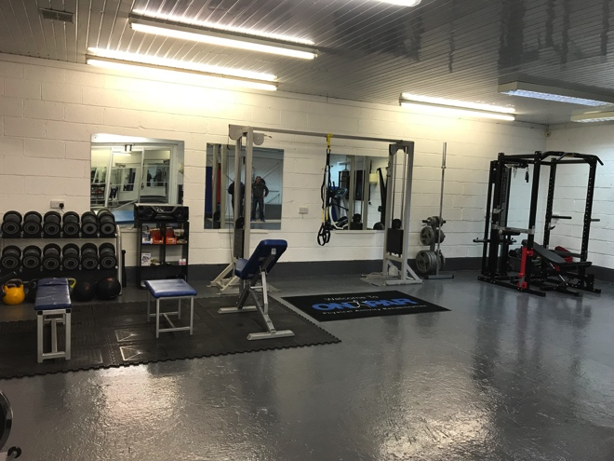
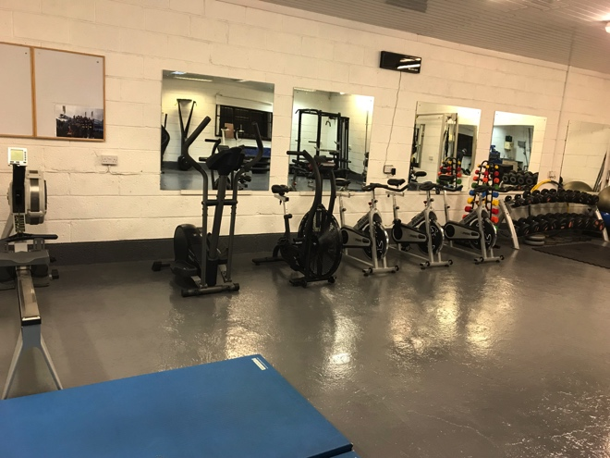

Appendix 2 – Images of new premises

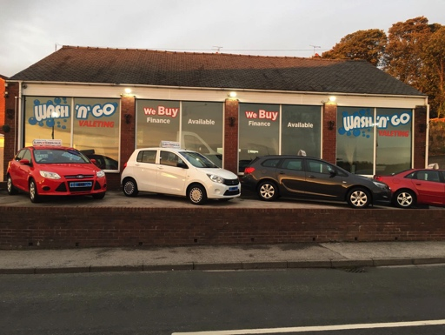
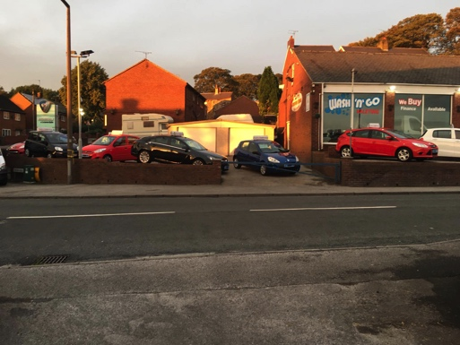
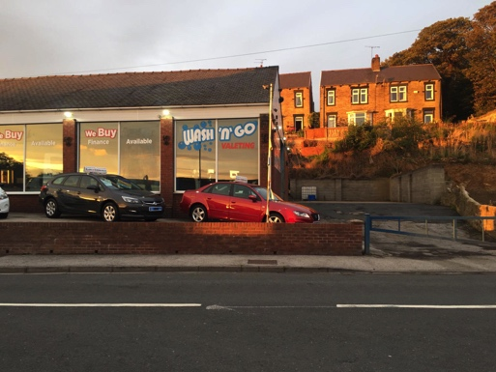

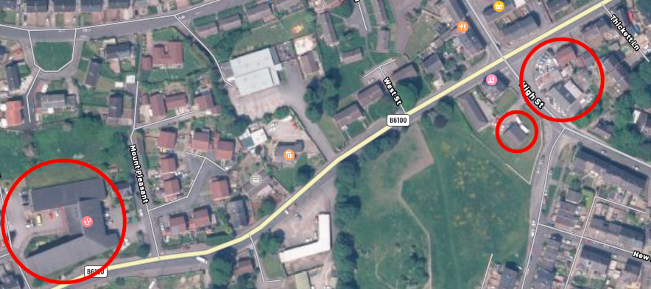
Appendix 3 – Map of current and new location
Dove Valley practice
Curent Location
New Location

Appendix 4: Property Search
Below are a range of properties available in Barnsley which do not suit the needs of the business proposed for a variety of reasons which are stated.
Car Pitch And Office At, Lambra Road, Barnsley, South Yorkshire, S71 1AA https://propertytoolkit.agencypilot.com/(S(da1jbhsntdcrx4sedzuiitv3))/PropertyDetails.aspx?siteid=34&pkey=34+2985
Reasons why the property is not suitable include:
- £12,000 per annum rental leasehold
- 2 mile away from current business
- Large outdoor space (indoor required)
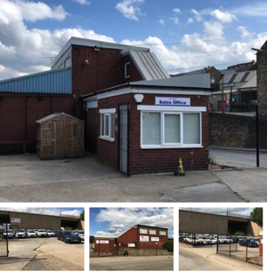
The Former Wombwell Lane Service Station, Wombwell Lane, Barnsley, S73 8EP http://www.wilbys.net/property/details-3851
Reasons why the property is not suitable include:
- Rental of £15000 per annum
- 2.5 miles away from current business
- Shared forecourt not private
- 1,782 sq. ft
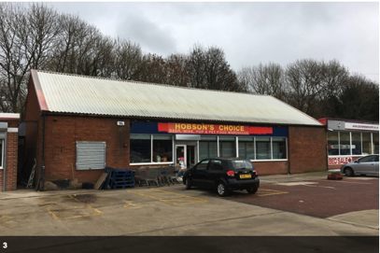
Chesham Road, Barnsley S70
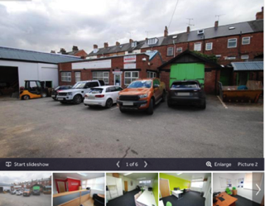
https://www.rightmove.co.uk/commercial-property-to-let/property-71951564.html
Reasons why the property is not suitable include:
- Rental of £807 per month
- 2.5 miles away from current business
- 1,152 sq. ft
- 4 small offices (large indoor space required)

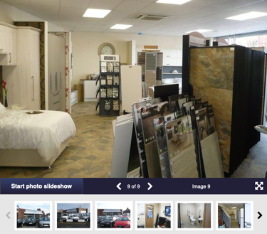
Retail premises to let in Barnsley Road, Wombwell, Barnsley S73 https://www.primelocation.com/to-rent/commercial/details/51280655?search_identifier=f76c36dc533413d6fff6b7bb958cb9c0#05JKRFIOuCd7Eq3h.97
Reasons why the property is not suitable include:
- Rental of £16,250 per annum
- 2.9 miles away from current business
- 1,307 sq. ft
- Only 3 parking bays
- Small indoor space

Former Co-op, 166 Barnsley Road, Darfield, Barnsley, S73 9DQ https://propertytoolkit.agencypilot.com/(S(da1jbhsntdcrx4sedzuiitv3))/PropertyDetails.aspx?siteid=34&pkey=34+424
Reasons why the property is not suitable include:
- Rental of £20,000 per annum
- 4 miles away from current business

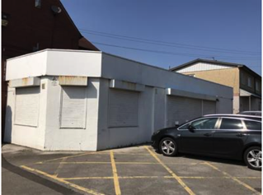

Hannaby Engineering Limited, Melville Street, Wombwell, Barnsley, S73 8HJ https://propertytoolkit.agencypilot.com/(S(da1jbhsntdcrx4sedzuiitv3))/PropertyDetails.aspx?siteid=34&pkey=34+2665
Reasons why the property is not suitable include:
- £225,000 (out of budget)
- 2.9 miles away from current business

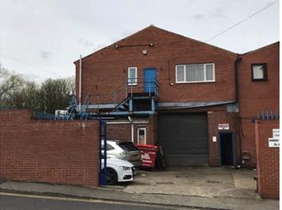
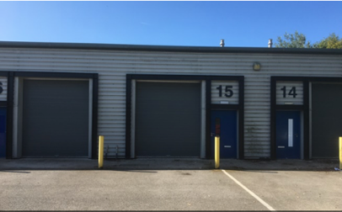
Unit 15 & 22, Longfields Court, Middlewoods Way, Carlton, Barnsley, S71 3GN http://www.wilbys.net/property/details-5091
Reasons why the property is not suitable include:
- £873,21 rental per calendar month
- 4.9 miles away from current business
- 1,136 sq. ft.
- No windows/open space/light
- Minimal parking available
- Industrial estate

Unit 6F Redbrook Business Park, Wilthorpe Road, Barnsley, S75 1JN https://propertytoolkit.agencypilot.com/(S(da1jbhsntdcrx4sedzuiitv3))/PropertyDetails.aspx?siteid=34&pkey=34+1167
Reasons why the property is not suitable include:
- Leasehold £15,445 per annum
- 4 miles away from current business
- No windows/open space/light
- Industrial estate
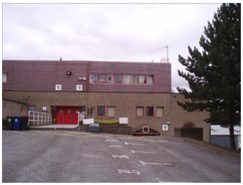

Claycliffe Business Park, Unit 19 Cannon Way, Barnsley, S75 1JU https://www.knightfrank.co.uk/properties/commercial/to-let/uk-yorkshire-south-yorkshire-barnsley/all-types/all-floor
Reasons why the property is not suitable include:
- Leasehold £12,000 per annum
- 4.6 miles away from current business
- No windows/open space/light
- Industrial estate/ recommended use distribution
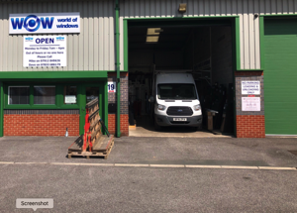

Unit 2, Mitchells Enterprise Centre, Baulk Lane, Wombwell, Barnsley, South Yorkshire https://www.commercialpropertypartners.co.uk/properties/unit-2-mitchells-enterprise-centre-baulk-lane-wombwell-barnsley-south-yorkshire
Reasons why the property is not suitable include:
- Leasehold £12,000 per annum
- 2.5 miles away from current business
- No windows/open space/light
- Industrial estate
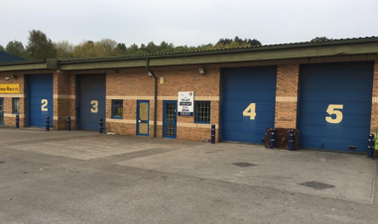
\

Unit 2, Old Mill Lane, Barnsley S71
https://www.primelocation.com/to-rent/commercial/details/50089913?search_identifier=7bb00d2e2e25643f855733283209cf0f#lIpvCHmyDvswhfFr.97
Reasons why the property is not suitable include:
- Property to let
- No price available
- 2.8 miles away from current business

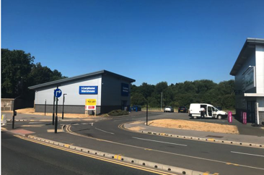

Mitchells Industrial Park, Bradberry Balk Lane Wombwell, Barnsley S73
https://www.primelocation.com/to-rent/commercial/details/51280987?search_identifier=28a1e67c6289db7fdc3724c647ca4676#LkgG3JbXE7ZRXVwO.97
Reasons why the property is not suitable include:
- Property to let
- No price available
- 2.5 miles away from current business
- Previous use as a recycling plant

