Location: 134 Genn Lane – Barnsley – S70 6NW
Report Type: Arboricultural Impact Assessment
Arboricultural Method Statement Tree Protection
Date: July 2022

Contents
- Section 1 : Introduction -
- Section 2 : Site location, and proposed development plans
- Section 3 : Tree protection measures during construction
- Section 4 : Pre-development Works - -
- Section 5 – Potential Conflict And control measure
- Section 6 – Appendix 6 Tree Data

Introduction
This report has been prepared by Dave Thomas of BAM Construction Ltd on behalf of the applicant Mr Bryan Mangham.
134 Genn lane is located in Wosbrough, Barnsley, and is accessed directly from Genn Lane
A pre-development survey of trees on the site was undertaken by AWA Tree consultants in April 2022 and a pre-development tree survey report was produced to guide design.
This arboricultural Impact Assessment, Method Statement, & Protection Plan has been prepared to further inform the development process.
This report considers tree data previously produced by AWA Tree consultants to provide further arboricultural information and advice in relation to the proposed re-development of the site.
It does not reassess the condition, retention values, or information previously supplied, but concentrates solely on the potential impacts of the proposals on the present tree stock.
The proposed changes include the Construction of a summer house in keeping with the current property which is a listed building, to further enhance the property and surrounding area.
Fig 1 shows the approximate extent of the site

Section 4
Pre - development works
Prior to site works commencing at 134 Genn Lane,, this method statement will be passed to all contractors and used as reference during construction.
Tree cover across the site is predominantly located around the periphery of the property with a mixture of semi mature stock predating much of the existing layout, with more recent tree planting across the property in the form of semi-mature individual landscape features.
All existing trees that come into conflict with the new development proposals and where possible will be protected by utilising heres type fencing [ SECTION 2 - Fig 2 ], and secured to 100 x 100 posts imbedded and concreted into the ground.
Note : The tree protection fencing will be erected prior to any construction works commencing.
Appropriate tree protection zone signage [ Section 2 – fig 3 ] with waterproof covering, will be affixed to the heres fencing and be placed at regular intervals warning that the works are in a “’Construction Exclusion Zone - Keep Out’ “
All Construction material and storage must be confined to an area outside of all root protection areas, all ground levels where trees are located should be maintained.
The fencing needs to be erected according to the locations found on the Tree Protection Plan. Fig 4 and maintained for the duration of the works

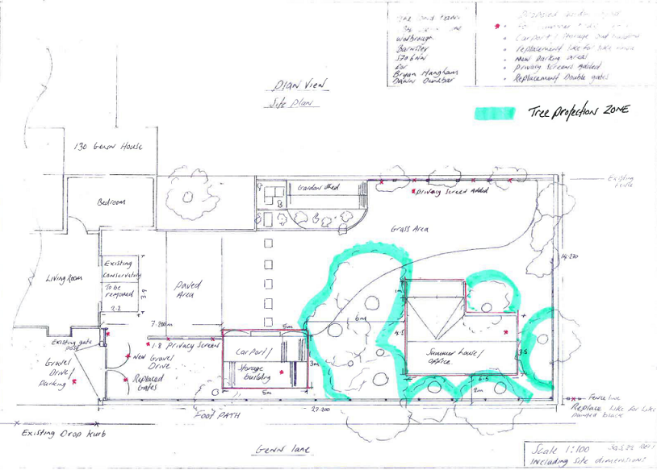

FIG 4
Site Information 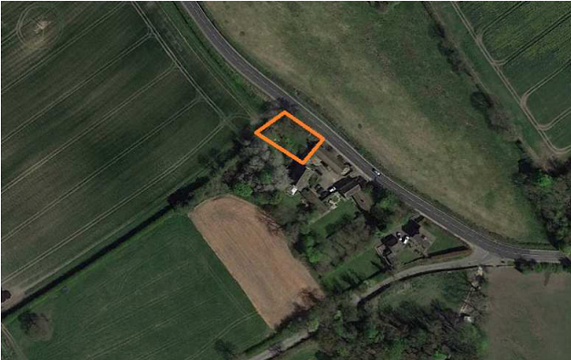
Fig 1

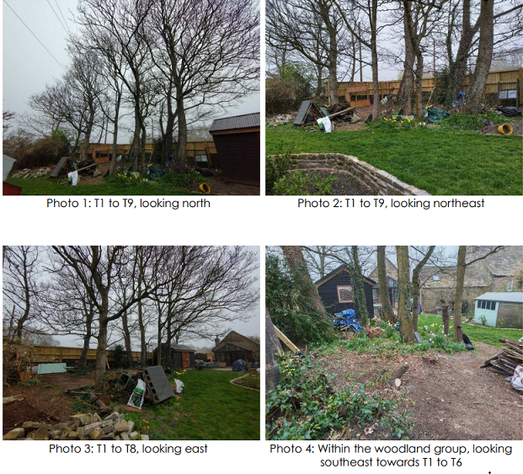

Section 5 : Potential Conflict and control measures
Damage to trees due to construction works and landscaping.
Trees can be damaged following construction when landscaping of gardens and tree planting is undertaken.
Mitigation / Countermeasure: Post development landscaping will be kept to a minimum within the root protection areas.
Tractor mounted rotavation or other heavy mechanical cultivation must not be used within the root protection areas of retained trees.
All cultivation within RPA’s will be carefully undertaken by hand or pedestrian controlled light machinery to avoid root damage.
Changes to soil levels adjacent to trees can severely affect the trees structural integrity and its ability to gain moisture and nutrients from the surrounding soil.
Building material storage and operations that can contaminate soil, such as cement mixing, must be confined to areas outside the construction exclusion zones.
The trees should not be used to attach notices, cables or other services.
Where plant or other boomed vehicles are used on site, care must be taken to ensure that no contact is made with any retained trees or the tree protection fencing, and that adequate clearances are checked prior to any lifting operations near tree cover.
- No new utilities are proposed within the root protection areas of retained trees.
- No alteration to existing underground services are proposed near or adjacent to trees,
Only once all construction works have been completed can the protective fencing and any ground protection be removed.
Post development landscaping should be kept to a minimum within the root protection areas of retained trees.
No ground excavation or mechanised ground treatments / rotavation will be undertaken within the protected areas of trees not previously subject to the impact of hard surfacing or buildings etc, with all landscaping being undertaken by hand or with hand operated machinery in these areas.
All excavations within root protections areas must only be undertaken using hand tools or pedestrian operated machinery.
The required excavations must be kept to a minimum to avoid unnecessary root damage and ideally undertaken during the presence of an arboriculturalist.
Great care must be taken not to damage the bark of roots that can be retained in order to avoid wounds which could be exploited by pathogens.
• Exposed roots that can be retained must be wrapped with dry sacking if to be left for extended periods e.g. overnight. Sacking must be removed prior to backfilling.

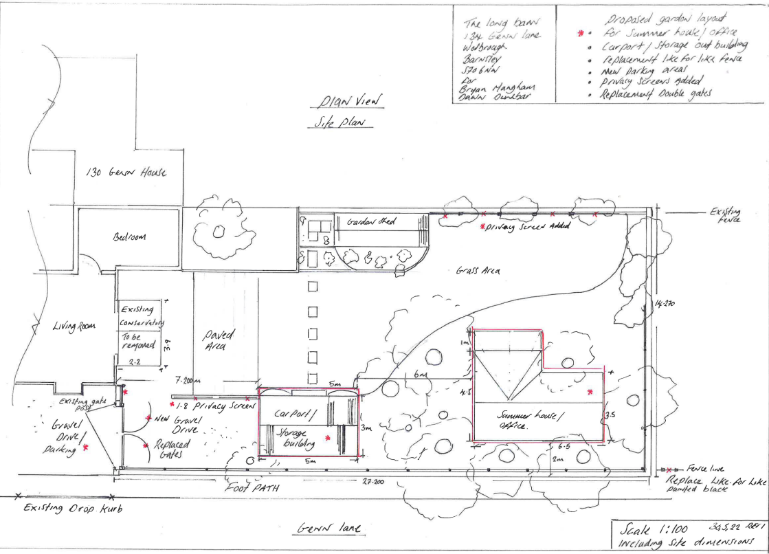

All roots >25mm should be preserved and worked around. Where this is not possible, severance should only take place after consultation with the tree officer / appointed arboriculturalist.
Roots must be cut using a sharp knife leaving as small a wound and as clean a cut as possible.
Great care must be taken not to allow contaminants, such as oils, into the excavation.

Appendix 6 : Tree Data
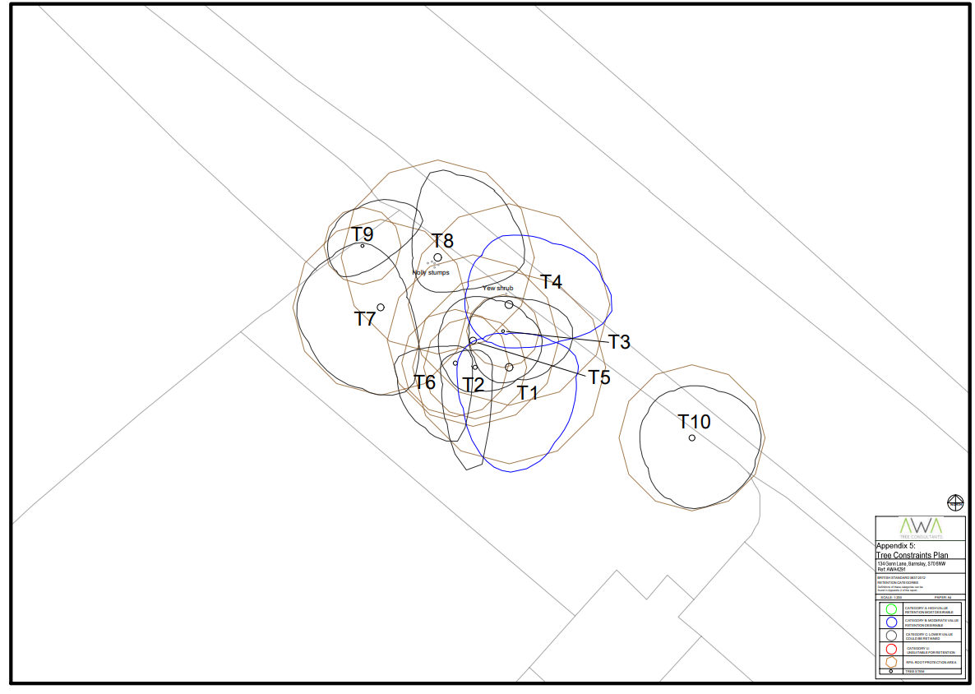

Section 3 – Tree protection measures
Damage to trees during the construction process.
During any construction process, trees could be damaged due a variety of reasons and construction pressures. Mitigation / Countermeasure:
All retained trees wil be protected during the construction process by the installation of appropriate protective fencing [ FIG 2 ]and maintaining the agreed construction exclusion zones as shown within [FIG 4] along with appropriate signage [ FIG 3 ]

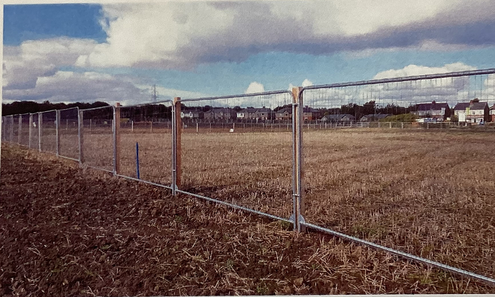
Fig2
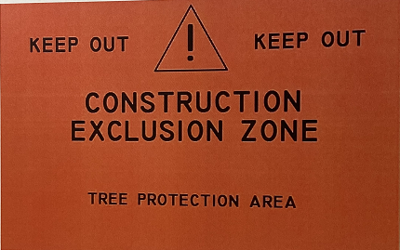
Fig 3

