We also plan to replace the windows and patio doors, which are insecure, and weather damaged in both the extension and original parts of the property. The scale and cost of this would likely require it to be undertaken in several stages. The current windows are wood and are rotting and leak (figure 5). They are bulky and do not appear to fit well with the diamond mullions of the original property, extending beyond the outer line of the house in places. At the Listed Property Show (23, 24 October 2024) in Great Malvern we sought advice from several window suppliers and a conservation oﬃcer who suggested alternatives including metal windows, which have a smaller profile and would fit better with the mullions. Touchstone Glazing Solutions (Brighouse) have advised us of Dronfield Woodhouse Hall, a Grade II* listed building that was granted approval to replace some of their current wooden windows with metal ones and a Grade II* listed building in S35 0JH which also had approval to fit metal windows, and we are keen to discuss if this is something we could do to our property.

Figure 5. Internal view of a window on the front elevation (showing details for original part of building).

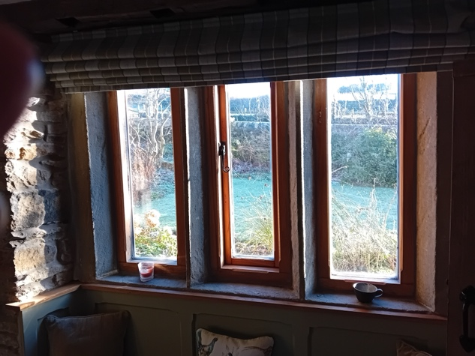

Figure 6.
Front elevation showing original part of building with windows to be replaced immediately.
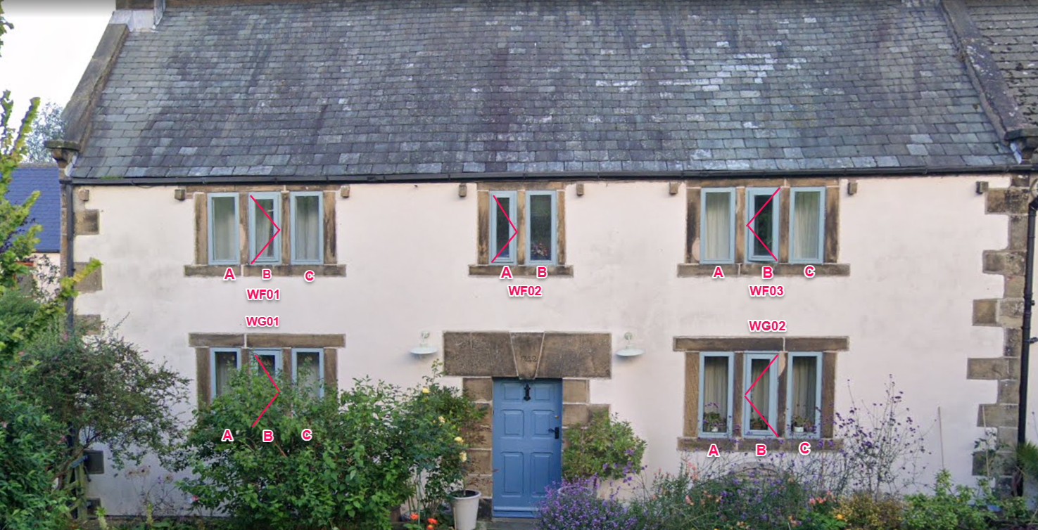

Figure 7. Details of replacement metal windows

We also aim to replace the patio doors (figures 8a, b and c). Details of replacement doors at Figure 9.

Height of opening: 2060mm
Width of opening: 1860mm
Both doors open outwards currently, although they leak and are diﬃcult to open
Length of wall between door and window: 1620mm

Figure 8a. Current patio doors

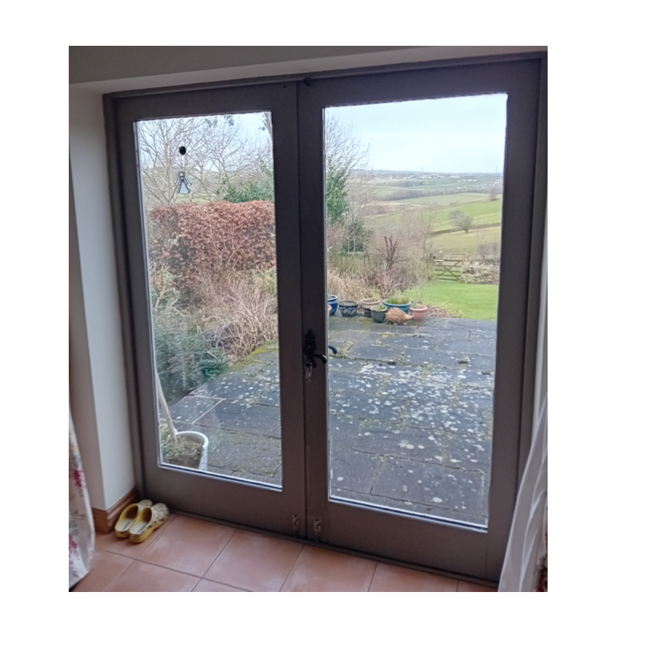

Figure 8b. Plan of patio doors

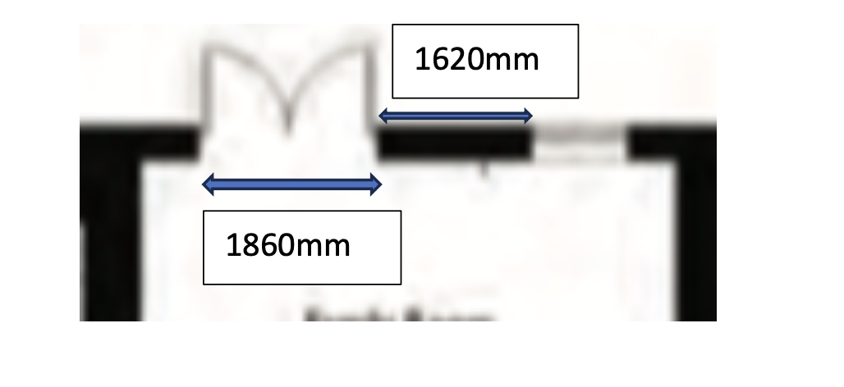
Figure 8c. Rear elevation showing patio doors and rear windows (apologies, but the image is reversed!)

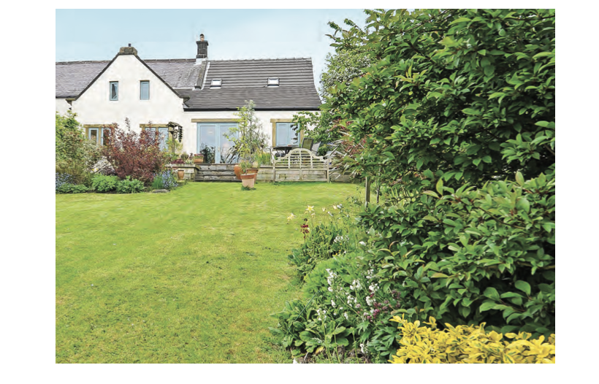

Figure 9. Details of replacement patio doors. Two options have been provided because we are advised that the tile floor covering and screeding to be laid in the family room will have an influence on the final dimensions of the doors.
Option 1

Option 2

Figure 10. Overall plan of ground floor.
