
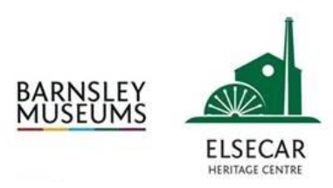

Heritage Statement in support of
Planning & Listed Building Application

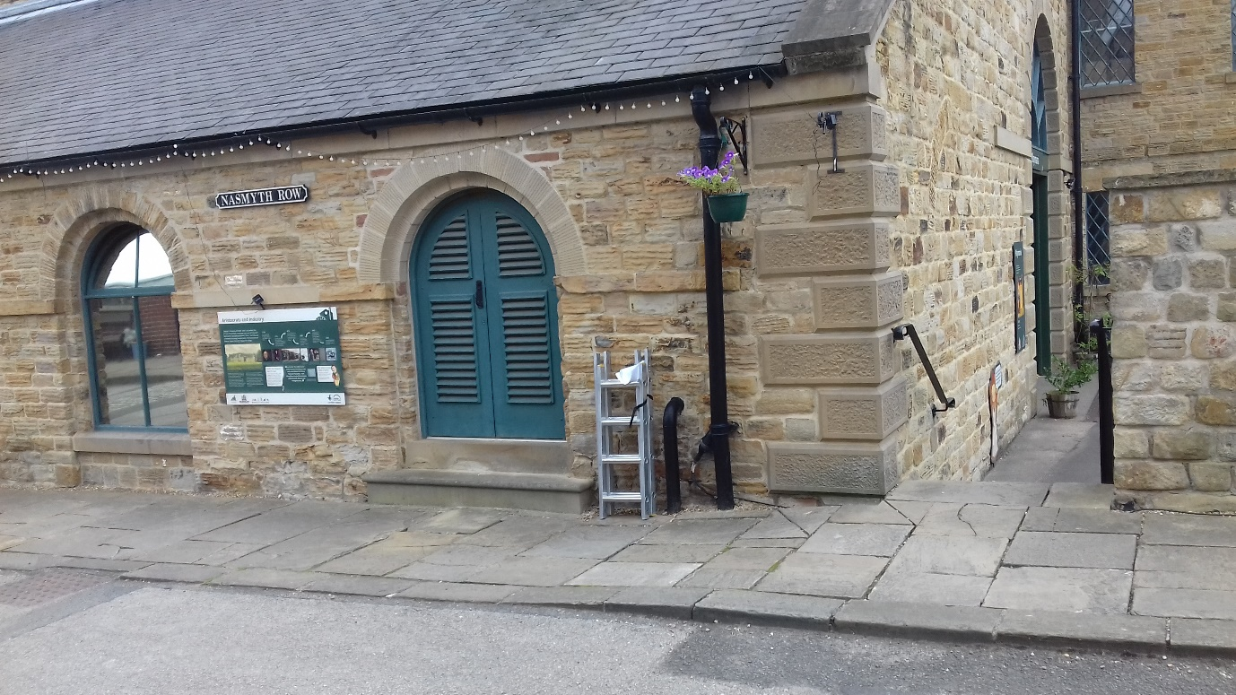

New Condensate drain
Building 17, Playmania, Elsecar Heritage Centre

March 2022

Contents

- Proposed works under consideration

- Relevant Legislation / Planning Policies

- Designated Heritage Assets

- Elsecar Heritage Centre History

- Heritage Values

- Heritage Impact Assessment

- Conclusion

- Appendix A – Listed Building Entries

Proposed works under consideration

The following impact assessment considers the heritage impacts of the works proposed to replace
the existing boilers serving Building 17 – Playmania. The original boilers are an old non-condensing type which are now not permitted under current Building Regs and are proposed to be replaced with a couple of modern more high efficiency low NOx condensing type boilers. This requires an outlet for the condensate from the boilers and as there is no internal drain we propose to drop the condensate pipe externally into a local soakaway under the adjacent pavement the required distance away from the building footprint. The only visible evidence of this externally will be an approx. 400mm length of black 32mm dia condensate drain pipe dropping from Boiler room floor level to below ground adjacent to the building. From here the condensate drain will run underground to a soakaway under the pavement. The condensate pipe will drop between an existing cast iron down pipe and existing black painted incoming gas main which will effectively “hide” the new condensate drain pipe.

Relevant Legislation / Planning Policy

Planning (Listed Buildings and Conservation Areas) Act 1990
In terms of the impact on the special character and appearance of the listed building, Section 16 (2) of the Planning (Listed Buildings and Conservation Areas) Act 1990, states:
In considering whether to grant listed building consent for any works the local planning authority or the Secretary of State shall have special regard to the desirability of preserving the building or its setting or any features of special architectural of historic interest which it possesses
The National Planning Policy Framework (NPPF)

NPPF para 189 and 190: The NPPF requires applicants to describe the significance (heritage) of any heritage asset affected by a proposal including any contribution made by the setting of the asset. The level of detail should be proportionate to the importance of the asset and the degree of intervention the proposal represents. The local Planning Authorities will take the heritage significance of an asset into account and consider any impacts on the asset to avoid conflict with the conservation of the asset.

NPPF para 193: Great weight given to an asset’s conservation, irrespective of the degree of harm

NPPF para 194: Any harm to or loss of significance will require clear and convincing justification

Barnsley Local Plan Policies

Barnsley Local Plan Policy HE1: The Historic Environment: Positively encourage developments that help in the management, conservation and understanding of the historic environment
Barnsley Local Plan Policy HE3: Developments affecting Historic Buildings: Proposals involving historic buildings should conserve and where appropriate enhance, respect historic precedents, and capitalise on opportunities to reveal significance

Designated Heritage Assets

This building is listed on the register and is regarded as a listed Grade II* building.

Elsecar Heritage Centre is a named Heritage Action Zone (HAZ), which is a partnership between Barnsley Museums and Historic England to further explore the history of the site. As a result of the HAZ, there have been 6 new listings on the site and 9 existing Grade II listings have been upgraded to Grade II* status, which puts them into the top 10% of England’s most important historic buildings.
The Former Elsecar Ironworks Site, the boundary of which sits behind Building 15, was also recently given Scheduled Monument status, which further adds to the historic value of the wider site and the village of Elsecar.
Elsecar’s History
The 4th Earl of Fitzwilliam inherited the Wentworth Estate from his uncle in 1782 and by the end of 1795 the Elsecar New Colliery has been sunk. By this time the Elsecar Ironworks has also been built by John and William Darwin & Co., and were originally situated near outcrops of ironstone towards the back of the Centre – you can still see the ruins of these buildings on the site today.

The ironstone was mined close to Elsecar, although the best ironstone came from Tankersley and was brought to the ironworks by horse and cart. Darwin & Co. sold pig iron and made domestic ranges, spouting rails for colliery tramways, window frames and arches which can still be seen on various buildings around the site.

Elsecar New Colliery was much deeper than those previously sunk in the area and so a Newcomen Beam Engine was built to extract water from the mine, allowing the exploration of deeper coal seams. The Engine ran from 1795 to 1923 when it was replaced with electric pumps.

The Elsecar workshops were built in 1850 to facilitate a more effective management of the various industrial enterprises around the Fitzwilliam estate. The coal board took over the workshops in 1947 following the nationalisation of the pits. As the collieries began to close the demand for the workshop facilities began to decline, eventually leading to their closure. In 1986 the Department of the Environment listed most of the buildings to be of special architectural or historic interest. Barnsley Council purchased the workshops along with the Newcomen Beam Engine in 1988 and started a programme of conservation and restoration.
Heritage Values

The significances and sensitivities of the heritage assets in the affected areas can usefully
be identified following the practice and advice provided in the English Heritage Conservation Principles (2008).

Evidential Value

Overall, the heritage centre has substantial evidential value with respect to what it can tell us about the past industrial production processes that were undertaken on the site. There are still a number of buildings on the site, such as the large prominent stone chimney in the heart of the centre and the workshops and offices, which also housed the Earl’s own private railway station where they would depart with their guests for days out to the nearby Doncaster racecourse for example.

Historical Value

Overall, the principal historical value remaining here would arise from the association with the previous landowners and the revolutionary industrial processes that they carried out on the site. The historical nature of the site hits you as soon as you walk into the courtyard, when faced with the sheer scale of the stone built industrial buildings such as Building 17, the former fitting shop, with the towering stone chimney beyond, which can been seen from neighbouring villages and beyond, acting almost as a landmark to the village itself. The cobbled streets and exposed railway tracks also add to the authenticity to the site history.

Aesthetic Value

The aesthetic value of the site at Elsecar is clear from the sheer scale of the site and the arrangement of the buildings on the site, which instantly give the impression of a functional, working industrial works. This is further enhanced by the well dressed, coursed sandstone buildings, many of which still display original features, which reflects the pride that the Fitzwilliam’s had in their estate. According to the listing (credit: Historic England) they would regularly provide tours to visitors and hold public open events to showcase their industrial achievements and breakthroughs.

Communal/Social Value

This area of heritage value is concerned with how heritage assets are used and valued by
society. Clearly, overall the heritage centre has a high degree of communal / social value. The site owned and operated by BMBC through Barnsley Museums as a free visitor attraction but also offers learning opportunities to local schools and is also popular as a wedding venue for those looking to get married in a historic, industrial setting. The presence of the Newcomen Beam Engine, for example, which is the only one of its type in the world that is still operational and in its original location, gives visitors a unique opportunity to experience a piece of history, which is unique to this site. The Heritage Action Zone status has also provided opportunities to engage with the wider borough and beyond including through the press and even TV, when ‘The Man Engine’ art installation visited the site in 2018.

Heritage Impact Assessment

The proposed works in the roof replacement provides an opportunity to remove the existing finish, which has low aesthetic value and replace it with a Welsh slate finish, which will reflect that of the original building. In addition to this, the renewal of the rainwater goods, will further enhance the appearance of the building and this can only be seen as having a positive impact on the heritage of this building and also the wider site. The remainder of the building fabric will be retained in its current state.

Conclusion

Overall, we would suggest the proposal is justified and represents no harm to the heritage significance of the listed building and is therefore in accordance with local and national planning policy.

Appendix A – Listed Building Entries (Source www.historicengland.org.uk)

Building 1, former Elsecar Ironworks casting shed
Heritage Category: Listed Building
Grade: II*
List Entry Number: 1465684
Date first listed: 19-Oct-2020
Statutory Address:
Elsecar Heritage Centre, Wath Road, Elsecar, Barnsley, S74 8HJ

Building 19, former workshop at Elsecar Ironworks
Heritage Category: Listed Building
Grade: II*
List Entry Number: 1191442
Date first listed: 04-Dec-1986
Date of most recent amendment: 19-Oct-2020
Statutory Address:
Elsecar Heritage Centre, Wath Road, Elsecar, Barnsley, S74 8HJ

Building 17, former fitting shop at Elsecar Central Workshops
Heritage Category: Listed Building
Grade: II*
List Entry Number: 1287085
Date first listed: 04-Dec-1986
Date of most recent amendment: 19-Oct-2020
Statutory Address:
Elsecar Heritage Centre, Wath Road, Elsecar, Barnsley, S74 8HJ

Buildings 4-7, stores at former Elsecar Central Workshops
Be the first to contribute
Heritage Category: Listed Building
Grade: II*
List Entry Number: 1465836
Date first listed: 04-Dec-1986
Date of most recent amendment: 19-Oct-2020
Statutory Address:
Elsecar Heritage Centre, Wath Road, Elsecar, Barnsley, S74 8HJ

Buildings 2 & 3 and boundary wall, former Elsecar Ironworks entry range
Heritage Category: Listed Building
Grade: II*
List Entry Number: 1465834
Date first listed: 04-Dec-1986
Date of most recent amendment: 19-Oct-2020
Statutory Address:
Elsecar Heritage Centre, Wath Road, Elsecar, Barnsley, S74 8HJ

Buildings 8-12, former workshops, offices and warehousing at the former Elsecar Central Workshops
Heritage Category: Listed Building
Grade: II*
List Entry Number: 1465837
Date first listed: 04-Dec-1986
Date of most recent amendment: 19-Oct-2020
Statutory Address:
Elsecar Heritage Centre, Wath Road, Elsecar, Barnsley, S74 8HJ

Buildings 13-14, former railway station, offices, housing and gate piers at Elsecar Central Workshops
Heritage Category: Listed Building
Grade: II*
List Entry Number: 1191337
Date first listed: 04-Dec-1986
Date of most recent amendment: 19-Oct-2020
Statutory Address:
Elsecar Heritage Centre, Wath Road, Elsecar, Barnsley, S74 8HJ

Buildings 20a and 21, former rolling mill at Elsecar Ironworks, including two halved colliery pit
Heritage Category: Listed Building
Grade: II*
List Entry Number: 1151097
Date first listed: 04-Dec-1986
Date of most recent amendment: 19-Oct-2020
Statutory Address:
Elsecar Heritage Centre, Wath Road, Elsecar, Barnsley, S74 8HJ

The former Elsecar New Colliery, including the Elsecar Newcomen Engine
Heritage Category: Scheduled Monument
List Entry Number: 1004790
Date first listed: 22-May-1973
Date of most recent amendment: 20-Oct-2020
Statutory Address: Newcomen Engine House, Distillery Side, Elsecar, Barnsley, S74 8HN

Housing at the former Elsecar Ironworks, 2 and 4 Forge Lane
Heritage Category: Listed Building
Grade: II*
List Entry Number: 1151096
Date first listed: 04-Dec-1986
Date of most recent amendment:
19-Oct-2020
Statutory Address:
2 Forge Lane, Elsecar, Barnsley, S74 8ER
Statutory Address:
4 Forge Lane, Elsecar, Barnsley, S74 8ER

Building 22, former Joiner's Shop, including chimney and rebuilt boiler house (building 16)
Heritage Category: Listed Building
Grade: II*
List Entry Number: 1315025
Date first listed: 04-Dec-1986
Date of most recent amendment: 19-Oct-2020
Statutory Address:
Elsecar Heritage Centre, Wath Road, Elsecar, Barnsley, S74 8HJ

The former Elsecar Ironworks
Heritage Category: Scheduled Monument
List Entry Number: 1465668
Date first listed: 20-Oct-2020
Location Description:
The eastern portion of Elsecar Heritage Centre, Wath Road, Elsecar, extending uphill eastwards to include the terrace on Furnace Hill, which was the former charge yard, along with associated features.

