PlanningStatement July 2019

Unit 7, Nexus @ Capitol park, Dodworth, Barnsley, S75 3UB

Change of use from a B1, B2 & B8 Unit to a flexible use of B1, B2, B8, D1 &D2.

Preparedfor:Premier Technical Ltd




Table of Contents
1. Introduction 3
2. Site Context 4
3. Description of Development 6
4. Planning Policy Context 9
5. Planning Analysis 13
6. Sequential Test 19
7. Summary and Conclusions 26
Appendices 29
Appendix 1 30
Appendix 2 31
Appendix 3 32
Appendix 4 33
Appendix 5 34
Appendix 6 35
Appendix 7 36
Appendix 8 37
Appendix 9 38
Appendix 10 39
- Introduction

This planning statement has been prepared by Premier Technical Ltd in respect of Unit 7, Nexus @ Capitol Park, Dodworth, Barnsley (Figure 1). The statement is to accompany a planning application for a flexible change of use of Unit 7 incorporatingalready designated employment use alongside a Flight Simulation experience and training centre.

This planning statement examines the planning context for the site and provides analysis of the development proposals. Accordingly, this report is structured as follows;

- Site Context;
- Description of development;
- Planning policy context;
- Planning analysis;
- Sequential test; and
- Summary and conclusions

Figure 1 – Proposed unit 7
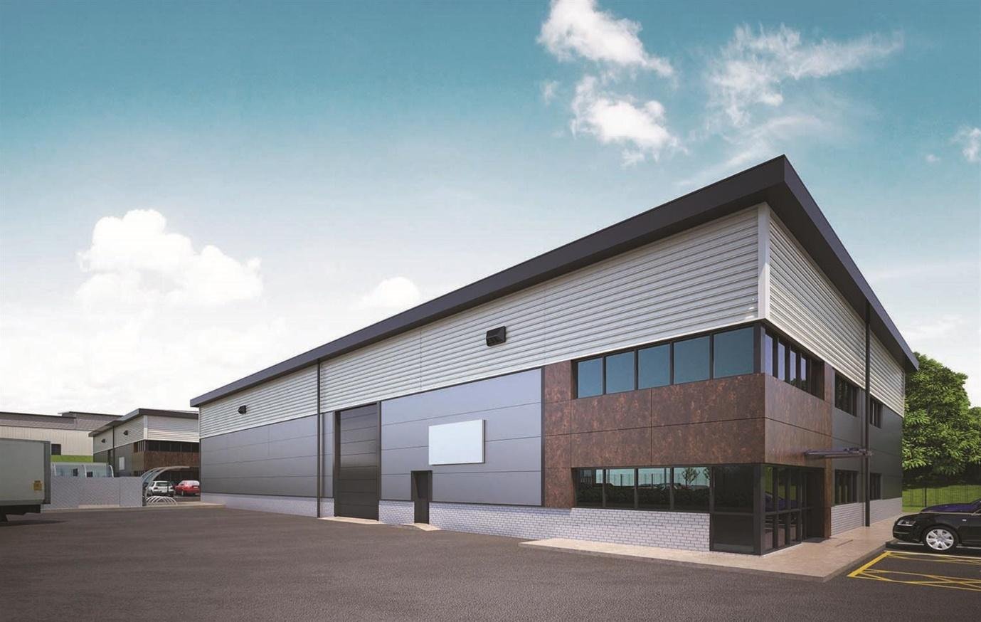

- Site Context

The Site
Outline Planning Permission was originally granted in 2005 for employment development (comprising B1, B2 and B8 Use), a hotel and park and ride site at Capitol Park (ref: B/04/1998/DO). The first phase of the Capitol Park development, comprising a hotel and pub/restaurant was built in 2006, and is located to the east of the Whinby Roundabout. Later phases of Capitol Park, comprising a mix of office and incubator business units, are located to the north and west of Capitol Close, which is the principal estate road. Current occupants of the wider development including Gem Imports, BREBUR and the NHS with a Blood bank Facility (Figure 2).To the north and east of the development lies the M1 motorway. Beyond that is a large proposed development (MU1 in Barnsley Local Plan) that will combine a mixture of housing and local facilities.

Figure 2 – Capitol Park development
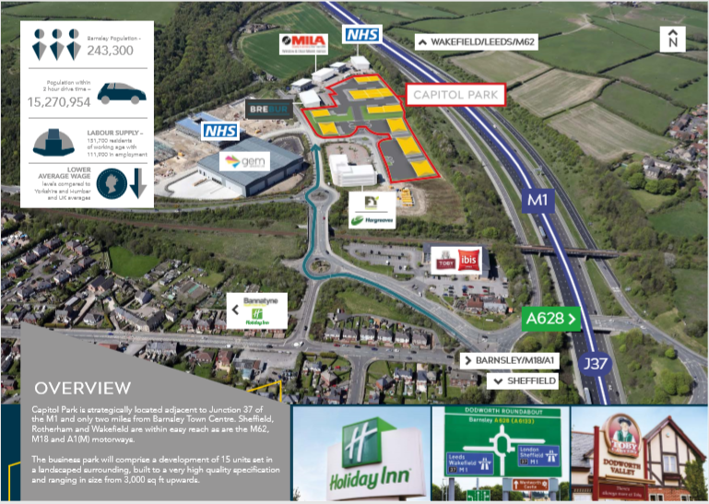

Planning permission was granted on 20th December 2017 for the erection of 15.no industrial units in 8 blocks with associated car parking (ref: 2017/1002). All pre-commencement conditions attached to this permission have been discharged, although Barnsley Council’s website indicates that some conditions relating to post-commencement and occupation stages remain to be discharged. They are on course to be completed in September 2019.

Nexus @ capitol Park
Nexus @ Capitol Park is the latest phase of The Capitol park development (Figure 3) where the aforementioned units have been constructed. The relevant planning permissions relating to Nexus @ Capitol Park are included in table 1 below;

Table 1:Planning application history
Reference | Description | Decision
2017/1002 | Erection of 15 no. industrial units in 8 blocks  (Classes B1, B2 and B8) with associated car parking. | 20.12.17
2017/1109 | Reserved matters of 2016/0713 – Erection of  general use Industrial (B2) use and storage  and distribution (B8) use with ancillary office (B1) use | 25.10.17
2016/0713 | Outline Planning application means of access for  general industrial (B2) use and storage and  distribution use (B8) with ancillary office (B1) use | 07.10.16

The applicant has currently got in place a pre agreement for a five year lease on unit 7 with the landlord, subject to planning permission being granted. Unit 7 hastotal floor space of 7,181 Square feet with 6,003 allocated to ground floor warehouse and office and 1,178 to first floor office. Crucially is has eaves height of 7.2 metres and a 4 metre full height loading door (Appendix 1). There are 7 parking spaces including 1 for disabled use. The building has reserved matters planning permission for employment uses (Use class B1, B2, B8)(Appendix 2)
Figure 3 – Nexus @ Capitol Park
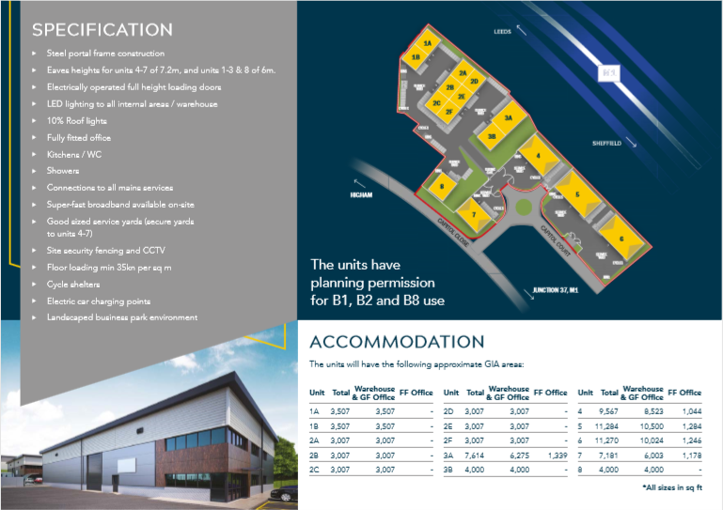
- Description of development

This planning application seeks approval for the following description of development:

Flexible change of use of building from employment use (B1, B2, B8) to a flight simulation experience and training centre (B1, B2, B8, D1, D2)

The flexible change of use would enable the unit to revert back to the consented employment use (B1, B2, B8) without requiring further planning permission. Only a part of the building will be used for Leisure and training use (D1,D2) with employment use (B1,B8) in the form of light industry, storage, offices and elements of Research and devlopment still forming a large part of the development proposal (Figure 4). It would also be considered that the permission if so granted was done on a personal permission basis whereby the D1 and D2 use would cease on the applicants vacation of the premises and revert back to the already consented employment uses.

Figure 4 – Proposed layout of Unit 7
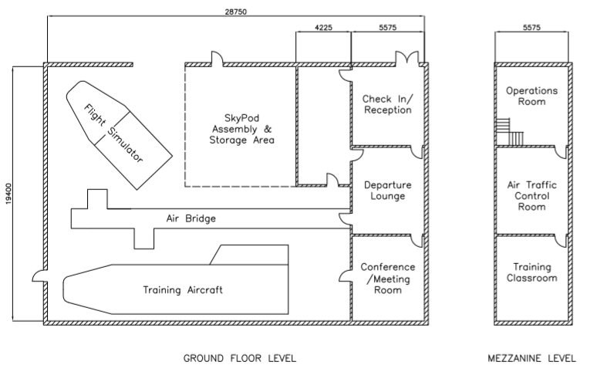

It would also be agreeable that the permission to change to a D1 and D2 use relates solely to the change of use described in the application form and planning statement. No other uses falling within the D1 and D2 category would be so permitted.

Additionally no exterior changes are proposed to the building and the development will cause minimal impact to the outside areas of the unit.No permanent interior alterations are proposed with only removable and superficial alterations required in order to progress the development.

The business
Premier Technical Ltd is a successful and established manufacturing and sales business formed in2009 and based at industrial premises in Goldthorpe. It has been supported since 2012 by BMBC’s award winning Enterprising Barnsley which has allowed it to grow and flourish and consider diversifying its services. The new venture is an opportunity to further build on their success and help promote BMBC’s emerging inclusive growth strategy.FlyMe Ltd was formed in 2019 as a subsidiary of Premier Technical Ltd.

The business plan for FlyMe Ltd and the proposed use of Unit 7, Nexus @ Capital park can be seen in Appendix 4 but the key points of it are as follows;

- FlyMeis as a fully immersive airport and flight simulator experience open to both public and corporate clients.The attraction will give the opportunity for groups, organisations, families or individuals to take to the cockpit of real passenger aircraft using the latest simulation visual and motion technology.

- All set in a themed airport environment using sounds, lighting, visuals and objects recreating the ‘theatre’ and excitement associated with air travel.The airport will contain a former passenger aircraft, a Boeing 737 previously operated by awell known commercial airline.

- Part of the unit will be used to finish, store and distribute“SkyPods” made from recycled airplane parts. The heavy manufacture of these will be done at the Goldthorpe facility with light industrial and storage proposed for Unit 7, Nexus @ Capitol Park. They will have a diversified market and are part of the business plan in Appendix 4.

- There will also be a further fully restored, recycled airplane housed in the unit where cabin crew training and health related courses can be carried out in association with local colleges and universities to enhance the local skill set and quality of courses offered.

- The business will employ 15 staff (9 FTE), bringing a new pool of skills to the area as well as increasing capacity (2 more full time staff) and job security at the Goldthorpe production facility.As the popularity of the attraction grows, it is anticipated that so will the required workforce.

- As a unique visitor attraction to the UK, people are expected to travel from various locations around the country. With this in mind, the attraction will support the local economy in terms of accommodation, nearby food outlets, plus the chance for people to see other attractions in the Barnsley area during their visit.

- As well as public, the business will attract businesses and corporate clients to the area and showcase what Barnsley has to offer in terms of investment and innovation. As a local company run by local people, raising the Gross added value (GVA) of the borough is an important consideration.

The business plan and proposal has the full backing of the Landlord of unit 7, the bank (Appendix 5), Enterprising Barnsley and local MP and Mayor of the Sheffield City Region (who provided a £2.20m loan for the construction of the units), Dan Jarvis (Appendix 6) who is excited by the prospect of such a unique business and attraction looking to invest in the Barnsley Borough. Local colleges are also showing a preliminary interest in using the facility to enhance their training and course content.
The Airplane for the simulator has been ordered and is due in the coming weeks, the first 2 pods are under construction and the website is set for launch. The business is set to go and awaiting a suitable unit to begin the recruitment process and get the business off the ground.

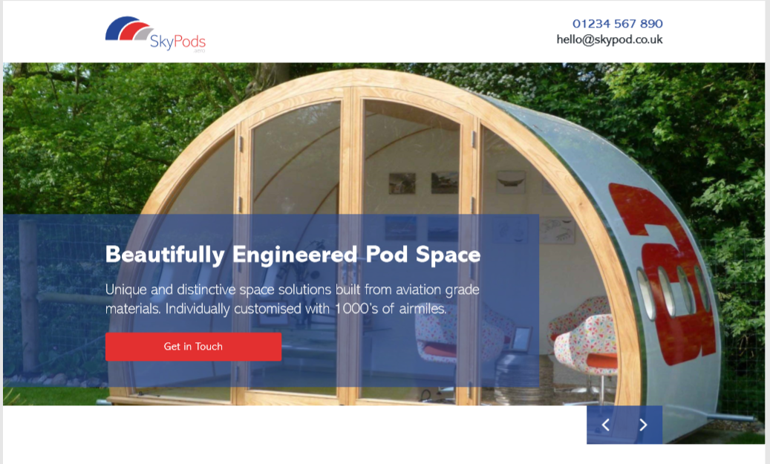

- Planning Policy Context

National Planning Policy Framework 2019

The National Planning Policy Framework (NPPF) provides details of national planning policy for England and Wales.

At the heart of the NPPF for decision making is the presumption in favour of sustainable development. For decision making this means;

- where there are no relevant development plan policies, or the policies which are most important for determining the application are out-of-date, granting permission unless:

- the application of policies in this Framework that protect areas or assets of particular importance provides a clear reason for refusing the development proposed; or
- any adverse impacts of doing so would significantly and demonstrably outweigh the benefits, when assessed against the policies in this Framework taken as a whole.
One of the NPPF’s 3 overarching objectives for sustainable growth is;
- an economic objective – to help build a strong, responsive and competitive economy, by ensuring that sufficient land of the right types is available in the right places and at the right time to support growth, innovation and improved productivity
Paragraph 81 of the NPPF states planning policies should be flexible enough to accommodate needs not anticipated in the plan, and to enable a rapid response to changes in economic circumstances
Paragraph 82 of the NPPF states planning policies and decisions should recognise and address the specific locational requirements of different sectors.
Paragraph 85 of the NPPFstates planning policies shouldallocate a range of suitable sites in town centres to meet the scale and type of development likely to be needed, looking at least ten years ahead. Meeting anticipated needs for retail, leisure, office and other main town centre uses over this period should not be compromised by limited site availability, so town centre boundaries should be kept under review where necessary
Paragraph 86 Local planning authorities should apply a sequential test to planning applications for main town centre uses
Paragraph 87 of the NPPF When considering edge of centre and out of centre proposals, preference should be given to accessible sites which are well connected to the town centre
Barnsley Local Plan (2014-2033)
Policy E3 on The Barnsley Local Plan (BLP)set the allocation of employment land of which Capitol Park falls under (ES5 on Appendix 3). On such land the following designated uses are allowed;
- Research and development and light industry (B1)
- General industry (B2)
- Storage and Distribution (B8)
Policy E3 also dictates that proposals for other employment generating uses may be considered on their merits, particularly in terms of providing jobs, skills and their contribution to the borough’s GVA.
Paragraph 8.23 of the BLP then goes on to state;
- Provision is made on the majority of sites for a range of employment creating uses. These will be mainly uses falling within Parts B1, B2 or B8 of the use classes’ order 1987. However, so that the process of widening the economic base and diversifying the local economy is not hindered, other job creating uses may be allowed.
Policy E5 is charged with Promoting Tourism in the borough and aims to do so by;
- Encouraging the provision of a wide range of venues and opportunities for cultural activity
- Encouraging the growth of the business tourism sector.
Paragraph 8.28states the future development of tourism is an important issue in both urban and rural areas. Tourism has an important role to play in Barnsley’s economy. We want to build on existing tourism potential of current attractions and to support and explore all opportunities to improve existing destinations and create new tourism and cultural attractions.
Parking Supplementary Planning Document (SPD) (2012)
The SPD supplements the Core strategy policy CSP 25 by setting out the parking standards the council will apply to all new developments. The maximum parking spaces per unit were determined at the original planning application for the site as a whole. This proposal has considered the maximum number of spaces permitted for each class of use the unit would be used for per the Regional Spatial Strategy (RSS)framework;
B1- 22 Spaces and 1 disabled bay
B2- 11 Spaces and 1 disabled bay
B8- 8 Spaces and 1 disabled bay
D1- 7 Spaces and 1 disabled bay
D2- 30 Spaces and 1 disabled bay

The proposed unit has 7 spaces and 1 disabled bay meaning it is at or below the maximum allowed spaces of any of the classes of use that permission is sought for. The unit itself sits at only 676 Sq M and so is well below the threshold of requiring the aforementioned standards but for robustness this process has still been carried out.

Planning Practice Guidelines
The planning practice guidelines (PPG) suggest it may not be possible to accommodate all forecast needs in a town centre: there may be physical or other constraints which make it inappropriate to do so. In those circumstances, planning authorities should plan positively to identify the most appropriate alternative strategy for meeting the need for these main town centre uses, having regard to the sequential and impact tests. This should ensure that any proposed main town centre uses which are not in an existing town centre are in the best locations to support the vitality and vibrancy of town centres, and that no likely significant adverse impacts on existing town centres arise.
The PPG goes on to state that;
- “promoting development on town centre locations can be more expensive and complicated than building elsewhere, local planning authorities need to be realistic and flexible in terms of their expectations”
The planning practice guidelines (PPG) also suggest when planning for tourism, local planning authorities should:
- consider the specific needs of the tourist industry, including particular locational or operational requirements;
- engage with representatives of the tourism industry;
- examine the broader social, economic, and environmental impacts of tourism;
- analyse the opportunities for tourism to support local services, vibrancy and enhance the built environment; and

Visitor Economy Strategy for Barnsley
According to this document, the vision for the Visitor economy in Barnsley is that by 2020, Barnsley will be recognised as an emerging tourism destination and be seen as a place worth visiting. In order to deliver this, one of 4 priority areas is;
- Investment– Providing high quality and distinctive experiences for visitors
The visitor economy is one of the five priority economic sectors identified by the council and the strategy goes on to cement the need for creativity and imagination to provide experiences which appeal to 21st century visitors.
In an overall growing sector, other unique experiences in the borough have been doing well. The strategy document states;
- Elsecar Heritage Railway footplate experiences have increased by a staggering 84% demonstrating the value visitors place on unique experiences.
In the SWOT (Strengths, Weaknesses, Opportunities, Threats) analysis provided by this document, on the list of main weaknesses are the following;
- Lack of quality, rounded visitor offer to attract longer stays
- Lack of major national attraction
- No sizeable competitive conference or meetings venue
This proposal addresses all of the above identified weaknesses in that strategy.

- Planning Analysis

Principle of Development
The principle of this development is to retain and operate within the parameters set out for land designated for employment use in policy E3 of the BLP. The ancillary business use and the light industrial use and storage are already of permitted use and will make up around 30% of the development while the D1 and D2 usage will create employment (Appendix 7) itself and bring skills to the area. The proposed use is as such, an employment generating use. Policy E3 of the BLP states proposals for other employment generating uses may be considered on their merits, particularly in terms of creating jobs, skills and their contribution to the borough’s GVA.
The direct contributions are obvious from Council Tax (BMBC), Corporation Tax, Vat and PAYE (Public purse) and rent to the landlord but other financial contributions must be considered.
The jobs and associated level of jobs that the business will help to provide will help to make a telling contribution to the economic offer of the borough. As all the jobs created will be classed as “Better Jobs” which is a clear requirement for not only Barnsley’s economic strategy, but its emerging inclusive growth strategy. Such jobs all pay above the living wage levels and command a skills level of equivalent to at least NVQ level 3-4 and would command salaries of £25-35K.Such jobs and commanding salaries would be equivalent to national pay salary level mean levels £26K - £31K (Source ONS ASHE 2018) which from a jobs perspective dramatically improve the economic offer of the economy (move away from a potential Low wage/un skilled economy) and also provide a higher quality of job compared to traditional B use roles (£20.1K)
It is also apparent that given the types of customers who would utilise the companies services that they would have a wider economic contribution to the economy (use of hotels, restaurants, cafes, other local amenities and tourism / leisure sites as part of an enhanced day or overnight spend as per BMBC tourism strategy ). This promotes multiplier effect economics LM3 principles and promotes BMBC key objectives of developing a thriving economy. The developments occupation of the unit could also play the part of an anchor tenant for the business park, giving confidence to other businesses to let units there.
Approximately 8.7 million people live within 44 miles of Barnsley (the average distance travelled for day trips in England) which is a huge potential customer base of day trippers. Factor this by the £21 (Economic impact of a day tripper) or the £38 for an overnight stay meaning a potential £183m or £330m revenue respectively brought to the area. As one in ten day trips include visiting a visitor attraction then the value of bringing this unique proposal to the borough cannot be underestimated.

On another application in the Barnsley area in an out of town development (Gateway 36, planning application 2014/1055) whereby a change of use was sought from Employment use (B1,B2 AND B8) to non employment land use (Sui Generis), a committee report found;
“Given wider objectives and the need to secure a planning permission that would help secure the funding for the four industrial units, it is considered that the conflict with the policy CSP19 (Loss of employment land) is not considered significant. The proposal is therefore considered to be an appropriate employment-led, mixed use development”
It is noted that around 30% of the units at the Gateway 36 development are occupied by non employment use businesses.
Further to this, the development in this proposal is part of another manufacturing business in the BMBC area. Premier Technical’s manufacturing site in Goldthorpe (an area specified for support and growth in policy YH5C in the RSS) already employs 9 fulltime and 3 part time members of staff plus 4 full time apprentices. The additional manufacturing capacity this development would bring would directly create 2 additional manufacturing jobs at circa £25,000 each (Qualified). The development would also secure jobs at the Goldthorpe site at a turbulent time for British Steel. British Steel is currently in administration and makes up over 50% of Premier Technical’s business turnover. If British Steel was to close or significantly reduce its operation, it is expected that up to 9 jobs would be lost including 1 x delivery operative, 3 x welding technicians, 1 x testing technician and 4 x level 2 welding and fabrication apprentices.Retaining and transferring those skills across the production of both businesses would allow most if not all of those jobs to be retained in those circumstances (Approx £130,000 worth of employment value). Safeguarded manufacturing jobs is key in relation to wider supply chain issues so it is necessary to recoup this gap via diversification as sales generated via FlyMe products would be manufactured at Goldthorpe to help increase turnover, competitiveness and productivity of the business as a whole (all economic priorities of current BMBC economic strategy and a fundamental part of BMBC emerging inclusive growth strategy).
With this in mind this development would create and secure significantly more jobs on the whole per Sq Ft (1 job per 636 Sq Ft) than many other permitted use businesses that could occupy the unit as outlined below;
Table 2 – B class unit Sq Feet per job created
Unit Address | Sq Ft per Job
Unit A Capitol Park | 3,000
Unit C Capitol Park | 7,500
R-Evolution J36 | 2,100
Helix R-Evolution J36 | 2,100
Unit 3 J38 Business park | 4,000
Oaks Lane | 9,300
Unit F & G Fallbank | 1,700
Dearne Mills | 6,300

Beyond the direct employment there is also the use of local services and the local supply chain which will generate and keep money in the area. Steel and aluminium from local firms will be used to create the SkyPods base and back, the pods will be painted, delivered and glazed by a Barnsley company, graphically designed, marketed and web hosted by a Barnsley company. The electrics will be supplied and fitted by a Barnsley based subcontractor and the internal fixings again provided locally, to the total contribution of around £6000 per pod into the local economy. With projected sales in the first year of 24 pods being a modest estimate, that is £144,000 into the GVA of the area from the manufacturing process alone. The economic value to the borough reaches far beyond the clear and direct financial contribution of the proposal.
The BLP policy E3 has designated the land at Capitol Park as employment land. Table 3 below
shows currently vacant units in Barnsley by usage class. It highlights that at present over 1,200,000 Sq.ft of vacant units are available for B1, B2 and B8 uses suggesting there is a healthy supply of empty units for this class of usage.

Table 3 – Vacant industrial units (Per BMBC enquiry report May 19)
Property | Industrial |  |  | Warehouse & Distribution |  |  | Office
Property | Units | Sqft | % of Sqft | Units | Sqft | % of Sqft | Units | Sqft | % of Sqft
Up to 1,000 sq.ft | 1 | 412 | 0.1% | 0 | 0 | 0.0% | 49 | 16,941 | 9.8%
1,000 to 2,000 sq.ft | 5 | 7,794 | 1.6% | 0 | 0 | 0.0% | 11 | 16,283 | 9.5%
2,000 to 5,000 sq. ft | 6 | 19,103 | 3.9% | 0 | 0 | 0.0% | 9 | 29,058 | 16.9%
5,000 to 10,000 sq.ft | 9 | 64,470 | 13.1% | 0 | 0 | 0.0% | 6 | 47,261 | 27.5%
10,000 to 25,000 sq.ft | 7 | 91,351 | 18.5% | 0 | 0 | 0.0% | 1 | 37,498 | 21.8%
25,000 to 50,000 sq.ft | 2 | 74,053 | 15.0% | 0 | 0 | 0.0% | 0 | 25,000 | 14.5%
50,000+ sq.ft | 3 | 235,867 | 47.8% | 4 | 571,072 | 100.0% | 0 | 0 | 0.0%
Total Property | 33 | 493,050 |  | 4 | 571,072 |  | 76 | 172,041

It is understood that currently there are no agreements in place on any of the 15 units at Nexus @ Capitol Park, with interest only lodged in 2 of them. The site has been actively marketed to interested parties by both Knight Frank and BMBC since October 2018. They have been advertised via direct marketing, social media campaigns, Rightmove and other property industry search platforms with awareness campaigns carried out with both local and regional intermediaries. With these units being one of the flagship employment locations in the adopted local plan and being built to address a shortage of this specific unit type, it is considered significant to have had such little interest or pre agreements in place so close to completion. In a successful appeal to the Secretary of State (Page 20) it is clear a unit does not need to have been stood empty or derelict to be granted a change of use from employment uses. If permission is granted then this development would begin immediately, paying rates and rent into the borough and beginning the recruitment process of local candidates.

The proposed development will also enhance the skills in the borough and help provide a facility for use by local colleges to attract students to the area. Barnsley college offers a course in Travel and Tourism in level 1,2 and 3 that gives the student a BTEC national diploma and within that a Level 2 certificate in cabin crew training. They also offer a HND in International Travel and Tourism Management through their university programme. Competition among colleges and Universities to attract students to their courses is high and a facility as unique as that proposed would enhance the quality and variety of the teaching as well as offering a unique learning experience for the students. We have provisional meetings lined up with Dearne Valley college and the Curriculum lead for Sport, Public services and Travel & Tourism for Barnsley college is confident the facility would be a big attraction for students (Appendix 8)
Premier Technical currently offer apprenticeships at their Goldthorpe site and would be doing so at the development site as well as work experience for college and school students. It would be an exciting and variedplace to work, being both a tourist attraction in itself but having the facilities to provide realistic airport and airplane procedures to enhance the students learning and skills. By attracting students from out of town areas and retaining students in Barnsley, the GVA of the area is also increased as indicated in research by NEF consulting who commented;
“The Gross Value Added supported by student spending throughout the UK is of the order of £25 billion per annum. This represents 1.03% of UK GDP”
They went on to produce a table of expected spend by students in the local area per year. As can be seen in Table 4 below, the average student spends £20175.57 per year, much of it in the direct local area where the Higher education institution is based. Students also bring in secondary multiplier effect revenue from family and friends who visit, plus it increases their likely hood to settle and work in the area.
Table 4 – Total demand generated by UK students
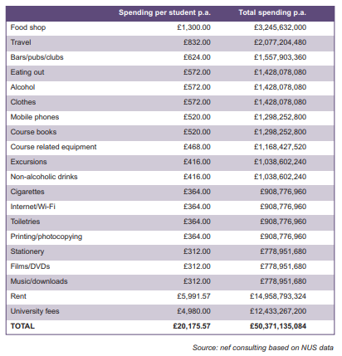
Impact Statement
An impact assessment is not required in line with NPPF guidelines.However Paragraph 89 of the NPPF states planning policy should consider the impact of the proposal on town centre vitality and viability, including local consumer choice and trade in the town centre and the wider retail catchment. This proposal would have minimal impact on the town centre’s current and proposed leisure offerings. Due to its unique nature it would not take footfall from the town centre, indeed it would bring people to the area who would not otherwise have visited who will subsequently spend time in the centre, improving the town centre vitality. The proposed unit is situated just 1.2 miles from the centre of the town per the BLP boundaries on one straight road with links to public transport networks of both bus and train routes meaning excellent sustainable transport links for users to then spend time in the centre itself.
This development does not breach the threshold set in RSS or SPD policy for providing a travel assessment or plan but it has been carefully considered. The proposed unit has 7 spaces including 1 for disabled users and has access to Capitol Park’s bicycle parking. This relatively limited amount of parking spaces should encourage users and staff to use public transport or other sustainable forms of travel as it is generally accepted that availability of car parking has a major influence on a person’s choice of transport (SPD). There are also electric car charging stations available.
Despite this there will be users and staff who chose to drive. BMBC have made it clear through policy E3 this unit is designated for employment use and want to maximise employee numbers there, meaning any business that occupies units at Capitol Park will be faced with the same issue. The proposed development will have a managed stream of visitors due to a booking system whereby there would one be one user on the simulator at any given time slot. There would also only be a maximum of 5 staff on site at any one time due to the interchanging nature of the proposed employment matrix. In terms of corporate clients then they will be encouraged to travel together by mini bus, train or car pooling to negate the limited parking spaces. It is also understood that many corporate clients depending on where they have travelled from, would stay at a nearby hotel or eat at the local pub and use the facilities for parking that they provide. Colleges and education institutions sending students to use the facility usually provide group transport or promote public transport as many of the students cannot drive in that age bracket.

Further to this, with respect to the Core strategy CSP 25 of the SPD, the development would be encouraging all visitors to make use of the train station that can be accessed directly or indirectly from a number of main cities. With the developments proximity to the Trans Pennine trail, on site shower facilities, bicycle parking and an employee bike to work scheme, the development will also fully meet the need of cyclists and pedestrians.

Impact on traffic, noise and the environment would be significantly less than other currently approved employment use businesses that could occupy the unit due to clean and light industrial processes including only internal fixings and cleaning. There would be no generators or heavy machinery. Deliveries and collections in regards the pods are expected to be only 2 in and 2 out per month in the first year. There would be no other scheduled deliveries with only light traffic thereafter.

- Sequential Test
Introduction
This proposal accompanies a planning application for a flexible change of use to incorporate some D1 and D2 use. Currently unit 7 does not have planning permission granted for this type of use and per NPPF policy, this type of use is a “Town centre use”. This proportionate sequential test sets out to assess in centre sites in terms of availability, suitability and viability.
- Availability – Whether sites are available. It should be noted that the NPPF requires that to be sequentially preferable, a potential alternative site must be “available” not “available in a number of years” as confirmed by the Secretary Of State in his decision in June 2014 on a called in application at Rushden Lakes

- Suitability – Whether a site could be developed for the proposal having regard to the requirement to demonstrate flexibility and whether the site is suitable to accommodate the specific need or demand the proposal is intended to meet.

- Viability –Whether there is a reasonable prospect that the development will occur on the site at a particular point in time, again having regard to the specific nature of the need or operator demand the proposal is intended to meet.

Relevant Case Law
The application of the sequential approach should also accord with the approach set down in established case law and Secretary Of State decisions, in particular;
- Supreme Court Decision of Tesco Stores Ltd v Dundee City Council (2012) – ref. UKSC 13 (21 March 2012)
- High Court decision of Zurich v North Lincolnshire and Simons developments (2012)- Case no:CO/4764/2012
- Secretary of State Call-in Decision at Rushden Lakes (2014)-appeal re. APP/G2815/V/12/2190175
The key points are;
- The sequential test relates entirely to what is proposed by the application and whether it can be accommodated on an actual alternative site, not some other proposal which the planning authority might seek to substitute for it which is something less than sought by the developer (Dundee)

- The “Dundee” case is legally binding in that the sequential approach does not require a “suitable” site to be one that can only accommodate a proposal if the proposal is altered/reduced.

- Dundee applies in England and even if the sequential test is not fully satisfied, the local planning authority is not required to automatically refuse permission – a balancing exercise is still required (North Lincolnshire)

- Flexibility can be demonstrated by developers not seeking to maximise their footprint (Rushden Lakes)

- The sequential approach is only concerned with sites that are available now (Rushden Lakes)

In light of the above, the pertinent question posed by the sequential approach is whether there are any suitable sites that are available now that could meet the size, format and market requirements of a Flight simulation Experience and training centre.
Other Cases
- In 2016 BMBC granted planning permission (ref:2016/0436) to allow a flexible use of Class D2 on an A1 site. This permission would revert back to the previously approved A1 only once the occupant no longer utilised the site, synonymous with this application and proposal. The committee report in June 2016 regarding that application stated that;
“The applicant has demonstrated that there are no sequentially preferable sites to accommodate the proposed development and that the proposal will not have a significant adverse impact on the Town Centre plan or the planned investment in the Better Barnsley Scheme. There is no evidence that the impacts of the proposal would significantly and demonstrably outweigh the benefits when assessed against the policies in the NPPF as a whole. Accordingly, the presumption in favour of sustainable development applies and the application is therefore recommended for approval”.

- Similarly in 2017 at Unit 5, Helix at Gateway, Birdwell, S70 5SZ planning permission was granted to allow change of use from employment use B1/B8 to Sui Generis use as a car supermarket (Ref 2017/1611). This development is 3.3 miles as the crow flies from Barnsley Town centre and the unit is 75,277 Sqft and at the time of the application had reserved right planning permission for employment uses. Permission was granted on the basis that the new use would create jobs and negate the impact of the loss of a substantially sized unit designated to employment use. A Training and Employment plan was put into place to which this proposal would also be agreeable that ensured employment of local members of staff. Around 30% of the units in the Gateway 36 development have been allocated to developments that fall outside of the employment use class in order to stimulate sustainable economic development of the site. The committee found on the initial application (2014/1055) that;
“Given wider objectives and the need to secure a planning permission that would help secure the funding for the four industrial units, it is considered that the conflict with the policy CSP19 (Loss of employment land) is not considered significant. The proposal is therefore considered to be an appropriate employment-led, mixed use development”
- An appeal to the Secretary of State heard on March 2016 (APP/C8310/W/15/3135864) where permission was refused to grant use D2 to an industrial unit with permitted B1, B2, B8 was successfully allowed. The inspector commented that the development would create a number of jobs, thus negating the negative impact on the loss of an employment land unit. They also commented that;

“Also of significance is advice in the NPPF that the Government is committed to ensuring that the planning system does everything it can to support sustainable economic growth and that planning should not act as an impediment to it. Significant weight should be placed on the need to support economic growth through the planning system and in this case I place significant weight on that factor”
In her comments, the inspector noted that the unit had not been empty for an excessive amount of time and was considered a prime industrial unit for employment use.
Site search parameters
A sequential approach to site selection has been applied in this proposal, taking on board the relevant Court decisions and Secretary of State and appeal decisions.
Due to the large catchment area of the business then a number of Town Centres have been considered for robustness. Due to operational demands of the business plan and proposal then the search parameters have been narrowed. Appendix 9 shows a radius reachable within a 30 minute drive time and a reachable area in 60 minutes on public transport from Premier Technical’s current production facility.
This established search radius is important for a number of reasons;
- SkyPods will be initially manufactured in Goldthorpe. Operationally, delivery time and distance to the development must be kept to a minimum for cost, environmental impact and lost manufacturing run time.

- Staff based at Goldthorpe will be multi skilled and expected to travel between sites. Increasing their commute is not cost effective for the business, nor is it fair on staff to expect them to travel for any substantial length of time.

- To move the development any further from Premier Technical’s base (near where most current staff live) would also reduce the likely hood of staff travelling by sustainable means which is something being encouraged on the new development.

- The flight simulator will rely on very technical and specialist equipment and software. The business model relies critically on a member of technical staff being able to reach the facility in the shortest possible time due to part of the business being in the experience sector.
This parameter search identified Town Centres satisfying the initial criteria of proximity as Doncaster, Rotherham, Barnsley and on the outskirts, Sheffield. In terms of competition of what is available in each of these towns then Doncaster (Jet Simulator), Sheffield (Flight Deck Simulator) and Rotherham (RS Simtech) have versions of flight simulation experiences on a commercial level. Similarly, those towns bring large and popular leisure alternatives in the form of Doncaster Dome, Magna, Ice Sheffield, Meadowhall, Sheffield Arena and Yorskhire Wildlife park amongst others. Looking forward then the new Gulliver’s Valley theme park at Rother valley will also be located as such that it will draw visitors primarily from the Towns of Rotherham, Sheffield and Doncaster with Barnsley less directly affected.
Premier Technical also have a long history of working with Enterprising Barnsley and their support has been and continues to be valuable to the viability of the current and future business expansion. Due to the combination of the above factors, Barnsley becomes the clear choice location on an operational and commercial level and fits with the business plan and model of the proposal. For this reason the other considered town centres are unsuitable without changing or altering the business proposal and do not meet its marketing requirements, which to re-consider Dundee;
“The “Dundee” case is legally binding in that the sequential approach does not require a “suitable” site to be one that can only accommodate a proposal if the proposal is altered/reduced”
Again for robustness a search has been conducted for Town Centre and out of centre leisure units in Rotherham, Sheffield and Doncaster and none were available at the size, quality, layout and accessibility required. These centres failed the sequential test for availability, suitability and viability on the very specific needs of this proposed business.
There is also the consideration when identifying the sequentially preferable centre of corporate clients. Corporate clients form a large part of the business plan for this development. Although the catchment area on the whole is large, the majority of the local corporate clients will come from the financial centres of Sheffield and Leeds. Barnsley is 30 minutes by car and 24 minutes by train from Sheffield and 30 minutes by car and 32 Minutes by train from Leeds making it almost exactly equidistant between the two. This makes it ideally situated to equally attract corporate clients from both these cities. If the proposal was to be situated in Sheffield, Doncaster or Rotherham then at least one of those travel times doubles and from a marketing, commercial and accessibility standpoint the business plan and viability weakens significantly. Consideration must also be placed strategically on the proposed introduction and route of HS2 for rail travel. For corporate clients and individuals coming from major cities outside of Yorkshire, being as well connected as Barnsley is to both Leeds and Sheffield which will have stops on the service is a major factor for encouraging and attracting visitors by sustainable travel in the future.
Due to the combination of all of the above, then without altering the business proposal or sacrificing the viability of the business model, Barnsley Town Centre is the onlysequentially preferable centre for this proposal.
A Flight simulator experience centre has very specific requirements. To be considered suitable the unit must have;
- A large open plan floor space to accommodate an airplane cockpit on a motion platform with safe operating space, an 8 metre airplane section and storage room for working on up to 3 or 4 airplane sections making up SkyPods. Plus a reception area, ancillary office space and other operational space.
- Appropriate ceiling height to house the aforementioned equipment
- Loading door capable of fitting in large airplane sections (4 metre minimum)
- Easily accessible location for visitors and delivery of goods
- Close to sustainable local transport links for staff and visitors
- Sufficient and free on site parking
- Clean and aesthetically sound internally and externally due to experience part of the business model (Grade A unit)
The overall aim and objective of the proposal is to provide the residents of Barnsley with a Leisure facility to be proud of and attract interest in the local area. It will not only provide a facility unique to the locality but also a significant attraction for day trippers and people beyond the region to have a further reason to visit. It will also attract businesses and corporate clients which in turn will showcase what the area has to offer and provide further scope for inward investment to contribute to the GVA of the borough. There is no other fully comparable facility to the development proposed in the UK.
Given the aim and objective of the proposal, particularly the scale and layout of the facility that would be necessary, the search parameters of the sequential test should be to look for large open plan units of sufficient height with appropriate car parking, access and services.
Barnsley Town centre sites
The below table summarises the conclusions for the sites included in the BLP 2019. None of these sites have unallocated proposals for leisure use.
Table 5 – Barnsley town centre sites
Site | Available? | Suitable? | Viable? | Conclusion
The Glassworks | x | x | x | Leisure space to include cinema,restaurants,bars. No units of the size and scale required and access for deliveries is difficult
Heelis Street/New Street | x | x | x | The site has consent for a food store. There are also issues with the topography.
Land between the Transport interchange and Harborough Hill | x | x | x | Not ready or developed and allocated for a mixture of uses including ancillary retail. The planning history suggest it is not viable
None of the sites allocated for retail or leisure within the BLP are sequentially preferable to the application site for the proposed development.
Vacant units within Barnsley Town Centre
Vacant sites/Units in the town centre have also been taken into consideration. An independent search plus a thorough search through Enterprising Barnsley’s catalogue of properties (Appendix 10) showed no suitable units are currently available in the areas designated as town centre or edge of town centre on the BLP 2019. The following table shows the units available regarding leisure or alternative use provided by Enterprising Barnsley;
Table 6 – Barnsley town centre Units
Site | Available? | Suitable? | Viable? | Size
Former Salvation army Citadel – S70 1SS | Yes | x | x | 3,691 Sqft
Former Treadles Wine Bar – S70 2RN | Yes | x | x | 1,227 Sqft
29-31 New Street – S70 1RZ | Yes | x | x | 3,183 Sqft
2nd Floor 20/22 May Day Green –S70 1SH | Yes | x | x | 2,484 Sqft
Wellington House – S70 1SW | Yes | x | x | 3,000 Sqft
Church Street - S70 | Yes | x | x | 3,229 Sqft

All of the above sites are confirmed by Enterprising Barnsley as being unsuitable due to the quality, size, structural layout or design of the buildings which are insufficient to meet the needs of this development. They also go on to say that no other urban principle site could be considered due to the small nature of the remaining units being under 2,000 Sqft.
For robustness of the sequential test, this proposal also considered other Grade A industrial units taking into account all the district Centres (Cudworth, Hoyland, Wombwell, Goldthorpe, Penistone, Royston) and local centres (Athersley, Bolton on Dearne, Darfield, Darton, Dodworth, Grimethorpe, Hoyland Common, Lundwood, Mapplewell, Stairfoot, Thurnscoe). There is nothing available, suitable or viable in the “centre” of any of these options with only 1 A grade unit between 5,000 and 10,000 Sqft in the entire borough per the table below.
Table 7 – Available units by quality
Size of unit | Number of Units | Grade A | Grade B | Grade C
Up to 1,000 sq.ft | 1 | 1 | 0 | 0
1,000 to 2,000 sq.ft | 5 | 4 | 0 | 1
2,000 to 5,000 sq.ft | 6 | 0 | 1 | 5
5,000 to 10,000 sq.ft | 9 | 1 | 2 | 6
10,000 to 25,000 sq.ft | 7 | 2 | 3 | 2
25,000 to 50,000 sq.ft | 2 | 1 | 1 | 0
50,000+ sq.ft | 3 | 2 | 0 | 1
Total | 33 | 11 | 7 | 15
The 1 available unit isRock House in Cudworth (significantly out of town centre), which at 10,000 Sq.ft is too large for this proposal and is currently a retail unit with no open plan floor space and no suitable loading door. It also has insufficient eaves height so fails the sequential test on the grounds of suitability and viability.
The Grade B and C units in the 5,000 to 10,000 sq.ft category are also not suitable for this development.
Conclusion of the Sequential Test
To be sequentially preferable a site must be suitable, viable and available. Premier Technical’s requirements are a large open plan unit of circa 7,000 Square feet with high eaves, a 4metre loading door, easily accessible, good transport links and with a certain aesthetic quality. The conclusions for all of the identified sites are;

- For operational, commercial and marketing reasons a parameter was set out inside a 30 minute drive time and 60 minute public transport journey time of Premier Technical’s Goldthorpe facility that identified the towns of Barnsley, Rotherham, Doncaster and Sheffield.

- Due to competition of other leisure offerings, falling within distance and travel time parameters of key operational details and previous experience and support in the marketplace, Barnsley was established as the only sequentially preferable centre for the proposal.

- Vacant units and allocated development sites in the centre of Barnsley have been considered and none are suitable, Viable or available.

- Developments such as Glassworks and Barnsley Market developments are not yet complete and are an unrealistic option on the grounds of suitability, plus have already signed pre agreements with many tenants offering leisure facilities e.gCineworld.

- In the light of Dundee, none of the sites considered can be classed as suitable for this unique proposal in the format it is proposed.

- The overall conclusion is that the application site is by far the most sequentially preferable location for the proposed development. The proposal therefore accords with the parameters set out in the NPPF and BLP policies.

- Summary and Conclusions

- This proposal has been submitted in support of a planning application by Premier Technical Ltd to provide a Flight simulation experience and training centre at Unit 7, Nexus @ Capitol park, Dodworth, Barnsley. It seeks a flexible change of use for part of the unit from Employment uses (B1, B2, B8) to allow training (D1) and Leisure (D2) to take place.

- The proposal will vastly improve the leisure offer in Barnsley and the wider area while providing a major and unique attraction to increase the number of visitors and students and promote localised economic expenditure, thus improving the GVA of the borough.

- The statement has reviewed planning policy for the site and the proposed use, and assessed the proposal against the relevant development management policies contained in NPPF guidance relating to leisure developments and the most relevant leisure and town centre policies in the BDP. It has also considered advice from the PPG, the Parking SPD (Particularly CSP 25) and the economic and leisure strategies of the borough.

- The main points to address are as follows;

Does the proposal meet the economic objectives of the BDP and the NPPF?The proposal meets the economic objectives for Barnsley as outlined in the adopted BLP and those outlined in the NPPF, because it will create and help retain a significant number of jobs and facilitate direct investment in the area. It will also support and enhance an already established business that makes a significant contribution the areas GVA. The development will still be utilising employment land uses B1 and B8 in the unit and the D1 and D2 training and leisure uses will also produce employment and not compromise the use of employment designated land. Indeed job per Sq feet ratio produced will be higher than some current B use occupants. There will be further multiplier effect contributions to GVA from supply chain and the attraction of students.

Does the proposal enhance the borough’s leisure and tourism offer?The proposal will give the borough a unique attraction to be proud of. It will not only give the people of Barnsley a greater choice of leisure activity but also attract day trippers and corporate clients from outside the borough and subsequently put Barnsley on the map. The development directly addresses three key weaknesses identified in the SWOT analysis of the Visitor Economy Strategy for Barnsley.

Whether there are any preferable centres or town or edge-of-centre sites that are available and suitable for the proposalBarnsley is the only sequentially preferable centre for the development. Other centres were considered but for commercial, operational and marketing reasons were not suitable or viable. A search of units in those centres also showed they failed in terms of availability. The application site is the only unit possible for this development in Barnsley. In light of the case law established by Dundee, sites in Barnsley town centre could not address the same requirements as Nexus @ Capitol park in helping provide the area with a leisure offer that can be genuinely unique to Barnsley. Following a thorough search for alternatives and confirmed by Enterprising Barnsley, there are no other sites, central or otherwise, able to meet the demands of this proposal which satisfy the tests of availability, suitability and viability. The sequential test is therefore passed.

Whether there is any clear evidence of significant adverse impacts?The proposal will not lead to a significant adverse impact on existing, committed or planned public and private investment, namely the Better Barnsley scheme for the redevelopment of the town centre markets. Nor will it result in a loss of town centre trade. Conversely due to its proximity to the centre, it has the possibility to increase visitors to the area who will visit the town and use other facilities in the centre and beyond and so support other schemes that aim to provide economic growth. There will be no material significant impact on the noise, traffic or pollution of the area.

Whether the balance of impacts and other material considerations are acceptable, having regard in particular to the NPPF advice that developments should be approved unless any adverse impacts would significantly outweigh the benefits? The proposal will deliver other material benefits including;

- Enabling investment in the locality in the form of delivering a new leisure destinationattracting visitors, key business decision makers and students to the area to spend money and invest.

- Increased local employment and spending adding to the GVA of the borough. The NPPF states that “significant weight should be placed on the need to support economic growth through the planning system”. It follows that everything must be done to support the economic regeneration of the development without delay. The proposal represents an opportunity for the Council to support sustainable economic growth and job creation in line with the Jobs and Business plan vision.

- Supporting quality training courses in the area to bring new skills and employment opportunities to the area and its residents, enriching what Barnsley can offer. Premier Technical has a reputation of up skilling and progressing staff, investing in Apprentices and skills based training. There will be opportunities for work experience and leisure based apprenticeships as well as providing a first class facility for local colleges.

- Supporting manufacturingby increasing production at the applicants other facility in order to strengthen job security and facilitate extra employment and apprenticeship opportunities. Premier Technical has invested in the area with new machinery, growth of manufacturing facility and the global export of products.
Does the proposal raise any significant adverse impacts with accessibility and transport? Due to its location just off the motorway and away from housing, plus the limited number of visitors at any one time, there are no significant adverse impacts with transport and accessibility.The development satisfies CSP 25 with7 private and safe parking spaces including disable bay to accommodate the well managed visitor numbers who wish to drive. There are also electric car charging stations to promote and accommodate the use of Hybrid or electric vehicles. The proposed developments proximity to the Trans Pennine Trail for cyclists and public transportoptions in the shape of multiple bus routes for town centre visitors and local residents and a well served train station means visitors and staff will be encouraged to use the sustainable public transport of the area.
It is evident from the proposal that the application should be supported as there are no material considerations that the application should not be approved. The overall conclusion is therefore that the policy advice contained in the NPPF, the policy of the Barnsley Local Plan, the numerous economic strategies of the region and the various case law and successful local applications and appeals to the Secretary of State adds substantial weight to the presumption that planning permissions should be approved without delay.

________________________________________________________
Appendices
________________________________________________________

________________________________________________________
Appendix 1
Unit 7 Plans and Elevation
________________________________________________________

Appendix 2
Planning permission 2017/1002
________________________________________________________

________________________________________________________
Appendix 3
Barnsley Local Plan map extract
________________________________________________________

________________________________________________________
Appendix 4
FlyMe Business Plan
________________________________________________________

________________________________________________________
Appendix 5
Bank support email
________________________________________________________

________________________________________________________
Appendix 6
Dan Jarvis Support
________________________________________________________

________________________________________________________
Appendix 7
Employment Matrix
________________________________________________________

________________________________________________________
Appendix 8
Barnsley college Curriculum Lead Email
________________________________________________________

________________________________________________________
Appendix 9
Initial Search parameters
________________________________________________________

________________________________________________________
Appendix 10
Enterprising Barnsley property search
________________________________________________________

