RISK ASSESSMENT & METHOD STATEMENT

PARKSIDE SPORTS & COMMUNITY CENTRE

FOR

JOINERY

Hughie Construction Limited

New York Stadium
New York Way
Rotherham
South Yorkshire
S60 1FJ

Tel: 07901 235886
Email: admin@hclimited.co.uk

Date of Issue | Comments | Ref No. | Authorised by | Revision
21/08/2024 | Issued to site | 014 | Richard Kirk | 01
Review: 21/08/2025

Site Specific Risk Assessment & Method Statement

Location: PARKSIDE SPORTS & COMMUNITY CENTRE, HOYLAND

Project Title: CONSTRUCTION OF NEW SPORTS & COMMUNITY FACILITY

Issue Number: 01

Compiled by: Richard Kirk

Company Position: Managing Director

Date Compiled: 21/08/2024

Date Issued: 21/08/2024

Project Details

Description of work to be undertaken:

The scope of works to be carried out by Hughie Construction Limited comprises of Joinery Works

Please read this document carefully and implement the requirements of this method statement.

Site Specific Risk Assessment: Joinery Works
Risk Assessment Ref. | 014
Contract Location:  PARKSIDE SPORTS & COMMUNITY CENTRE, HOYLAND |  | Issue date:  21/08/2024
General Activities / Scope of Work: JOINERY WORKS

What are the hazards: | Who might be harmed and how? | Risk Rating |  |  | Precautions already in place | What further action is necessary | Residual Risk Rating
What are the hazards: | Who might be harmed and how? | Probability | Severity | Risk | Precautions already in place | What further action is necessary | Probability | Severity | Risk
Manual Handling Injuries | Workers | 5 | 5 | 25 | - Use mechanical aids and ensure proper lifting techniques.  - Provide manual handling training and regular reviews of lifting procedures. | - N/A | 1 | 5 | 5
Contact with Sharp Tools | Workers | 5 | 5 | 25 | - Use personal protective equipment (PPE) such as gloves. Ensure tools are well-maintained | - Provide training on safe tool use and conduct regular tool inspections. | 1 | 5 | 5
Falling from height | Serious or even fatal injury could occur if an worker falls from height. Others working below also at risk. | 5 | 5 | 25 | - Sufficient Step-Ups to be available, all in good condition.  - Where required platforms, with guardrail to be used. | - Include work at height in toolbox talk before beginning work on day one. | 1 | 5 | 5
Slips and trips | All workers, and tradesmen nearby, may suffer sprains, bruising or fractures if they trip over objects, such as work debris, or slip on spillages. | 5 | 3 | 15 | - All operators wear safety boots – ‘no boots, no job’ policy.  - Good housekeeping, e.g. debris put in skip, brush available to use to keep work area clear.  - All trailing cables in work area hung up or otherwise kept out of harm’s way.  - Safe route to job agreed with site manager based on site health and safety plan. | - Manager to check on-site housekeeping during visits.  - Include in site induction before beginning work on day one. | 1 | 3 | 3
Vibration | Operatives | 5 | 3 | 15 | - Train operator to recognize VWF and WBV. If fingers tingle after prolonged use take break. Keep hands warm. Use gloves. Avoid smoking. Refer to HAVS risk assessment. | - Ensure breaks are taken when using equipment and PPE is worn correctly. | 1 | 5 | 5
Workplace transport | Operators risk serious or even fatal injuries from moving vehicles on site – particularly when reversing. | 5 | 5 | 25 | - Safe route to workplace and to welfare facilities, agreed with site manager based on site health and safety plan.  - Ensure traffic plan is effectively communicated to everyone on site in addition to the school.  - Staff know that they must never move vehicles on a site unless authorised by site manager. | - Include in site induction before beginning work on day one. | 1 | 5 | 5
Wood Dust Exposure | Workers | 5 | 5 | 25 | - Use dust extraction systems and wear dust masks. Ensure proper ventilation. | - Conduct regular air quality monitoring and provide training on handling wood dust. | 1 | 5 | 5
Noise Exposure | Workers | 5 | 5 | 20 | - Use hearing protection and limit exposure time. | - Conduct regular noise level monitoring and provide training on noise hazards | 1 | 5 | 5
Contact with Machinery | Workers | 5 | 5 | 20 | - Ensure machinery is properly guarded and maintained. Use lockout/tagout procedures. | - Provide training on machinery safety and conduct regular maintenance checks. | 1 | 5 | 5
Fire Hazards | Workers | 5 | 5 | 20 | - Keep flammable materials away from ignition sources. Have fire extinguishers available. | - Conduct fire drills and provide training on fire safety. | 1 | 5 | 5
Chemical Exposure (e.g., adhesives, finishes) | Workers | 5 | 5 | 20 | - Use PPE and ensure proper storage and handling of chemicals. | - Conduct COSHH assessments and provide training on handling hazardous substances | 1 | 5 | 5
Substance - Hazard from chemical contact. (Dust and potential asbestos.) Refer to COSHH assessment. | Workers | 5 | 4 | 20 | Control the cause of dust at source.  Contain dust wherever possible by keeping the work area clean.  Isolate areas to reduce the number of personnel exposed.  Control with dust suppression measures (such as very fine water spray methods). Good housekeeping to reduce airborne dust.  Personal Protective Equipment (only to be considered as a last resort)  Dust masks of EN 149 FFP1 Standard.  Eating, drinking and smoking shall be prohibited on site.  Asbestos:  COSHH assessment to be carried out by site supervisor to identify any hazardous materials  - Halt all work immediately and isolate work area. Contact asbestos professional to isolate and/or remove asbestos. | - Ensure work area is isolated and trained professionals are contacted immediately | 1 | 4 | 4
Use of power tools | Operatives and nearby tradesmen | 3 | 5 | 15 | - Pre use visual inspection for damage/defects to tools, cables, plugs  - Provision of PPE; Gloves, Hearing protection, defenders/plugs, Dust masks  - Cables to be routed away from aisles and walkways where they could create trip hazards to other persons and/or expose cables to potential damage.  - All power tools to be 110 volts | - All power tools to undergo regular PAT testing. | 1 | 5 | 5
Manual handling | Operators risk injury, particularly to the back, from lifting and handling heavy or awkward objects,  e.g. bags of cement and gravel. s | 5 | 4 | 20 | - Use TILE assessment described below.  - Where possible, mechanical means to be used to transport materials.  - Where the movement requires short distances operatives will use barrows or where this risk is minimal passage of materials between numbers of operatives.  - All materials will be below the recommended guidance for manual handling lifting weight of 25kg. | - Remind operatives of safe system of work at site induction. | 1 | 4 | 4
Welfare | Good welfare facilities reduce risk of dermatitis, help good hygiene etc. | 3 | 4 | 12 | - Agreement with site manager that staff may use site welfare facilities – toilets, washing facilities with hot and cold water and mess room/kitchen. | - Tell staff about facilities at site induction on day one. | 1 | 4 | 4
PROBABILITY = Likely (5) - Probable (4) - Possible (3) - Remote (2) - Improbable (1)
SEVERITY = Catastrophic (5) - Major (4) - Reportable (3) - Serious (2) - Minor (1) RISK = PROBABILITY x SEVERITY
* Residual risk is the level of risk that remains after suitable and sufficient control measures are introduced.

Persons at Risk | Probability |  | Severity |  | 5 | 4 | 3 | 2 | 1
 |  |  |  |  | L | Pr | Po | R | I |  | 8-25  Not Acceptable
P – Public | Likely (L) 5 |  | 5 | C | 25 | 20 | 15 | 10 | 5 |  | 8-25  Not Acceptable
E - Employee | Probable (Pr) 4 |  | 4 | Ma | 20 | 16 | 12 | 8 | 4
C – Contractor | Possible (Po) 3 |  | 3 | R | 15 | 12 | 9 | 6 | 3 |  | 1-6  Acceptable
V – Visitor | Remote (R) 2 |  | 2 | S | 10 | 8 | 6 | 4 | 2 |  | 1-6  Acceptable
 | Improbable (I) 1 |  | 1 | Mi | 5 | 4 | 3 | 2 | 1

Site Specific Method Statement: Joinery Works

Method of Work:

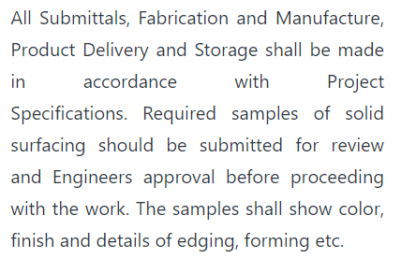

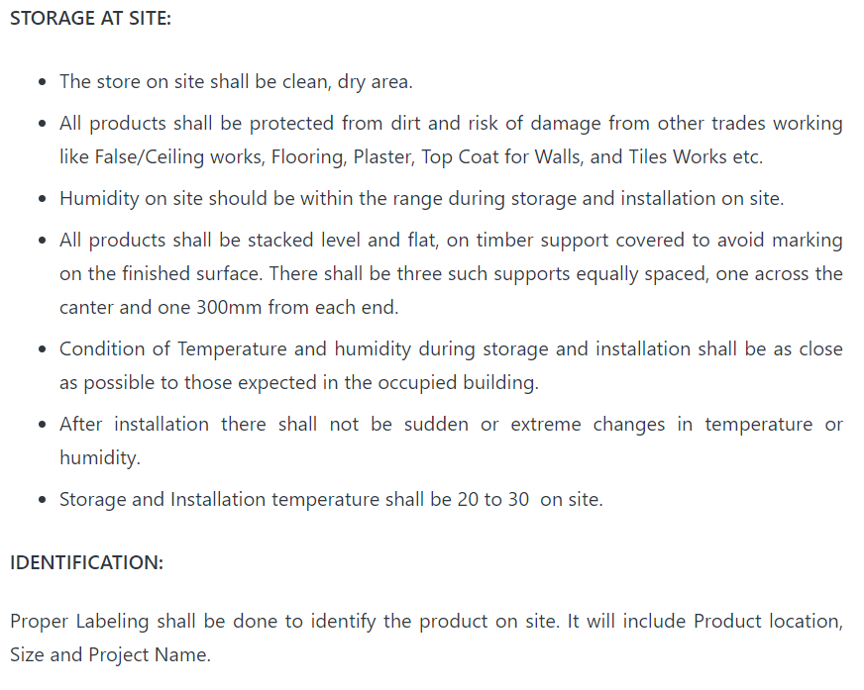

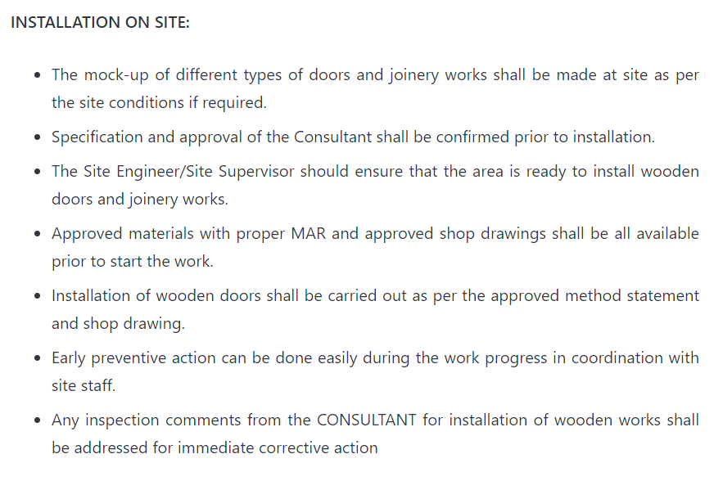

Installation of cupboards

Make sure basic services are in place before installation i.e. power supply, site readiness etc.

Fix the wooden packing pieces to wall for unit and avoid direct contact to the wall.

Fix the assembled cupboard carcass received from factory in place by screw through the fixing spacer making sure is aligned properly.

Fix the shutters in place at respective carcasses.

Install the units skirting after making final level adjustment.

Install the granite and sink.

Install all accessories like handles, knobs etc.

Clean and protect units with polyurethane sheet or any protective materials ready for inspection.

Control Measures to Reduce Risks: Risk Control Systems (RCS) and Workplace Precautions (WP)
Risk Control Systems in operation: Daily / Weekly inspections, Audits, Reviews, Safety Checks, Recording and Monitoring, Site Safety Tours. Workplace Precautions in operation: Safety Signs, Barriers, Fixed Fencing, Guards, Protective Equipment, Personal Protective Clothing, Overall Prevention Policies, Training, Toolbox Talks, Site Inductions, Risk Assessments and Method Statements.
- Use work equipment or other measures to prevent falls where we cannot avoid working at height.
- Where we cannot eliminate the risk of a fall use work equipment or other measures to minimise the distance and consequences of a fall should a fall occur.
Other Precautions: All Electrical Tools used will be PAT tested, inspected and recorded. All electrical items on site will be 110v or below. Any above this must be fitted with an RCD device. Noise assessments will be carried out were applicable. The tools selected for use will not exceed the Meter per second calculation with personal exposure above 8hrs. Manual handling assessments to be completed where practical all loads above 25kgs will be carried by 2 operatives or mechanically transported.
Tools/Equipment/ Resources Required:  - Spirt Levels  - Hand tools for installation  - Manual Circular saw  - Jig saw  - Cordless drill  - Mitre saw machine  Power tools  Labour  Site/lift supervisor, labourers  Labour resources may fluctuate during the project. Confirmation of resources will be determined by work load and programme. | PPE Requirements:  - Protective Clothing - trousers and minimum of tee-shirts to be worn  - Hard Hats on site when using lift (Mandatory)  - Knee Pads  - Hand/Arm Protection – Gloves (Mandatory)  - Eye protection as per site rules (Mandatory) – Med/high impact goggles  - Ear protection where levels exceed 85dba above 90dba (Mandatory)  - Safety Boots with steel mid sole at all times (Mandatory)  - Hi Visibility Clothing as per site rules (Mandatory) – Must not be cut down
Access to the Place of Work

Prior to commencement of work the site manager, supervisors and operatives and all other visitors on behalf of Hughie Construction Limited will attend a site induction.

- Access to site for operatives will be controlled by entry and exit procedures.
- All Hughie Construction Limited site operatives and visitors and representatives will sign in and out of site daily at the site office and use access control system
- In accordance with Construction (Design and Management) Regulations 2015, The Principal Contractor will ensure a traffic management plan has been developed and implemented and that is clearly identified and transport/plant and pedestrians are segregated by means of fixed barriers or other suitable means.
- Main access to workface will be via main, most suitable entrance. If for any reason this is not possible, Principal Contractor will arrange access via an alternative route through designated walkways which will require a review of this method statement.
- PC will supply suitable contractor site compound facilities.
- Delivery vehicles will be guided to the lay down area within the compound with the aid of the vehicle marshal (banksman) following traffic route. All reversing of vehicles will be directed by a competent banksman and to be kept to a minimum
- Delivery times will be sympathetic to traffic movements.
- Deliveries should be prior booked with the transport co-ordinator.

Plant and Equipment to be Used Mechanical and Electrical
All tools and leads will be PAT tested and tagged and records kept in the site file.

Mitre saw machine

Locate and ensure you are familiar with all machine operations and controls.

Ensure all guards are fitted, secure and functional. Do not operate if guards are missing or faulty.

Ensure the saw is properly secured to a work table by bolts/clamps at approximately hip height.

Ensure the saw is operated on an RCD protected circuit.

Check workspaces and walkways to ensure no slip/trip hazards are present.

Keep table and work area clear of all tools, off-cut timber and sawdust.

Start the dust extraction unit before using the machine.

OPERATIONAL SAFETY CHECKS

Ensure all adjustments are secure before making a cut.

Use clamps to secure and support the workpiece to a stable platform. Do not use a length stop on the free scrap end of a clamped workpiece.

Before turning on the saw, perform a dry run of the cutting operation to ensure no problems will occur when the cut is made.

Avoid reaching over the saw line. Do not cross arms when cutting.

When pulling the saw down with your right hand, keep the left hand, especially the thumb, well clear of the line of cut.

If workpiece is bowed or warped, clamp it with the outside bowed face toward the fence.

After finishing the cut, release the switch, hold the saw arm down and wait for blade to stop before removing work or off-cut piece.

Before making any adjustments, disconnect the plug from the power source and bring the machine to a complete standstill.

Leave the machine in a safe, clean and tidy state.

POTENTIAL HAZARDS AND INJURIES

Saw may grab and ‘kick-back’ toward operator.

Flying chips and airborne dust.

Contact with rotating blade.

Eye injuries.

Noise.

DON’T

Do not use faulty equipment. Immediately report suspect equipment.

Do not exceed the maximum cut for the machine.

Do not cut more than one workpiece at a time.

Do not start the saw with the blade touching the workpiece. Allow the blade to reach full speed first.

Do not cut branches, dowel, or wood with embedded nails or screws.

Do not rip solid timber along the grain.

Do not cut ferrous or non-ferrous material.

Materials Handling and Storage

Distribution and Handling of Materials

- Storage of materials will be at the workface. Storage area at workface is minimal.
- All plant will be tested and inspected and supplied with current certification. Copies will be forwarded to PC.
- Packaging will be stored on site in a safe manner away from the work faces and will be removed when emptied or reused when new deliveries arrive for storage and ease of transfer.
- A look ahead programme will be used to estimate quantities of materials required.

General Manual Handling TILE

- Task
- Individual
- Load
- Environment

Does the task require:
- Twisting of the trunk?
- Stooping or poor posture?
- Reaching upwards?
- Holding or manoeuvring loads away from the trunk of the body?
- Excessive carrying of loads?
- Excessive lifting or lowering?
- Excessive pushing or pulling?
- A process forcing a rate of work?
- Prolonged physical effort?
- Insufficient rest and recovery?
If you answer yes to any of the above questions, then the risk of manual handling injury is increased because of the task.

Individual
The second factor to consider is the individual. This is the person who will be doing the manual handling. Their strength and capabilities can have an impact, but so can knowledge of the load and task, along with training and experience.
- Does the manual handling require a certain level of strength?
- Does the activity require a person of a certain height?
- Does the individual have a health problem?
- Is the individual pregnant?
- Have they been trained in safe manual handling and lifting technique?
- Do they know how to handle the load properly?
- Does this activity require any special information or training?

Power Sources and Isolations required include details of any Permit to Works (Hot work, Electric Isolations etc.

- N/A
Training Requirements

All personnel will be trained and fully competent within their scope of works as defined as those with the knowledge, experience and training to carry out the task in a safe manner. All training will be carried out to HSE/CITB/ or equivalent approved accreditation.

- CSCS training and accreditation
- All operatives are to receive information and instruction on the content of this method statement and the attached risk assessments.
- All operatives are to receive a site safety induction prior to the commencement of works.
- All operatives using power tools are to have received suitable and sufficient training in the use of the equipment.
- Only those considered competent to use such equipment shall be permitted to operate such tools.
- All operatives are to receive training on safe manual handling techniques and asbestos awareness.
- All operatives are also to receive training in safe working practices for work at height including the safe use of safety harnesses.
- All work is to be carried out by competent experienced window fitters in accordance with current building regulations requirements. A record of all training shall be maintained and will be available on request.

Hazardous Substances

- Reference should be made to the COSHH Assessment manual based on site with the Hughie Construction Limited site manager for full details of safety requirements.
Supervision and Coordination of Activities

- Hughie Construction Limited Site manager will control all site activities on a daily basis and his responsibility is to control the working area and interface Hughie Construction Limited activities with other trades and contractors who may be affected by our scope of works
- Site emergency procedures must be strictly adhered with and all site rules will apply.
- The Site manager will have overall responsibility for the safe coordination of Hughie Construction Limited.
- He will attend safety coordination meetings held and will liaise with the Principal Contractor and all other contractors to ensure all work can be carried out in a safe manner.
- He will highlight any unsafe conditions or actions and will inform site management team.

Environmental Considerations
Site environmental considerations issued by the Principal contractor must be adhered to at all times as this is a sensitive area the site rules and conditions must be maintained at all times.

- Under no circumstances must any waste materials, fuels or any other contaminate be allowed to enter the drainage system. Clean out of containers will only be permitted in accordance with procedures for controlling spillage and disposal waste.
- Containers will be cleaned out at the end of each shift by the competent operator and disposed of into the waste skips provided. All waste will be segregated prior to placement into skips.
- Hughie Construction Limited will supply spill kits for use by our operatives.
- All insulation and package materials must be kept from entering drainage systems.
- These include for general waste, timber, waste plastics and cardboard etc. and special waste.
- Noise will be kept to a minimum whilst on site.
- Foul and abuse language will not be tolerated and operatives found using such language or gestures will be removed from site immediately.
Fire and Emergency Procedures

- The fire and emergency plan and procedures given at the site induction will be strictly adhered to during the project and all site operatives will adhere to the information given.
- Under no circumstances must any appliance or alarm for the use in the event of an emergency be tampered with and any abuse of such equipment will result in the offender being removed from site permanently.
- When any alarm is sounded the operatives must observe the evacuation criteria and will down tools and make their way to the nearest assembly point for the site head count and will not return to the workface until the all clear has been given by the site management emergency coordinator.
Protection of the Public

Hughie Construction Limited traffic must be kept to a minimum and local traffic around the perimeter of the site must be treated with care. Road safety is paramount.

Fencing provided by the Principal Contract must not be removed unless specific authority has been given and must be replaced immediately after completion of the task required.
Waste Disposal Arrangements

- Any debris will be collected (at daily intervals as a minimum) and will not be allowed to accumulate and disposed in accordance with Health Safety and Environment Plan procedures.
- Skips are to be provided and waste will be segregated and disposed into the relative skip for that waste. Following each working shift, the debris will be removed and deposited into the skips provided during the working day.
- Skips will be provided and an appointed licensed waste carrier will remove all accumulated waste to an authorised waste disposal agency as per contract agreement. Transfer notes will be retained on site.

Review of Method Statement

The Hughie Construction Limited site manager responsible for the works will ensure that the work area has been inspected and is free from risk of injury or that suitable and sufficient measures have been taken to comply with current health and safety legislation prior to any work being undertaken.

All operatives will attend induction training and receive the method statement explanation and issued with task specific instruction/toolbox talks.

Method statements and all the above-mentioned assessments will be closely monitored for compliance and where a safer alternative to the system of work can be improved, the method statement will be updated accordingly and the agreed system adopted.

Hughie Construction Limited site manager will ensure all operatives involved within the package works understand the method statement and risk assessment.

Method Statements and risk assessments to be updated to reflect any changes in working practices or methods. No works will proceed until approval has been confirmed.

Any amendments required to be incorporated & subsequently approved prior to work commencing. Approval will be required in writing.

The company will encourage any new initiatives to a safer system of work by consultation with the work force, Supervisors and Managers for continuous improvement.
Communication of Risk Assessment and Method Statement

- All operatives will be instructed of the risk assessment and method statement for their scope of works as part of the Tool Box Talk procedures prior to commencing work.
- They must ensure they fully understand the work involved, the hazards and the level of risk they may be exposed
- Following instruction, they each must sign the register attached
- Each operative must work to the method statement, any deviation must be authorised by the Hughie Construction Limited site manager and in agreement from the Principal Contractor.
- Any operative not working to the specific method statement will be subject to disciplinary action.

Approved by – ( Printed Name & Signature ):
Richard Kirk (Managing Director)
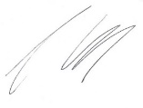

Review date: 21/08/2024

Emergency Contacts | Name | Contact Number
Director | Richard Kirk | 07496 098997
Safety and Environment Advisor | Pearson Holland Management Services | 01924 211211
Off Site Emergency Number | Head Office | 01226 212055
Out of Hours/24 hr Emergency Number | Head Office | 01226 212055

Revision of Method Statement Details

Revised by | Date of Revision | Authorised by

Risk Assessment & Method Statement Register
Date | Names | Signature(s):

