Planning and Heritage Statement
Installation of external wall insulation to side and rear elevation of 94 Sackville Street, Barnsley, S70 2BY
Introduction
This statement has been prepared in support of a planning application for the installation of external wall insulation to the side and rear elevations of end end-terrace property, 94 Sackville Street, Barnsley, S70 2BY.
Planning Policy
The following Local Plan policies are considered of significant relevance to the proposed development.

Policy D1 High Quality Design and Place Making
‘Design Principles
Development is expected to be of high-quality design and will be expected to respect, take advantage of and reinforce the distinctive, local character and features of Barnsley, including:
- Landscape character, topography, green Infrastructure assets, important habitats, woodlands and other natural features;
- Views and vistas to key buildings, landmarks, skylines and gateways; and
- Heritage and townscape character including the scale, layout, building styles and materials of the built form in the locality.
Through its layout and design development should:
- Contribute to place making and be of high quality, that contributes to a healthy, safe and sustainable environment;
- Complement and enhance the character and setting of distinctive places, including Barnsley Town Centre, Penistone, rural villages and Conservation Areas;
- Help to transform the character of physical environments that have become run down and are lacking in distinctiveness;
- Provide an accessible and inclusive environment for the users of individual buildings and surrounding spaces;
- Provide clear and obvious connections to the surrounding street and pedestrian network;
- Ensure ease of movement and legibility for all users, ensure overlooking of streets, spaces and pedestrian routes through the arrangement and orientation of buildings and the location of entrances;
- Promote safe, secure environments and access routes with priority for pedestrians and cyclists;
- Create clear distinctions between public and private spaces;
- Display architectural quality and express proposed uses through its composition, scale, form, proportions and arrangement of materials, colours and details;
- Make the best use of high-quality materials;
- Include a comprehensive and high-quality scheme for hard and soft landscaping; and
- Provide high quality public realm. Supplementary Planning
In terms of place making development should make a positive contribution to achieving qualities of a successful place such as character, legibility, permeability and vitality.’

Policy HE1 The Historic Environment
‘We will positively encourage developments which will help in the management, conservation, understanding and enjoyment of Barnsley’s historic environment, especially for those assets which are at risk This will be achieved by:- a. Supporting proposals which conserve and enhance the significance and setting of the borough’s heritage assets, paying particular attention to those elements which contribute most to the borough’s distinctive character and sense of place… This will be achieved by:-…
- By ensuring that proposals affecting a designated heritage asset (or an archaeological site of national importance such as a Scheduled Ancient Monument) conserve those elements which contribute to its significance. Harm to such elements will be permitted only where this is outweighed by the public benefits of the proposal. Substantial harm or total loss to the significance of a designated heritage asset (or an archaeological site of national importance) will be permitted only in exceptional circumstances where there is a clearly defined public benefit.’

Conservation Area Appraisal
The site is located within the Victoria Road Conservation Area (last amended June 1979). Paragraph 4.1 of the Conservation Area Appraisal sets out that; ‘The buildings located within the Conservation Area were almost entirely built between the latter end of the 19th Century and early part of the 20th Century. They comprise detached, semi-detached, and groups of terraced properties with front gardens and low walls abutting the street’…’The prominent building material used in the construction of buildings in the conservation area is coursed sandstone that in most cases has weathered black over the years. This blackened building material is an important characteristic of buildings in the area and at one time Barnsley had the nickname of “Black Barnsley” due to its appearance and predominant use throughout the town.’
The majority of properties are two storeys with Welsh slate roof coverings. It is noted that original windows have been replaced with upvc materials, incorporating inappropriate elements such as glazing bars and trickle vents.
The Conservation Area has a number of vacant buildings falling into disrepair, and some infill development which detract from the special character of the Conservation Area.
It is acknowledged the modern developments within the Conservation Area are of little architectural interest due to modern building techniques and design trends.
Sackville Street is home to several buildings that preceded the main construction period of the area in the late 19th Century. The Sackville Street section of the Conservation Area Appraisal does not identify the site, or neighbouring properties, as having significant architectural merit.
The recommendations of the Conservation Area Appraisal set out that; ‘new developments that follow the form of the area’s existing character should utilise traditional styles and materials e.g. timber framed windows in preference to upvc as modern alternatives can often look out of place on traditionally styled buildings. This methodology should also apply to other materials and details such as roofs, doors and stonework.’
The Map of the Conservation Area highlights that the application property makes a positive contribution to the Conservation Area.
Figure 1: Map of Important Buildings
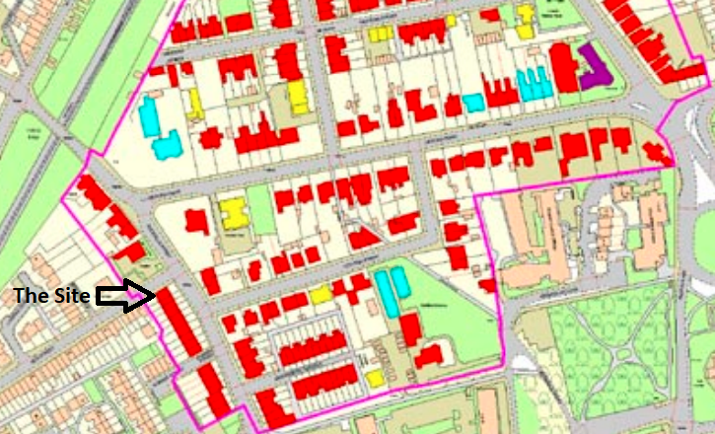
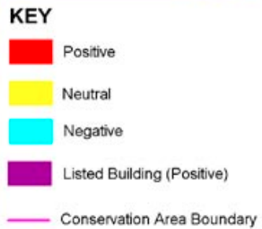

In terms of key views within the Conservation Area, the Map at page 29 of the Conservation Area Appraisal identifies the internal view along Sackville Street as important.
The application property is not a Listed Building.
The Conservation Area boundary includes the entire site.

Figure 2: Map of Important Views
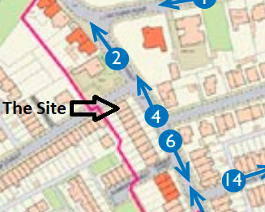
Figure 3: Photograph 4
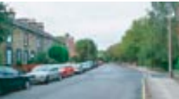
The Site
The property forms the end of a terrace at the junction of Sackville Street and Kier Street.
The front elevation is finished in coursed sandstone which has weathered black over the years. The windows are framed in black painted stonework. The windows are upvc with diamond glazing bars. There is a low-level stone wall encompassing the front garden.
The gable end currently hosts the Kier Street road sign at high-level. The gable end is finished in coursed sandstone which has weathered black over the years. The gable end features a range of windows at varying levels. There is detailed quoining at the corner of the front and side elevation. The gable end wall is back of pavement and ties into the front and rear boundary wall. A lamppost is located on Kier Street.
The rear elevation is finished in red brick with stone lintels above and below window openings. A single storey rear extension has been erected (date unknown).
Figure 4: Front Elevation
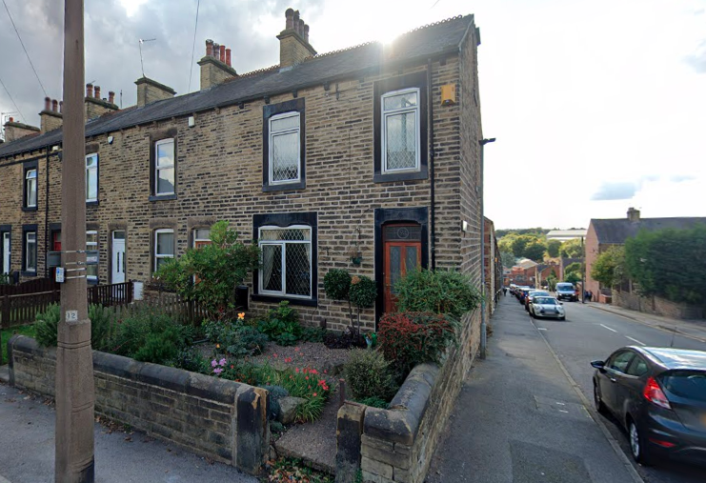

Figure 5: Side Elevation/Gable End
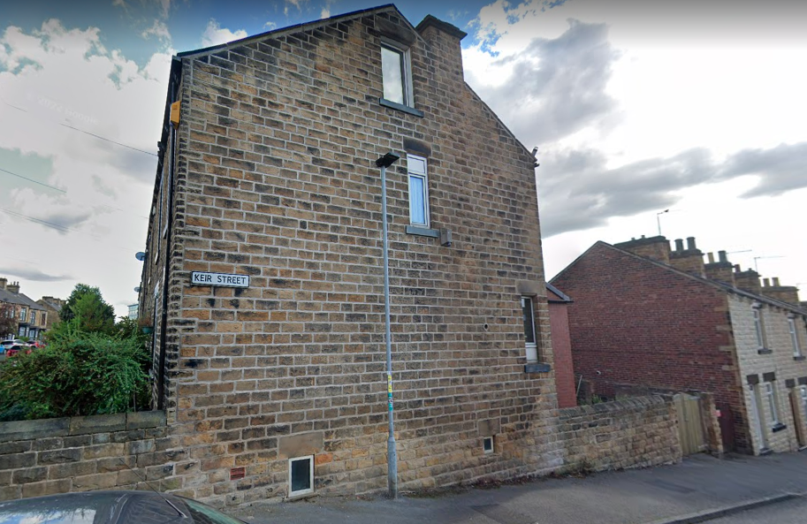
Figure 6: Rear Elevation
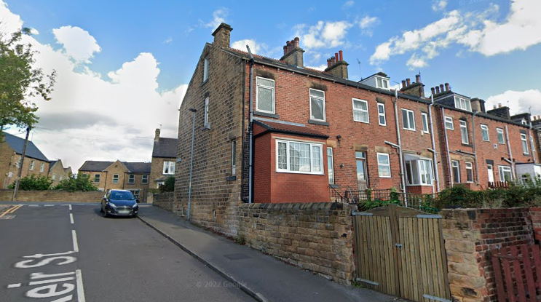

Proposed Development
It is proposed that external wall insulation is applied to the gable end and rear elevation of 94 Sackville Street.
The insulation will protrude 105mmfrom the original façade. The gable end external wall insulation with stone effect finish will return into the existing boundary wall. The external wall insulation will extend down to the pavement with insulation board for areas below the Damp Proof Course (DPC).
It is proposed that a stone effect finish is applied to the external wall insulation to replicate the original coursed sandstone finish. Below are photograph examples of how existing features, including quoining and lintels, can be replicated. It is proposed that the black weathering can be replicated.
It is proposed that the external wall insulation to the rear elevation will replicate the original red brick finish. The single storey rear extension will not be wrapped in external wall insulation.
Figure 7: Examples of coursed stone finish
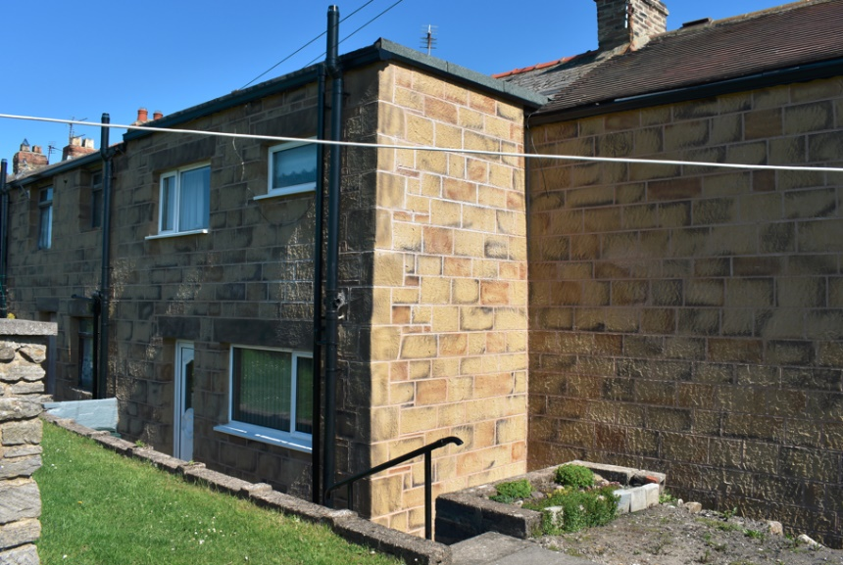
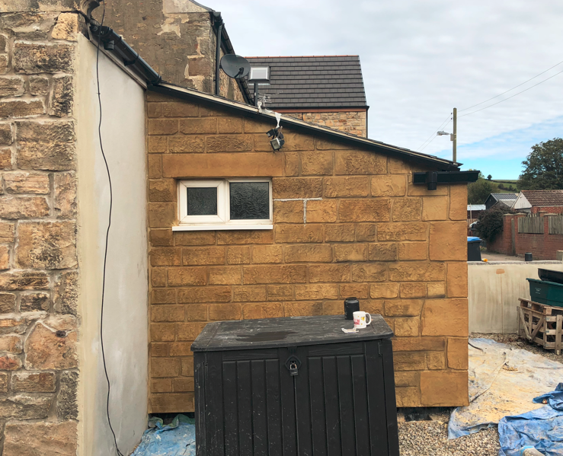

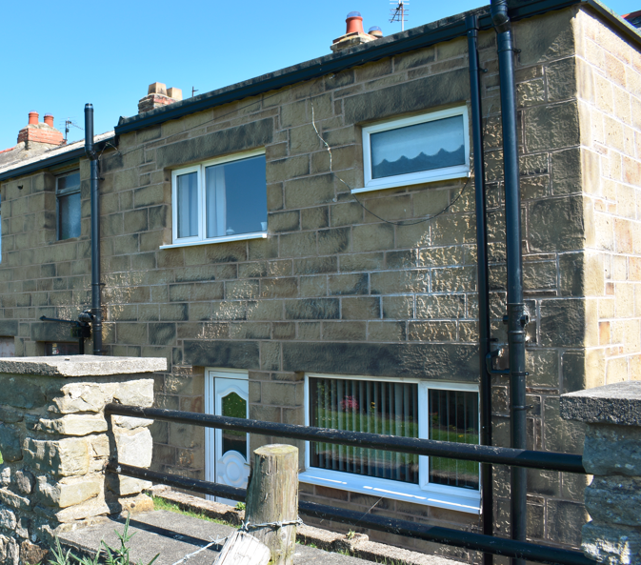
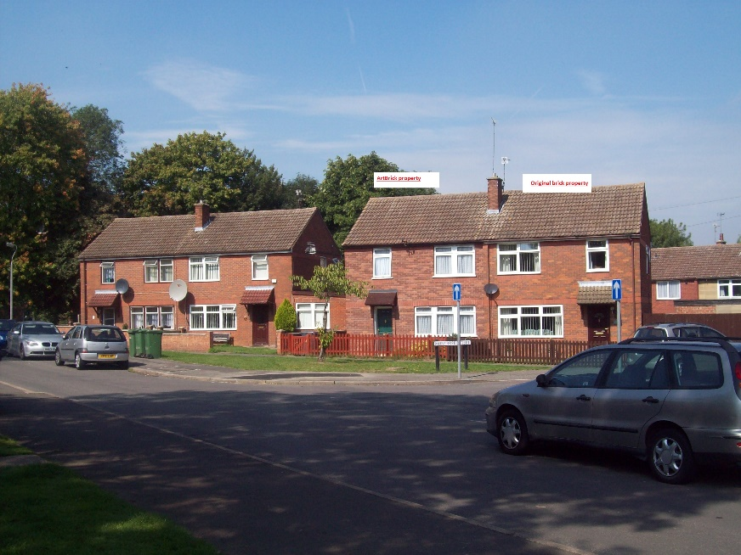

Assessment
The proposed development seeks to install external wall insulation to the side and rear elevations of 94 Sackville Street. The proposed finish will be a of a high-quality which replicates the original stonework detailing and weathered appearance of the façade. The front elevation of the property makes the greatest positive contribution to the Conservation Area and frames an important view along Sackville Street. The proposed development therefore aligns with the intentions of Local Plan Policy D1 and Policy HE1. The use of a sandstone effect finish to the gable end will respect and supplement the distinctive sandstone finish in the wider Conservation Area. The external wall insulation will also contribute to the health of residents, in line within Local Plan Policy D1. The original façade will remain preserved and intact should the external wall insulation be removed in the future.
Conclusion
The proposed development will enhance the health and comfort of a residential property which currently has an EPC rating of E. It is anticipated that in applying external wall insulation will enhance the EPC rating to D.
The installation will be sensitive to the original detailing of the coursed sandstone, quoining, stone lintels and black weathering. The rear elevation will be replicated with red brick finish. Overall the installation of external wall insulation will be of high-quality and in accordance with policies D1 and HE1 of the Local Plan.

