Notes to car parking plan, 1920/0712

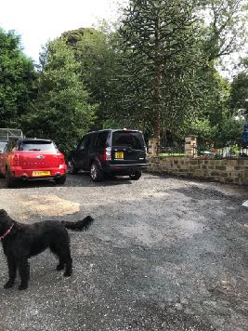
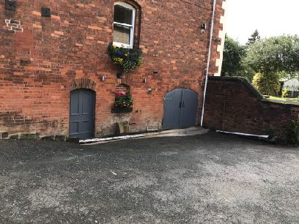
Staff and private parking are located to the side and rear of the property.

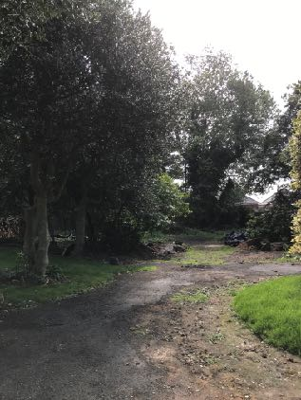
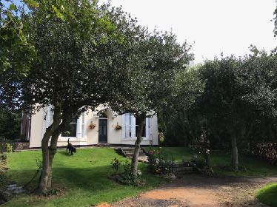
Visitor parking is located to the front/right of the property and consists of 10 numbered bays. The bays will be identified by a numbered sign.

9 of the spaces will be a minimum of 4.8 x 2.4M and one Disabled space will be 6.5 x 3M

There will be provision for bicycles as indicated on the plan.

The spaces are located at least a meter away from existing tress and can be further moved if needed and still retaining minimum sizes and manoeuvrability.

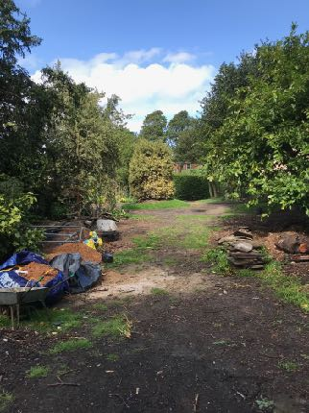
This area was used by previous owners as a dumping ground and several tons of rubble and rubbish have already been removed. The area contained a number of dead and diseased trees some overhanging the road which were in danger of falling into the road. Most were overcrowded Leylandii, which we have removed. The remaining Ash, Holly and Yew trees are now looking healthy.
The base is at present a mixture of hard packed rubble, soil tarmac and it is proposed to cover this with an environmentally friendly acceptable material.

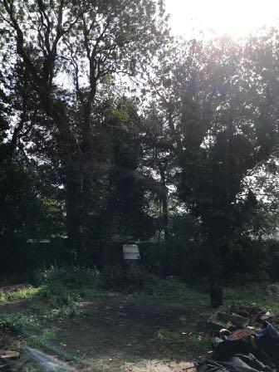

The 2 large Ash trees that are located close to the right boundary running a long side Locke Park have recently been managed by a qualified tree surgeon and will continue to be monitored and managed to make sure they remain safe and healthy.

To keep the car parking area has natural and in keeping with a residential Victorian property we would like to retain the trees and shrubs and intend to re introduce plants and shrubs that would have been in evidence when the property was built.

There will be a carpark management plan that will assist with parking and entry/exiting of the car park.

