Heritage Statement

This statement is in support of an application to have an EV charger installed at the property. The proposed location is on the external wall within the internal courtyard of the Barley House property as per below.

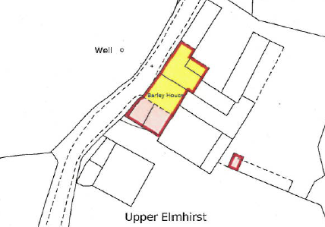

The existing property is a recent barn conversion (in the year 2000). It is constructed in narrow coursed stone rubble walling with stone dressings to openings under a steeply pitched artificial stone slate roof.
Heritage Asset
Barley House is part of a L shaped group of farm buildings and stabling which is Grade II listed (23rd November 1987). The farm buildings were part of Upper Elmhirst Farm and they stand to the south west of the main farm house and adjacent to South Lane. The buildings sit within the open countryside and are a fine example of rural and farming heritage.
The listing describes the building as:
Range of barns and stabling. Late C18 or early C19. Thinly-coursed rubble. Stone slate roof. L-shape plan. Two storeys. Two, large, segmental-headed cart entries, to left, with quoined jambs. Three small quoined entrances to right, two of which have slightly-cambered heads. Two square pitching-holes at high level. At far left the range returns at 90° and has a quoined entrance and a single-light window. Roof hipped at right end. Rear main range: two, quoined, square-headed opposed cart entries. Some later lights. Symmetrical arrangement of round-arched ventilation loops. Interior: slender queen-post roof trusses.
DESIGN & LOCATION
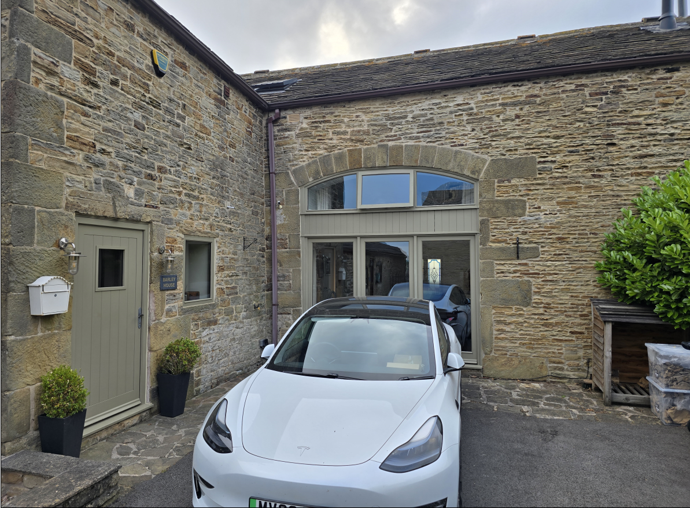
The charger is to be fitted within the inner courtyard, not viewable from the road, see below.

The choice of charger an Anderson EV A3, has been specifically chosen to minimise the impact to the external appearance of the property. It allows for the connector and cable to be stored inside the charger when it is not in use. In addition, the external panels of the charger can be purchased in different colours. The proposed colour for the body and external panel is Hampton Stone as below.
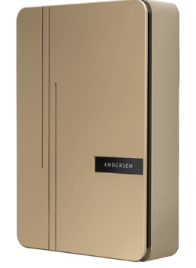
Further, the proposed wiring is to run internally to the building reducing the impact on the external appearance.
There is clearly a balance to be reached in reducing carbon emissions both personally and across the borough itself whilst maintain historical buildings. I believe my proposals reach that balance, but I am keen to work with the conservation office over any other concerns you may have.
Many Thanks

Jonathan Greaves

