HERITAGE STATEMENT
St Marys Church Hall, Church Lane, Worsbrough Barnsley S70 5LQ

- Introduction
This Heritage Statement has been prepared to support an application for Listed Building Consent for the renovation, conservation and enhancement of the property.

Please refer to the documents submitted: drawings and the scope of works.

- Proposal
The church hall is a charming example of a 17th century village building which has seen many school & church activities over the years and has been the hub of village & church social life. Unfortunately time has begun to take its toll on this pretty historic building.

The project will be undertaken extremely sympathetically with little or no demolition. The hall needs to be protected from further damp issues and given a new lease of life for future church and village generations to come, where it will prove yet again to be a valuable gathering space for all.

The current and potential users include:
- Choir practises
- Drop-in
- Wednesday Communion
- Wives Club
- Mothers Union
- VIP
- Harvest Suppers
- Christmas Services and concerts
- Summer Fayre
- Polling Station
- Parent and toddler groups
- Bible study
- Bereavement support
- Weddings
- Funerals
- Baptism parties
- Hire for private parties
- Keep fit / yoga / slimming club
- Concert and musical evenings
- Theatre /drama productions
- Community and Church social events
- Conferences / meetings
- Workshops
- Youth / children’s clubs
- Choir club

Works include: general repairs including small areas of re-pointing to the stone facade (using lime mortar), roof repairs, (using matching materials). Replacement of the defective timber windows with matching frames but including double glazed units to provide enhanced insulation. Damp and timber treatment - the damp proofing to be electro osmotic damp proof course providing minimal disturbance to the existing fabric, all existing finishes to be salvaged where possible or replaced with matching materials and designs. Formation of an accessible WC, new kitchen fixtures fittings and appliances, refurbishment of the outdoor WC facilities with a weather proofed open walkway, roof insulation, rewiring and new heating installation, floor finishes, painting and decorating.

- Description of the Church Hall
Originally built as a school, parts of the building may date back to 1560 when court rolls record that William Elmehyrste and William Broddeswoth were allowed to build a grammar school on waste ground near the Church. However it appears the building as it stands now dates from the late 16th early 17th century.

Listing Text
Worsbrough Worsbrough Village
SE30SW
The Old School
GV 11

School now church rooms. Late C16 – C17 with later additions. Deeply coursed, dressed sandstone, Welsh slate roof. Irregular plan. Shaped kneelers, cavetto-moulded gable copings. Rebuilt stone ridge stack. 4 large transomed casements with glazing bars in chamfered surrounds, chamfered doorway between bays.

OS Grid: SE349026
Mapcode National GBR LW4R.N3
Mapcode Global: WHDCX.BS8V
Plus Code: 9C5WGG9G+Q9

Entry Name: Number 12 and the old school
Listing Date: 4 December 1986
Grade: II
Source: Historic England
Source ID: 11925519
English Heritage Legacy ID: 333987
Location: Barnsley, S70
County: Barnsley
Electoral Ward/Division: Worsbrough
Traditional County: Yorkshire
Lieutenancy Area (Ceremonial County): South Yorkshire
Church of England Parish: Worsbrough St Mary
Church of England Diocese: Sheffield

- Impact of proposed works
The proposed works are designed to have little impact on the building and will be carried out in sympathy with and matching the original style and materials used. It is considered that the refurbishments and alterations proposed are the most effective and appropriate form of building design to achieve the required objective whilst respecting the setting, appearance and character of the listed building

- Summary and conclusions
It is considered that the proposed repairs and enhancements are necessary to preserve the fabric of the building and give it a new lease of life with minimal intrusion. The modifications are in keeping with the original historic features of the property and should be commended. The proposals are considered to positively contribute to the character, appearance and
setting of the Grade ll listed building

- Photographs

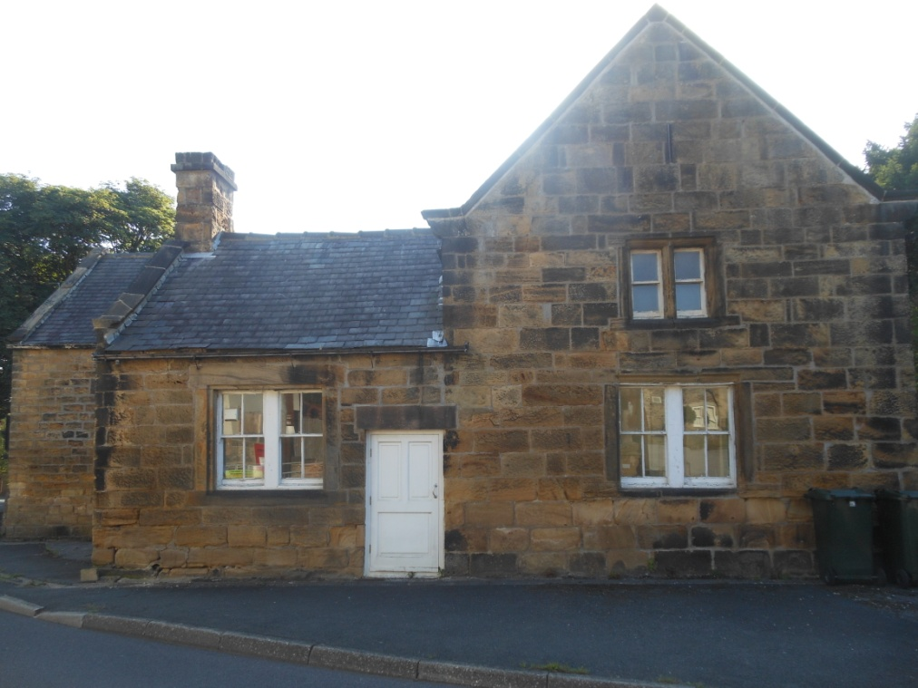 West Elevation

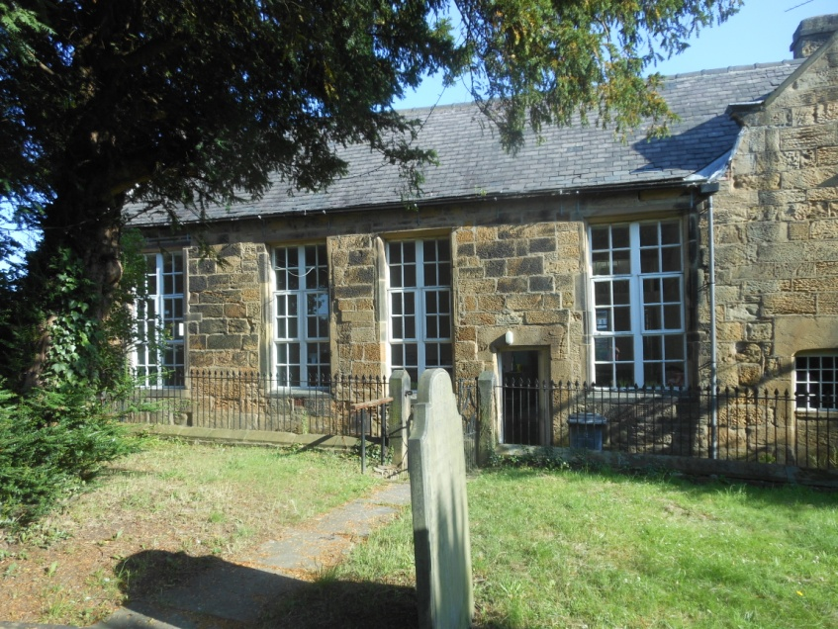 South Elevation

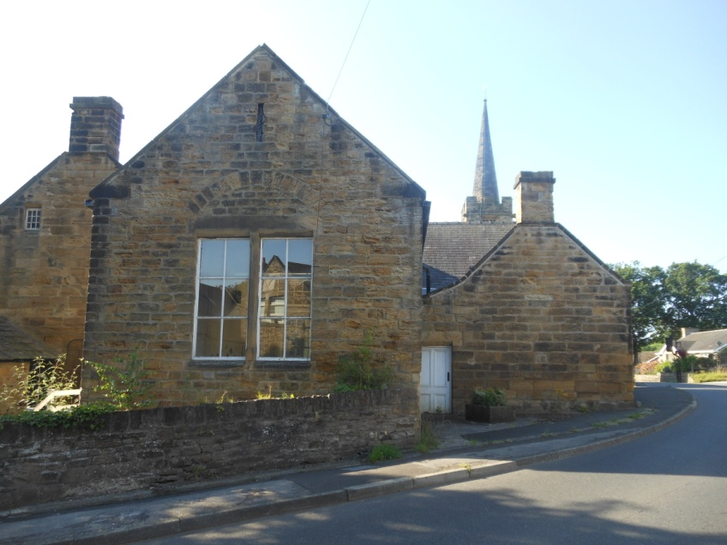 North Elevation

