Existing Front Elevation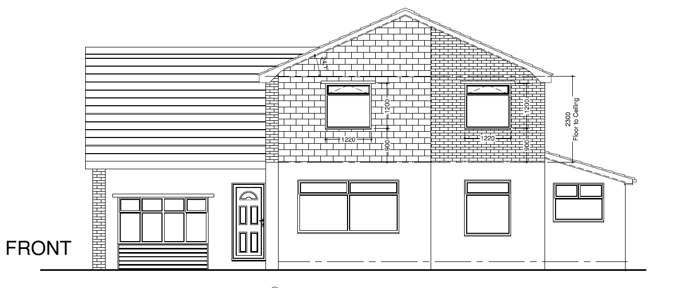

Proposed Front Elevation – Addition of Velux Windows

Existing Rear Elevation

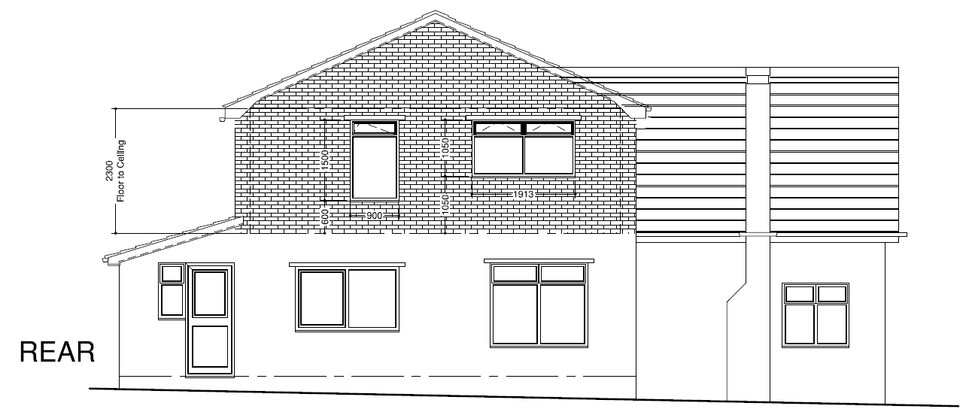

Proposed Rear Elevation

Current Side Elevation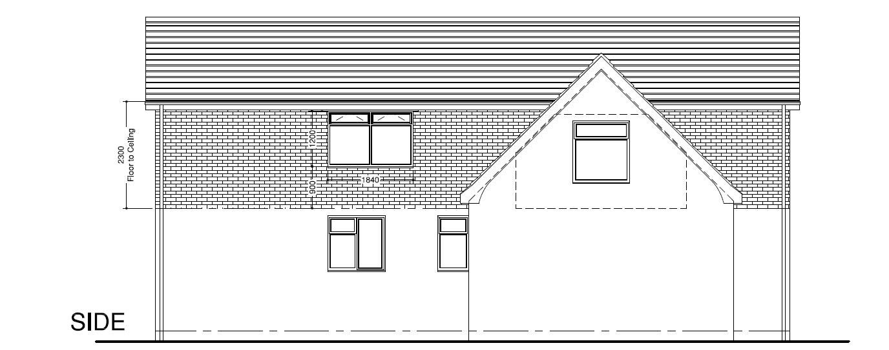

Proposed Side eleveation

Rear of house Front of house

