Flood Risk Assessment

Bar Lane / A61 to Lee Lane Active Travel Scheme, between Athersley North and Royston, Barnsley

On behalf of Barnsley Metropolitan Borough Council, Transport Department
Date: March 2022

Revision Record
Rev | Description | Date | Originator | Checker | Approver
A | Flood Risk Assessment | 31/03/22 | W. Atkins | N. Fovargue | W. Atkins

Prepared by:
BMBC Highways Design team
Westgate Plaza
1 Westgate
Western Street
Barnsley
S70 2DR

Contents

1 Introduction/ 1
1.1 Site Description 1
1.2 Data Collection 1
1.3 Proposed Development 1
2 Data 2
2.1 Topographic Survey 2
2.2 Environment Agency 2
2.2.1 Flood Risk 2
2.3 Correspondence 2
2.4 Existing Drainage 2
3 Flood Risk Assessment 3
3.1 Fluvial Flood Risk 3
3.2 Tidal Flood Risk 3
3.3 Overland Flow 3
3.4 Groundwater flooding 5
3.5 Groundwater Vulnerability 5
3.6 Sewer Flooding 5
3.7 Climate Change 5
4 Site Drainage 6
4.1 Existing Site Drainage 6
4.2 Proposed New Development Drainage 6
5 Flood Risk Management 7

Figures
Figure 1: Former William Freeman site, surface water flow paths 3
Figure 2: View of surface water flow path, located within the west banking of the cutting area, adjacent to the former William Freeman factory site. 4
Figure 3: View looking north, within the cutting, immediately downstream of flow path identified in Figure 2. 4
Figure 4: Images of typical boggy conditions within the cutting area, September 2021. 6

Appendices
Appendix A - Preliminary Design Drawings
Appendix B - Consultations
Appendix C - Storage Calculations
Appendix D - Survey Records

Introduction/
This report has been prepared on behalf of Barnsley Metropolitan Borough Council Transport Department to accompany a planning application for the resurfacing and reprofiling of a public right of way from the junction of Bar Lane and Wakefield Road, A61, Athersley North, to Lee Lane, Royston. The report has been prepared in accordance with the National Planning Policy Framework and associated technical guidance.

Site Description
The site follows the route of a dismantled railway for approximately 1600m, centred on grid reference 434280,410305, covering an area of approximately 5.4ha. A site location plan, drawing reference ATS-BAR LN-LEE LN-013-P1, is included in Appendix A.

The site is bordered by agricultural land and residential properties to the east, agricultural land to the west, the A61, Wakefield Road to the south and the B6428, Lee Lane, to the north.
An unnamed minor watercourse flows across the site from east to west to the northern end.

Data Collection
Data sources that have been used for this flood risk assessment are:
- Topographical survey (BMB/590/SP, dated 16/12/2021)
- Phase 2 Ground Investigation Report (Reference: 151116GI, dated March 2022)
- Arboricultural Survey Report (AWA4078, dated February 2022)
- Preliminary Ecological Appraisal Report (ER-5922-01, dated 12/01/2022)
- SYMAS Mining Report (MAL.21.009, dated 03/09/21)
- Geo-Environmental Investigation (NLM/DRS/120700197.20070986, dated 10/08/07)
- Flood Risk Assessment for the adjacent William Freeman site (JRP Associates, December 2017)
- Environment Agency datasets
- Barnsley MBC asset records
- Barnsley MBC Lead Local Flood Authority records
- Staincross Station Bridge, B3.032, Principal Inspection Report (dated 08/01/2018)

Proposed Development
This FRA is produced to support a Planning Application for the surfacing and reprofiling of a public right of way from Wakefield Road, A61, Athersley North to Lee Lane, Royston. These works form part of a larger overall scheme to improve active travel links from Royston, Carlton, Athersley, Smithies and other adjacent villages to Barnsley town centre. The ultimate need for the scheme is to reduce congestion levels on the A61.

The provision of an active travel link will encourage modal shift from vehicle use to cycling and walking. Barnsley suffers from relatively high levels of social exclusion and poor health, resulting from historically high levels of inactivity and obesity. The provision of attractive and safe active travel links aims to improve connectivity to social facilities and encourage the uptake of physical activity.

The proposed scheme General Arrangement Sections – ATS-BAR LN-LEE LN-014 to 017 (Rev. P2) are included in Appendix A.

Data

Topographic Survey
A topographical survey of the site is included in Appendix D. The site follows the route of an abandoned railway, with an approximate north-south alignment. The site generally falls from south to north, with a high point of 92.77 m AOD at the immediate south of Wakefield Road, A61, and a low point of 78.80mm AOD, 70m south of Lee Lane.
Although the general fall is from south to north, there is an area, located within the first 400m of the southern end, that falls south to a local low point at the immediate north of the A61 highway bridge.

Environment Agency

Flood Risk
The Environment Agency's (EA) flood risk maps were consulted and the site is found to lie in Flood Zone 1, Low Risk, with a probability of flooding less than 0.1% per annum. The EA’s flood risk maps for the area are included in Appendix B.
The Environment Agency’s map of the risk of flooding from surface water identifies an area to the south of the site, adjacent to Wakefield Road, that is susceptible to flooding from surface water. It is believed that this risk is due to the geographical makeup of the site, being an old railway cutting, and an issue with surface water discharging into the cutting from adjacent land.
The EA map of the risk of flooding from surface water is included in Appendix B.

Correspondence
Barnsley MBC, as Lead Local Flood Authority, has been consulted and copies of its responses are included in Appendix B.

Existing Drainage
Public sewer records for the area indicate existing foul and combined sewers serving the residential area to the east and south of the site. No public sewers are shown within the boundary of the site.

Flood Risk Assessment

Fluvial Flood Risk
As discussed above, the Environment Agency's flood risk maps indicate that the site is found to lie in Flood Zone 1, Low Risk, with a probability of flooding less than 0.1% per annum.

Tidal Flood Risk
The site is approximately 90 km from the coast and with minimum ground levels of 78.8m AOD. The risk of tidal flooding is negligible.

Overland Flow
As discussed above, the Environment Agency’s map of the risk of flooding from surface water identifies an area to the south of the site, adjacent to Wakefield Road, that is susceptible to flooding from surface water. It is believed that this risk is due to the geographical makeup of the site, being an old railway cutting, and an issue with surface water discharging into the cutting from adjacent land (see Figures 1 to 3).

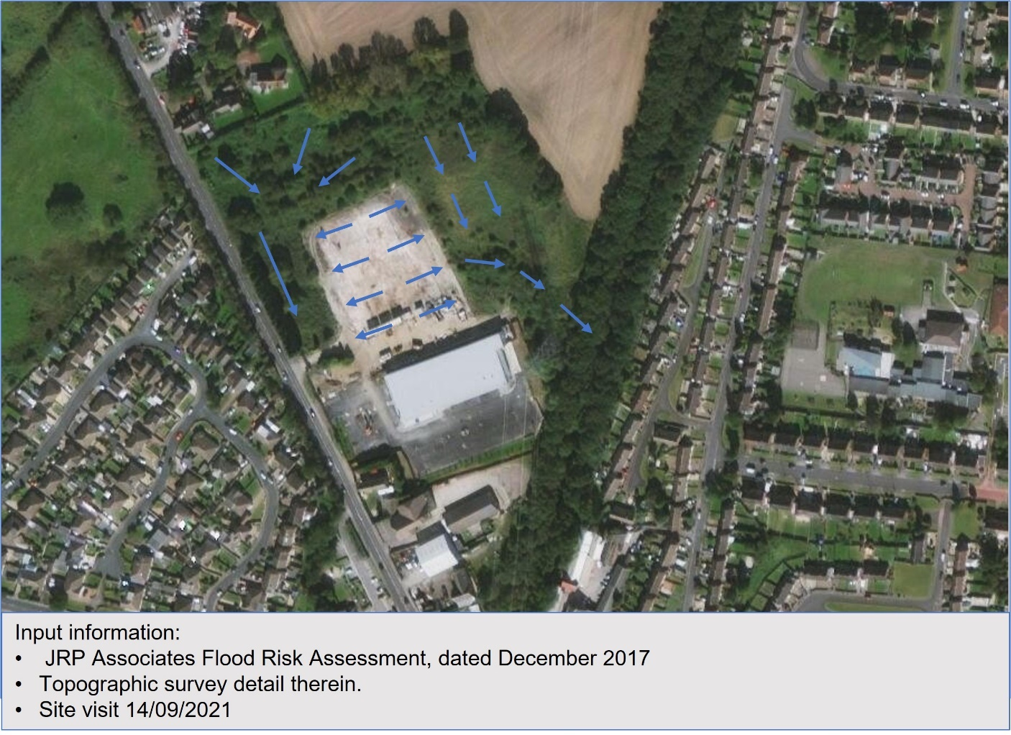
Figure 1: Former William Freeman site, surface water flow paths

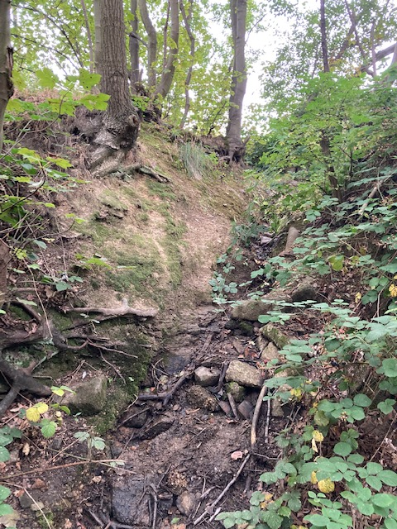
Figure 2: View of surface water flow path, located within the west banking of the cutting area, adjacent to the former William Freeman factory site.

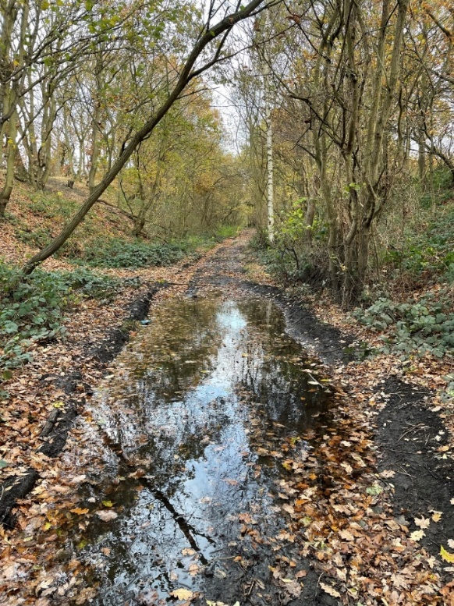
Figure 3: View looking north, within the cutting, immediately downstream of flow path identified in Figure 2.

This section of public right of way has suffered with flooding issues for a number of years, associated with previous adjacent industrial buildings discharging surface water into the cutting. Although the building is now demolished the flows continue to discharge into the cutting from the remaining hard standing and adjacent grassland (see Figure 1).

As part of the scheme, it is our intention to install a 325m length swale / detention ditch along the side of the shared cycleway, to store the anticipated flows from the site and discharge at a suitable rate to a watercourse located north of the cutting area.

Groundwater flooding
The ground investigation report prepared by Abbeydale BEC in March 2022 confirms groundwater levels on the site remained below ground and below that of the proposed drainage features (groundwater was monitored at three locations over a period of five weeks).

The risk of groundwater flooding is therefore considered negligible.

Groundwater Vulnerability
The Environment Agency's Groundwater Vulnerability Map indicates no source protection zones within the vicinity of the site.

Sewer Flooding
Consultation with Yorkshire Water’s sewer records shows that there are no public sewers within the site so the risk of flooding from sewers is considered to be low.

Climate Change
In accordance with NPPF, the effects of future climate change should be considered.

The achievable maximum volume of the proposed flood storage swale is limited by the available width within the cutting and the shallow level of rockhead in the area. The proposed swale design can accommodate the present 1 in 100 year, 6 hour event runoff volume from a conservatively estimated contributing area.

A climate change allowance has not been applied, in this instance, as the former William Freeman site has been granted planning permission for residential development, which includes formal drainage and flood mitigation measures for the site. When the site is developed, the present contributing area to the proposed swale will be reduced by approximately two thirds.

As the former William Freeman remains undeveloped, it is intended that the proposed swale accepts and stores the anticipated runoff volume from this area. Post development, there will be an available volume of swale to receive / store exceedance flows that may arise from the adjacent site.

Site Drainage

Existing Site Drainage
The area within the cutting is generally found to be boggy (see figure, below), with a surface water flow path entering the cutting from the former William Freeman factory site. A number of surface water drains and ditches have been identified within the site. However, the majority of these appear to be filled or to have been severed during past works to increase ground levels at, and immediately south of, the A61 highway bridge. The existing site drainage therefore no longer functions.

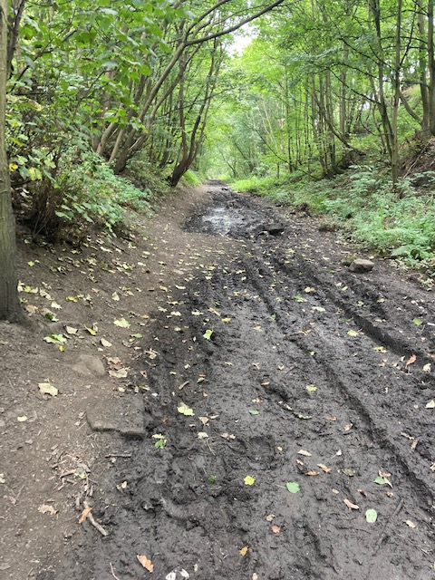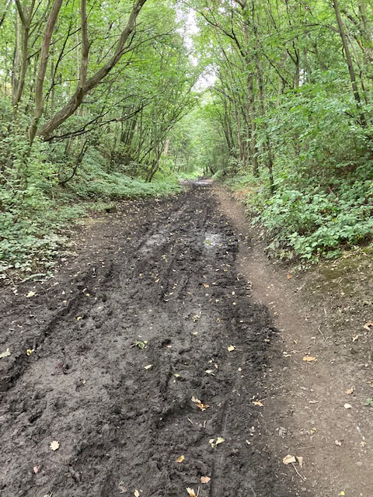
Figure 4: Images of typical boggy conditions within the cutting area, September 2021.

Proposed New Development Drainage
In accordance with the recommendations in NPPF, the design of the new development should adopt measures to reduce the impact of surface water runoff through the use of sustainable drainage techniques.

The scheme includes the installation of a 325m length swale / detention ditch along the side of the proposed shared cycleway, to store the 1 in 100 year, 6 hour runoff volume from the site and adjacent land and discharge at a suitable rate to a watercourse.

The proposal includes the installation of a flow control structure at the downstream of the swale, to limit pass forward flows to a greenfield rate of 5l/s. Downstream of the swale, a proposed 300m length, soft engineered shallow channel will transfer the pass forward flow north, atop the dismantled railway embankment. Any remaining flow* reaching the outfall of the channel will be discharged to an existing embankment toe drain, which discharges to a downstream watercourse.

Drawings showing the proposed attenuation system are detailed in the General Arrangement Sections, ATS-BAR LN-LEE LN-014-017(Rev. P2), included in Appendix A.

*The length, gradient and construction of the soft engineered channel will enable pass forward flows to be further attenuated and naturally drain through the embankment material on route to the outfall.

Flood Risk Management
It is proposed to install flood mitigation measures within the scheme, as described in Section 4.2, to reduce issues of surface water flooding to the site. This will provide dry access to a site which is currently prone to flooding, following rainfall events, and inaccessible at some times of year.

In addition to the installation of a swale, it is proposed to raise the shared cycleway levels to provide a dry surface and to reduce existing steeper gradients to improve accessibility. Where the shared cycleway is located immediately adjacent to the toe of cutting embankments, drainage aggregate strip drains will be installed to contain and drain surface water flows.

Drawings showing the proposed attenuation system are detailed in the General Arrangement Sections, ATS-BAR LN-LEE LN-014-017(Rev. P2), included in Appendix A.

Flood storage calculations are included in Appendix C.

- - Preliminary Design Drawings
- - Consultations
- - Storage Calculations
- - Survey Records

