Code of Best Practice 2016: Edition Published: 24.11.2016
Appendix D: Supplementary Information Template
1. Site Details
Site Name | Kennels farm Mast location 2
National Grid Reference | SE 41532 11993
Site Ref Number
Site Address | Barnsley Road, Hemsworth WF9 4PQ
Site Type (macro or Micro) | Macro

2. Pre-Application Check List
Site Selection (for New Sites only)
(Would not generally apply to upgrades/alterations to existing site including redevelopment or replacement of an existing site to facilitate an upgrade or sharing with another operator)
Was a local planning authority mast register available to check for suitable sites by the operator or the local planning authority? If no | No | If no explain why:  The planning authority does not hold or maintain a mast register.
Were industry site databases checked for suitable sites by the operator: | Yes | If no explain why: Sites Databases were checked from Cellnex, WIG, Airwave, Yorkshire Water and Network Rail.
Site Specific pre-application consultation with local planning authority
Was there pre-application contact: | Yes
Date of pre-application contact: | 16/04/2021
Summary of outcome/Main issues raised: | I note the proposal is now for a triangular shaped mast of 3m width at the base which tapers to 1m at the top. The overall height is 36m.  Summary of outcome/Main issues raised (include copies of relevant correspondence):  - Green belt area - can get round this as is near road, already was an access in and not affecting any residents. Site is close to existing steel lattice Pylons  - Main issue is the height of the mast.  - We have support from local ward councillors.  - Visualisations showing the telegraph pole height compared to the mast.  - Statement on mast sharing and how many operators can share this specific mast – cannot mast share unless 36m.  - Want better coverage for Barnsley area. Matthew Smith mentioned currently is 99.2% and would like it nearer to 100%. In response to this the mapping tool we use is limited at this stage as it does not consider that there may be for example a tree in front of the apex, so the property is not included. The tool is only based on the very centre of the property so in actual reality the coverage will be higher.  - Conservation officer has been consulted and no issues although need a conservation report for application.  - A requirement for planning is an LVIA (Landscape and visual impact report) the visualisations will be added to this report. LVIA has been commissioned and will follow.
Community Consultation
The mast will provide coverage to much of the Barnsley MBC and especially to businesses and residential properties in the NE Ward.
We have contacted all three of the NE Ward councillors; they are:
- Cllr Anita Cherryholme
- Cllr Jeff Ennis OBE
- Cllr Dorothy Higginbottom
We have written confirmation of support for this mast from Councillors Cherryholme and Ennis (evidence can be provided if required). Cllr Higginbottom said in very nice way that she was unable to comment as she sits on the Planning Committee within Barnsley MBC.

We identified that the main local communities to benefit from the faster broadband from the Kennels Farm mast would be Brierley, Shafton and Cudworth. In trying to inform and consult with the town and parish council in these areas, we found that Cudworth was administered directly from Barnsley MBC, Brierley Town Council has been abolished, so that that left Shafton. Shafton Town Council met on Monday, 26th July 2021, and discussed the mast build and its benefits to Shafton. The following day, the clerk informed us via email that the Council had agreed to support the mast build project. Again, evidence can be provided.

Superfast South Yorkshire Broadband Programme (SFSY): We have spoken to the Barnsley MBC Programme Manager of the Superfast South Yorkshire broadband programme, Martin Owens. He is supportive of any deployment that enhances the connectivity options for SY residents and businesses, which the Kennels Farm mast will do. The broadband coverage delivered from Kennels Farm will supplement that coverage provided by the SFSY programme. The understanding is that Martin will be consulted when the full application is submitted.

Summary of outcome/Main issues raised (include copies of relevant correspondence):

No issues – Strong support for the proposed mast; the written support can be supplied

School/College
Location of site in relation to school/college (include name of school/college):

There are no schools within proximity (1km) of the proposed mast. The headteachers of schools in the local communities of Shafton, Brierley and Cudworth within the coverage area have been contacted and no adverse comments or issues have been raised to date. The schools in question are Brierley C of E School, Shafton Primary and, in Cudworth, Cherrydale Primary and Churchfield Primary (part of the Waterton Academy Trust). The pupils, and their families, in all four schools would benefit from the provision of faster broadband from the new mast, and there would be opportunity for the schools themselves to receive a >100Mbps service from the wireless delivery.

Outline of consultation carried out with school/college (include evidence of consultation):

Have consulted all either verbally or via email. No adverse comments recieved

Summary of outcome/Main issues raised (include copies of relevant correspondence):

No issues raised
Civil Aviation Authority/Secretary of State for Defence/Aerodrome Operator consultation
Will the structure be within 3km of an aerodrome or airfield? |  | No
Has the Civil Aviation Authority/Secretary of State for Defence/Aerodrome Operator been notified? |  | No
Details of response:
Developer’s Notice
Copy of Developer’s Notice enclosed? | Yes
Date Served: | 28/07/2021

3. Proposed Development
The proposed site:
The proposed site is the corner of a farmer’s field, close to the main road off of Barewell Hill. The site is to be purchased by Quickline subject to Planning permission. The site already has road access via a slipway from Barewell Hill and adequate space for 2 vehicles to join the main road when leaving the proposed site. We can confirm that this already meets the Highways agency requirements. The land is on a natural high point for the surrounding communities of South Heindley, Fitzwilliam, Hemsworth, Royston, Brierley, Shafton, Grimesthorpe, Cudworth, South Kirkby and Kinsley.

In the adjacent field there are several existing steel lattice pylons which are around 40-50m in height. The mast is approximately 140m to the northwest of the nearest pylon. Due to the pylon’s positions on the higher point of the hill, they are much higher than the proposed telecommunications mast.

Enclose map showing the cell centre and adjoining cells if appropriate:
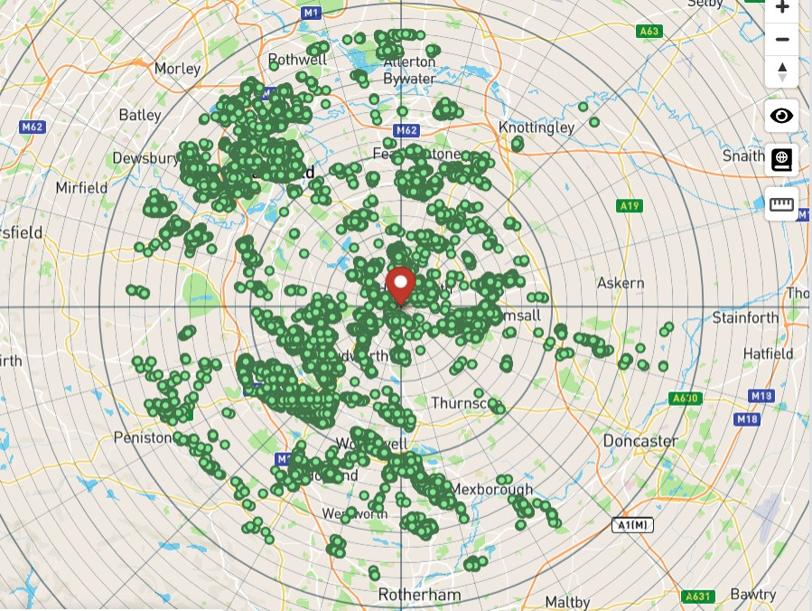

The above map shows the cell centre (in red) with the green dots showing the communities that will receive a signal from this mast.

Type of Structure (e.g., tower, mast, etc): | Lattice Tower 36m, Tri base
Description: | The proposal is to erect a triangular lattice mast at the height of 36m with a portable 10’ x 10’ container, and to be enclosed with a 2.4m high palisade fence.
Overall Height (metres): | 36m
Height of existing building (where applicable): | n/a
Equipment Housing: | 10’ x 10’ portacabin type container
Length (metres): | 10’
Width (metres) | 10’
Height (metres) | 8’
Tower/mast etc – type of material and external colour: | Hot dipped galvanised steel EN1461 – Grey Steel
Equipment housing – type of material and external colour: | 10’ x 10’ container
Reasons for choice of design, making reference to pre-application responses
Quickline Communications Limited’s Network
Quickline provides superfast internet connectivity to residents, businesses, and the public sector through its fibre and Fixed Wireless Access networks, working in conjunction with partner organisations. Quickline is currently working with the UK Government’s Building Digital UK (BDUK) initiative to provide superfast broadband connectivity of at least 30 Mbps, and over 100Mbs to rural areas where there is currently very little or no access to broadband services. The company also supports the UK Government’s Project Gigabit and Gigabit Vouchers schemes, which are part of a £5billion investment to provide ‘hard to reach areas’ with broadband connectivity where communications infrastructure is more costly to build or uneconomic to provide without public investment.

Outside of the BDUK project, Quickline aims to provide connectivity to all with no geographic or social boundaries. For example, it provides connectivity to support a number of initiatives, including “Superfast Wi-Fi ‘Hot Zones’” and “Safe and Connected” (a project developed with schools, children in care, and vulnerable adults that allows care providers to control content and also monitor any signs of suicide risk, self-harming, grooming etc.)

This network is based upon wireless mast distribution and relies upon the installation of next generation 5G base station infrastructure consisting of antennas, transmission dishes, and related apparatus to provide wireless radio coverage from relatively highpoints in the landscape. This approach ensures that tall trees and hills, as well as manmade features such tall buildings, do not block radio signals across the intended coverage area. The customer then receives broadband services via an antenna installed on their property, which is smaller than most TV aerials and satellite dishes.

Based upon pre consultation with the planning authority the structure has been reduced from a 4m quad tower to a 3m Tri tower, narrowing its profile has the height increases, this will also help the mast blend in better with the existing nearby power pylons.
As this site is being funded through a government initiative the site must be made available as neutral host platform for use by other operators. The height at 36m, width and design of the mast has taken this into account to provide the structural strength and space to take additional radios and antennae, we have tried to keep the mast as narrow as possible but still provide the structural support to take the weight of additional equipment for other Network providers. The exact number of additional equipment cannot be ascertained as this depends upon the quantity, size, weight, and wind loading characteristics of the specific antennae a provider would want to deploy, along with the actual height deployed, however we would expect this site could support 360 coverage for at least three other operators, and many additional Point to point links to other onward locations. Should other operators wish to site share on this mast space would be available at competitive market rates via Cellnex (Arqiva) and Wireless Infrastructure Group (WIG). This should help reduce the need for further masts to be built in the surrounding area. In addition to this, the next generation radios to be deployed by Quickline will also be open access. Open Access is required as part of the Superfast Programme awarded to us by local authorities and BDUK / DEFRA is a contractual obligation whereby Quickline as the network infrastructure provider creates an open market and a platform for internet service providers (ISPs) to access. This allows ISPs to operate in a competitive marketplace.

Technical Information
Is an International Commission on Non-Ionizing Radiation Protection Declaration attached Certificate of conformity available for this site and is it enclosed with this submission (mandatory) | Yes

4. Technical Justification
Enclose predictive coverage plots if appropriate, e.g., to show coverage improvement. Proposals to improve capacity will not generally require coverage plots.
Reason(s) why site required e.g., coverage, upgrade, capacity:
The below plots show the predicted areas of premises coverage area of Kennels farm mast at 36m. The green dots show clusters of properties that will have line of sight to the mast.
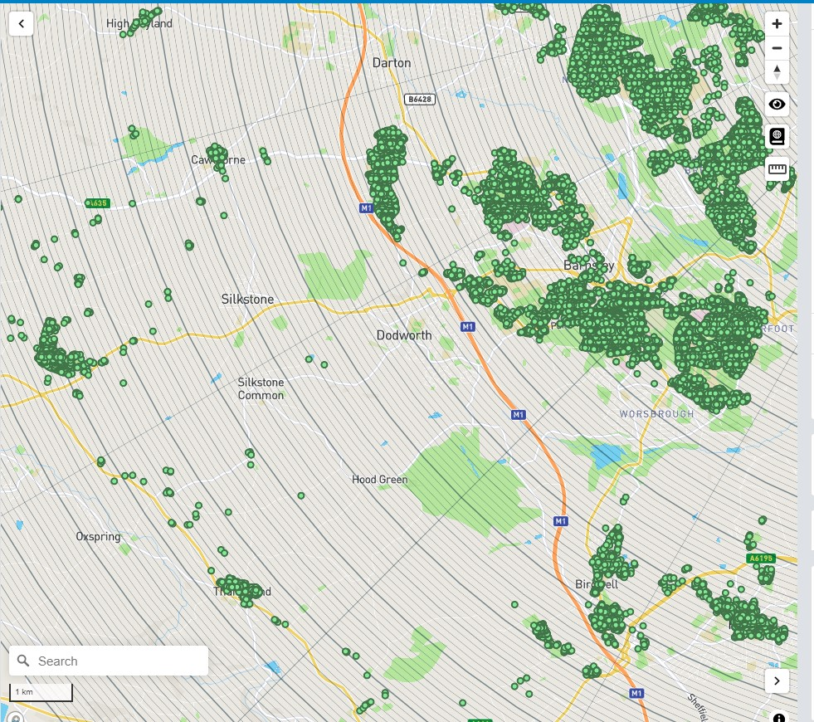

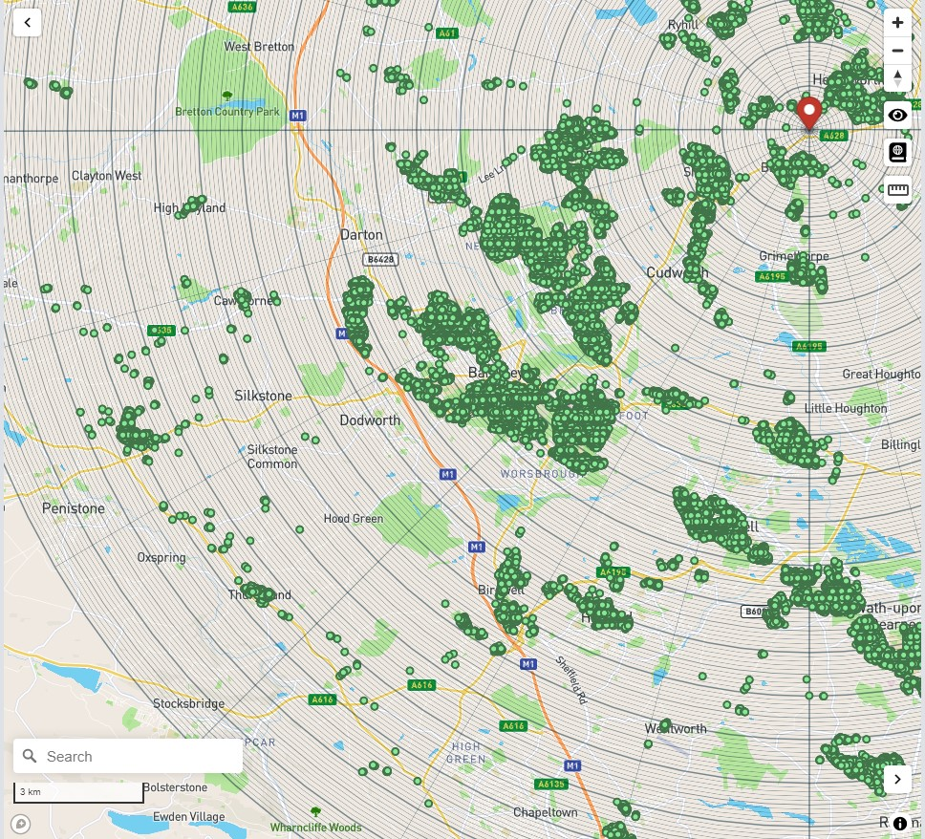

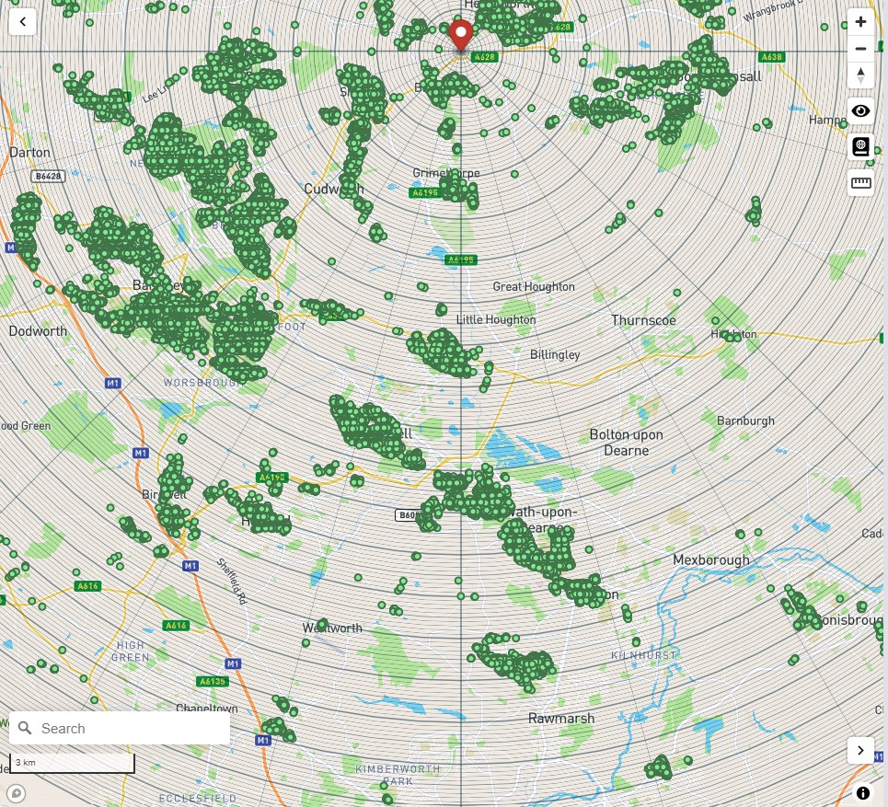

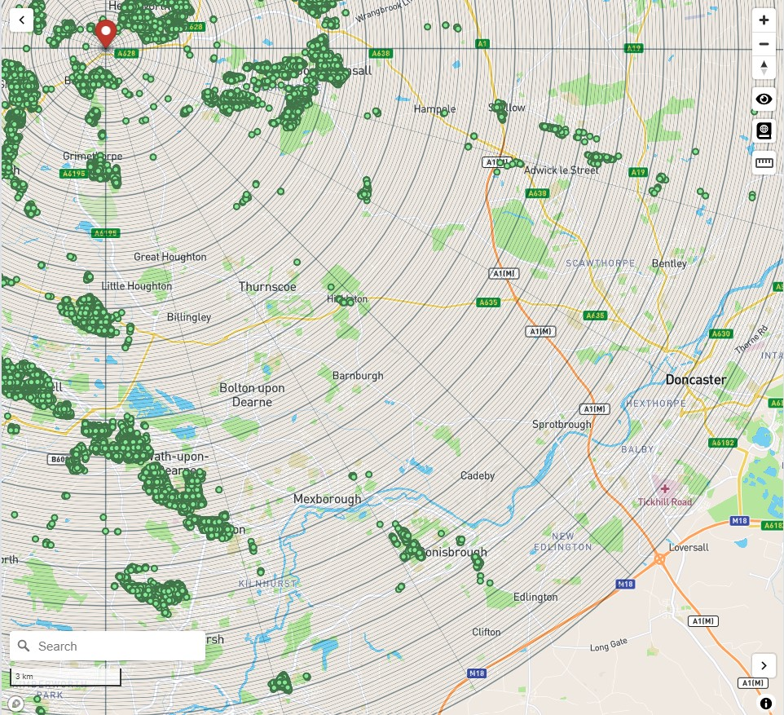

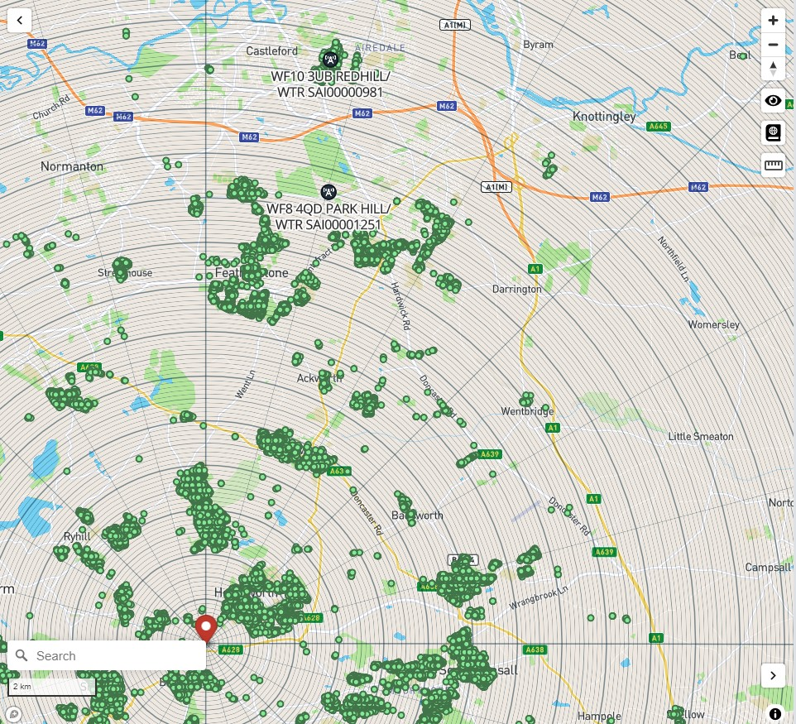

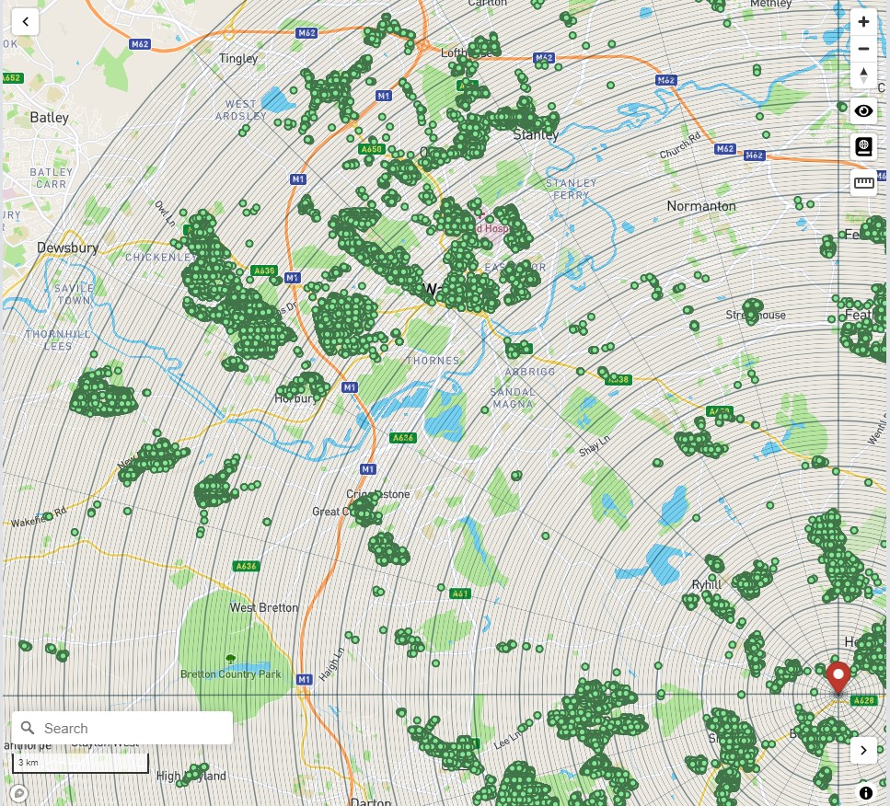

This proposal is for a lattice telecommunications mast which Quickline have an Ofcom Spectrum Licence to Operate. The site will have a 10 x 10’ portable container equipment room with Grid power connectivity, as well as fibre backhaul connectivity to Hemsworth Openreach Exchange.

The site is required as part of the West Yorkshire County Council / Broadband Development UK (BDUK) phase 3 of the Governments Gigabit project to deliver ultrafast broadband to rural communities throughout the county who currently have poor or no broadband connectivity. This site will cover 915 target intervention premises negating the requirement to build multiple smaller local masts.

The site sits on a high position in between Barnsley and Wakefield overlooking the entire area. It also offers good coverage of the Barnsley and Wakefield districts. By erecting the proposed 36m mast, the coverage will capture around a total of 81,000 unique properties and businesses of which 31,971 fall within the Barnsley postcodes, many of which are rural and hard to reach and would be difficult or too costly to reach with a fibre connection. The mast will provide broadband coverage with minimum speeds of 30Mbs and up to speeds well in excess of 100Mbs.

The development of the proposed site on Barewell Hill will form part of an extensive network to provide coverage throughout Wakefield and Barnsley. Our Next Generation Fixed Wireless Access core coverage for this project has been designed primarily based on erecting mast in sensitive areas, and mast sharing agreements with WIG and Cellnex. The next generation technology to be deployed is cutting edge and will be one of the first of its kind to be deployed in Europe. The aim of this government funded project is to provide high speed broadband (superfast with ultrafast capabilities), for rural communities and businesses that currently do not have access (commonly known as “not spots”). It will also provide a “neutral host” platform to support future technology services and upgrades.

This site once built will be added to the Wireless Infrastructure Group (WIG) and Cellnex marketing database for Joint venture commercial share agreements.
5. Site Selection Process
Alternative sites considered and not chosen (not required for upgrades/alterations to existing sites including redevelopment or replacement of an existing site to facilitate an upgrade or sharing with another operator).
Site Name and address | National Grid Reference | Reason for not choosing
Arqiva 88466 Huddersfield Church West | 53.594 -183948 | Not space for additional antennae
Arqiva Crossland Heath Golf Club | 53.6179 -0.28303 | Still in discussion with Cellnex however space is only available at 12m and will be more of an infill site to the North West of the coverage area in West Yorkshire
WIG Hollinghurst farm, Wakefield | 53.647546 -1.562024 | Restricted height / lease issues – Site rejected by WIG
WIG Highfields Farm, Wakefield | 53.613969 -1.484691 | Restricted height / lease issues – Site rejected by WIG
Yorkshire Water Askern DN6 0PP | 53.615607 -1.154394 | Unable to come to commercial agreement with Yorkshire water
Yorkshire Water Goldthorpe S63 9JF | 53.536335 -1.295633 | Unable to come to a commercial agreement with Yorkshire water
Yorkshire Water Potter Hill S35 4QB | 53.470141, -1.502770 | Unable to come to a commercial agreement with Yorkshire water
Kennels Farm Airwave Tower | SE 42014 12452 | Too small, no spare capacity
Havercroft Airwave Tower | SE 39479 13850 | Too small, no spare capacity, covered too small a coverage area.
Kennels farm Mast 1 | SE 41683 12235 | Unable to obtain lease / permission from Landowner
Warmfield Common | 53.681771, -1.430476 | Unable to obtain lease / permission from landowner

If no alternative site options have been investigated, please explain why:
The above sites were considered as alternatives but have been found to be unsuitable replacements for the Kennels Farm 2 mast due to the reasons stated above.

The original scheme that was to be located at Kennels farm mast 1, was going to be part of Wakefield initiative for increasing the 5G capability in this area, and it still is, hence why the mast was going to be placed further up the road within the Wakefield district. After some time and effort, the land registry came back with complications on the land purchase, and the land was in fact part of a trust, so we couldn’t purchase it through the farmer that we initially consulted with. The farmer then provided us with the proposed piece of land, that we are now seeking planning permission for. This was also a great location for the mast, as it already had adequate access from the main road already established.

It also became apparent that the HS2 is proposed to be developed and constructed close to the original site, and the new location is further away from this proposed train line.

Land use planning designations:

Additional relevant information (planning policy and material considerations):
The National Planning Policy Framework 2019 (NPPF) supports development that leads to the provision of high-quality communications. At paragraph 112 it says: “112. Advanced, high quality and reliable communications infrastructure is essential for economic growth and social well-being. Planning policies and decisions should support the expansion of electronic communications networks, including next generation mobile technology (such as 5G) and full fibre broadband connections.
At the heart of the NPPF is a presumption in favour of sustainable development. Specifically, in respect of protected landscapes, the NPPF states that planning policies should support economic growth in rural areas in order to create jobs and prosperity by taking a positive approach to sustainable new development. It also says that appropriate weight should be given to conserving landscape and scenic beauty in National Parks, the Broads, and Areas of Outstanding Natural Beauty, which have the highest status of protection in relation to landscape and scenic beauty. The conservation of wildlife and cultural heritage are important considerations in all these areas and should be given great weight in National Parks and the Broads.
At the same time, those who represent rural areas recognise that a modern telecommunications infrastructure network is vital for a modern economy and society and is particularly important in preventing a rural/urban digital divide; while operators recognise the need to respect the environment, particularly in sensitive areas such as National Parks and in siting development in rural areas, operators will take these principles into account.

Confirmation that submitted drawings have been checked for accuracy.
Name: (Agent) | Mark Bullivant
Operator: | Quickline Communications Limited
Address: | Quickline Communications Limited  Unit 3, Priory Court,  Saxon Way,  Hessle  HU13 9PB
Telephone / Email: | 07487 435171 / mark.bullivant@quickline.co.uk
Signed
Date:

