Ref: 2015/0262

Applicant: Alan Beardshall
Description: Erection of single storey side extension to dwelling.
Site Address: 10 Moorbank Road, Wombwell, Barnsley

Site Description
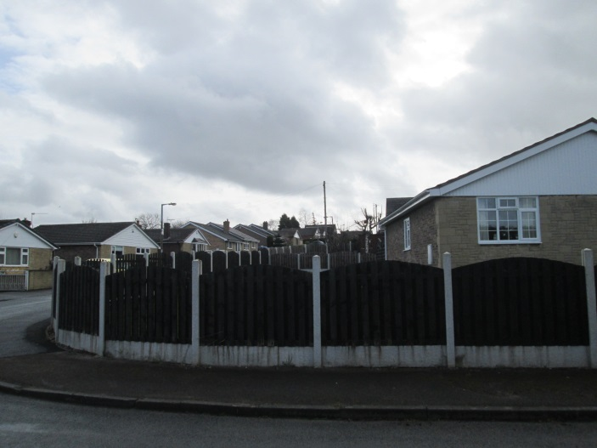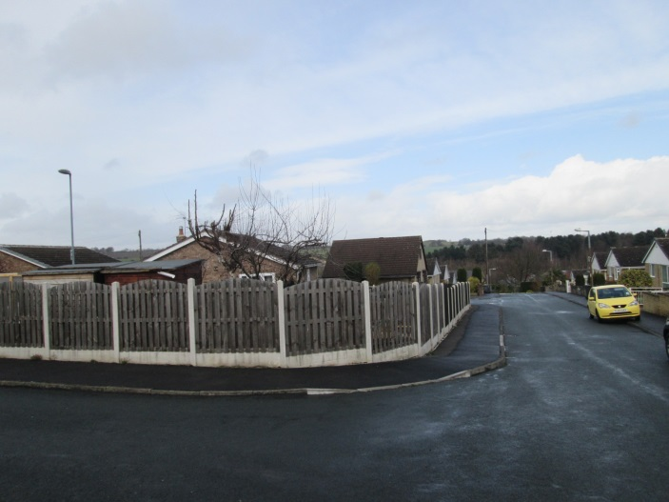
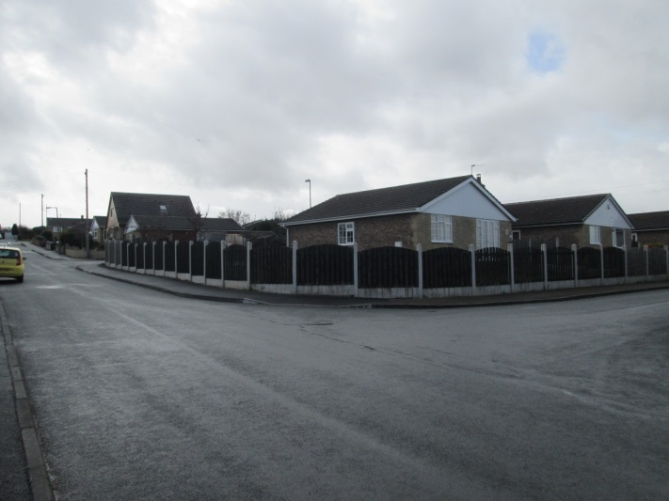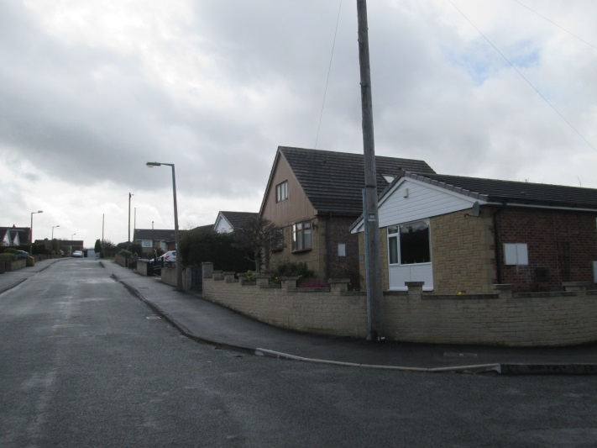

This is a corner bungalow that has its main frontage to Moorbank Road but the side elevation faces Moorbank Close. There is a generous side garden that is surrounded by a close boarded fence. To the north the bungalows are further forward than the side elevation of No. 10 and to the south there is a large roof extension.

Proposed Development

To build a full length extension (slight set back) on the side garden with a hipped roof over. The extension would be 3m wide leaving between 4.7m and 6.3m retained garden width.

Policy Context

Planning decision should be made in accordance with the development plan unless material considerations indicate otherwise and the NPPF does not change the statutory status of the development plan as the starting point for decision making. The development plan consists of the Core Strategy and saved Unitary Development Plan policies. The Council has also adopted a series of Supplementary Planning Documents and Supplementary Planning Guidance Notes, which are other material considerations.
Core Strategy

CSP29 Design.

Saved UDP Policies

The site is within Housing Policy Area on the UDP.

SPDs/SPGs

House Extensions

Proposals for house extensions, roof alterations, outbuildings and other domestic alterations
should:
1. be of a scale and design which harmonises with the existing building
2. not adversely affect the amenity of neighbouring properties
3. maintain the character of the street scene and
4. not interfere with highway safety.

The design of a single storey side extension should reflect the design of the existing dwelling
in terms of roof style, pitch materials and detailing and should not have an excessive sideways
projection (i.e. more than two thirds the width of the original dwelling). A lean-to roof is a more traditional form and could beused as an option against a gable wall to reduce the impact on a neighbouring property.

Habitable rooms in the roof space of single storey side extensions will not normally be
permitted, particularly where the eaves height would be increased (leaving a number of
courses of brick work between the top of the fenestration and the bottom of the eaves) and/or
dormer windows would be introduced.

On corner plots the sideways projection or a single storey side extension should not exceed
more than half the width of the existing gap between the original dwelling and the side
boundary.

In addition, on a corner plot where the rear elevation of the dwelling is clearly visible, a set
back of 500mm will also be required at the rear to ensure the extension remains subordinate
and to avoid the unsightly bonding of old and new materials.

Emerging Local Plan

The Draft Local Plan allocates the site as urban fabric.

NPPF

The National Planning Policy Framework sets out the Government’s planning policies for England and how these are expected to be applied. At the heart is a presumption in favour of sustainable development.

Consultations

None

Representations

None received

Assessment

Principle of development

Domestic extensions that comply with the SPD on House Extensions would generally be acceptable in principle. The proposal is for a corner plot and the sideways projection does not not exceed more than half the width of the existing gap between the original dwelling and the side
boundary. The rear elevation of the dwelling would not be clearly visible so no set back is needed

Residential Amenity

There is no impact on any nearby dwelling as the nearest property is on the opposite side of the road.

Visual Amenity

There is an ample side garden to accommodate the extension and there is no clear encroachment on any building line. Furthermore, there are other more prominent visual intrusions in the immediate vicinity.

Recommendation

Grant subject to conditions

