TRAVEL TO SITE

The site is located at 21 Carr head Road in the Howbrook area of Barnsley. The site is accessed via an existing vehicular access off Carr Head Road set back from the highway. The access off Carr Head road will remain unchanged The site is also accessible to the following local amenities.
Chemist located at Foster Way, High Green, Sheffield within a distance of 1 Mile
Post Office and convenience store also located within a distance of 1 Mile (High Green or Wortley)
Sainsbury’s Local located within a distance of 1 Mile (High Green)
Large Asda, located in Chapeltown some 2.5 miles away
The M1 motorway J36 is easily accessible via the A616 . Trains can be caught at Chapeltown station to Sheffield Meadowhall and beyond.

THE SITE

The site is located at 21 Carr Head road in a popular residential area of Howbrook. The site currently stands a new dwelling tastefully built and maintained and forms a substantial and aesthetic addition to the street seen. The site was developed by the current owner and are the applicant. The existing dwelling received planning consent on the 10th of February 2017 under ref 2017/0173. The dwelling was completed in 2018.
A tarmac drive leads through access and privacy gates to a private rear area and access to the existing garage. The drive sweeps round at an upper level supported by a retaining wall to a raised paved patio and garden area with the dwelling set down at a lower level down some external steps. The garden, patio and dwelling are exceptionally maintained and are a credit to the applicant. Paved areas lead on towards the rear to a lawned garden with boundary wall looking out to open fields. Boundary walls and fencing provide screening to neighbouring properties and all completed in accordance with the original planning consent.

BRIEF
The applicant does not use part of the garage to the right-hand side and is generally used for storage. The left-hand section is regularly used for the parking of their car. Further car parking spaces are available on the drive as well as a space on the front forecourt.
The applicant wishes to increase the floor space of their kitchen and dining area to enlarge the kitchen and site the dining space within a modest single storey rear extension. This will use a section of the existing lower patio space and to reconfigure the existing retaining wall to accommodate. The position of the extension and retaining wall is required to still maintain vehicular access to the left-hand section of the garage and negates the need for the right-hand section. The applicant wishes to partially demolish this section to reduce the overall width. This will allow for greater amenity space to this area and also to allow a view and light to the dining room extension which is set down from the drive as indicated thus reducing the overbearing effect on the garage. All other parts of the dwelling shall remain unchanged.

PLANNING HISTORY
The site has had a previous application ref 2017/0173 for the new dwelling in 2017 which stands today. The dwelling was also signed off for habitation under building regulations in 2018.

USE

The end use of the extension is intended further floor space and upgraded kitchen area for the applicant and their family.

AMOUNT

The size of the extension maximises the use of the site area available without being dominant to the existing host dwelling. The size also allows the continued garaging of the family car to the remaining left-hand garage. The extension being single storey as well as being set down from the upper drive level has no impact on the amenity of neighbouring properties, will not reduce light in any way and will not be visible from the street scene. The partial removal of the garage allows for greater amenity space and removes the feeling of the site being over developed.

The extension does not affect any existing site lines from the neighbours therefore intrusion is virtually non-existent. The sliding doors lead out to a private section of the lower patio.

LAYOUT

The extension has been set out to have the dining area to be placed in the extension to give scope for an elongated kitchen. Rear facing windows and Velux roof lights will maximise the light levels to this rear area to make the extension light and airy.
The layout of the ground floor still accommodates the current requirements of Part M of the Building Regulations

SCALE

The extension has been designed be subsidiary with roof abutments below the cills of the upper windows. In other circumstances, the extension would fall within the current General permitted Development rights.
The design and materials are also shown to blend in with its existing host dwelling.

LANDSCAPING

The remaining area after part of the garage is removed is to improve the area of overall amenity and be finished in paving to match the existing. Lower patio paving and the driveway will all be made good after siting the extension

APPEARANCE

The Extension has been designed that all the new materials shall match the existing dwelling. The materials shall be salvaged and re used where possible to maintain sustainability. (See schedule of materials below)

ACCESS

The car parking areas directly to the side of the dwelling shall remain. The drive allows for additional off-street parking after the removal of the right-hand garage. The gate openings shall remain for site security as well as hiding the extension from general view.

INTERNAL CIRCULATION

The extension is designed maintaining accessibility in accordance with part M of the building regulations.
SOCKETS AND SWITCHES
All electrical sockets and switches and other appropriate equipment in habitable rooms are to be set at heights between 450mm and 1200mm from finished floor level.

MEANS OF ESCAPE

The means of escape has been provided in accordance with Part B of the Building Regulations by means of escape windows, existing smoke detection and a protected route to the outside air via the entrance halls. The assembly points shall be to the front of the building.

PLANNING ASSESSMENT
The National Planning Policy Framework was published on 27 March 2012. The Framework is an important material consideration that should be interpreted alongside the development plan. In accordance with paragraph’s 7 and 9 of the Framework, there is a presumption in favour of sustainable development.
The proposed extension will incorporate a high-quality design and the matching of materials that is responsive to the character of the existing dwelling and commensurate with other residential properties.
Overall, the design of the proposal ensures the scale of built-form will remain in keeping with the surrounding residential character.
The proposed extension will be constructed to the latest Building Regulation requirements and therefore be very well insulated and have energy efficient heating systems. Wherever possible, building materials will be sourced locally. Solar gain has been considered throughout the proposed layout is proposed to the kitchen, dining room and circulation areas. This will reduce dependence on electric lighting and enhance the sustainability of the property.
Design Principles
A high-quality development will be expected by the applicant, which would respect, take advantage of and enhance the distinctive features of host dwelling.
The scale and massing of the proposed extension has carefully considered the privacy, outlook and residential amenity of neighbouring properties. Reference has previously been made by Planning Officers to a distinctive, residential character. However, the surrounding area currently has a mix of property styles, types and materials. It is considered that the extension would be absorbed and will not be visible from the street scene.
In light of the above, it is therefore respectfully requested that planning permission be granted for a proposed extension and partial garage demolition at Holly Cottage 21 Carr Head Road, Howbrook.

MATERIALS SCHEDULE

Facing Material
Random coursed natural stonework to match the existing and
tooth bonded back to the existing structure

Roof Slates
“Greys” stone slate in buff finish to match the existing main roof and to
suit pitch.
Windows
Woodgrain UPVC to the new rear window to match the existing style.
Wood grain UPVC framed side sliding doors

Rainwater Goods
Black aluminium profile gutters.
Black aluminium down pipes.
Patio
Existing stone paving salvaged and re-laid to extended areas to client’s
choice
Drive
Tarmac to be made good after siting extension and retaining wall

SITE PHOTOS

LOCATION OF EXTENSION

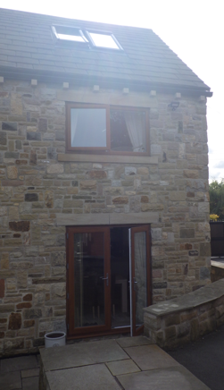

REAR ELEVATION

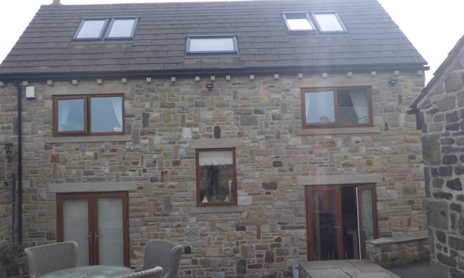

SIDE ELEVATION AND LOCATION OF EXTENSION

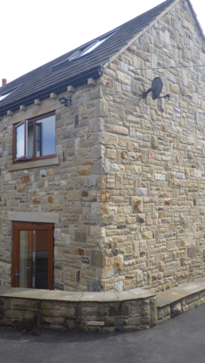

EXISTING GARAGE. RIGHT HAND SIDE TO BE DEMOLISHED

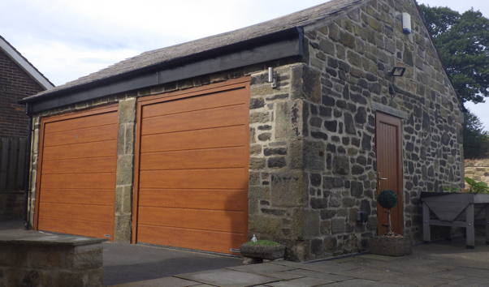

LOWER PATIO AND LEVELS

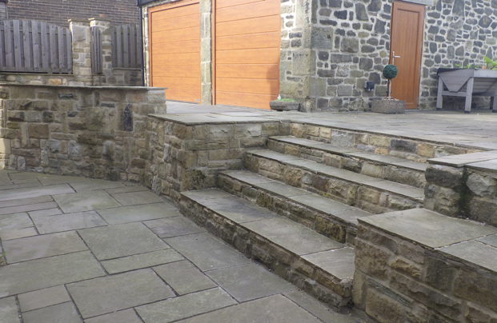

PAUL GOUDGE
Design

Architectural Design Consultants
32 Hollybank Close
Intake
Sheffield S12 2BN
Tel/Fax: (0114) 2544900

PROPOSED DESIGN AND ACCESS STATEMENT FOR ALTERATIONS AND EXTENSION
AT
HOLLY COTTAGE
21 CARR HEAD ROAD
HOWBROOK
BARNSLEY

For
MR & MRS G. VARNAM




