IMAGES FROM DRAWING 350GOB(0-)1

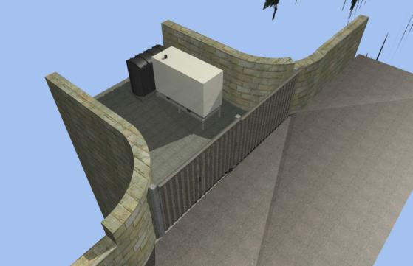
Birds’ Eye

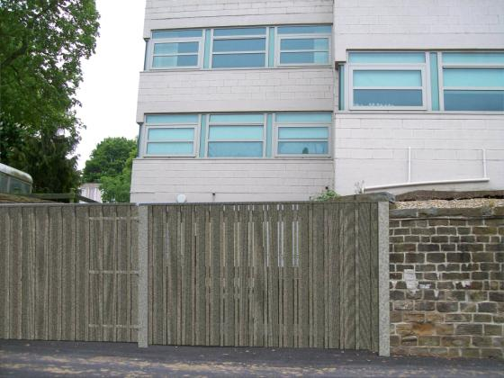
Photomontage

