2023/0086

Mr & Mrs C & L Black

Sunny Bank Cottage, 39 High Street, Silkstone, Barnsley, S75 4JN

Alterations at first floor level including rear dormer extension, rear raised terrace, and additional windows

Site Description

The dwelling is a large, detached bungalow located in Silkstone. The dwelling was formerly subdivided but has since been sold as one dwelling solely as 39 High Street. This section of High Street has a consistent residential street scene but with a variety of dwelling types and designs. The dwelling has a parking area to the front leading to an integral garage. To the rear is a garden area.

Planning History

B/85/1347/PR - Erection of extension to bungalow

B/00/1364/PR - Increase height of roof to form first floor accommodation

Proposed Development

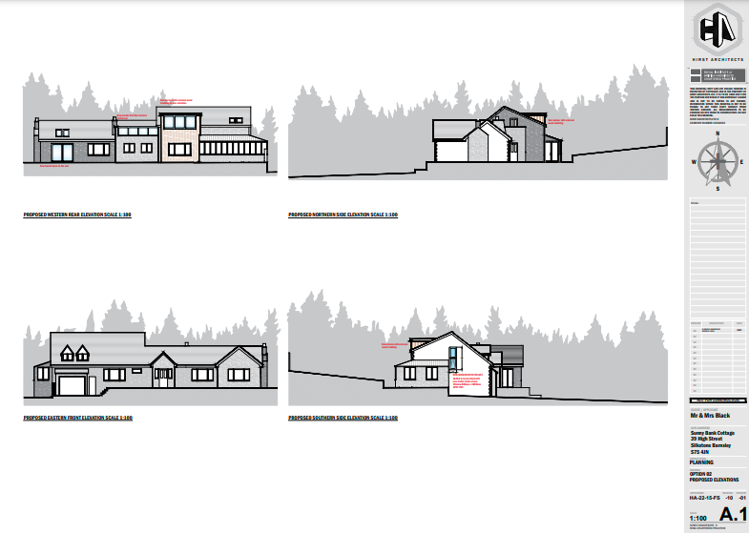

The applicant is seeking approval for alterations at first floor level including a rear dormer extension, a rear raised terrace, and additional windows. The terrace will be formed form a conversion of the existing pitched roof to a flat roof with a height of 3.95 meters and a width of 4.75 meters. The dormer will be set into the existing pitched roof. The materials used will be matching below the terrace with the addition of a glass screen and balustrades. The dormer will be constructed of wooden cladding.

Policy Context

Planning decisions should be made in accordance with the development plan unless material considerations indicate otherwise and the NPPF does not change the statutory status of the development plan as the starting point for decision making. The Local Plan was adopted in January 2019 and is also now accompanied by seven masterplan frameworks which apply to the largest site allocations (housing, employment and mixed-use sites). In addition, the Council has adopted a series of Supplementary Planning Documents and Neighbourhood Plans which provide supporting guidance and specific local policies and are a material consideration in the decision-making process.

The Local Plan review was approved at the full Council meeting on 24th November 2022.The review determined that the Local Plan remains fit for purpose and is adequately delivering its objectives. This means no updates to the Local Plan, in whole or in part, are to be carried out ahead of a further review. The next review is due to take place in 2027 or earlier if circumstances, require it.

Local Plan Allocation – Urban Fabric

To the extent that development plan policies are material to an application for planning permission the decision on the application must be taken in accordance with the development plan unless there are material considerations that indicate otherwise (section 70(2) of the Town and Country Planning Act 1990 and section 38(6) of the Planning and Compulsory Purchase Act 2004).

In reference to this application, the following policies are relevant:

Policy SD1: Presumption in favour of Sustainable Development – States that proposals for development will be approved where there will be no significant adverse effect on the living conditions and residential amenity of existing and future residents. Development will be expected to be compatible with neighbouring land and will not significantly prejudice the current or future use of neighbouring land. Policy GD1 below will be applied to all development.

Policy GD1: General Development – Development will be approved if there will be no significant adverse effect on the living conditions and residential amenity of existing and future residents. Development will be expected to be compatible with neighbouring land and will not significantly prejudice the current or future use of neighbouring land.

Policy D1: High quality design and place making – Development is expected to be of a high-quality design and will be expected to respect, take advantage of and reinforce the distinctive, local character and other features of Barnsley.

Supplementary Planning Document: House extensions and Other Domestic Alterations

This document establishes the design principles that specifically apply to the consideration of planning applications for house extensions, roof alterations, outbuildings & other domestic alterations. The general principles are that proposals should;

- Be of a scale and design which harmonises with the existing building;

- Not adversely affect the amenity of neighbouring properties;

- Maintain the character of the street scene; and

- Not interfere with highway safety

The above principles are to reflect the revised principles in the NPPF, which promote high quality design and a good standard of amenity for all existing and future occupants of land and buildings.

National Planning Policy Framework

The NPPF sets out the Government’s planning policies and how these are expected to be applied. The core of this is a presumption in favour of sustainable development. Proposals that align with the Local Plan should be approved unless material considerations indicate otherwise. In respect of this application, relevant policies include:

Section 12: Achieving well designed places - The Government attaches great importance to the design of the built environment. Good design is a key aspect of sustainable development, creates better places in which to live and work and helps make development acceptable to communities. It is important to plan positively for the inclusion of high-quality design for all developments, including individual buildings, public and private spaces and wider area development schemes.

Within section 12, paragraph 134 states that “development that is not well designed should be refused, especially where it fails to reflect local design policies and government guidance on design, taking into account any local design guidance and supplementary planning documents such as design guides and codes”.

Consultations

Silkstone Parish Council were consulted and provided no response.

Representations

Neighbour notification letters were sent to surrounding properties, one objection was received and in summary raised the following points;

- The proposed plan will create a first-floor terrace and rear dormer extension with windows facing our property. The current layout for the property just has a tiled roof where the proposed terrace will be located.

- The new dormer extension currently has a roof with windows that face upwards, not directly into our property.

- The terrace will overlook our property and windows in the dormer extension will face directly into our conservatory and rear garden.

- Since having a roof added to our conservatory, we use the room extensively. The proposal will impact on our privacy as we will have new windows in the proposed dormer and a terrace now facing directly into our conservatory and rear garden.

Assessment

Principle of Development

The site falls within urban fabric which has no specific land allocation; however, the site and surrounding area is made up principally of housing. Extensions to residential properties are considered acceptable where they do not have a detrimental impact on the amenity of surrounding residents, visual amenity and highway safety.

Visual Amenity

The SPD states that ‘materials should normally be of the same type, colour and texture to the existing house or as close a match as possible’. In this case, the proposed materials are present on the existing dwelling as the dormers on the front of the dwelling as also constructed of wooden cladding.
The proposed terrace and dormer window are set to the rear of the property and would not be highly visible from public vantage points. The use of materials is appropriate for each use, and neither is considered to be an incongruous feature, nor will they detrimentally affect the character of the existing dwelling and surrounding street scene. The proposed development is therefore not considered to be contrary to Local Plan Policy D1: High Quality Design and Place Making and is considered acceptable in terms of visual amenity.

Residential Amenity

The main impact of the proposed terrace area on residential amenity is overlooking of neighbouring properties. The SPD states, “decking and raised platforms will only be allowed where the privacy of neighbouring residents is not detrimentally affected by significantly increased overlooking”. The proposed terrace will look onto a neighbouring property (1 Towngate) however it will predominantly look onto its blank side elevation and the distance will be greater than 12 meters. Additionally, 1 Towngate is on a higher ground level than the host dwelling therefore reducing the impact of overlooking into the garden area.

With regards to the conservatory erected at 1 Towngate, this conservatory has a triple aspect window therefore potential overlooking from the east could be mitigated without a significant loss of outlook to the conservatory. Already a portion of the conservatory window facing east is screened by the existing boundary treatment. It is also noted that due to the level differences between the properties the conservatory in question can be argued to overlook the garden area of 39 High Street.

The proposal is considered to be in compliance with Local Plan Policy GD1: General Development and is acceptable in terms of residential amenity.

Highway Safety

There will be no impact upon highway safety.

Recommendation

Approve with conditions

