
Tree Protection:
TPO 17

Inspector:
Graeme Golding MICFor
Arboricultural Manager
BSc Social and Community Forestry - Chartered Arboriculturist
LANTRA Professional Tree Inspector
Site Number:
1590.
Date of inspection:
19th June 2025.
Site:
The Pastures.
Foxmill View, Millhouse Green,
Sheffield, S36 9AB.
Annual Tree Health & Woodland Inspection.


In this
document:
Introduction Limitations Methodology
Tree Works Priority Age Classification Ash Dieback
Site Description Site Survey Recommendations
Site Plan

Annual Tree Health & Woodland Inspection

Introduction
In endeavour to sustain and maintain sound management of the tree and woodland asset associated with the title site a general condition survey has been carried out

The primary aims of the task are:
- To assess the current condition of the existing woodland and individual trees to meet the audit requirements for the site.

- Identify any and all arboricultural and tree management related matters that need address.

Limitations
The details and conditions of the trees and general condition of other assets/aspects around the site are recorded as found during the time of the survey, where the weather conditions were sunny, slight cloud, 14°C.
Changes to existing site conditions may influence the condition of individual tree specimens or groups of trees that, where as a result of common crown establishment, have a common interaction.

While every effort has been made to detect defects, no guarantee can be given as to the absolute safety or otherwise of any individual tree or groups of trees where their crowns have an influencing factor.

Trees are living organisms and are subject to influence by sudden changes in climatic conditions.

The trees have been inspected from ground level employing Visual Tree Assessment (VTA) techniques.

Trees and Woodland areas inspected/assessed by pedestrian traverses around the specific site, to observe any tree health related issues or damage caused by climatic extremes, that could produce an unacceptable risk to any users of the site or neighbouring properties including roads, footpaths etc.

Should any issues be observed during the inspection works will be programmed accordingly to alleviate any potential risks.

Where access is restricted due to gradients/physical

these are viewed from as safe proximity as can be achieved and visual aids such as binoculars are used.

No decay detection equipment was used, unless stated. It is recommended that trees continue to be inspected regularly.

The information contained within this report is for the sole use of Greenbelt Group Ltd, its officers and any agents approved by them, relative to the site in question.
Any reference to the details of the survey by any third party is done so at their own risk.

Methodology
All individual trees have been inspected from ground level employing Visual Tree Assessment (VTA) techniques.

Trees and Woodland areas inspected/assessed by pedestrian traverses around the specific site, to observe any tree health related issues or damage caused by climatic extremes that could produce an unacceptable risk to any users of the site or neighbouring properties including roads, footpaths etc.

Should any issues be observed during the inspection works will be programmed accordingly to alleviate any
potential risks.

Where access is restricted due to gradients/physical obstructions to allow 360-degree, examination of trees these are viewed from as safe proximity as can be achieved and visual aids such as binoculars are used.

While every effort has been made to detect defects, no guarantee can be given as to the absolute safety or otherwise of any individual tree or groups of trees where their crowns have an influencing factor.

Trees are living organisms and are subject to influence by sudden changes in climatic conditions.

The information contained within this report is for the sole use of Greenbelt Group Ltd, its officers and any agents approved by them, relative to the site in question.

Any reference to the details of the survey by any third party is done so at their own risk.

Works Prioritizations
Priority levels for identified works or works proposals.

High - Works should be completed at the earliest opportunity.

Moderate - Works to be completed within a six-month timescale.

Low - Less time critical, works should be undertaken within a twelve-to-twenty-four-month timescale or part of a long- term management plan.

Age Classification
Age class of trees is recorded as follows:

Semi-mature: Established tree but less than 1/3 of its potential life expectancy.

Early Mature: Well-developed trees but not yet fully matured, typically of 1/3rd to 2/3rd life expectancy.

Mature: Typically, of over 2/3rd life expectancy.
Over-Mature: tree coming to the end of their natural lifespan and typically containing significant structural defects and or decay.

Ash Dieback
Chalara, known commonly as Ash Die Back caused by the fungus (Hymenoscyphus fraxineus) is now considered to be endemic and widespread throughout much of the UK. Symptoms/symptomology are not always obvious on mature trees, especially when leaves have already fallen.

The rate of decline of infected trees and the long-term prognosis for the health of Ash trees generally is currently uncertain.

Some research suggested that the UK may experience losses of up to 95% of its Ash trees and that, once infected, trees decline rapidly causing premature failure of the canopy of the infected trees.

Premature removal of healthy trees is, however, not recommended at this stage. Once trees are infected and reach less than 50% of their normal foliar density, then it may be prudent to consider the removal of such trees where they pose a threat to persons or property.

Site Description

This site is abutting the river Don, tree lines banks of mixed age and species, hosting ash dieback.

There is a mixed verity of amenity trees throughout the open spaces of this site.

There is a woodland area to the north side of the site that hosts a lade/stream with a desire line weaving its way through it.

To the east side is the continuation of the lade and a tree covered strip.

Site Survey

Advisory, with the recent extreme climatic occurrences, drought and storms, trees can become stressed and exhibit ill health, this can be over a short- or long-term period.

The trees will be monitored accordingly, annually by the Arboricultural Manager and monthly by the Operations Manager, should there be any observed tree health actions be required, depending on the work priority/prescription, the prescriptions will be programmed accordingly.

Recently, the month of May has been uncharacteristically dry, this can and will affect some trees by placing them in to stress, this can be observed by small chlorotic foliage or necrotic foliage.

Once again, the trees exhibited good foliar colour, good apical dominance, some trees exhibited stress, no visual issues observed.

Observed some minor storm damage, not an issues to the trees health.

Area 1 – Species composition: - goat willow, alder, ash and sycamore, young to mature in age, some signs of ash dieback symptomology.

Area 2 – Species composition: - willow, sycamore, ash, birch, alder, young to mature in age, some signs of ash dieback symptomology.

Area 3 - Species composition: -willow, ash, birch, sycamore, hawthorn, alder, beech, rowan. Young to mature in age, some signs of ash dieback symptomology.

Area 4 – Species composition, elm, ash, alder, sycamore. Dead elm at side of lade, and leylandii branch that has snapped from neighbouring hedge.

Area 3 has a tree T1 that overhangs a garage, this tree has slight root plate movement, prescribe the removal of the tree within 6 months

Under Common Law affected land owners can prune any overhanging growth providing the cuts are made on their side of the boundary. If the works undertaken weaken or subject the trees to stress and ill health, the perpetrator/s can be held to account of their actions in a court of law.

If tree failure occurs after unauthorised works, Greenbelt will not be held responsible.

Recommendations
Prescribed work: T1, prescribe the removal of the tree within 6 months, the tree is damaging the garage. The tree requires removal due to the damage it is causing.

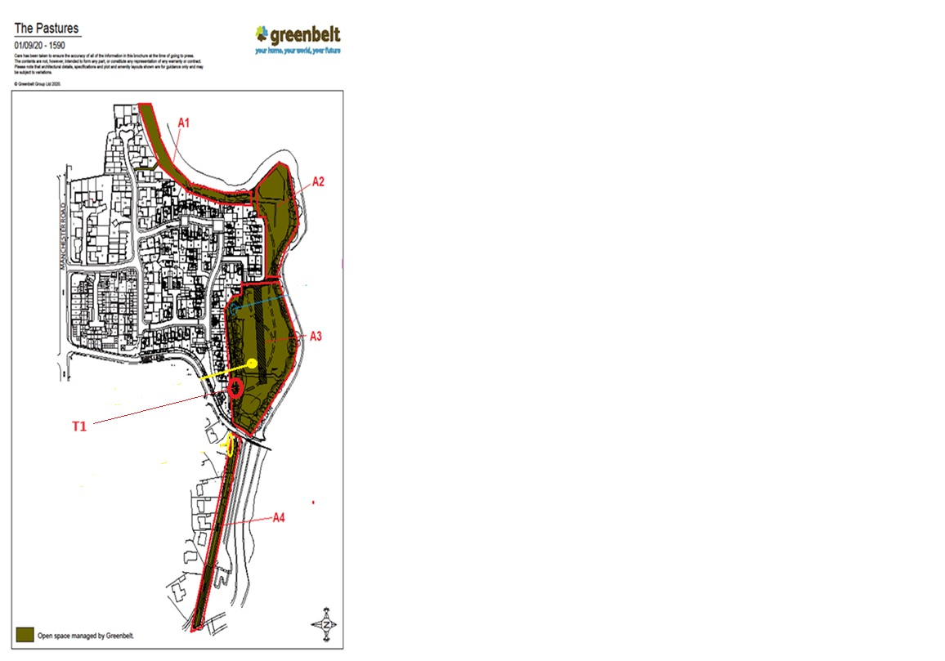



Some of the experts who trust us













03450 940 940
enquiries@greenbelt.co.uk greenbelt.co.uk
Scotland Greenbelt McCafferty House
99 Firhill Road
Glasgow G20 7BE
England (North) Greenbelt
4335 Park Approach
Thorpe Park Leeds LS15 8GB
England (South) Greenbelt
Friars House
Manor House Drive Coventry CV1 2TE
Greenbelt
Ulster Gazette Ar

