Shaw Lane, Carlton, Barnsley
Dearne Valley Wetlands SSSI
Impact Assessment

Consultation Draft - Without Prejudice

June 29th 2024

Who we are:
Baker Consultants is an ecology and sustainability consultancy. We work in terrestrial, freshwater and marine environments, providing a range of services to industry, government, developers, public services and utilities.

Baker Consultants comprises a highly experienced team of professional ecologists. We do wildlife surveys - but they are only the first steps in the process for most projects. We are also involved in ecological assessment, environmental law, biodiversity management and design planning.

We don’t just work with wildlife, because we know that communication with clients, design teams and conservation bodies is the key to project success. Explaining the implications of survey data, and interpreting legislation, policy and best practice is one of our strengths. We help decisions to be made and actions taken, allowing constraints to be kept to a minimum and project risks to be managed.

Our approach is scientific, pragmatic and creative. Alongside tried and tested methods, we seek to innovate, introduce clients to new ways of thinking and always deliver sound commercial awareness. You will find us honest and approachable, but we’re not afraid to be robust and challenging - or to ask difficult questions.

We do believe in nature conservation. But we also believe in good development, well delivered. We know that, with our input, projects and plans can provide benefits for both nature and people.

That’s not the whole story.
For more information, look at our web site www.bakerconsultants.co.uk, subscribe to our blog, or call us on 01629 593958.



Baker Consultants Ltd
Cromford Station
Cromford Bridge
Matlock
Derbyshire DE4 5JJ
info@bakerconsultants.co.uk
www.bakerconsultants.co.uk
01629 593958

Company No. 6702156

© Baker Consultants Ltd



Disclosure and Limitation:
Baker Consultants has prepared this document for the sole use of the commissioning client in accordance with the agreed scope of works and Terms and Conditions under which our services were performed. The evidence and opinion provided is true and has been prepared in accordance with the guidance of our professional institution’s Code of Professional Conduct. No other warranty is made as to the professional advice included in this document or any other services provided by us. This document may not be relied upon by any third party without the prior and express written agreement of Baker Consultants.

Unless otherwise stated in this document, the assessments made assume that the study site referred to will continue to be used for its current purpose without significant change. The assessment, recommendations and conclusions contained in this document may be based upon information provided by third parties and upon the assumption that the information is relevant, correct and complete. There has been no independent verification of information obtained from third parties, unless otherwise stated in the report.

Where field investigations have been carried out, these have been restricted to the agreed scope of works and carried out to a level of detail required to achieve the stated objectives of the services. Natural habitats and species distributions may change over time and further data should be sought following any significant delay from the publication of this document.

Report Contents

1 Introduction 3
2 Natural England’s consultation response 3
3 Summary and Conclusions 9

Introduction
    - The document provided an assessment of the potential effects on the proposed development at Shaw Lane upon the Dearne Valley Wetland Site of Special Scientific Interest (SSSI). In addition, the report considers potential impacts in combination with the other parts of the Local Plan housing allocation MU3 of which the Shaw Lane is part.
    - In its reason for refusal 4 the Council stated ‘The applicants have not adequately assessed the impact of the development on the SSSI’ a reference to the Dearne Valley Wetlands SSSI. The aim of the document is to address this criticism to the satisfaction of both the Council and Natural England.
    - The Dearne Valley Wetland SSSI is a large archipelago site comprising a total of 649.99 ha across Barnsley, Rotherham and Doncaster. The species interest of the site breeding and non-breeding birds associated with wetland habitats. The nearest parts of the SSSI to the proposed Shaw Lane development are compartment units 001 and 002 Pool Ings and Sandybridge and Carlton Marsh respectively which are located to the east of the railway line which marks the eastern boundary of the development site.
    - The railway line which is raised on an embankment along the length of the development site boundary offers a considerable physical buffer between the site and the SSSI.

Natural England’s consultation response
    - Natural England was consulted by the Council and a response was received dates 12 April 2022. Natural England has not objected to the planning application but rather has requested that further information be provided regarding possible impacts on the Dearne Valley Wetland SSSI including an assessment of impacts of water quality, increase recreational pressure, loss of functionally linked land and air quality. Each of these impact pathways are addressed below.

Charges in recreational pressure
    - Both SSSI units 001 and 002 are accessible to the public. The Pool Ings and Sandybridge unit is located immediately to the south of Rabbit Ings Country Park and within the SSSI there are numerous footpaths that connect with the Country Park. Furthermore, the SSSI notification papers from May 2021 (CDXX) highlight that the site is important for recreation where at paragraph 1.4 it is stated ‘The site is important for both formal and informal recreation and attracts people from a wide area. A significant part of the attraction for visitors is its nationally important wildlife interest and there are key visitor facilities at the RSPB site of Old Moor, one of five RSPB reserves within the SSSI’. There is no suggestion in the SSSI documents that recreational pressure is currently or may be in the future be likely to cause damage to the site and should therefore be restricted.
    - The designation document lists operations that require will require Natural England’s consent this list includes ‘Recreational or other activities likely to damage or disturb the features of special interest.’ It is clear therefore that recreational activities only need to be considered where they are likely to damage or disturb the features of special interest.
    - Public access to Carlton Marsh Nature Reserve (SSSI unit 002) is actively promoted on the Yorkshire Wildlife Trust website (https://www.ywt.org.uk/nature-reserves/carlton-marsh-nature-reserve). The only restriction set out on the website is for dogs to be kept on leads. Facilities include a car park (off Shaw Lane), a picnic area and a network of walking routes. Pool Ings (Unit 001) of the SSSI also has public rights of way through the site and a network of informal paths and tracks that connect with Rabbit Ings Country Park which is located immediately to the north of the SSSI.
    - There is no evidence to suggest that the footpath network which may be accessed by new residents at the proposed development will result in any adverse effects upon the SSSI’s features of special interest. NE has not identified any threats from recreational pressure in their SSSI notification documents and YWT promote access to Carlton Marsh. Furthermore, the Carlton Masterplan Framework highlights the linkages to the SSSI as a benefit of the allocation of MU3 (see for example page 5 and page 60).
    - Finally, is should be noted that both of the SSSI units 001 and 002 are classified as being in “favourable” condition with ‘no identified condition threats’ .
    - Notwithstanding the above assessment the appellant is offering to provide, on a precautionary basis, fair and reasonable funds to the Council that will be used to improve access and recreation facilities within Pool Ings and Carlton Marshes. The funds will be used to provide signage, dog waste bins and fencing within the SSSI.

Water Quality
    - Discharges of foul and surface water are fully addressed in the evidence of Mr A Laird. In summary, surface water drainage will be through a Sustainable Urban Drainage System (SUDS) in order to maintain green field runoff rates. SUDS also assists in maintaining water quality such as reducing suspended solids. By designing the SUDS in accordance with Construction Industry Research and Information Association (CIRIA) “The SuDS Manual” (C753) the quality of surface water runoff will be maintained and potentially improved when compared to the current agricultural drainage.
    - Foul water will be discharged into the existing sewage system and will therefore be treated in within current sewage treatment works consents.
    - The proposed project will therefore have no effects upon the Dearn Valley Wetlands SSSI through changed in hydrology.

Loss of Functionally Linked Land
    - The concept of ‘functionally linked land’ FLL is one which is usually applied to Habitats site (Special Protection Area, Special Areas of Conservation and Ramsar sites). While I am very familiar with the application of this concept to these sites, despite my wide experience in the application of nature conservation law I have never before known the concept of FLL to be applied to Sites of Special Scientific Interest. The concept of FLL is entirely based on the legal structure of the Habitats Regulations 2017 (as amended) and those legal tests are not mirrored in the legal structure of those parts of the Wildlife and Countryside Act 1981 (as amended).
    - Nonetheless I have below addressed NE’s comments on the possible loss of functionally linked land as set out in its consultation response.
    - Functionally linked lands is defined as ‘areas of land or sea occurring outside a designated site which is considered to be critical to, or necessary for, the ecological or behavioural functions in a relevant season of a qualifying feature for which a Special Areas of Conservation (SAC)/ Special Protection Area (SPA)/ Ramsar site has been designated. ‘ It is clear from this definition that FLL must have an ecological ‘function’ which is not trivial, but one which is ‘critical to or necessry for’ supporting the qualifying features of a designated site. If the concept of FLL can be applied to a SSSI (and given that the concept is entirely based on authoritative decision concerning Habitats sites I think this is highly problematic) in order for land to be FLL for an SSSI it would have to provide a critical function for the interest features of the SSSI. Given that the Dearn Valley Wetlands is designated for the wetland birds it supports the proposed site would have to provided habitat that would be critical to supporting those interest features.
    - In this case the features present on the proposed development site are not those which can be considered critical to supporting the SSSI. The arable land which makes up the majority of the site will not provide critical feeding habitat for wetland birds. Nor would it provide roosting habitat that would be any more attractive than any of the other arable land in the areas. The loss of the arable land could not therefore have any significant effect upon the Dearne Valley Wetland SSSI.
    - Furthermore during 2024 Baker Consultants has carried out a full breeding bird surveys of the development site including the placement of audio recorders in the vicinity of the pond to detect which species are using the site.
    - As would be expected of primarily arable land the site supports very low numbers of breeding birds (see Appendix 2). The only species of bird confirmed as breeding on the site chaffinch and magpie are not listed on the SSSI citation. Of those classed as probably breeding only yellowhammer and reed bunting are listed on the SSSI citation. There is no way of knowing whether these birds that are nesting outside the SSSI have any relationship with habitats within the SSSI or vice versa but in any event the numbers of pairs present are not significant (See Appendix 2). Furthermore, both the reed bunting and yellowhammer were associated with the habitat which can be retained and enhanced within the proposed development and the biodiversity net gain associated with the proposed development will mean that the breeding opportunities for these species will be improved.
    - As well as reed bunting and yellowhammer the acoustic bird surveys recorded an additional 7 bird species that are listed on the SSSI citation these are black-headed gull, long-tailed tit, lapwing, lesser whitetroat, linnet, snipe and water rail. The number of registrations for black-headed gull, lesser whitethroat, linnet, snipe and water rail were very small and not consistent across the recording periods. None of these species were therefore present on the site with such regularly as to demonstrate a functional linkage with the SSSI.
    - In the case of lapwing and long-tailed tit more detailed analysis of the data shows that the number of registrations across the acoustics survey periods are highly variable (see Figure 2 of Appendix 2 of this proof). This data cannot therefore be interpreted to demonstrate any consistent use of the site by either lapwing or long tailed tit and that they are using the site in a manner that would demonstrate any functional linkage.
    - It should also be noted that the habitat that will be lost as a consequence of planning permission being granted is arable land. As the aerial photographs demonstrate, for example see Figure 1 of Appendix 2 of this proof, there is a considerable amount of arable land in close proximity to the Dearn Valley Wetlands SSSI, particularly to the east which is also available to the bird species that are listed in the SSSI citation.
    - The data shows that the development site is not critical to or necessary for supporting the SSSI and cannot therefore be considered Functionally Linked Land. When considered in combination with other development identified within the Local Plan the same conclusion would be reached simply based on the extent of arable land available within the locality that is outside site allocation and is therefore unlikely to be developed in the future.

Air Quality
    - Natural England has advised that the effect of potential changes in air quality should be assessed using Natural England guidance NEA001. This guidance has been prepared to primarily apply to Habitats sites through the Habitats Regulations2017 (as amended). I have therefore set out below an assessment of the air quality impacts using this guidance however it must be born in mind that the Habitats Regulations has very different and much more strict impact thresholds when compared to the protection of SSSIs under the Wildlife and Countryside Act 1981 (as amended) and the guidance cannot therefore be transferred in totum across to SSSIs. For example, the legal test of ‘Like Significant Effects’ and the need of ‘Appropriate Assessment’ only apply to Habitats sites not SSSIs.
    - NEA001 has a number of steps that can be applied to the assessment of changes in air quality. These are summarised in Figure 1 below.
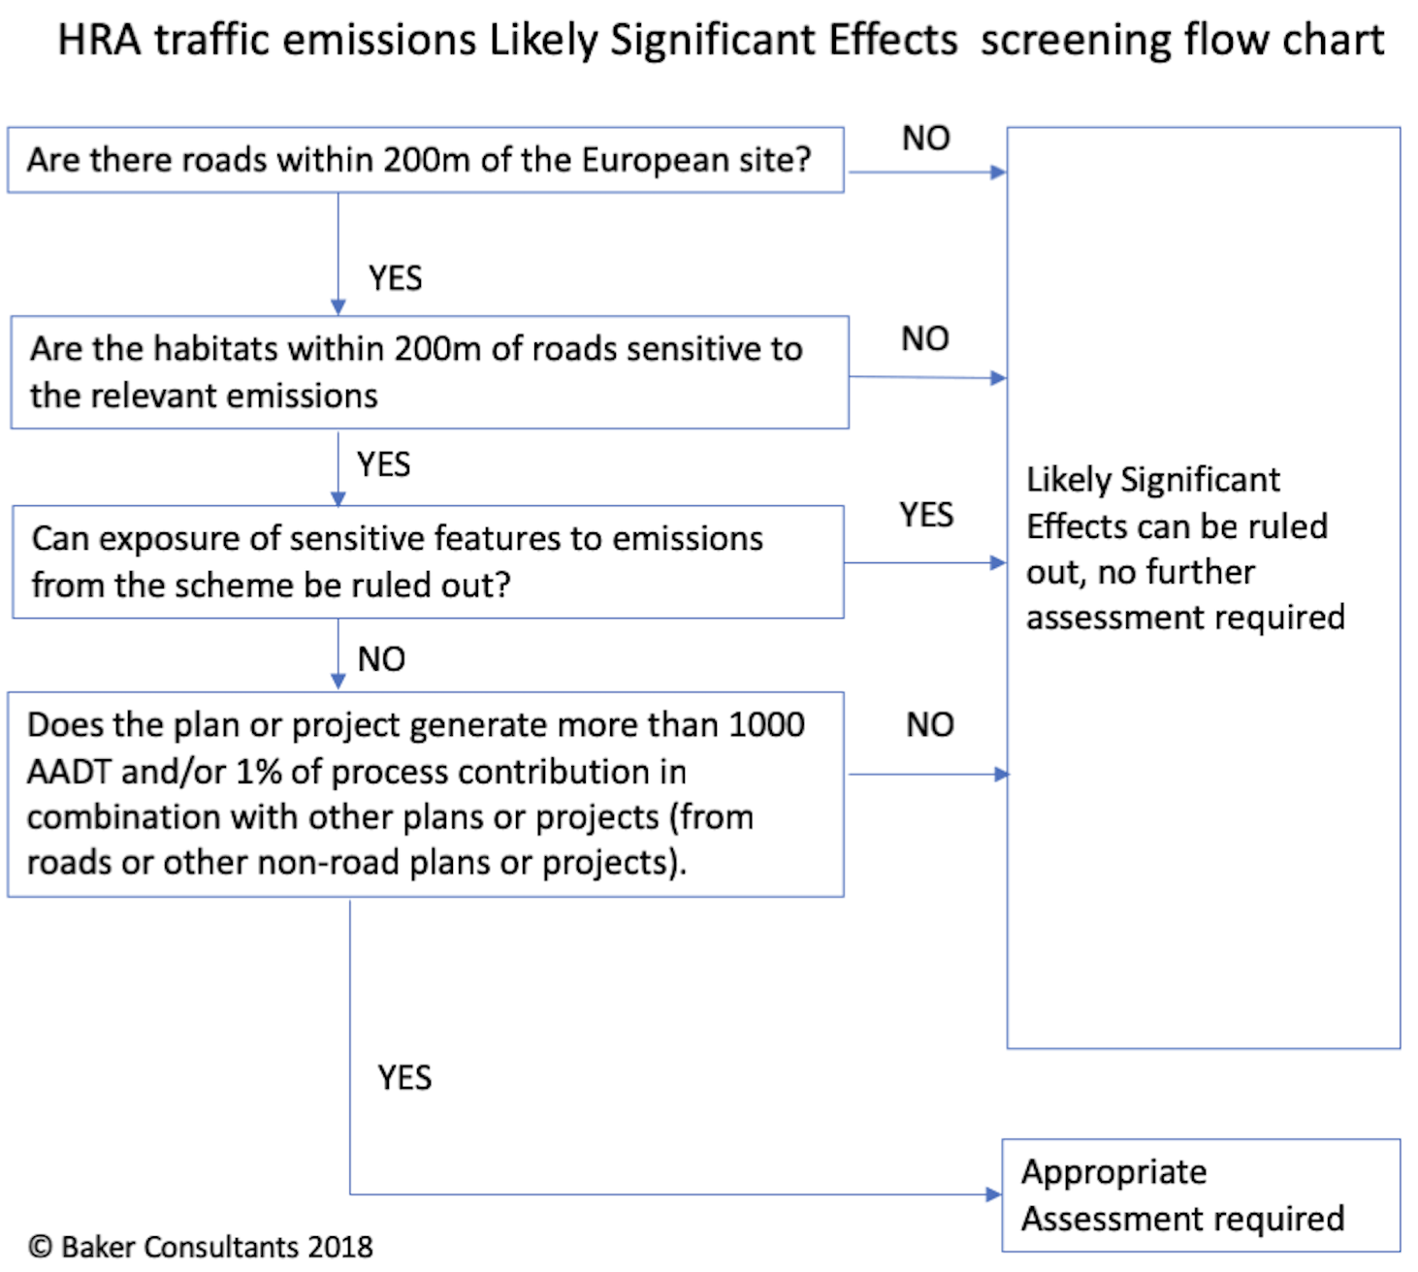

    - If we assume that the term “European site” in the flow chart is substituted for SSSI in this case there is a road which passes within 200m of the SSSI, Shaw Lane.
    - That being the case it is then necessary to consider whether the habitat within 200m of Shaw Lane are likely to support SSSI bird interest features that are considered to be sensitive to changes in air quality. In order to consider this one must refer to the Air Pollution Information System (APIS) website https://www.apis.ac.uk/srcl which sets out the critical loads and sensitivities for SSSIs. The APIS webtool shows that none of the species that are the interest features of the site are sensitive to changes in ammonia (NH3), oxides of Nitrogen (NOx) or Sulphur Dioxide (SO2). The APIS webtool also sets out critical loads for nutrient nitrogen and sensitivities for Dearne Valley Wetland SSSI. This shows that there is only 1 species where a critical load has been set for nutrient nitrogen and a further four species for which critical loads are not set yet the feature is considered sensitive and decisions should be taken on a site-specific level. The detailed are summarised Table 1 below.
- Extract from Air Pollution Information System APIS site relevant critical loads for nutrient nitrogen for Dearne Valley Wetlands SSSI
 | Min critical load for N (kg N/ ha/yr) | Max critical load for N (kg N/ha/yr) | Nitrogen critical load class | Reason
Bittern | 15 | 25 | Rich Fen | Potential negative impact on species due to impacts on the species' broad habitat.
Northern Shoveler | - | - | No comparable habitat with established critical load estimate available | Decision to be taken at a site specific level since habitat sensitivity depends on N or P limitation.
Gadwall | - | - | No comparable habitat with established critical load estimate available | Decision to be taken at a site specific level since habitat sensitivity depends on N or P limitation.
Common pochard | - | - | No comparable habitat with established critical load estimate available | Decision to be taken at a site specific level since habitat sensitivity depends on N or P limitation.
Black headed gull | - | - | No comparable habitat with established critical load estimate available | Decision to be taken at a site specific level since habitat sensitivity depends on N or P limitation.

    - The only road which could be subjected to change in air quality as a consequence of the project that is located within 200m of the SSSI is Shaw Lane. That being the case it is then necessary to establish whether the habitats within the SSSI that are within 200m of the road are likely to be supporting habitat for the species listed in Table 1. In the case of Bittern this is rich fen and for the other species they are mainly associated with open water habitats.
    - Bittern is only recorded within the SSSI at Dearne Valley Old Moor site which is located approximately 9km from the proposed development site. Any changes in air quality along Shaw Lane could not therefore affect this species.
    - The SSSI habitats that are within 200m of Shaw Lane are predominantly broad-leaved woodland flanking Cudworth Dyke and to the south of Shaw Lane (see Figure 2 below). These are not key habitats for Northern Shoveler, Gadwall, Common Pochard nor Black Headed Gull. The only habitat within the 200m zone that could support these species is a small area of open water amounting to 0.4 ha in area. This is not a significant area of open water in the context of the entire SSSI which covers a total area of 650 ha (0.06% of the SSSI).

Figure 2 SSSI Habitat within 200m of Shaw Lane.
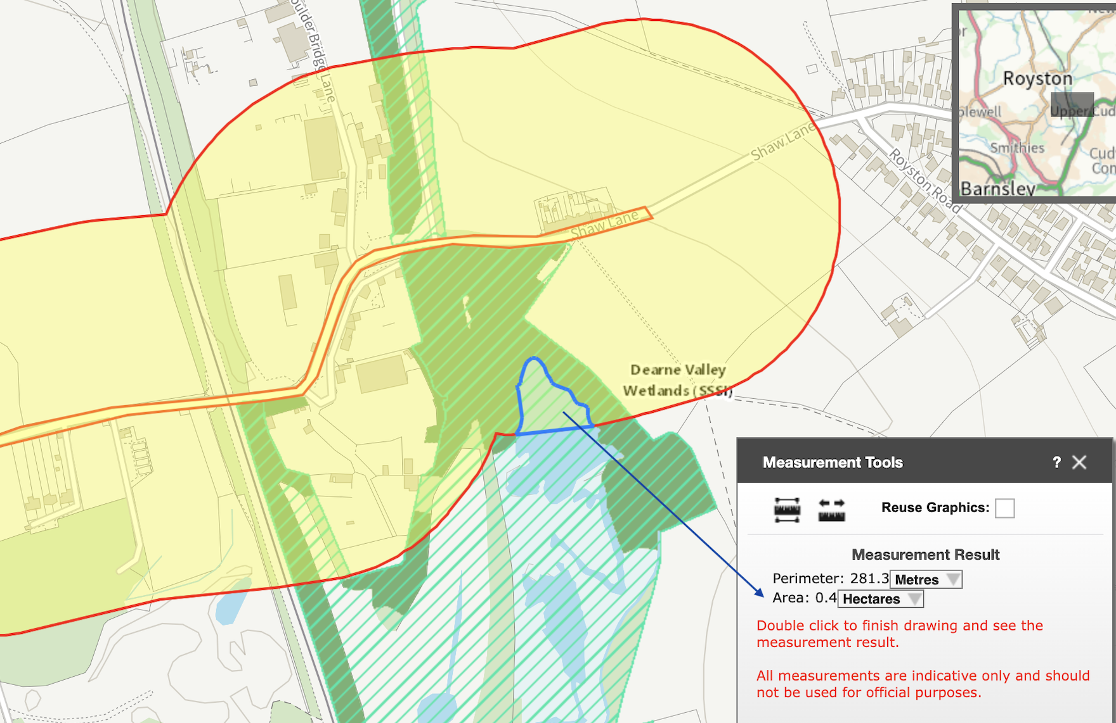
    - If changes in air quality were to occur as a result of the proposed development any significant effects upon the SSSI can be ruled out as the habitat that could be affected is small and cannot be considered significant. The same conclusion would apply for any in combinations effects that these would affect the same area.

Summary and Conclusions
    - Natural England had requested that further information be provided to assess the possible impacts of the proposed development upon the Dearne Valley Wetlands SSSI in combination with other developments. The issues raised were effects from changes in recreational pressure, air quality, water quality and loss of functionally linked land.
    - Based on up-to-date ecological survey data employing advanced ornithological survey techniques and data on hydrological and traffic generation, any impacts from changes in functionally linked land, air quality and water quality can be ruled out. The compartments of the SSSI that are closest to the development are already set up to receive visitors with established networks of footpaths and visitor facilities. Any increased in recreational pressure is considered highly unlikely to result in any increased risk of damage or disturbance to the birds that are the reason from the designation of the site as an SSSI. As a precautionary measure the appellant has offered to make a fair and reasonable contribution to the Council to assist in managing recreation on the SSSI.
    - Consequently, based on the evidence, it can be concluded that the proposed development will have no effects upon the Dearne Valley Wetland SSSI and as such there will be no in combination effects either.
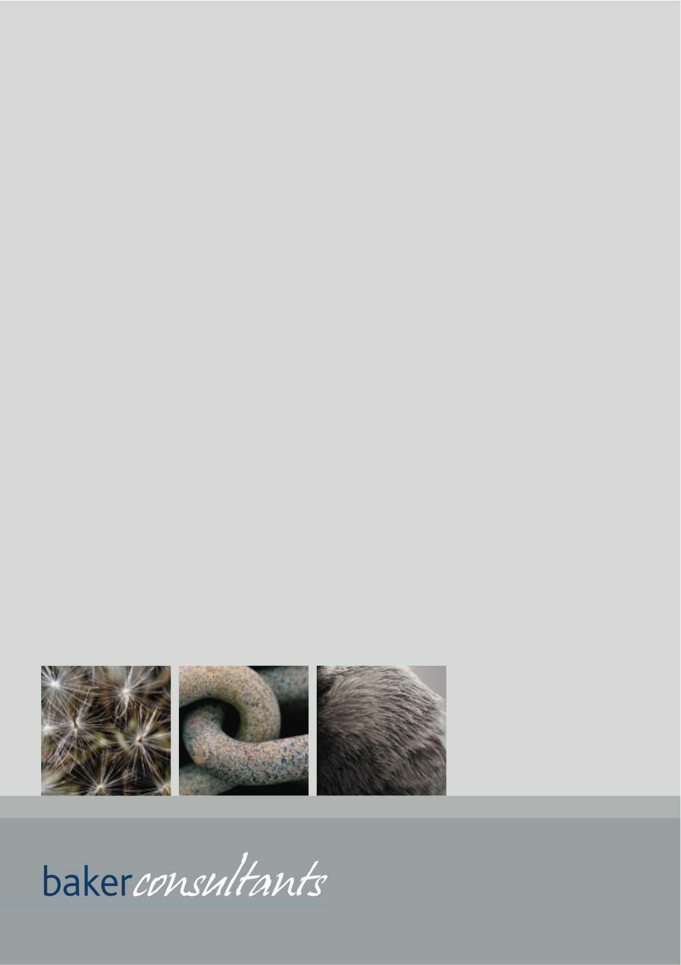

https://designatedsites.naturalengland.org.uk/SiteDetail.aspx?SiteCode=s2000814
NERC361. Natural England Identification of Functionally Linked Land supporting SPA waterbirds in the North West of England.
CHAPMAN, C. & TYLDESLEY, D. 2016. Functional linkage: How areas that are functionally linked to European sites have been considered when they may be affected by plans and projects - a review of authoritative decisions. Natural England Commissioned Reports, Number207.
Natural England’s approach to advising competent authorities on the assessment of road traffic emissions under the Habitats Regulations Version: June 2018

