DESIGN AND ACCESS STATEMENT

Erection of single storey two bedroom apartment adjacent to the western boundary of the courtyard and re-profiling of the land at the rear of The Laithe

ROYD HILL FARM, ROYD LANE, HIGHAM, BARNSLEY

GENERAL
The Site

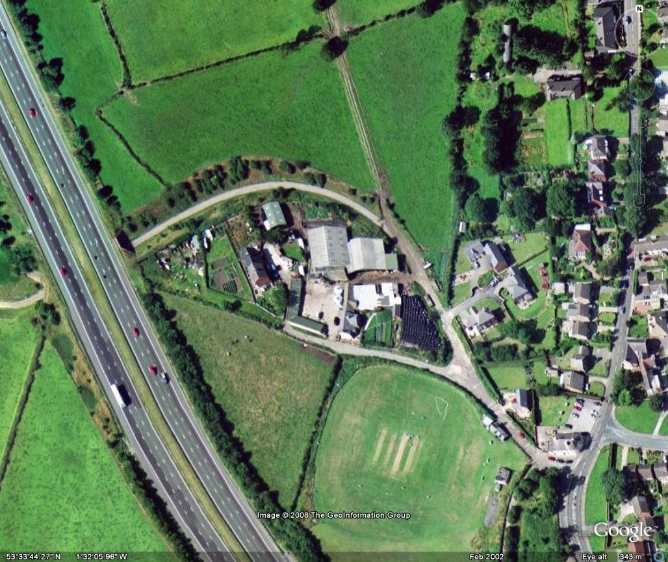

Royd Hill Farm is located in Higham, Barnsley. The Application site is approximately 153m2 and consists of a one storey outbuilding and is set within the demise of two recently converted barns.
The surrounding area is set within the Green Belt. To the East of the site there are three existing two storey dwellings. To the West of the site there are three relatively recently constructed detached dwellings, one of which has recently been extended.

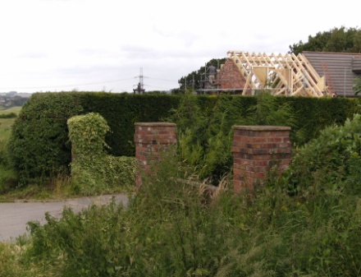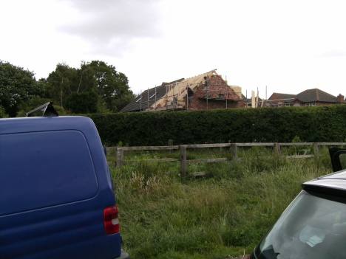
Extension to Surrounding Buildings
Main access to the site is from the South East and the Village of Higham. The main access road then divides into two directions which lead to the main courtyard, and the two dwellings to the West, and also around the perimeter of the site. The road carries on around the perimeter of the site, under the M1 motorway until, shortly after, it becomes a dirt track suitable for agricultural vehicles. The buildings form a flow of process traditional to farmsteads of its nature and era.
One of the recently converted barns is Grade II Listed. The building is of timber frame construction and it is the timber frame that is of particular interest.
The site is self contained and does not overshadow any neighbouring properties.
The building that form the application site are opposite the Farmhouse and Grade II listed barn and offer a degree of natural acoustic protection from the nearby M1 motorway. These have had the front block work wall removed due to poor design and structural faults. The rear wall of the building is of stone construction and can be dated back to the 1870s. The development will look to comply with a range of policies including GS7 Green Belt, GS8 & 13 Development within the Green Belt, BE2 and 2A Development affecting Listed Buildings and T2A vehicular access.
Alongside the relevant policies the site will be developed using guidance from ‘The Conversion of Traditional Farm Buildings : A Guide to Good Practice ‘ as published by English Heritage.

The following neighbours were consulted:

Name: Mr C Peake & Mrs P Trueman
Address: 22 Royd Lane, Higham, Barnsley
Comments: (See Appendix A)

Name: Mrs M Lane
Address: 26-28 Royd Lane, Higham, Barnsley
Comments: (See Appendix A)

Name: Mr D Dickinson & Mrs E Dickinson
Address: The Cow, Royd Hill Farm. Royd Lane, Higham, Barnsley
Comments: (See Appendix A)

The comments made by the neighbours demonstrate a clear understanding of the proposed works has been communicated. The residents are clearly in favour of the proposed building and believe that it will add value to both the site and the surrounding area by creating a mini hamlet.

Local Authority Consultation
Prior to the submission of this application a number of Pre Submission Assessment meetings have taken place between Matthew Burgin (BBAD Ltd), Darren Dickinson (site owner), Tony Wiles and Kieran Dunn (Barnsley MBC). These meetings resulted in significant changes to the proposed schemes in line with recommendations from both the Conservation and Planning Officer. The scheme has reduced the number of proposed dwellings from three to one and has further responded to the advice of the Local Authority by reducing the proposed building from two to one storey.

BUILD PROPOSAL -
Erection of single storey two bedroom apartment adjacent to the western boundary of the courtyard and re-profiling of the land at the rear of The Laithe and Ercetion of a Double Garage to the South East of the site.

The proposed building has evolved during the design stage firstly through advice from the Planning and Conservation Officers during pre application consultations and then by following English heritage guidelines for the Conversion of Traditional Farm Buildings. Initially the outbuildings were to be three, 1 ½ storey accommodation with the height of the existing rear wall to remain as existing. This design was discussed with the Planning and Conservation Officers but was seen as contrary to the traditional form of farm buildings. The proposed 1 ½ storey with dormers was the main reason for this and was not seen as a suitable form of construction in keeping with the existing form of the farmstead. The introduction of floor to eaves windows not only had no historical grounds but also had the appearance of being in competition aesthetically with its much larger neighbouring buildings. The Planning and Conservation Officer commented that it would be preferable to have a traditional 1 storey construction which would complement the existing Listed Building. Therefore, the proposed building is of a much smaller scale than the two barns and farmhouse. The neighbouring buildings could justify this appearance both through scale and historical usage. Consequently the final scheme has toned down the aesthetical appearance of the outbuilding by removing the large glazed panels in favour of traditional style windows. As the building has historically appeared as a secondary building within the farmstead, it now subtly blends in within the development.
The outbuilding already enjoys permission through application B/05/0601/DT for the demolition of the existing outbuilding and the erection of a new garage block. This permission was obtained by the previous owner of the site. This permission would result in the demolition of the existing building and the construction of a garage block that in our opinion is of poor design and moves away from the original design of the site. The existing permission allows for a building with a pitched roof and three large garage doors. Although this design would undoubtedly add value to the site we believe it does not enhance the setting of the Listed Building as well as it could and we have therefore proposed an alternative design.
After much research and consultation we propose to build a single storey cottage that in many ways recreates the original building dating back to the mid nineteenth century. The building would retain the original rear stone wall and a steel frame will be used to add further support to the structure. The render to rear wall is to be removed and the original stonework exposed and repaired using a lime mortar to match the rest of the site. As the area is within Green Belt the amount of new build has been kept to the minimum and only the front breezeblock walls are to be replaced by a random stone wall that is in keeping with the Listed Building. The windows are to be of a wooden construction and will once again match those installed in the Grade II Listed Building.
The roof is to follow the existing pitch and a stone tile similar to the one used on the approved outbuilding attached to the Listed Building is to be used. This tile has been approved by Tony Wiles from the Local Authority. The building will follow the footprint of the original building and overall there will be a reduction in the size from the original building as a part of the building is to be demolished to form a new opening. The courtyard which is currently of a concrete construction will be replaced with stone setts or some form of gravel and a dry stone wall will create a small front garden for the cottage. The remainder of the courtyard will remain open.

Current Volume = 490 m3
Proposed Volume = 433 m3

Proposed Increased = -12 %

Current Footprint = 150.00 m2
Proposed Footprint = 130.00m2

Proposed Footprint Increase = -12 %

Justification for Very Special Circumstances

We accept that the proposal does not fall within any of the accepted forms of development within the Green Belt as defined by PPG 2 and as such is considered to be inappropriate. PPG2 states that ‘inappropriate’ development is, by definition, harmful to the Green Belt and that the onus is on the applicant to show why permission should be granted and to show that ‘very special circumstances’ exist to justify a departure from the normal presumption against such development. Any perceived harm must therefore be clearly outweighed by other material considerations. In this case we are seeking to establish that the benefits in restoring the setting of the listed building with the creation of a single storey dwelling on the site far outweigh the perceived harm to the broader Green Belt.

Historical Importance & Enhancing the Setting of a Listed Building

The Listed building on the site was nationally listed in 1987 as holding special historic or architectural interest. List entry Number: 1191998. The Listed status of a property makes it a higher grade of “heritage asset”, a term used within Planning Policy Statement 5 (Ref PPS5). The interest is based around the
“Barn: Timber framing of C16 or C17 in two phases, cladding C17 or C18,altered. Coursed squared rubble. Stone slate roof. 4½ internal bays, the half bay being in the centre. Square-headed cart entrance to bay 3. Later doorway to left.
Rear: Projecting gabled porch with opposing cart entrance with cambered head.
Interior: Four frames with king-post trusses. Jawelled posts arched-braced
to tie-beams. Some braces from posts to arcade plate are visible in front wall. Trusses 2 and 3 are very close together and suggest two phases of building.”
As you can see from above, there is little doubt that the Listed Building is of special historical value and interest. Moreover, we would argue that the setting of the listed building is also an essential part of the building's character and thus should be given just as much care and consideration as the building itself. Consequently the design of the new building planned to stand in the setting of the Listed Building is particularly critical. The new building must be designed to respect the setting, alignment and use appropriate materials. We feel by moving away from the existing permission granted and towards a more sympathetic design we would further enhance the setting of a listed building that has significant historical value to the local area.
Having now established the historical importance of the building and the importance of its setting, we feel it would be beneficial to discuss the site to date and examine the works already completed. This will give a picture of what we wish to create for the courtyard and how we would look to enhance the setting of the Listed Building. The definition of enhance is to “intensify, increase, or further improve the quality, value, or extent of”.
We would argue that development that has already taken place on site has significantly improved the setting of the listed building. During the development of the site many unsightly buildings, breeze/brick walls and concrete pads have been removed and replaced with dry stone walls, grassed paddocks and stone buildings of a much higher design and build quality. All hard standing is York Stone and no expense has been spared to ensure the design and materials enhance the setting of the buildings on site. Such is the quality of the work undertaken so far that the Local Authority has commented on the quality of work and design. If successful with the application of the outbuilding, this standard of development can continue into the courtyard and complete the setting of the Listed Building.
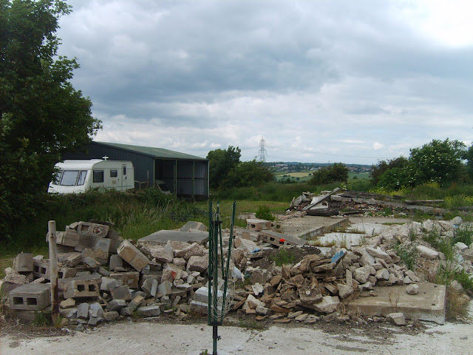
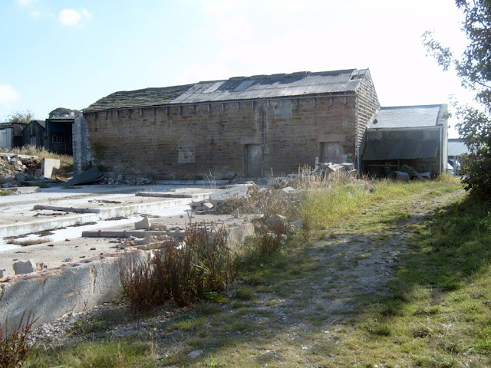

Large concrete pad for dairy building prior to development
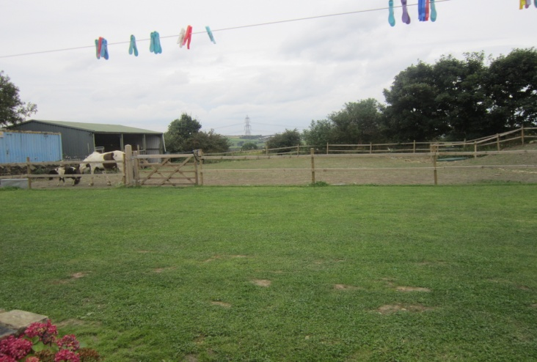
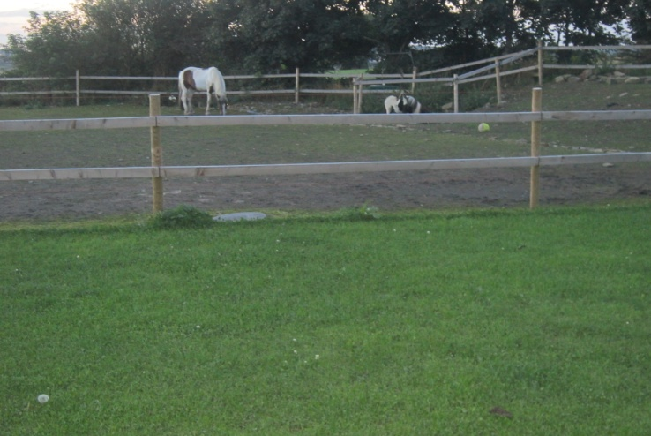

Pad removed and paddock created for horses
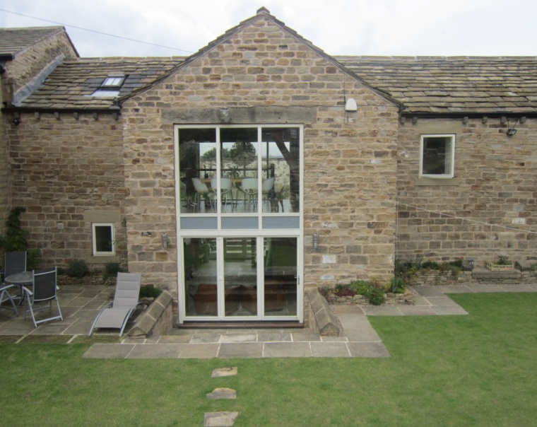
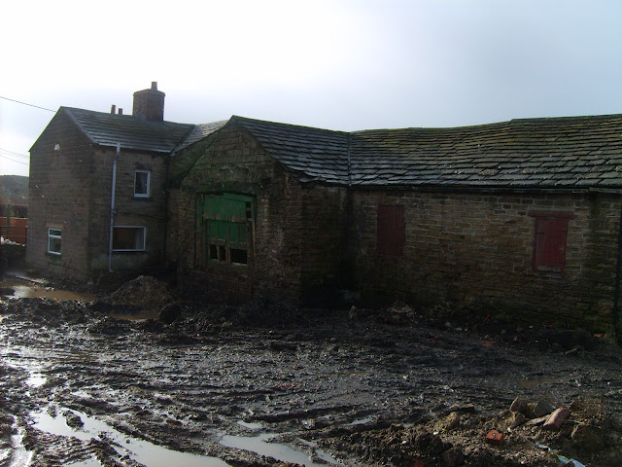

Rear of the Listed Building before and after development

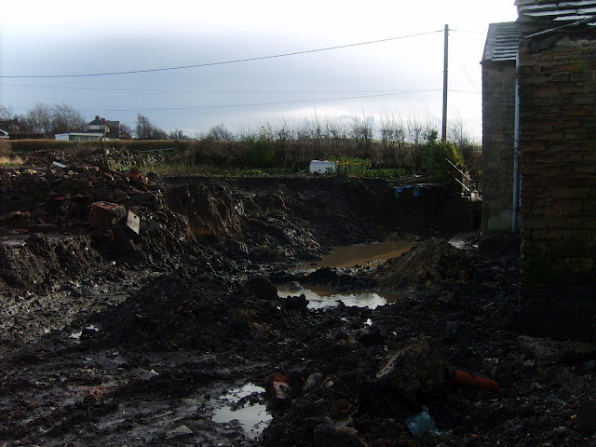
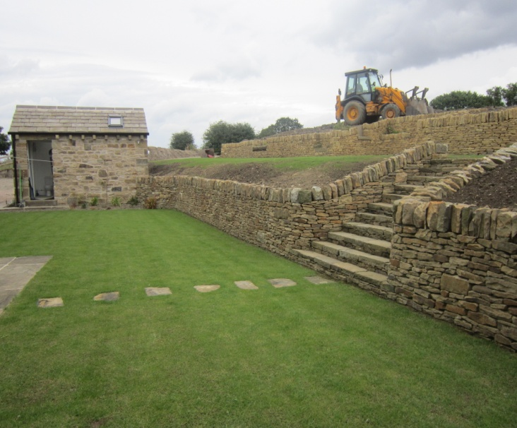

Rear of the Listed Building before and after development

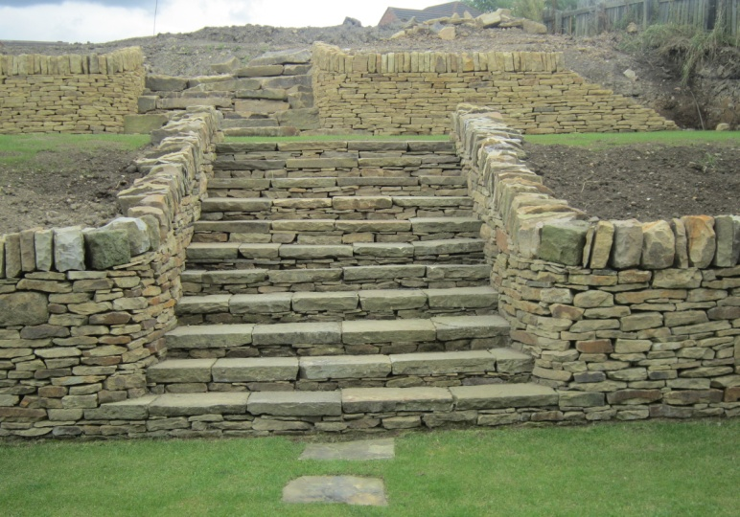
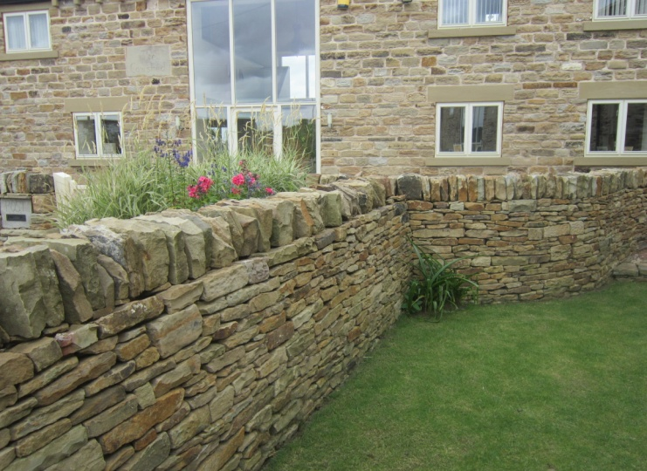

Dry Stone walling on the development

Viability:
In order to ensure the long term retention and continued maintenance of the
Site and the Grade 11 Listed Building it is appropriate that a viable use of the outbuilding is secured. Research has shown that the Grade II Listed Building dates to the mid sixteenth century and the current site layout can be traced back to 1870. Preserving the nature of this regular courtyard layout is essential to the historical integrity of the site and if designed correctly the proposed building would enhance the setting of the Grade 11 Listed Building and the farmstead overall. Many of the alterations to the site over the years have been carried out to poor design and construction standards and thus need to be redesigned and rebuilt sympathetically. Materials used have been inappropriate and the emphasis has clearly been on cost rather than quality. As demonstrated by the images above, the remainder of the site can be transformed and the Listed Building given an appropriate setting, but this work would come at a cost. The costs of the works required to bring the outbuilding and the courtyard up to an acceptable standard have been estimated at over £100,000. To make the works financially viable, the building needs to have a final monetary value that is worthy of such a substantial investment both in terms of time and money. This can only be achieved through the construction of a domestic dwelling. By allowing very special circumstances, the setting of the Listed Building and the site as a whole would benefit significantly.

Protecting the Openness of the Greenbelt

We understand that the fundamental aim of Green Belt policy is to prevent the uncontrolled spread of urban areas into open countryside. This is achieved by keeping land in the countryside permanently open or largely undeveloped. Planning applications for development in the Green Belt are subjected to rigorous scrutiny to make sure the aims of the Green Belt are upheld. The ‘openness’ of the Green Belt is its most important attribute. Openness can be harmed by (among other things) new built form, external storage, extensive hardstanding, car parking and boundary walls or fencing. Every application for development in the Green Belt is assessed against a number of criteria, with the most important test being the harm the development would have on openness.
In response we would argue that to date the development has in real terms increased the openness of the Green Belt. See image below.
Storage Buildings now removed to form open
land

Large agricultural building now removed to form paddock

Large agricultural building now removed to form paddock

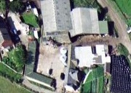

Moreover, the new design for the outbuilding further reduces the amount of building on site with the forming of a new opening. The design follows the original footprint of the existing buildings which can be traced back to 1870.There are no new boundary walls or fencing, no new hardstanding or external storage and we would argue the benefit of enhancing the setting of the Listed Building by granting Very Special Circumstances for the proposed scheme far outweigh the perceived harm to the broader Green Belt.

The flow of process of the existing farmstead and courtyard.

Whilst the main barn is believed to date back to the 15th century, the remaining buildings are more recent. It is possible that this barn is the only remaining original building and the other outbuildings have been added during the lifespan of the farmstead. As the roof of the second barn is of a slate construction, it would be reasonable to argue that the buildings could be dated around 1750-1880, during the boom period for agricultural activity. The use of blockwork and render, particularly on the outbuildings would suggest that the outbuildings have been modified piecemeal throughout this period.
Whilst individual buildings appear to have been removed, adapted and fallen into disrepair, the farmstead character has remained. The current form of the annex buildings is of benefit to the farmstead in a number of ways. Historically it demonstrates the flow of process, previously identified, within the courtyard plan. More recently it acts as an acoustic barrier from the nearby M1 Motorway. Standing in the courtyard the noise from the Motorway is substantially reduced compared to nearby areas outside the courtyard.
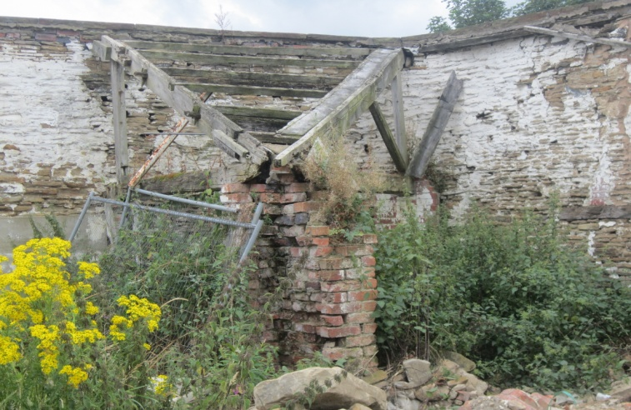
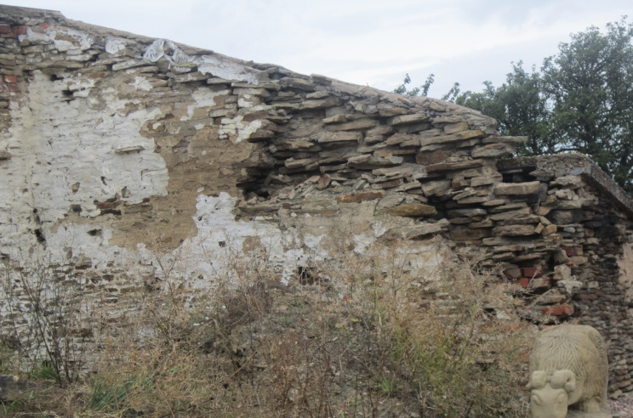
As discussed earlier, preserving the nature of this regular courtyard layout is essential and if designed correctly the outbuilding and courtyard would enhance the overall farmstead. Many of the alterations over the years have been carried out to poor design and construction standards and need to be redesigned and rebuilt sympathetically. Whilst the farmhouse, two barns and some of the site have undergone substantial restoration, the courtyard and the outbuildings have deteriorated into a poor state of repair. Parts of the outbuildings give the impression that they are currently in danger of collapse. Should the building be left without remedial action it appears that this is probable outcome for the buildings in the short- medium term. As with many existing farmsteads dereliction is becoming an increasing problem, particularly as the site clearly no longer has a viable mainstream or low key agricultural use. It would appear that an inherently sustainable redevelopment would be of long term benefit to site. From the neighbour consultation, this sentiment is shared by the current occupiers of the immediate surrounding properties.

Outbuilding rear wall in poor state of repair

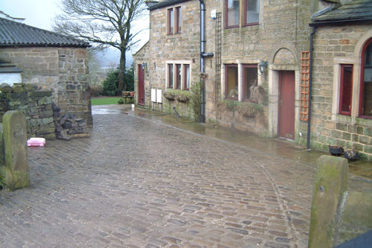
Additional occupation of the buildings not only gives the farmstead a sense of place but will increase the overall security of the site. The courtyard will be the central feature of the site and will be enveloped by sustainable residential developments. To enable the courtyard to retain this feeling and remain uncluttered, private and visitor parking to the three principal buildings has been allocated outside this area. As the courtyard is to become a focal point within the development it is important that it is complementary to the scheme as a whole. Currently the courtyard is of a concrete construction and has no aesthetic merits. It would appear that the surface is relatively new but is in a poor state with numerous cracks. To enhance the courtyard it is proposed to have a stone cobble or estate gravel effect finish, as indicated below. The cobble effect finish, along with York Stone paved areas to the front of the barns / farmhouse and small grassed gardens to the buildings will enhance a sense of community to the development. By granting Very Special Circumstances the proposed scheme can progress and the site and the setting of the Listed Building can be enhanced and maintained in a sustainable manner.
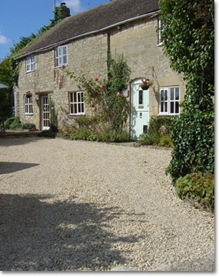

SITE SUSTAINABILITY
As the Applicants intend to occupy all of the dwellings they are committed to using renewable energy sources which will reduce carbon emissions way in excess of that recommended by SAP and Building Regulations.

In conjunction with the renewable heat source all dwellings within the site offer the following:
- Provision of a Home Office
- Outdoor drying spaces
- Adequate space for internal and external recycling bins
- Adequate space for external storage, suitable for cycle storage
- All insulants used will have a Global Warming Potential of less than 5
- 100% of light fittings will be energy efficient
- All dwellings to have water butts.

