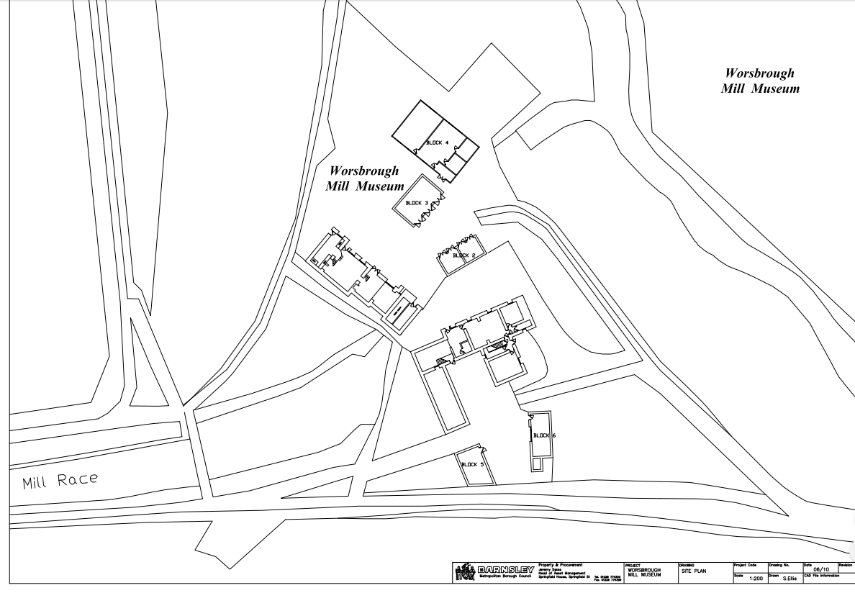
North
Art Installation location on grass verge
Access road from Car Park (A61)

Grade II* listed Corn Mill
Grade II Listed Mill Cottage

